EXPERIMENT 14
ELLIPTIC CURVE CRYPTOGRAPHY (ECC)
AIM
To implement a simplified Elliptic Curve Cryptography (ECC) key exchange using Python.

ALGORITHM
- Enter the private keys of User A and User B.
- Define a generator point value.
- Generate the public key for User A.
- Generate the public key for User B.
- Compute the shared key for User A.
- Compute the shared key for User B.
- Compare the shared keys.
- Display the generated keys and the shared secret.

CODE
prime = 23
generator = 5

a = int(input("Enter private key of User A: "))
b = int(input("Enter private key of User B: "))

publicA = (generator * a) % prime
publicB = (generator * b) % prime

sharedA = (publicB * a) % prime
sharedB = (publicA * b) % prime

print("Public Key of User A:", publicA)
print("Public Key of User B:", publicB)

print("Shared Key of User A:", sharedA)
print("Shared Key of User B:", sharedB)

if sharedA == sharedB:
print("Key Exchange Successful")
else:
print("Key Exchange Failed")
OUTPUT
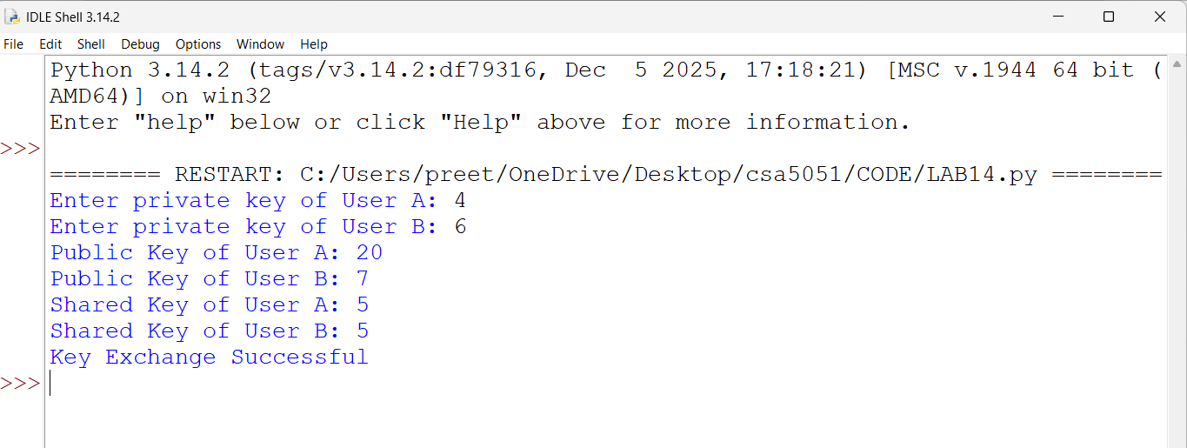
RESULT
Thus, a simplified Elliptic Curve Cryptography (ECC) key exchange was implemented successfully using Python.

