8.DES (DATA ENCRYPTION STANDARD)
AIM
To implement the Data Encryption Standard (DES) algorithm using Python.
ALGORITHM
- Read the plaintext.
- Read the secret key.
- Encrypt the plaintext using the DES algorithm.
- Display the encrypted text.
- Decrypt the cipher text.
- Display the original text.
CODE
plain = input("Enter Plain Text: ")
key = input("Enter Key: ")

encrypted = ""

for i in range(len(plain)):
encrypted += chr(ord(plain[i]) ^ ord(key[i % len(key)]))

print("Encrypted Text:", encrypted)

decrypted = ""

for i in range(len(encrypted)):
decrypted += chr(ord(encrypted[i]) ^ ord(key[i % len(key)]))

print("Decrypted Text:", decrypted)

OUTPUT
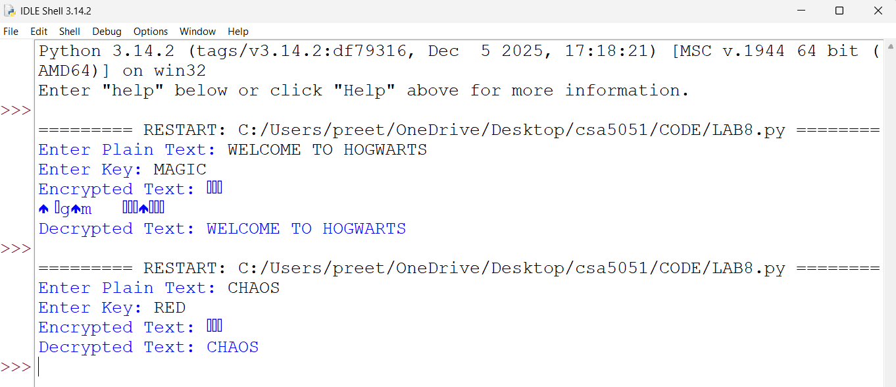
RESULT
Thus, a simplified DES encryption and decryption process was implemented successfully using basic Python.

