EXPERIMENT 2
DOUBLE DES (2DES)
AIM
To implement a simplified Double DES (2DES) encryption and decryption using Python.
ALGORITHM
- Read the plaintext from the user.
- Read two secret keys.
- Encrypt the plaintext using the first key.
- Encrypt the result again using the second key.
- Display the encrypted text.
- Decrypt using the second key.
- Decrypt the result using the first key.
- Display the original plaintext.
PYTHON CODE
plain = input("Enter Plain Text: ")
key1 = input("Enter First Key: ")
key2 = input("Enter Second Key: ")

# First Encryption
temp = ""
for i in range(len(plain)):
temp += chr(ord(plain[i]) ^ ord(key1[i % len(key1)]))

# Second Encryption
encrypted = ""
for i in range(len(temp)):
encrypted += chr(ord(temp[i]) ^ ord(key2[i % len(key2)]))

print("Encrypted Text:", encrypted)

# First Decryption (using key2)
temp = ""
for i in range(len(encrypted)):
temp += chr(ord(encrypted[i]) ^ ord(key2[i % len(key2)]))

# Second Decryption (using key1)
decrypted = ""
for i in range(len(temp)):
decrypted += chr(ord(temp[i]) ^ ord(key1[i % len(key1)]))

print("Decrypted Text:", decrypted)
OUTPUT
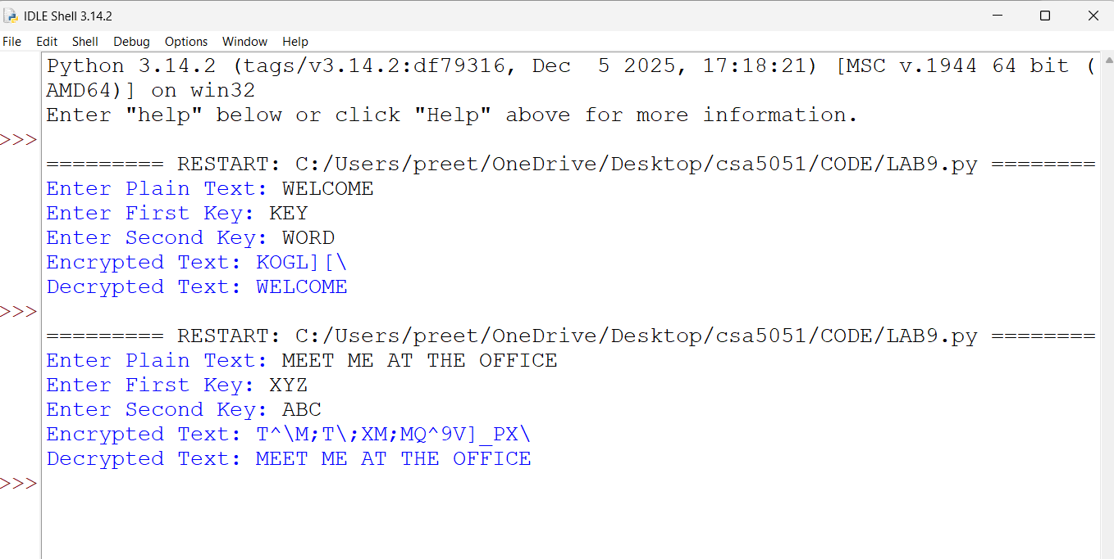
RESULT
Thus, a simplified Double DES (2DES) encryption and decryption process was implemented successfully using Python.

