SMART TRAFFIC LIGHT SIGNALS CONTROLLER

Here, a methods of Traffic signals to control in there, but commonly used automatic timing based, IR Sensors used mostly and in current technology used as advanced AI in anywhere over worldwide.
Many developed countries using IR Sensors with AI in traffic light signal to controlling.
SMART TRAFFIC SIGNALS:
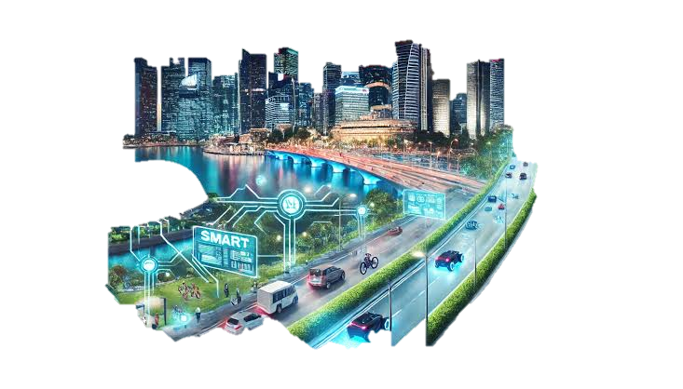

SMART CITY TRAFFIC CONTROLLER USING AI, SENSORS AND IoT

Introduction

Traffic congestion is one of the major challenges in modern cities. Traditional traffic signals operate with fixed timing and cannot respond to real-time traffic conditions. A Smart City Traffic Controller is an intelligent traffic management system that uses sensors, Artificial Intelligence (AI), cameras, and Internet of Things (IoT) technology to monitor traffic density and dynamically adjust signal timings. This improves traffic flow, reduces waiting time, saves fuel, and supports

Architecture of Smart Traffic ...

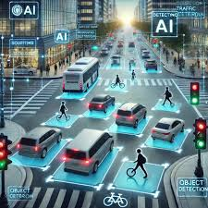 AI WITH SENSORS IN TRAFFIC SIGNAL CONTROLL

AI-Driven Traffic Lights: Reinforcement ...

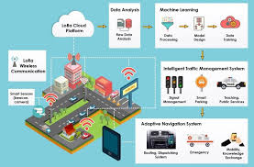 TRAFFIC SIGNALS WITH AUTOMATIC TIMMING BASED INNOVATIONS
------------------------------------------------------------------------------------------------------------------------------------------

Principle

The system works on the principle:
sense → Analyze → Decide → Control

- Sensors and cameras collect traffic information.
- AI analyzes vehicle density and congestion.
- The controller decides the optimal signal timing.
- Traffic lights are controlled automatically according to traffic conditions.
------------------------------------------------------------------------------------------------------------------------------------------
Technical Model (System Architecture)

SMART CITY TRAFFIC CONTROL
Sensors + cameras (IR, Ultrasonic, CCTV)

Data Collection

AI Analysis Vehicle Count & Density

Decision Controller Signal Timing Calculation

ESP32 / Arduino

Traffic signals (Red, Yellow, Green)

IoT Monitoring Smart City Developing
---------------------------------------------------------------------------------------------------------------------------------------
Working
1. Sensors and cameras continuously monitor traffic.
2. Vehicle data is collected and transmitted to the controller.
3. AI calculates traffic density and queue length.
4. The controller determines which lane requires priority.
5. Green signal duration is adjusted dynamically.
6. Traffic information is stored and monitored through IoT platforms.
7. Emergency vehicles can be given priority access.
------------------------------------------------------------------------------------------------------------------------------------------
Sensors Used
- IR Sensors – Vehicle detection.
- Ultrasonic Sensors – Queue length measurement.
- Radar Sensors – Vehicle speed detection.
- Inductive Loop Sensors – Vehicle presence detection.
- Cameras – AI-based traffic monitoring and vehicle counting.
------------------------------------------------------------------------------------------------------------------------------------------
AI in Traffic Control
AI is used for:
- Vehicle detection.
- Traffic density estimation.
- Congestion prediction.
- Dynamic signal timing.
- Emergency vehicle prioritization.
The AI system helps reduce unnecessary waiting and improves intersection efficiency.
---------------------------------------------------------------------------------------------------------------------------------------
Advantages
- Reduces traffic congestion.
- Decreases vehicle waiting time.
- Saves fuel and energy.
- Reduces air pollution.
- Improves road safety.
- Provides emergency vehicle priority.
- Enables real-time monitoring.
- Supports smart city infrastructure.
------------------------------------------------------------------------------------------------------------------------------------------
Applications

- Smart Cities
- Urban Intersections
- Highways
- Toll Plazas
- Airport Roads
- Industrial Zones
- Public Transportation Networks
----------------------------------------------------------------------------------------------------------------------
Countries Using Smart Traffic Control
- Singapore – AI-based adaptive traffic management.
- Japan – Sensor and camera-based traffic control systems.
- China – AI-driven traffic optimization in major cities.
- United States – Adaptive signal control technologies.
- United Kingdom – Intelligent urban traffic management.
- Australia – Smart signal coordination systems.
-----------------------------------------------------------------------------------------------------------------------------------
Future Development

Future advanced traffic systems can include:

- Reinforcement Learning for self-learning traffic signals.
- Vehicle-to-Infrastructure (V2I) communication.
- Cloud-based traffic analytics.
- Digital Twin traffic simulation.
- Smart emergency routing.
- Autonomous vehicle integration.
- City-wide AI traffic optimization.

---------------------------------------------------------------------------------------------------------------------------------------

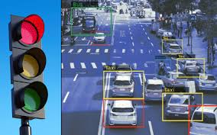

AI IN TRAFFIC SIGNALS:

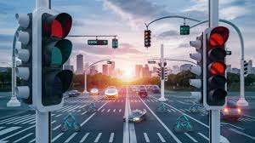

Conclusion

The Smart City Traffic Controller is an advanced traffic management solution that combines sensors, AI, and IoT technologies to optimize traffic flow in real time. By dynamically controlling traffic signals based on actual traffic conditions, the system reduces congestion, improves road safety, lowers fuel consumption, and contributes to the development of efficient and sustainable smart cities.

