**Conclusion 1 –**

The game is preferred by males more than females. This can be seen from the fact that a majority of players are males.

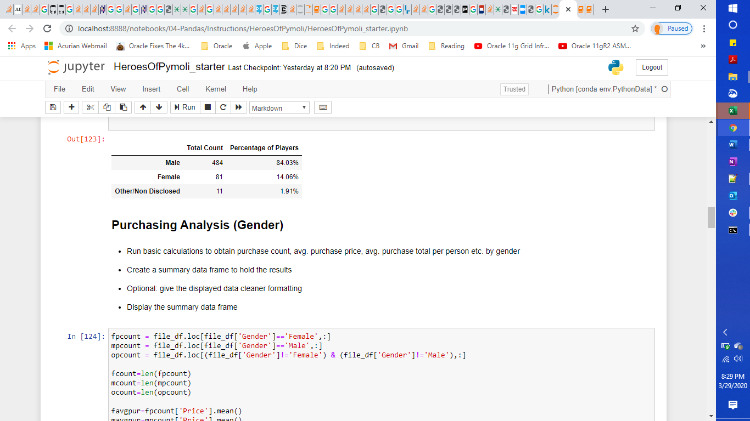

**Conclusion 2 –**

The target audience of the game is young people in the age range of 20-24. This can be based on the fact that people in 20-24 years constitute approx. 45% of the player count. Hence, this game is popular among age group 20-24 years and is less popular among other age groups.

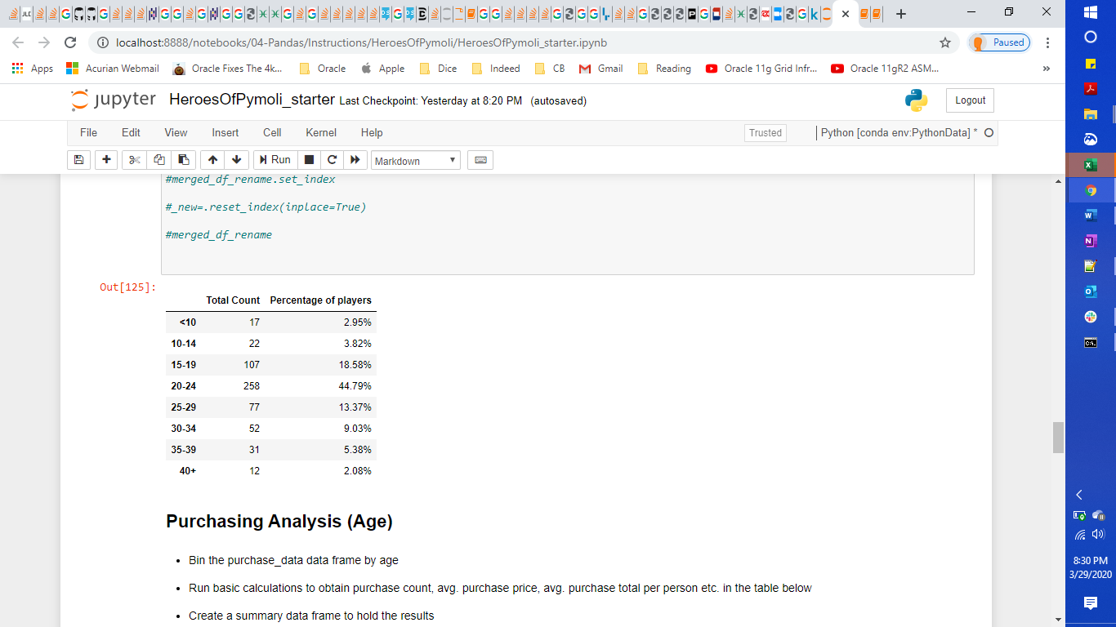

**Conclusion 3 –** The purchases made are predominantly by males. This can be seen from the number of purchase count.

