WATER QUALITY ANALYSIS

**Table of Contents**

# 1.Project Definition

# 2.Design Thinking

# 3.Innovation of the analysis

# 4.Steps to be followed for the analysis

# 5.Data Visualization

# 6.Model Development

# 7.Insights Gained

# 8.Conclusion

Problem definition:

The project involves using IBM Cognos to analyzing water quality data to assess the suitability of water for specific purposes, such as drinking. The objective is to identify potential issues or deviations from regulatory standards and determine water potability based on various parameters. This project includes defining analysis objectives, collecting water quality includes defining analysis objectives, collecting water quality

data, designing relevant visualizations in IBM Cognos, and building a predictive model.

Design Thinking:

1:Analysis Objectives: Define specific objectives for analyzing water quality data, including assessing potability, identifying deviations from standards, and understanding parameter relationships.

2:Data Collection: Gather the provided water quality data containing parameters like pH, Hardness, Solids, etc.

3:Visualization Strategy: Plan how to visualize parameter distributions, correlations, and potability using IBM Cognous suitable tools.

The data collection process for water quality analysis typically involves:

ANALYSIS OBJECTIVE:

1. *Sampling:* Collecting water samples from various sources such as rivers, lakes, or wells, ensuring proper techniques and appropriate containers to prevent contamination.

2. *Preservation and Storage:* Treating samples with appropriate preservatives to maintain their integrity and storing them in suitable conditions to prevent degradation or alteration.

3. *Transportation:* Safely transporting the collected samples to a laboratory, often following specific protocols to maintain sample integrity during transit.

4. *Analysis:* Conducting various tests and analyses on the collected samples, including physical, chemical, and biological tests to assess parameters such as pH, dissolved oxygen, pollutants, microbial content, etc.

5. *Recording and Interpretation:* Recording the results accurately and interpreting the data to draw conclusions about the water quality, potential hazards, and compliance with regulatory standards.

DATA COLLECTION PROCESS:

1. To Collect the dataset
2. Preprocess the dataset
3. Analyse the dataset
4. Recollect and the Visualize the model
5. Get the insights from the Visulized of the data model

1. *Dashboards:* Create interactive dashboards displaying key water quality metrics like pH levels, turbidity, or pollutant concentrations. Use graphs, charts, and gauges for quick insights.

2. *Geospatial Mapping:* Utilize geospatial features to plot water quality data on maps, showing the distribution of quality levels across different geographical areas or water sources.

3. *Trend Analysis:* Visualize trends over time, such as seasonal variations or long-term changes in water quality parameters using line charts or time-series visualizations.

4. *Comparative Analysis:* Compare water quality metrics between different locations, sources, or against regulatory standards using bar charts, histograms, or side-by-side comparisons.

1. *Advanced Analytics:* Incorporate predictive models or statistical analyses within Cognos to forecast potential water quality issues or correlations between different parameter.

PYTHON CODE INTEGRATION:

Water quality analysis using Python often involves libraries like Pandas for data handling, Matplotlib or Seaborn for visualization, and SciPy or NumPy for scientific computations. Here's a simple example illustrating how you might load, analyze, and visualize water quality data:

Firstly, ensure you have the necessary libraries installed:

DATA VISULIZATION:

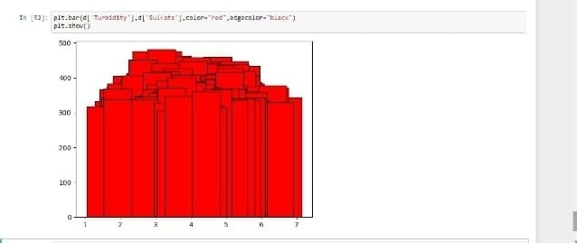

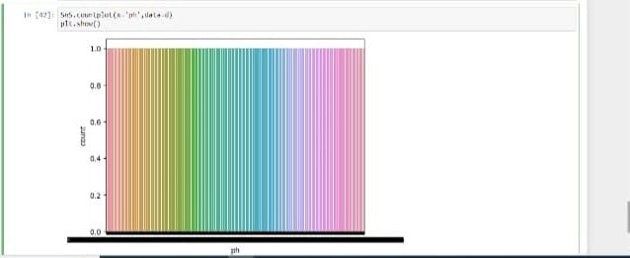

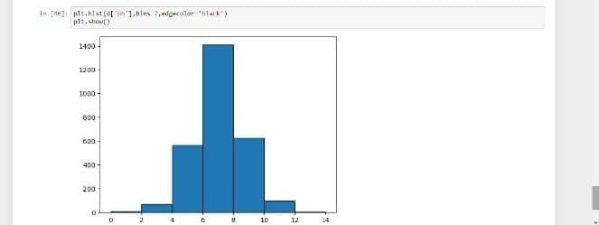

Replace 'water_quality_data.csv' with the actual file name containing your water quality data. The code showcases loading the data, displaying a snippet of it, and then creating a histogram to visualize the distribution of pH levels. You can extend this by analyzing other parameters and visualizing various aspects of your water quality dataset.Remember, in a real scenario, you'd perform more comprehensive data cleaning, analysis, and may apply statistical methods or machine learning models for prediction or classification tasks, depending on your analysis goals and the complexity of the data.

INSIGHT OF USER EXPERIENCE:

1. *Understanding Complexity:* Just as water quality analysis involves various parameters, understanding the complexities and nuances in user behavior, preferences, and interactions is crucial. Water quality analysis helps in comprehending multiple factors affecting water; similarly, website owners can benefit from understanding user data, such as demographics, behavior flow, and preferences, to tailor their websites accordingly.

2. *Optimization and Tailoring:* Just as water quality analysis aims to maintain certain standards, website owners can use user behavior data to optimize their site, offering a seamless and personalized experience. For instance, if water analysis identifies pollutants exceeding acceptable limits, corrective measures are taken. Similarly, if user data indicates high bounce rates on certain pages, optimizing those pages can enhance the overall user experience.

3. *Predictive Insights:* Water quality analysis often involves predictive modeling. Similarly, website owners can employ predictive analytics using user data to foresee potential issues or preferences, enabling them to proactively adjust their sites for better user experiences.

4. *A/B Testing and Iterative Improvements:* Like conducting controlled experiments in water quality analysis, website owners can perform A/B testing to refine their site elements, making iterative improvements based on user preferences and behaviors to enhance the overall user experience.

CONCLUSION:

Summarize the key takeaways from the water quality analysis and emphasize any critical actions that need to be taken.

E.PREETHI RAJALAKSHMI