GOOGLE GEMS HANDSON
ASSIGNMENT-3

Exercise-1: Fast vs Thinking Mode Comparison
Scenario
You want to build an intuitive understanding of when to use Fast mode versus Thinking mode by running the same type of task through each.
Answer: The fastest mode gives the answer fast and perfectly.
Fast mode:
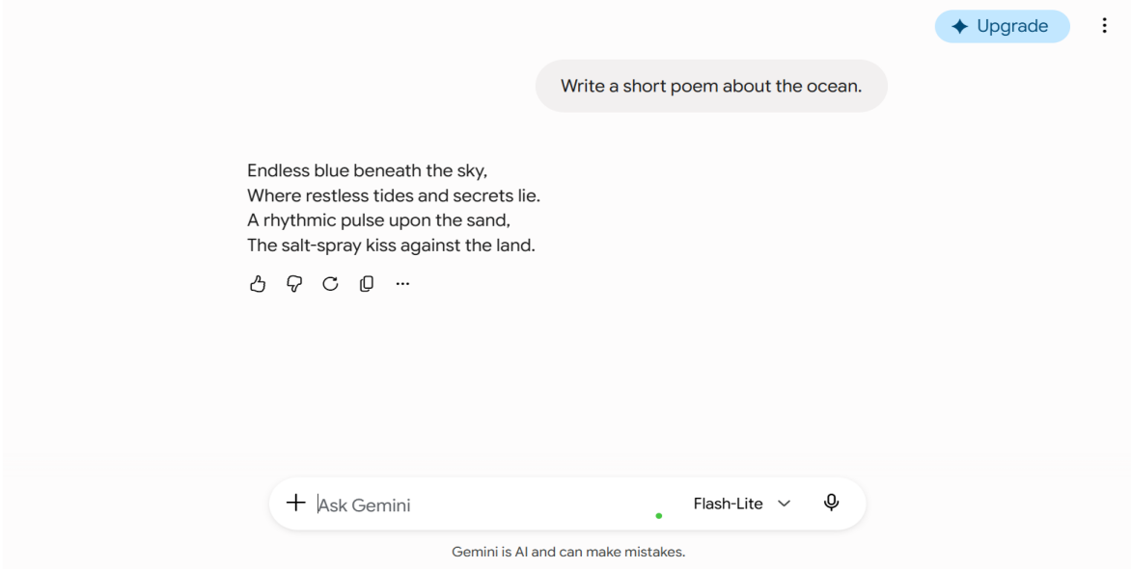

Thinking mode:

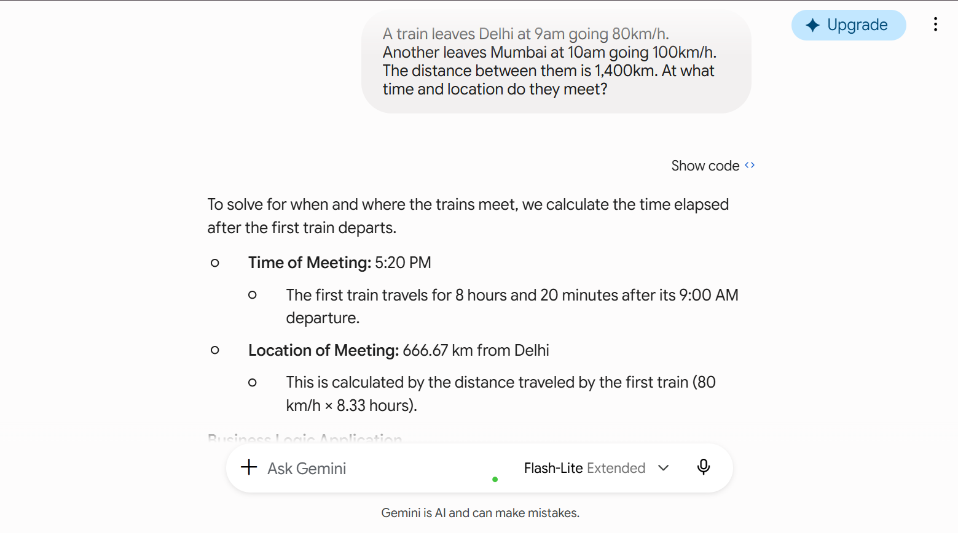
Exercise -2: Work in Canvas for Document Editing
Scenario
You need to write and iteratively improve a project proposal. Instead of copying and pasting text
back and forth in chat, you use the Canvas workspace.
Answer: A polished, refined proposal produced through targeted editing. I have clearly understoood that Canvas is superior to chat for long-form documents requiring multiple iterations.

Canvas workspace: Introduction enhancing step:
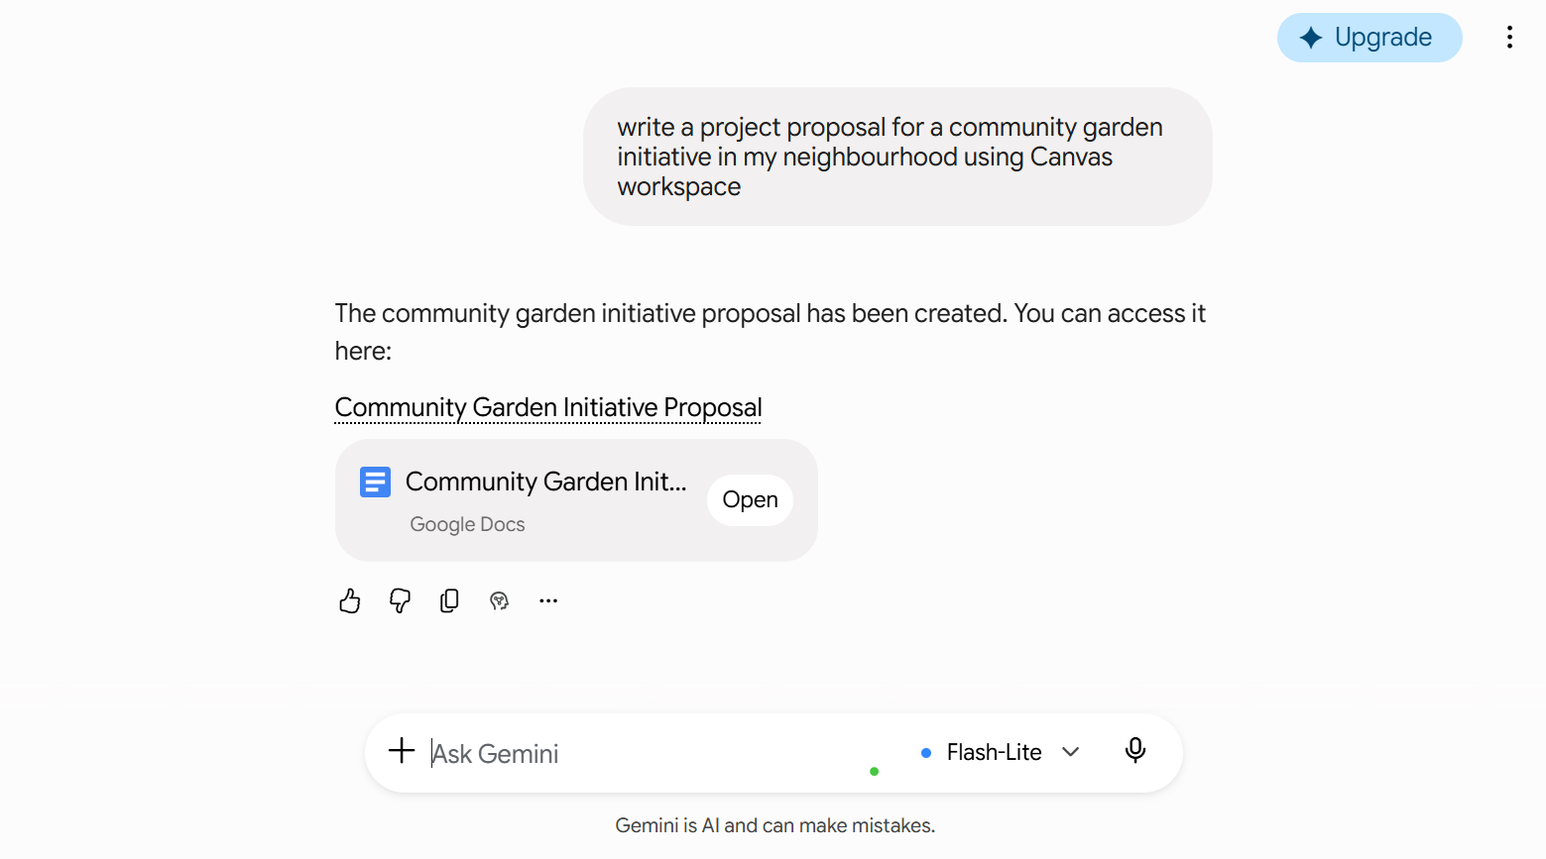

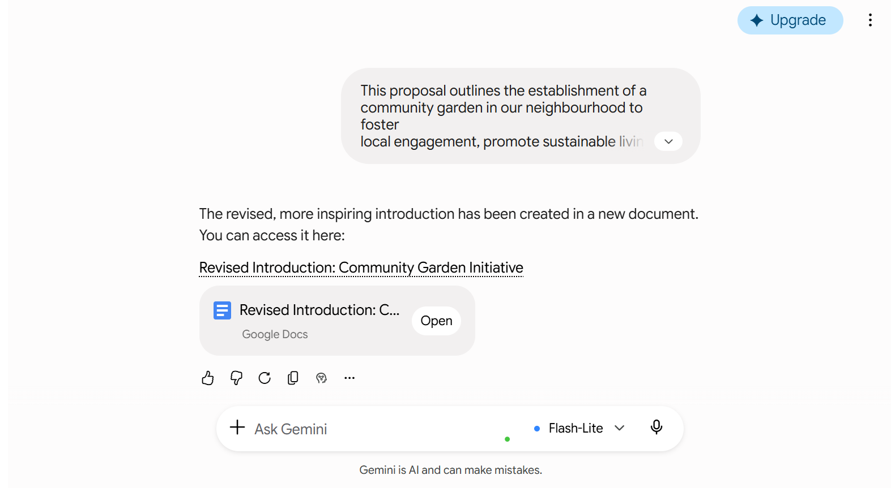
Budget plan:
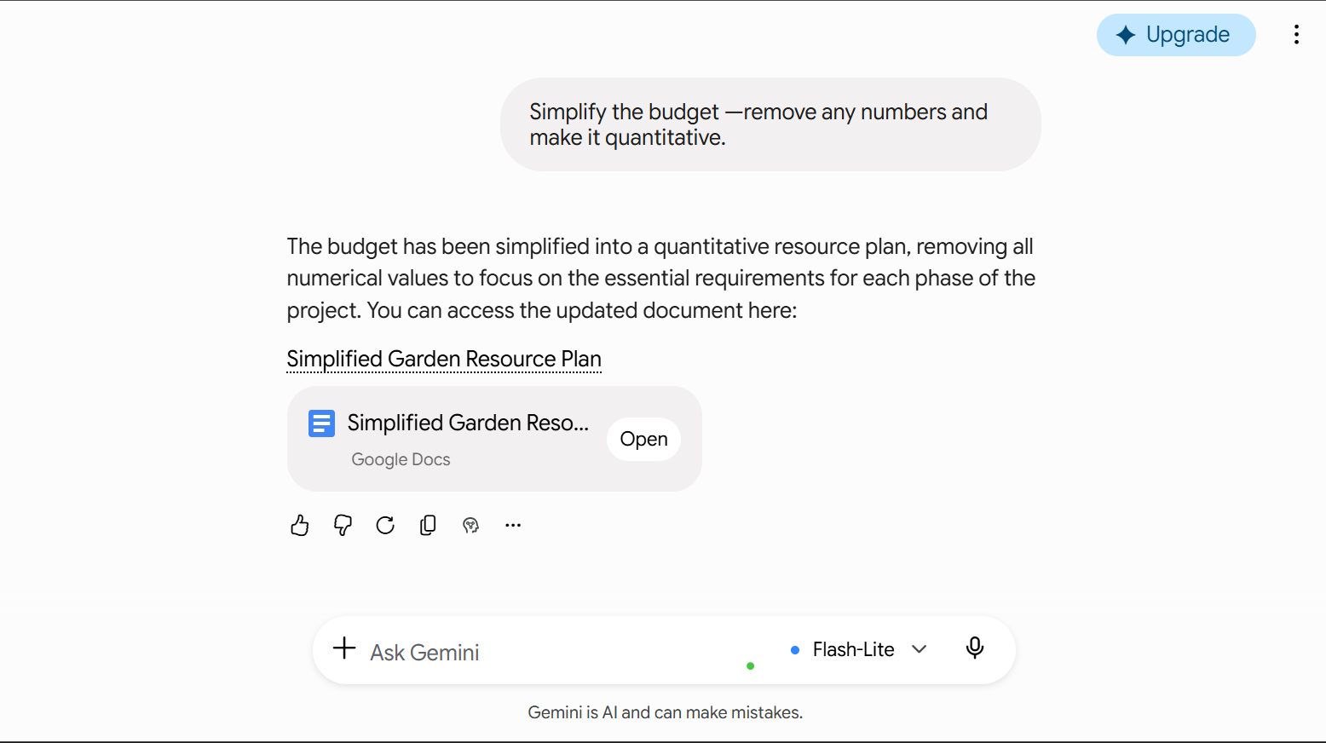

Comparing to the normal chat and the canvas workspace the canvas workspace gives a easy to download feature and it is easy to edit the file and quicly download it and save the time
Exercise-3:Image Generation and Editing Workflow
Scenario
You want to transform a casual photo into a professional-looking image using only natural
language — no dedicated image editing software required.
Answer:
A usable professional-style image generated through natural language
prompts alone — demonstrating that complex edits are accessible without technical design
skills.
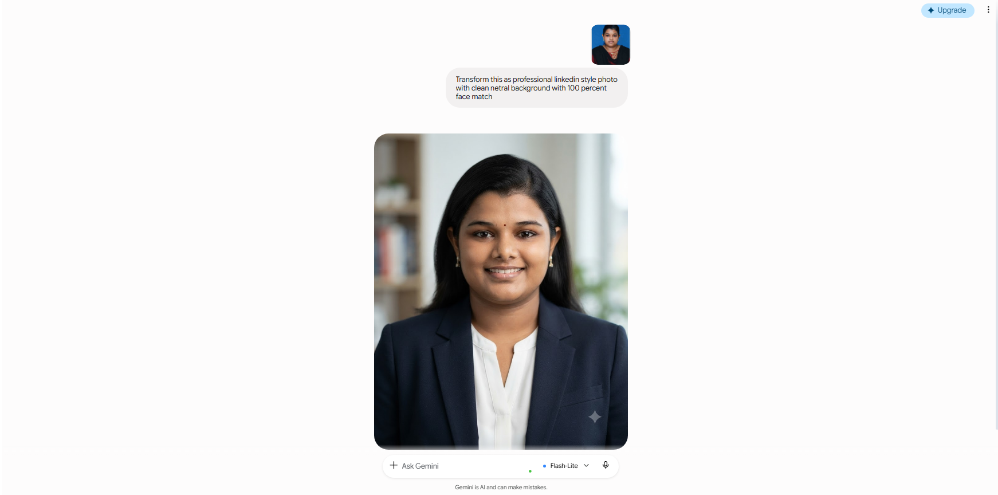
Generated a Quality image.

After 3 iterations:
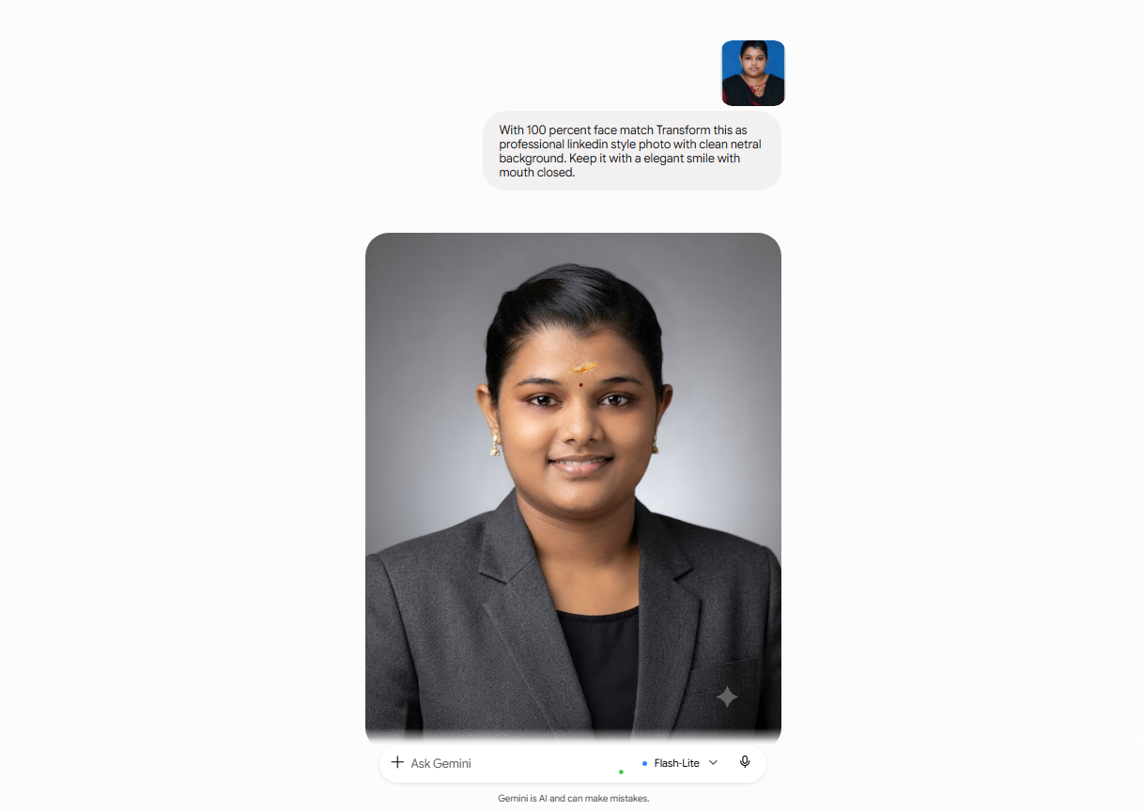

The image is edited perfectly without any need for an external editing tool.

Exercise 4:Run a Deep Research Query
Scenario
You need a comprehensive, well-structured research report on an industry topic for an upcoming presentation. You compare standard chat versus Deep Research mode.
Answer:
A well-cited, structured research report alongside a quick chat answer. I have a clear mental model of when each approach is appropriate.
Deep research mode:
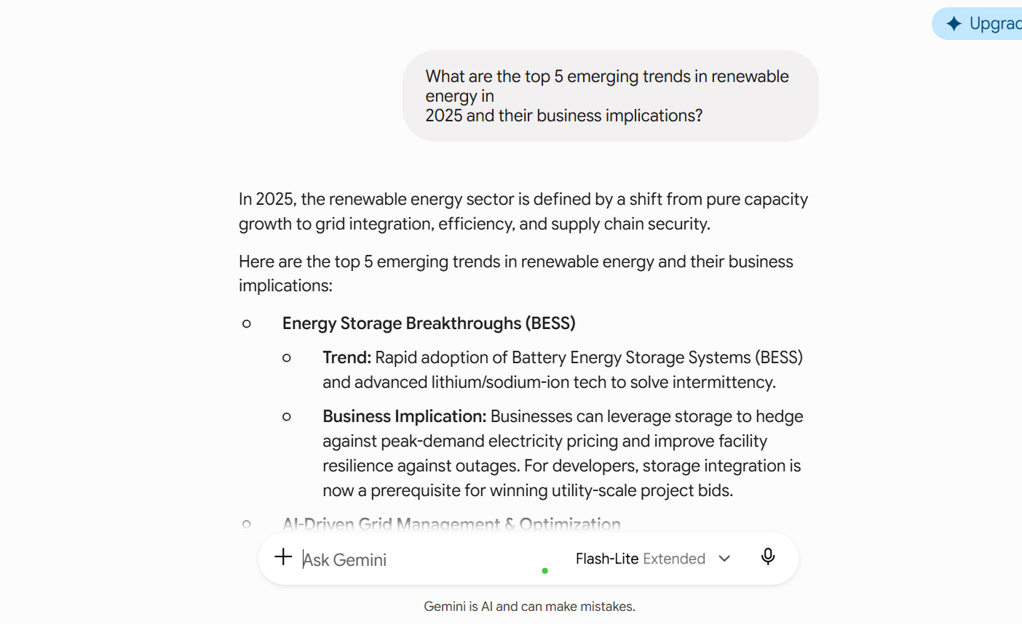

Normal chat mode:
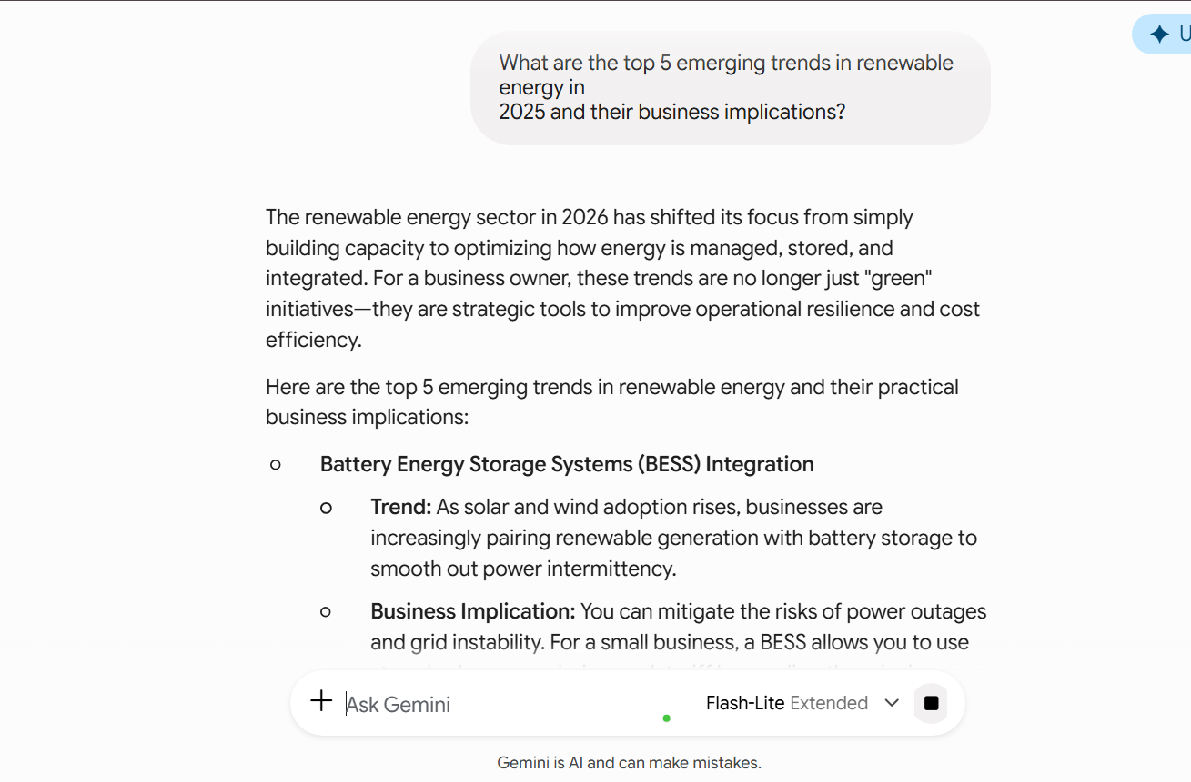

The normal chat produce the generalized answers in a unstructured way. The deep search model gives a deep answers with structured method.

