PROBLEM

You have been hired to design and manage a basic database system for a university. The university needs to store information about students, courses, and their enrollments. Your task is to create the database structure, enforce data integrity, and write queries to retrieve meaningful information.

Students

----------------

StudentID (Primary Key)

FirstName

LastName

Email (Unique, can be NULL)

Age (Must be 17 or older)

Major (Can be NULL)

Courses

---------------

CourseID (Primary Key)

CourseName

Credits (Must be greater than 0)

Department (e.g., 'CS', 'Math', 'History')

Enrollments

---------------------

EnrollmentID (Primary Key)

StudentID (Foreign Key → Students)

CourseID (Foreign Key → Courses)

EnrollmentDate

Grade (Can be NULL, must be between 0 and 100 if entered)

Create the Students, Courses, and Enrollments tables with appropriate constraints (PK, FK, CHECK, NOT NULL, UNIQUE).

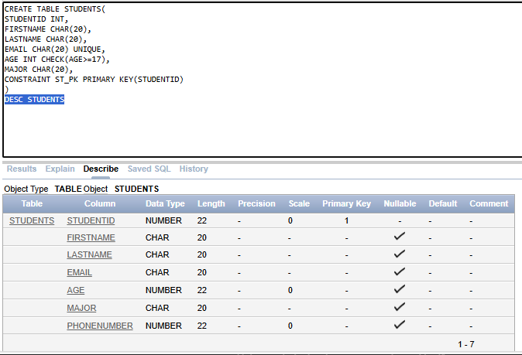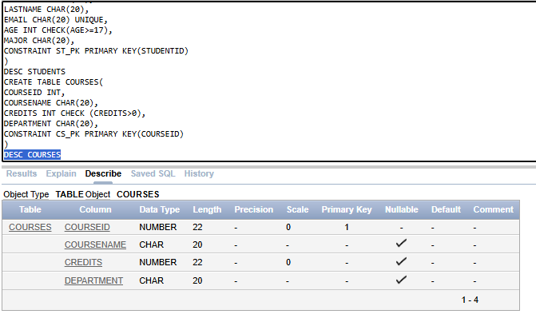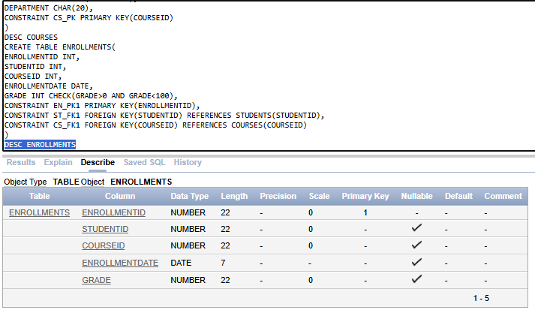

Add a PhoneNumber column to the Students table, which can be NULL.

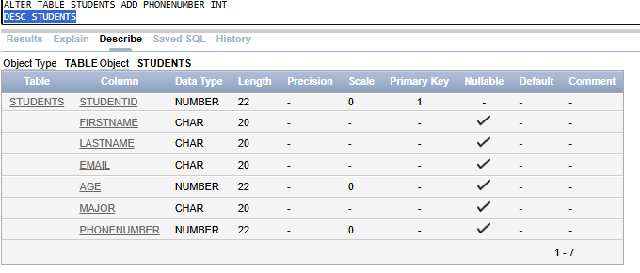

Modify the Credits column in Courses to accept a maximum of 6.

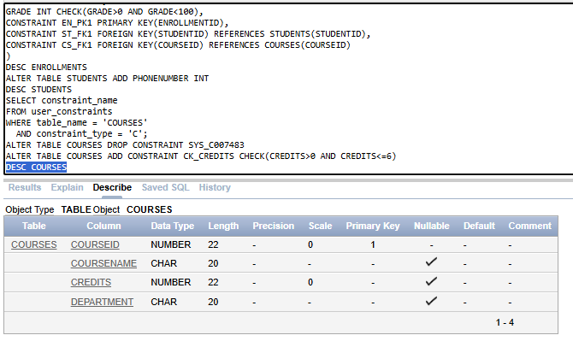

Insert at least 5 students, 3 courses, and 6 enrollments.

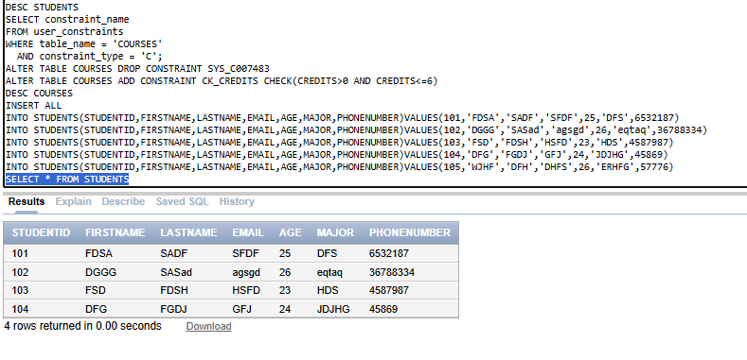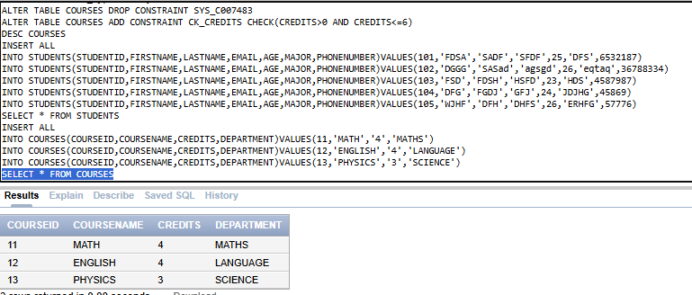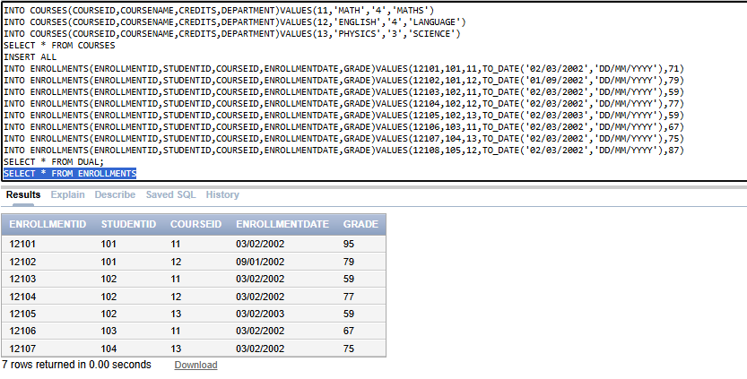

Update the grade of a student in one course to 95.

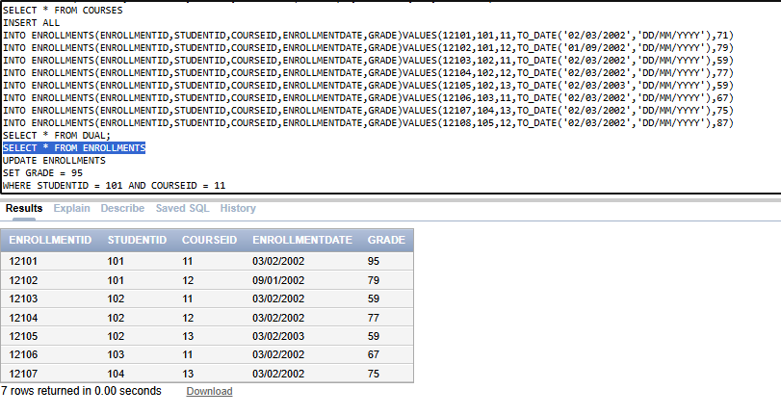

Delete a student record and all their enrollments.

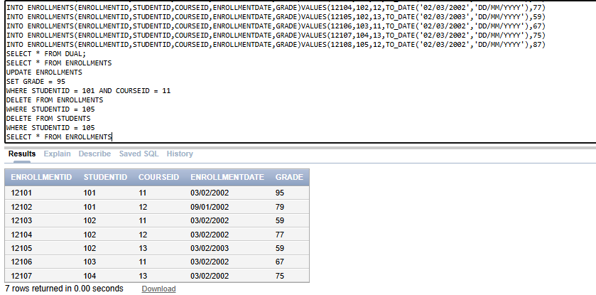

Retrieve all students sorted by LastName.

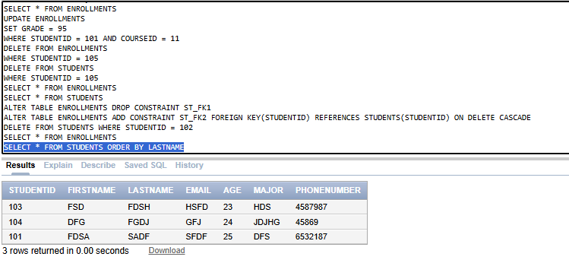

List all distinct majors among the students.

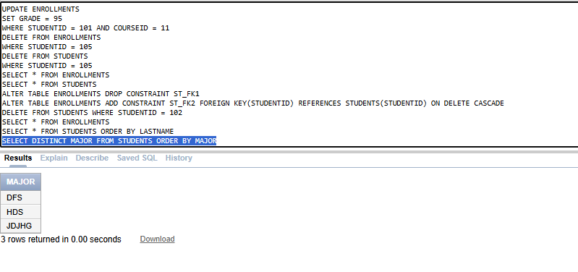

Find students who are older than 20 years.

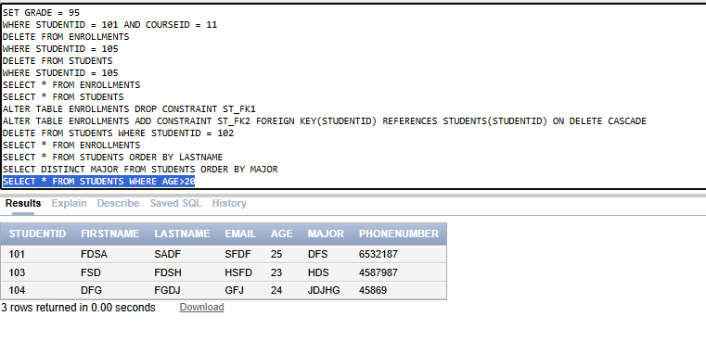

Show all courses that have more than 3 credits.

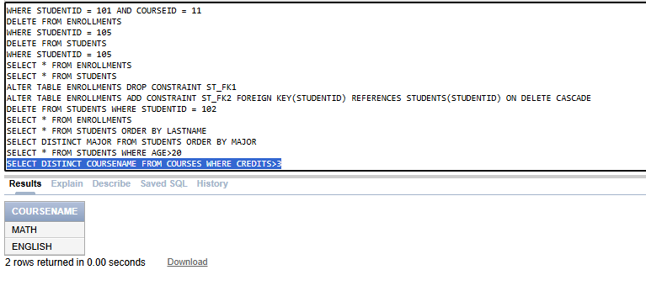

List all students whose first name starts with 'J'.

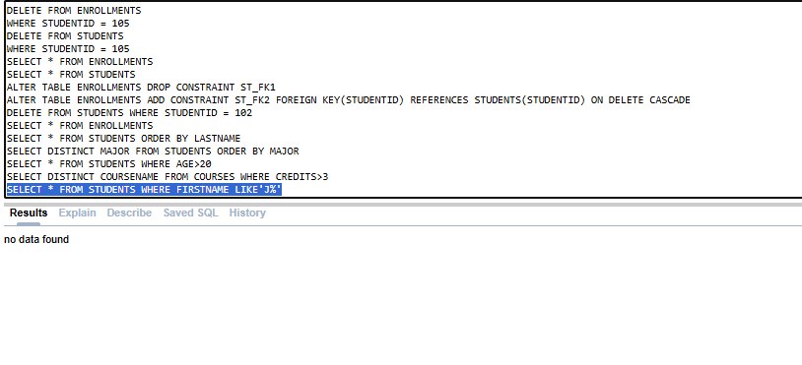

Find students with NULL email addresses.

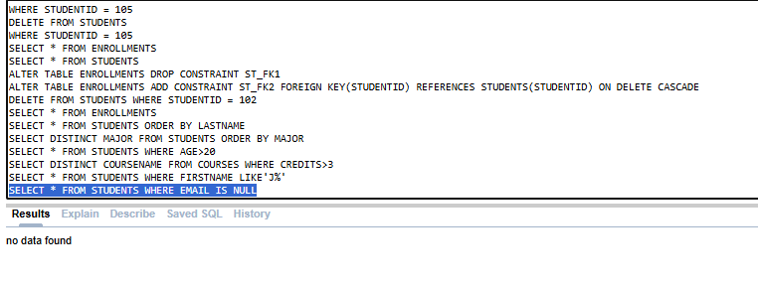

Display all enrollments where the grade is NULL.

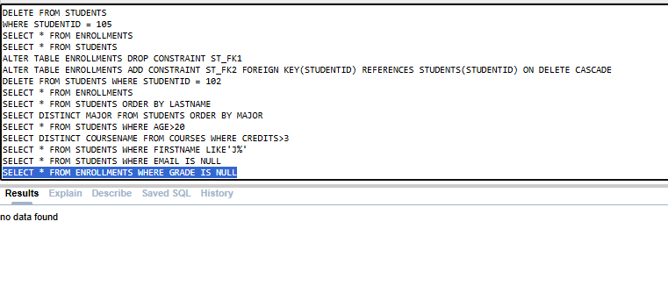

Show the credits and double the credits for all courses.

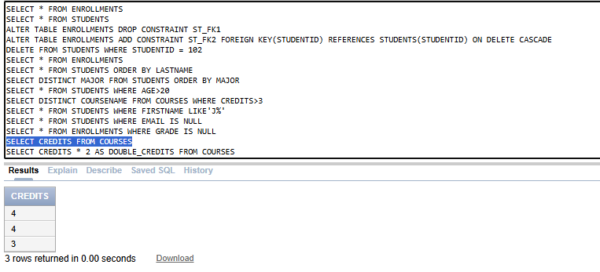

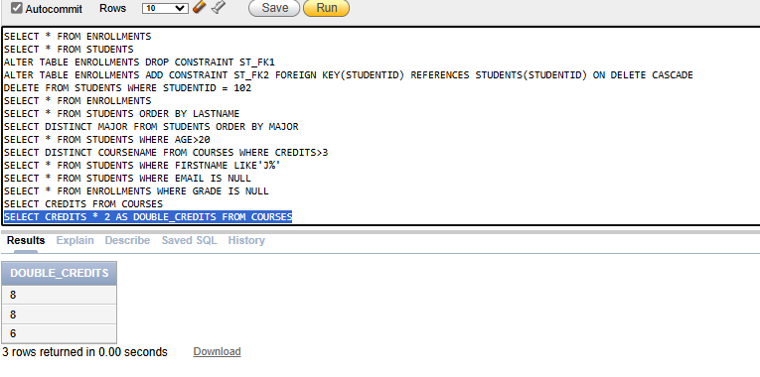

Find enrollments where the grade is between 80 and 100.

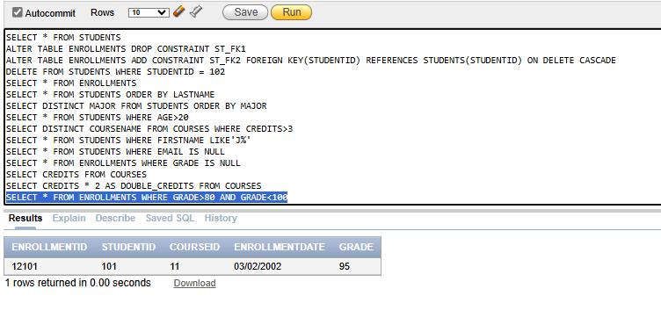

Retrieve students whose age is not equal to 21.

