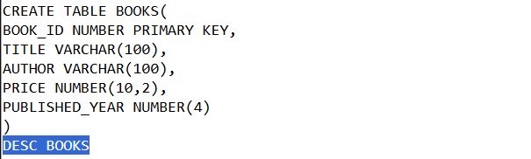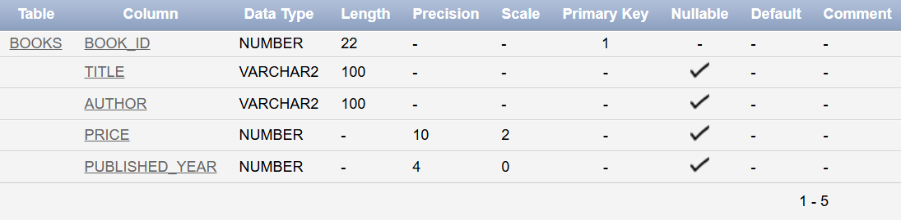

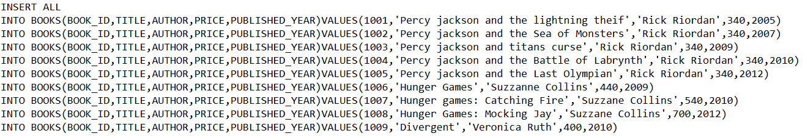

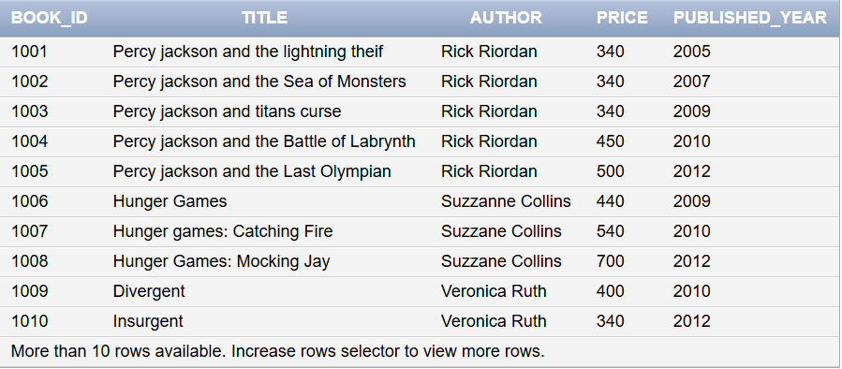

Find the titles of books published in the same year as book priced over 500

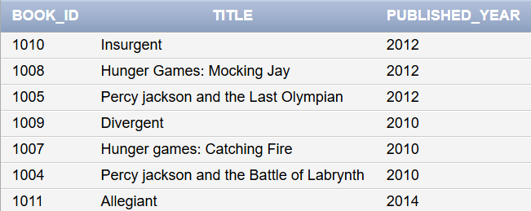

Find titles of books that are priced higher than any book published in 2005

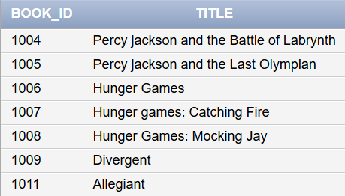

Find titles of books that are priced higher than any book published in 2014





-