STUDENTS1 (STUDENT_ID,STUDENT_NAME_DEPT_ID)

DEPARTMENTS(DEPT_ID,DEPT_NAME)

ENROLLMENTS1(STUDENT_ID,COURSE_ID,GRADE)

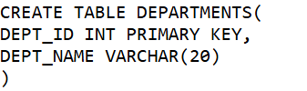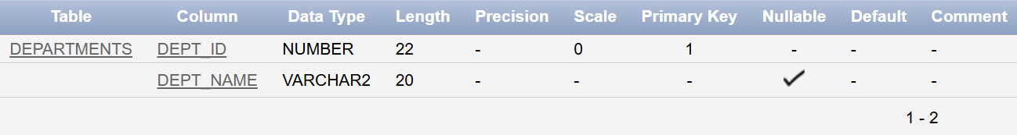

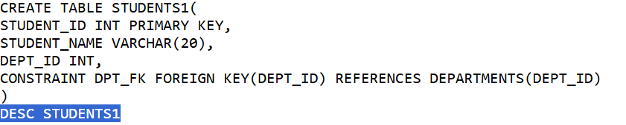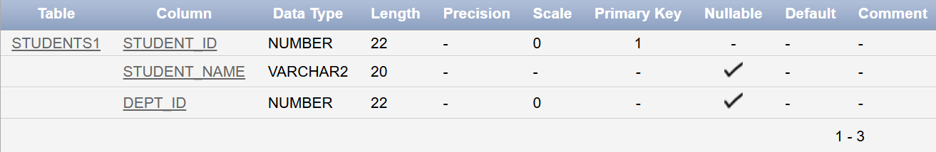

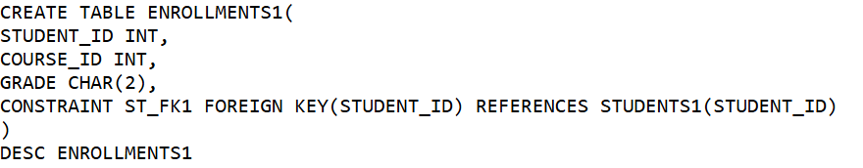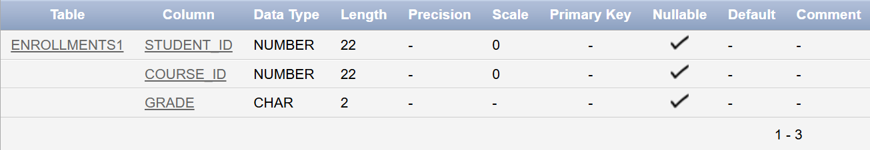

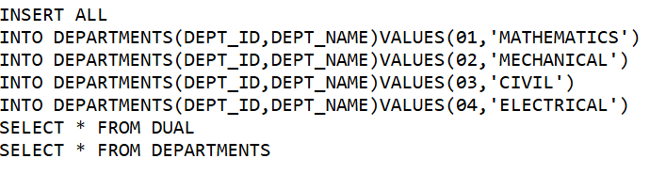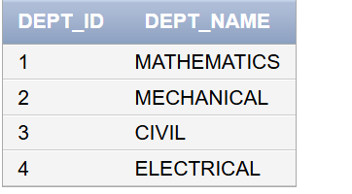

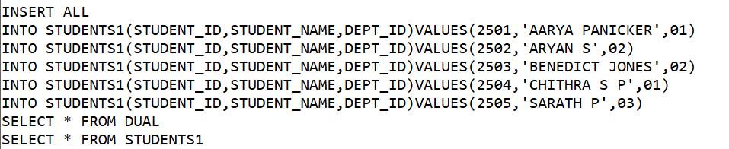

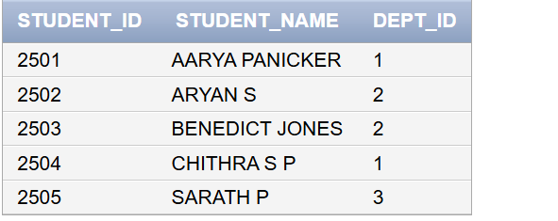

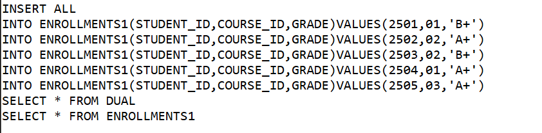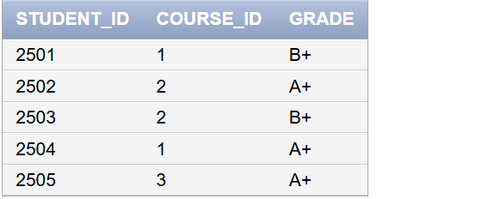

1. RETREIVE THE NAME OF STUDENTS ALONG WITH THEIR DEPARTMENTS

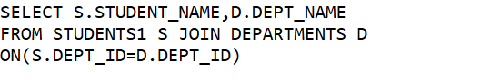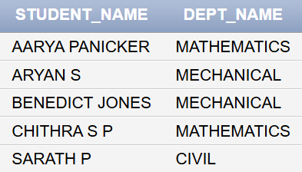

1. LIST ALL STUDENTS AND THEIR GRADES,INCLUDING STUDENTS MAY NOT HAVE ANY GRADES RECORDED.

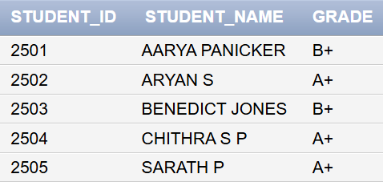

1. LIST ALL COUSES AND THE STUDENTS ENROLLED IN EACH COURSE,INCLUDING COURSE WITH NO STUDENTS

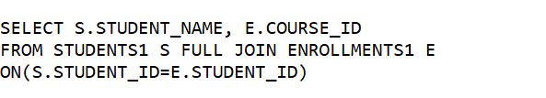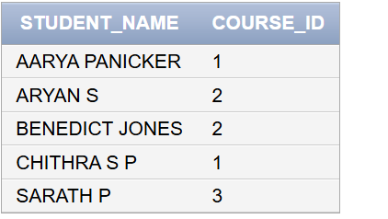

1. RETREIVE A LIST OF ALL STUDENTS AND ALL DEPARTMENT ENSURING ALL STUDENTS AND ALL DEPARTMENTS ARE SHOWN EVEN IF THEY DON’T MATCH

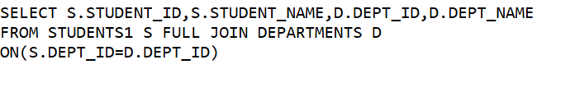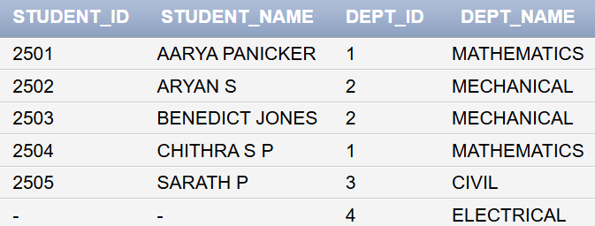

1. Generate a list of all possible student pairs