**FLIPKART**

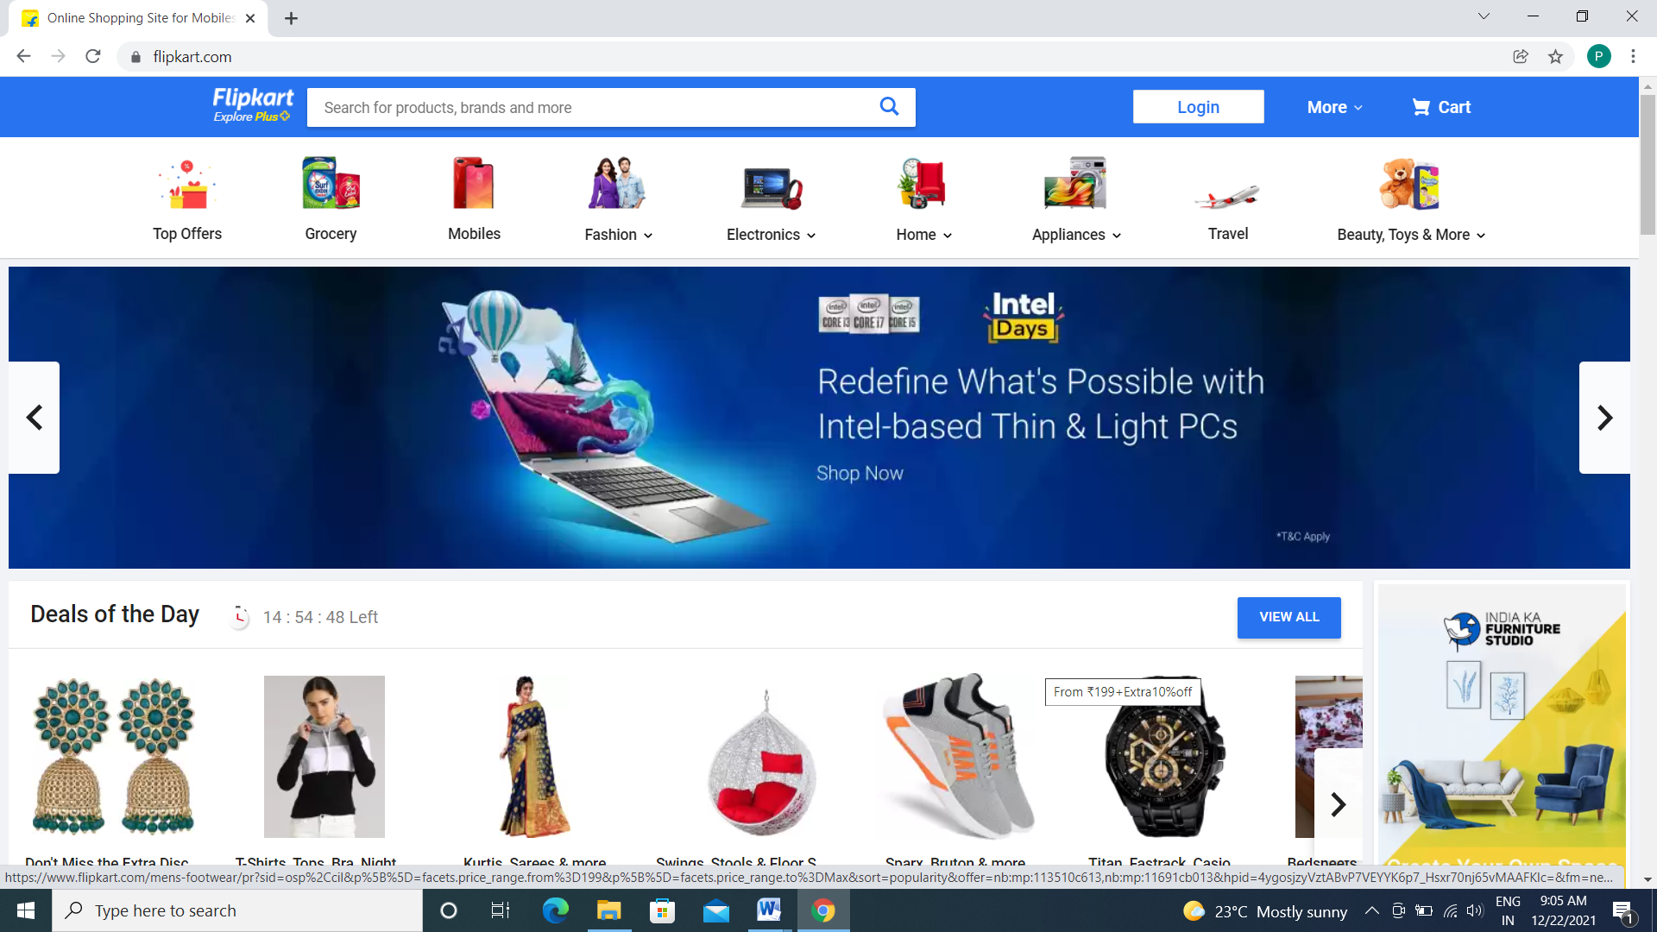

It is an e-commerce website for purchasing furnitures, home appliances, electronic devices, mobile phones, beauty products, toys, dress for both men and women.

**PAGES:**

Login/Signup page -> Home Page ->Listing Page ->Details page ->Payment Gateway

**LOGIN/SIGNUP PAGE:**

* E-mail id
* Password

**HOME PAGE:**

* Categories
* Items added to Cart
* Search
* Offers

**LISTING PAGE:**

* Filters
* Description of the product

**DETAILS PAGE:**

* Zoom-in to view product
* Add to cart/Buy Now
* Check delivery is available for the place

**PAYMENT GATEWAY:**

* Address to deliver
* Order Summary
* Payment Method
  + Using Card
  + Using GPay
  + Cash on delivery