Ek hi din mein chaar IPO, aur total issue size ₹8,800 crore se zyada. 15 October ko Zetwerk, Bonfiglioli Transmissions, Tonbo Imaging India aur Sahajanand Medical Technologies ke IPOs khul rahe hain, aur chaaron mein bidding 19 October tak chalegi.
Ek important baat pehle samajh lein. Zetwerk ko chhodkar baaki teeno IPOs pure OFS hain. OFS yaani Offer for Sale, jismein company naye shares jaari nahi karti, balki existing shareholders apne shares bechte hain. Isliye us paise mein se company ko kuch nahi milta, woh seedha bechne wale shareholders ko jaata hai. Zetwerk mein fresh issue bhi hai aur OFS bhi.
Zetwerk Manufacturing Businesses Limited: Zetwerk ek technology-led manufacturing platform hai, jo customers ke orders apni factories aur suppliers ke network ke zariye poore karwati hai. Price band ₹143 se ₹151 per share, issue size ₹5,012.33 crore. Isme ₹2,830 crore ka fresh issue hai aur ₹2,182.33 crore ka OFS. Fresh issue se ₹1,300 crore company ka karza chukane mein, ₹860 crore subsidiaries ke karze pay off karne mein, aur baaki acquisitions aur general corporate purposes mein lagega.
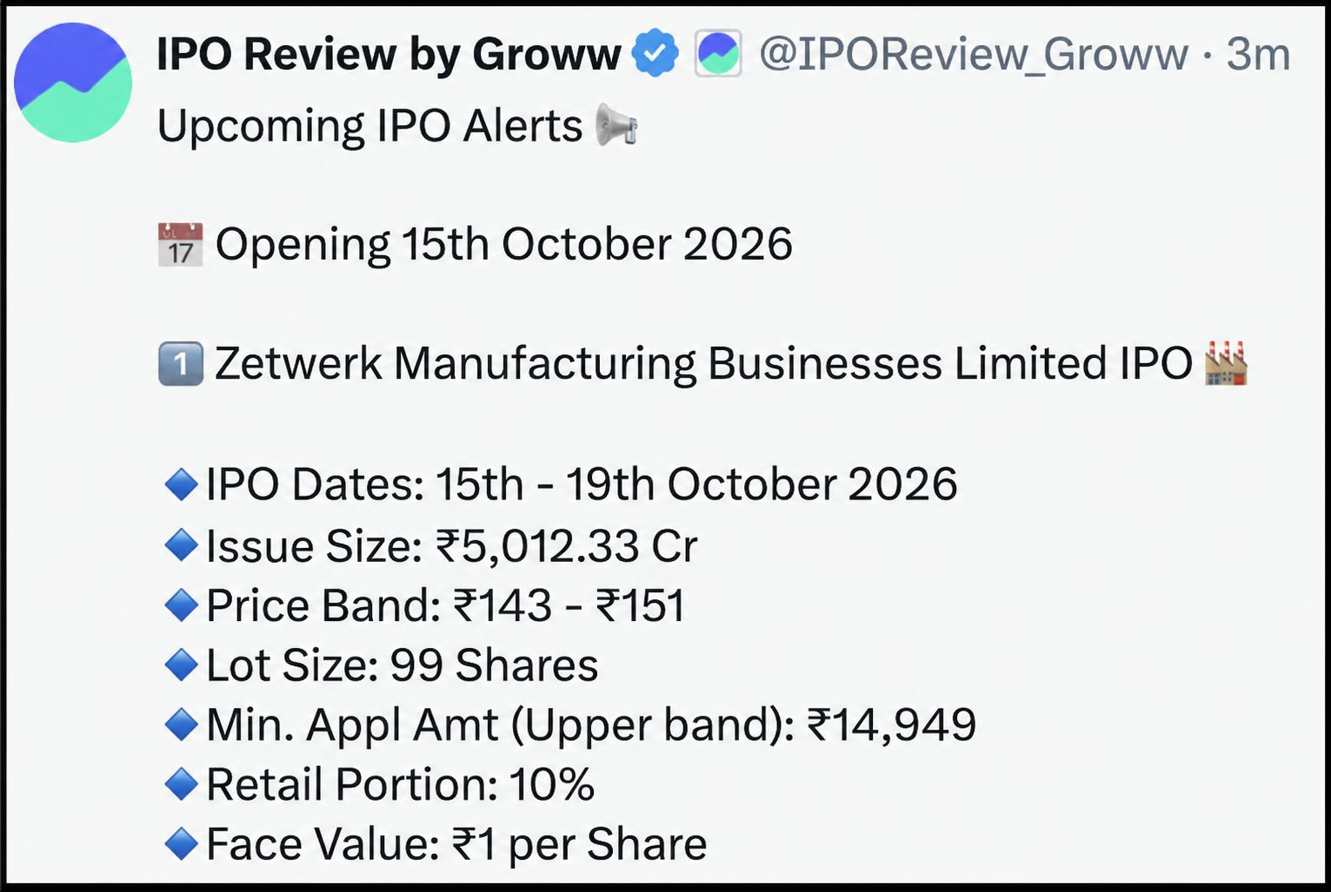
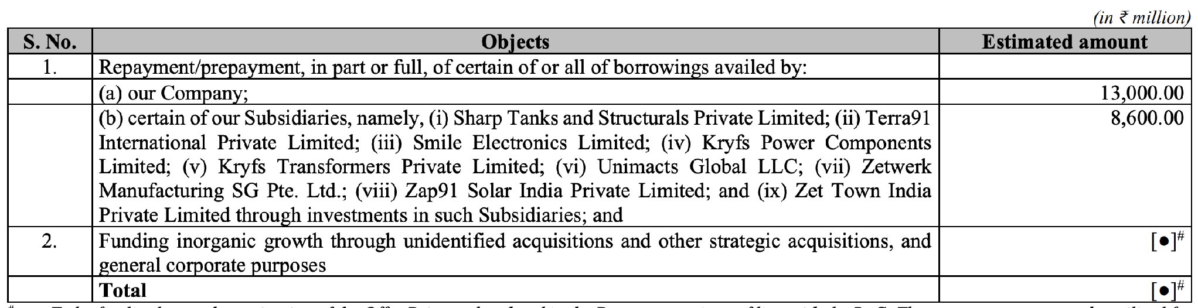
Source: Zetwerk Manufacturing Businesses Limited RHP
Bonfiglioli Transmissions Limited: Yeh company mechanical aur electro-mechanical power transmission solutions banati hai, jo industrial automation se lekar wind sector tak use hote hain. Price band ₹558 se ₹586 per share, issue size ₹2,533.66 crore, aur yeh poora OFS hai.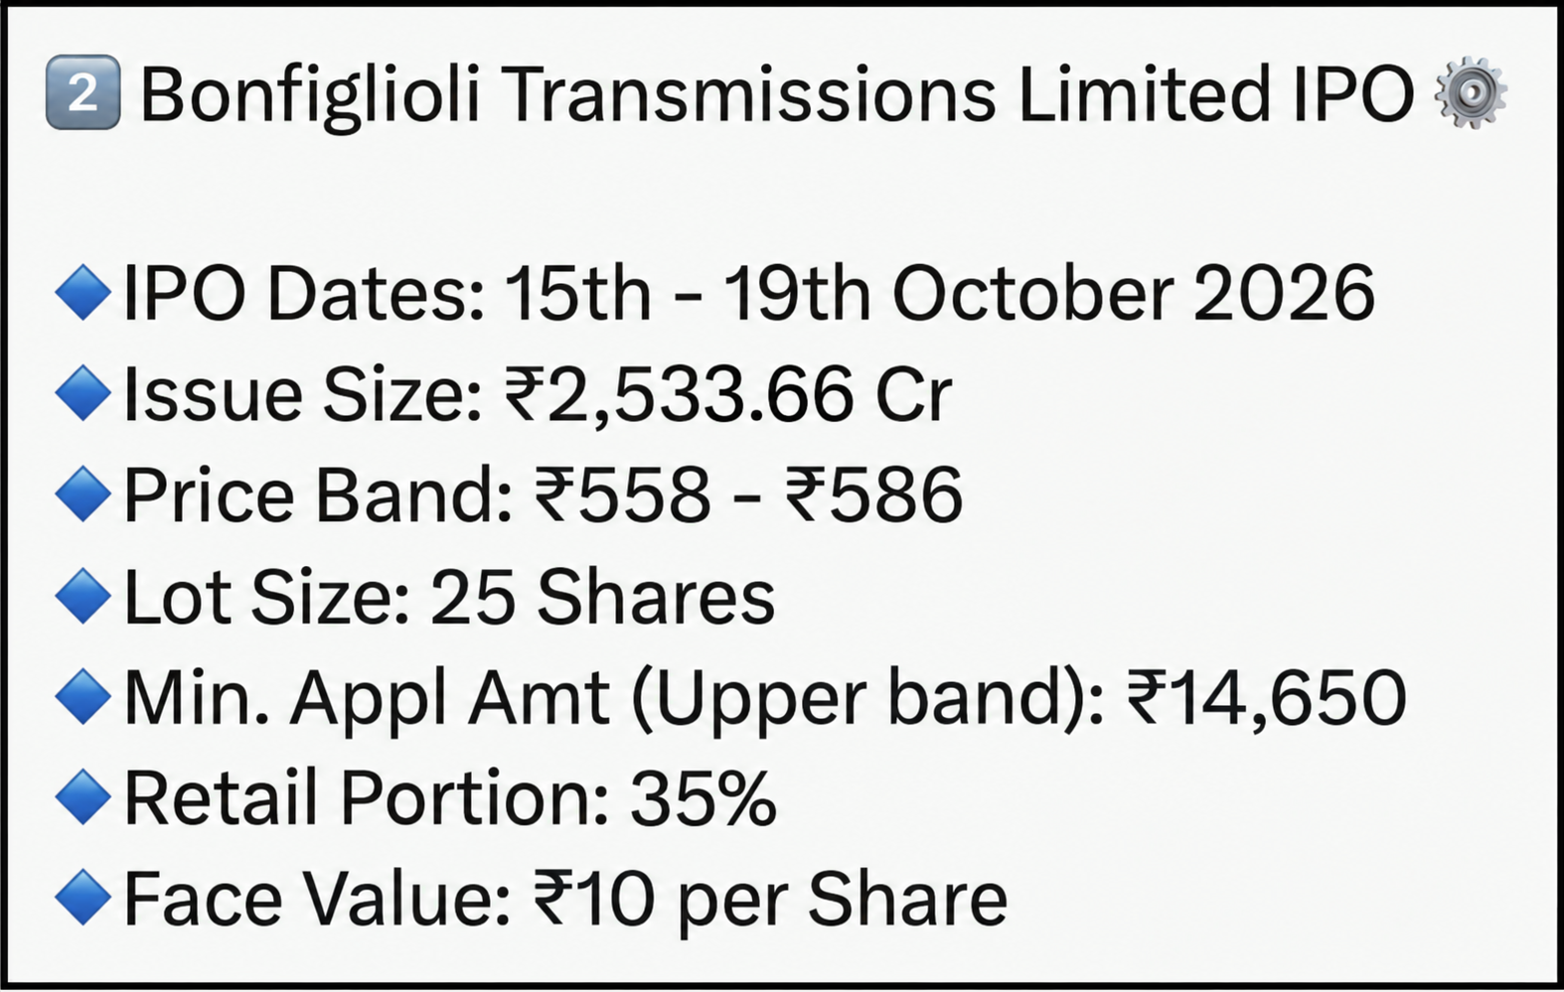
Tonbo Imaging India Limited: Defence aur security forces ko jo imaging aur sensing systems chahiye, Tonbo unhe design karti hai, jaise thermal imaging, surveillance aur targeting. Price band ₹665 se ₹700 per share, issue size ₹852.18 crore, poora OFS.
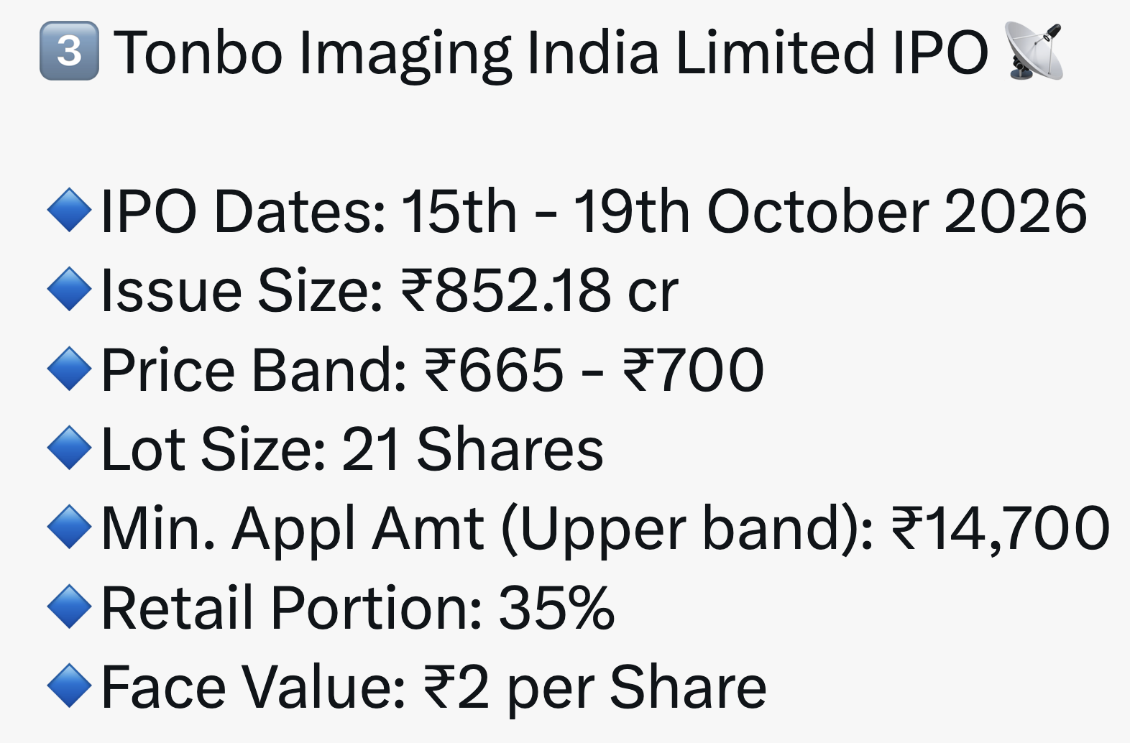
Sahajanand Medical Technologies Limited: Yeh company cardiac stents jaise medical devices banati hai, jinka use narrow ya blocked arteries ko khula rakhne mein hota hai. Price band ₹327 se ₹344 per share, issue size ₹475.48 crore, poora OFS.
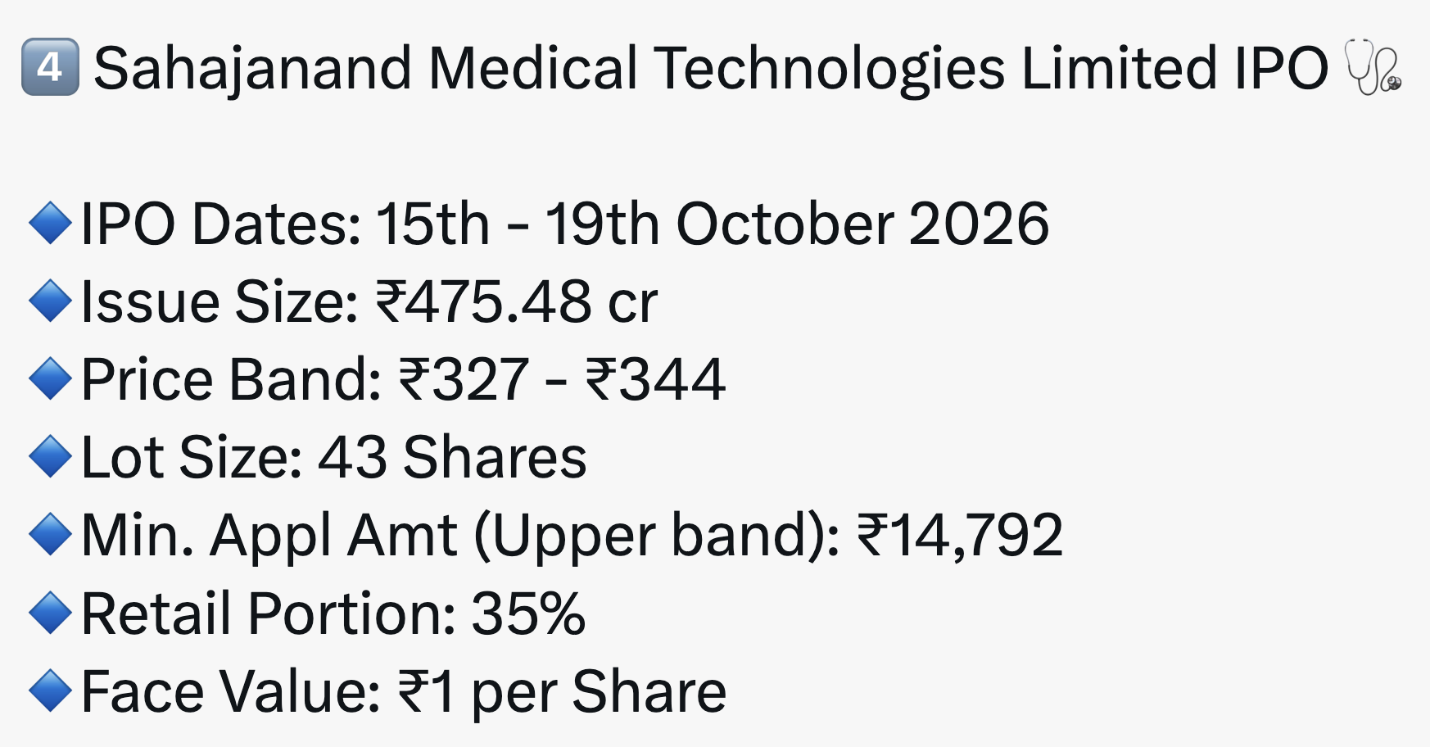
Aise hi IPO updates ke liye channel ko Like aur Subscribe karein aur comments mein batao app kis IPO mein apply kar rahe ho

Disclaimer: To read the RA disclaimer, please click here.
RA Sign :

Research Analyst : Bavadharini KS
RA Date : 14-10-2026

