PARKING LOT

**Name – Preeti Batch – H-J- Bhabha**

**Table of contents –**

* Introduction
* Python Files
* Key Features
* Language used

**Introduction:**

It creates parking lot with given number of slots. The cars follow Greedy approach while being parked in the slots.

**Python Files**

ParkingLot.py script defines the following functions -

1. create_parking_lot n - Given n number of slots, create a parking lot
2. park car_regno car_color - Parks a vehicle with given registration number and color in the nearest empty slot possible. If there are no more empty slots available, it shows a message "Sorry, parking lot is full".
3. status - Prints the slot number, registration number and color of the parked vehicles.
4. leave x - Removes vehicle from slot number x
5. There are few query functions to retrieve slot number from registration number of car, get registration numbers of cars with particular color etc.

**ParkingLot.py** can be run through shell or through file containing test cases.

**Vehicle.py** is a separate class where we can define the type of vehicles that can be parked. As of now, it only contains class Car

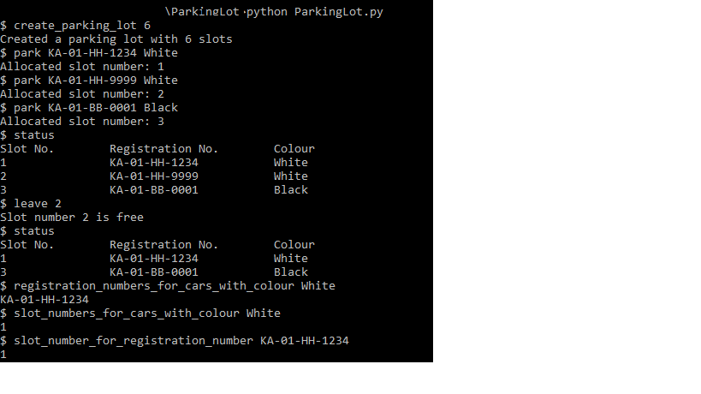

**Key Features:**

a). Registration number of all cars of a particular colour

b). Slot numbers at which car is parked with registration number

c). Slot numbers of all slots where car of a particular colour is parked.

**Language used :**

Python 3.9 In Visual Studio .