SauceDemo_Report - COMPLETED
Step 1: 01LoginPage_Loaded successfully
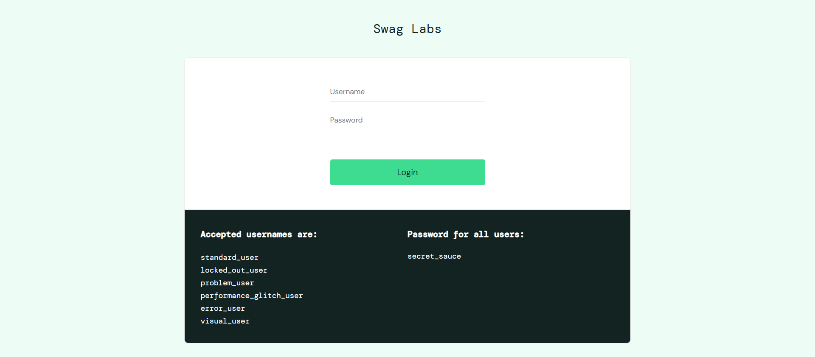
Step 2: 02_Credentials_Username_Entered
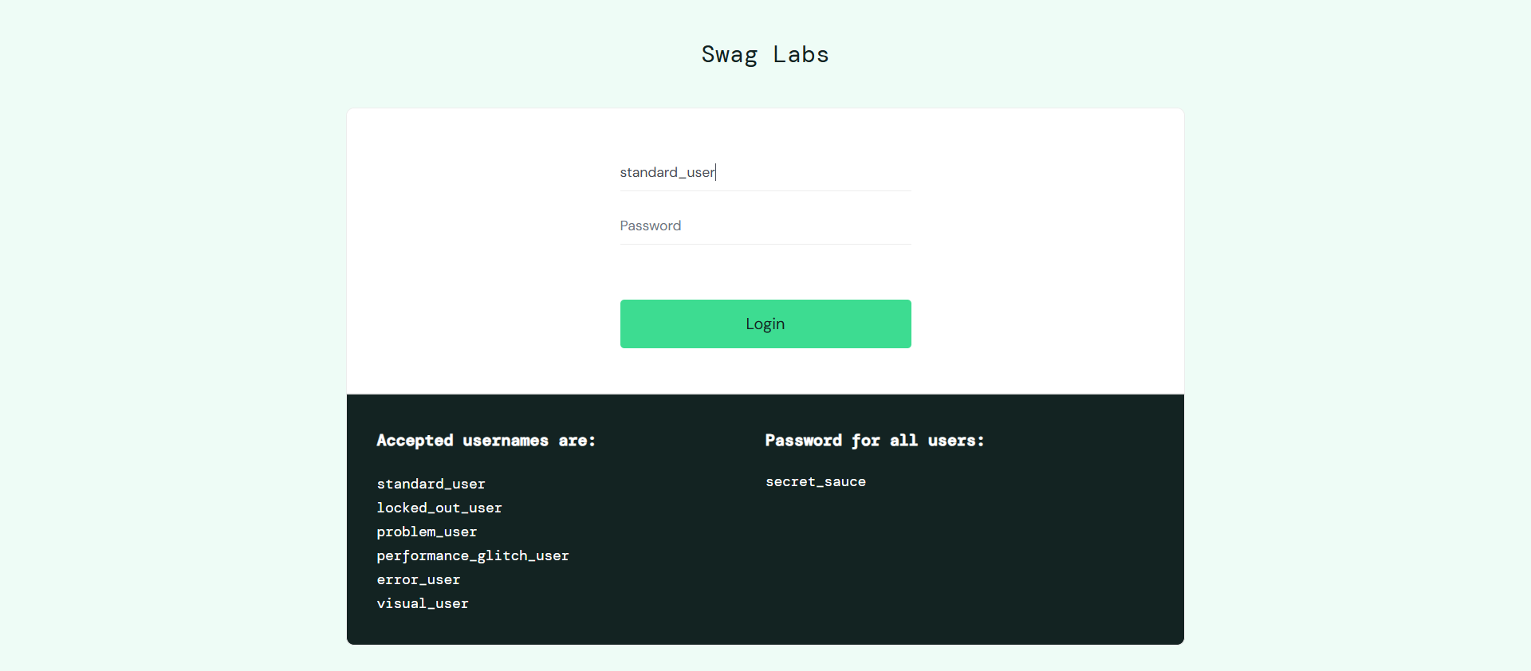
Step 3: 03_Credentials_Password_Entered
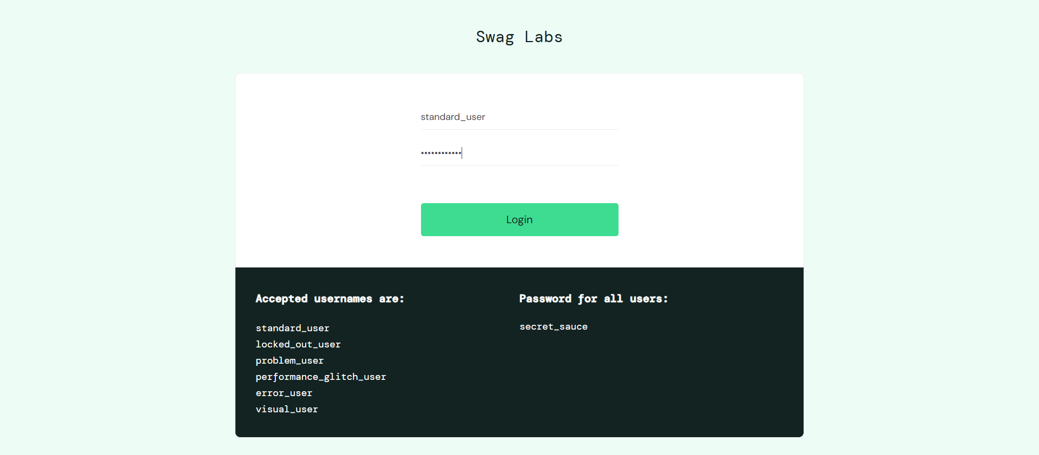
Step 4: 04_Login
Step 5: 08ProductClick
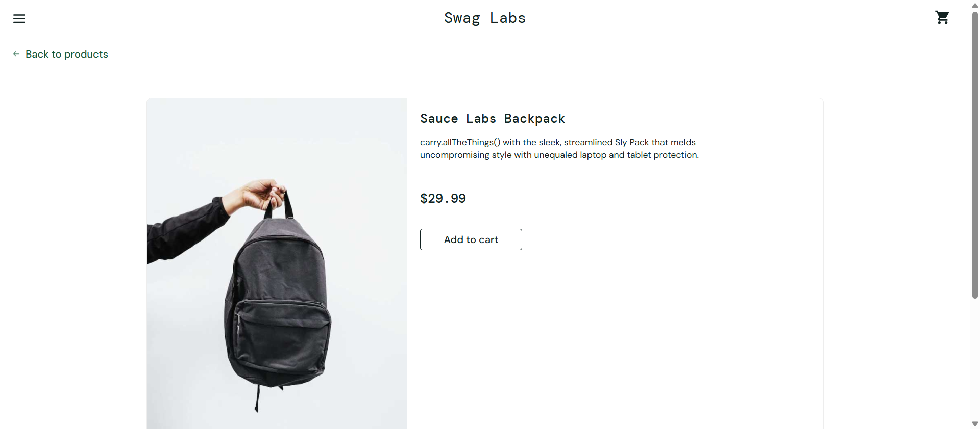
Step 6: 09Added_in_cart
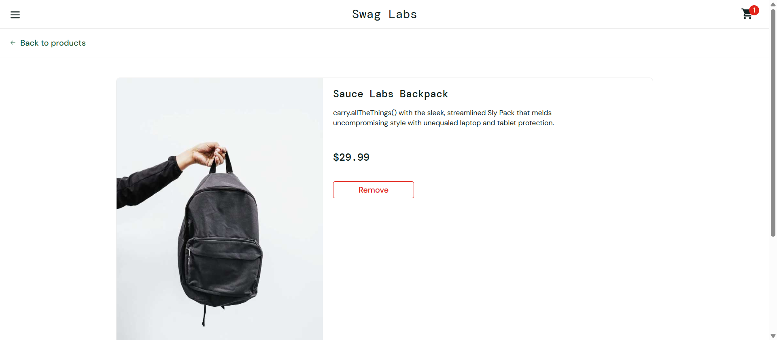
Step 7: 10OpenCart
Step 8: 11CheckOutPage
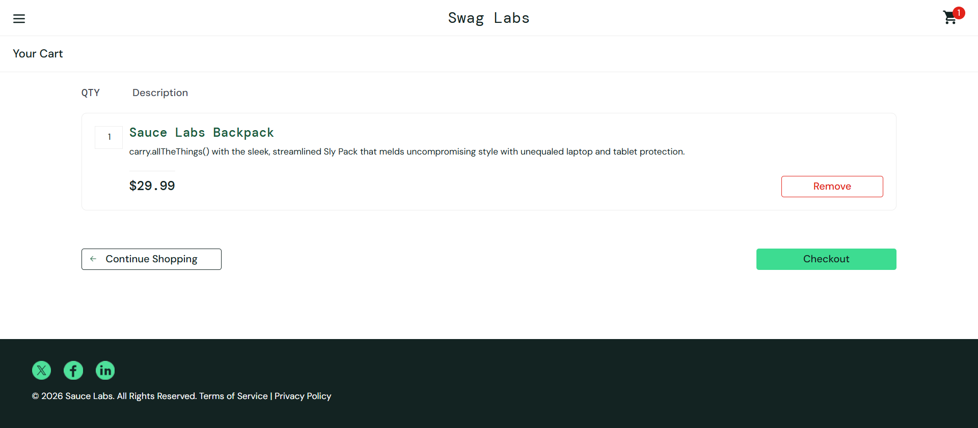
Step 9: 12Continue_Checkout
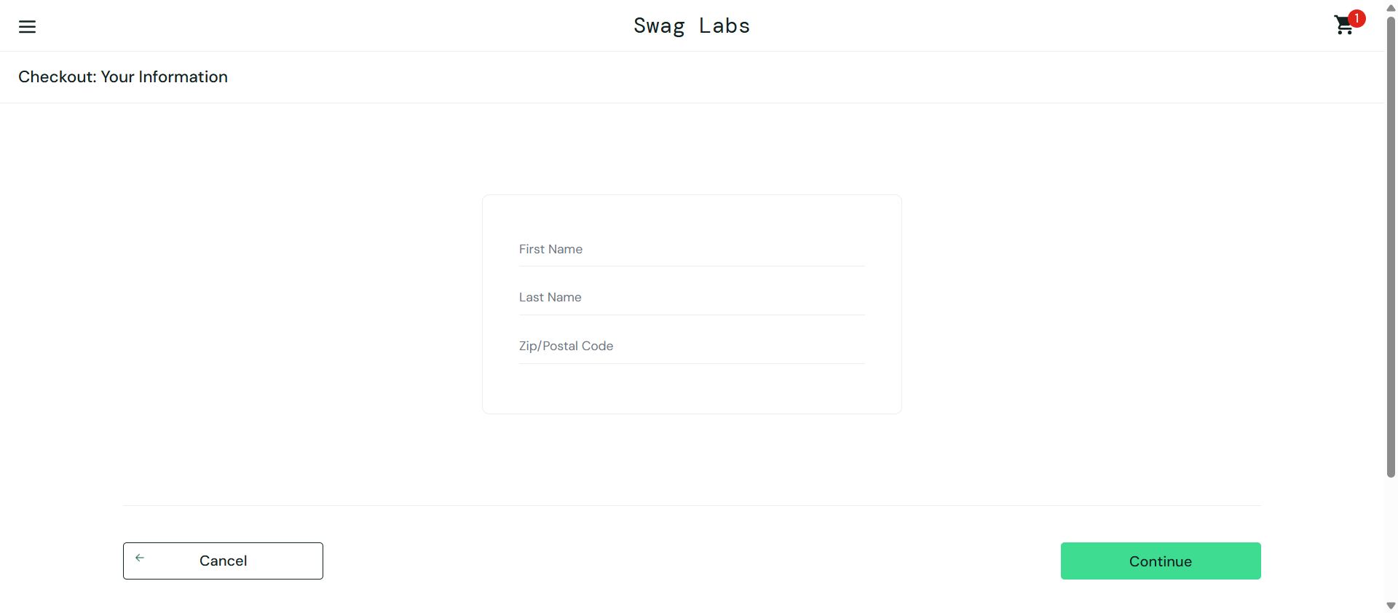
Step 10: 13username_entered
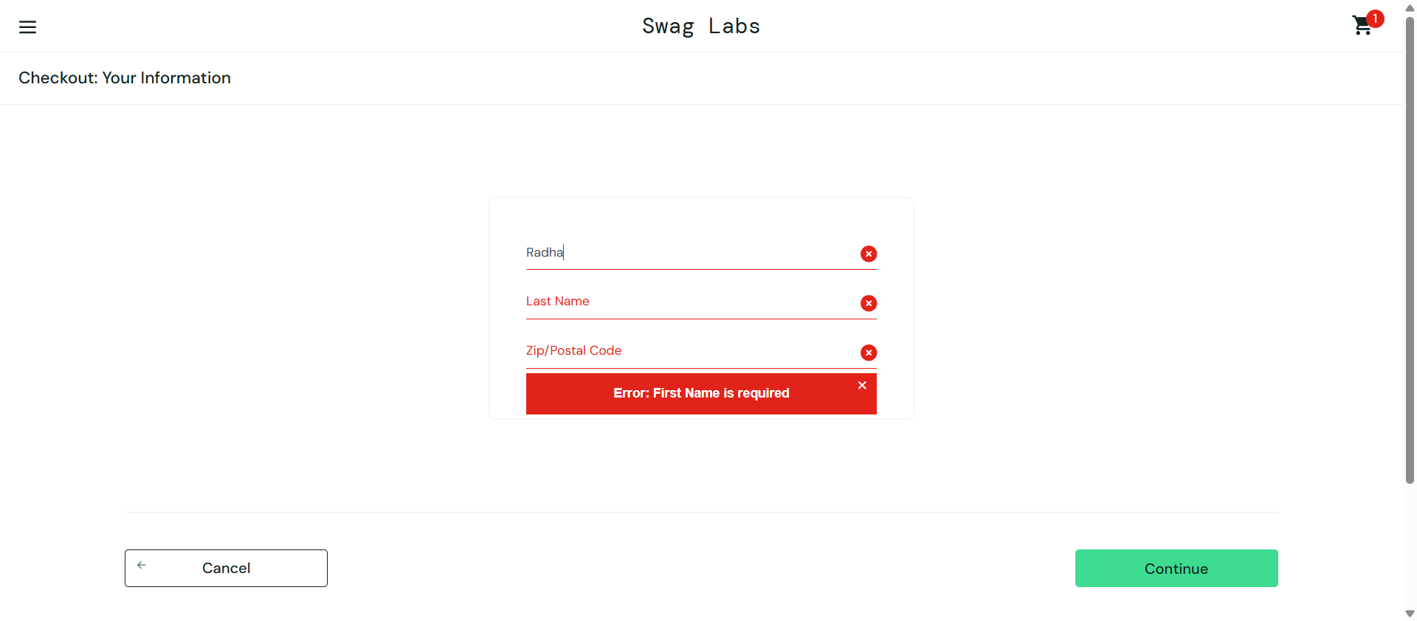
Step 11: 14Lastname_entered
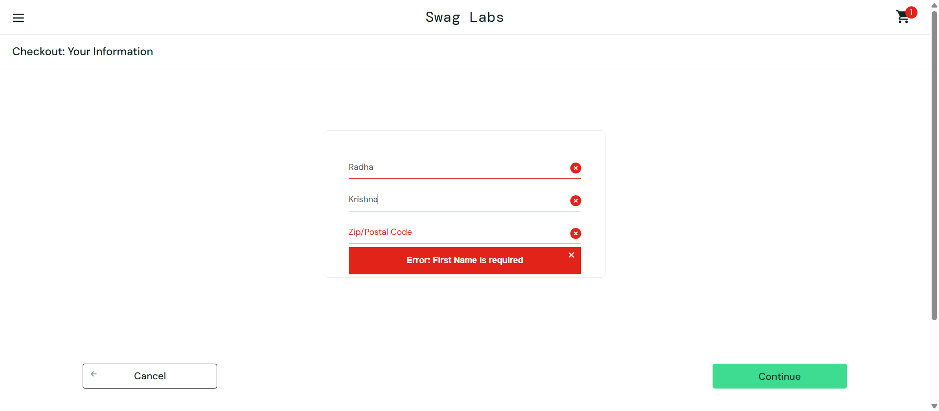
Step 12: 15Entered_Postalcode
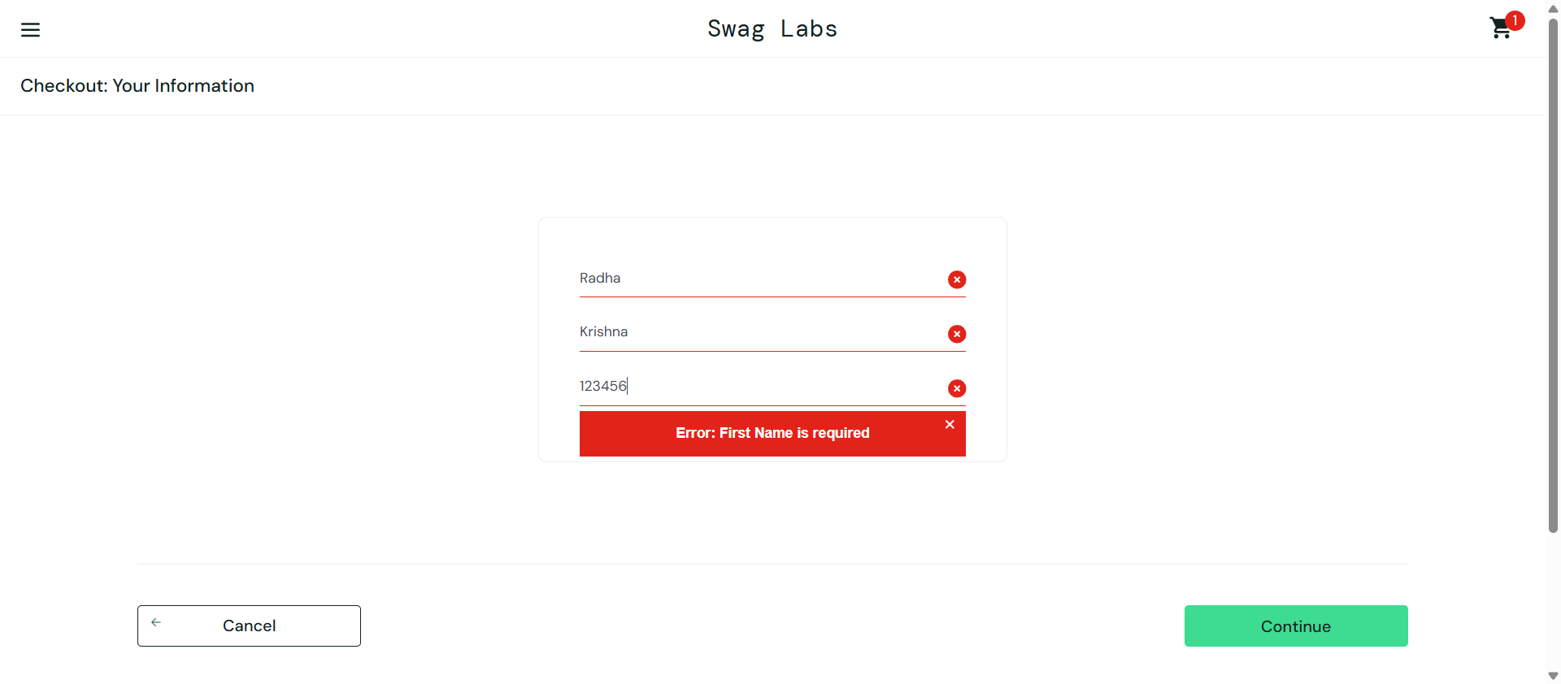
Step 13: 16Final
Step 14: 17Final_checkout
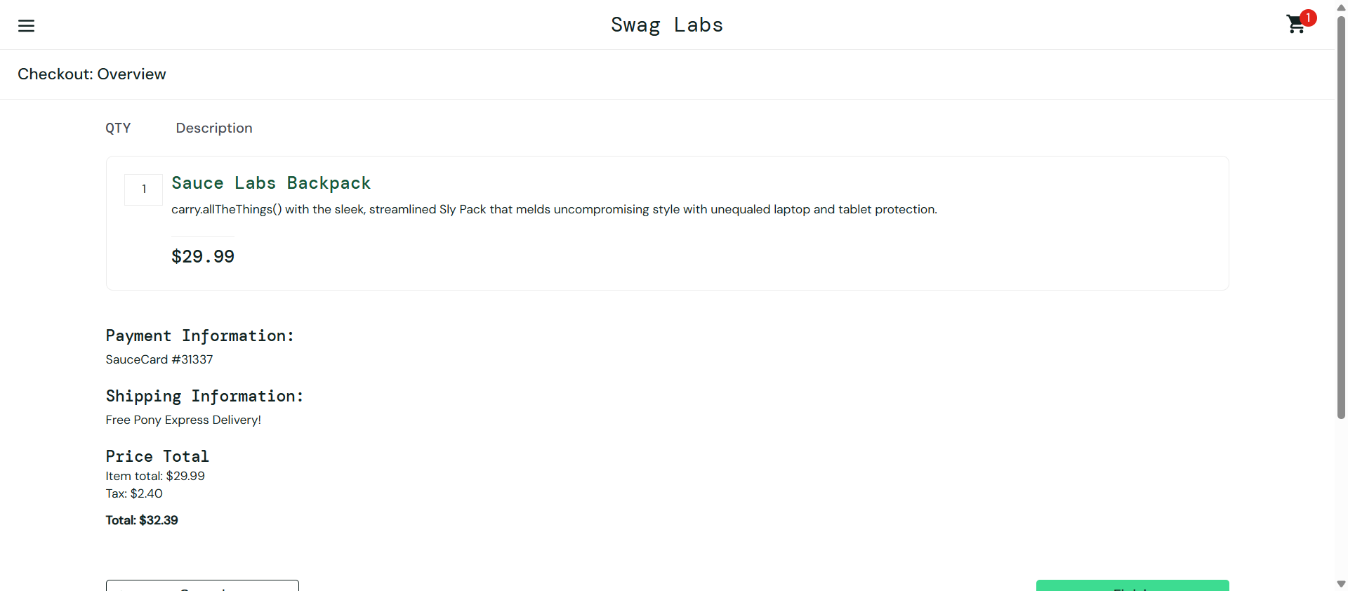
Step 15: 18Generate_report
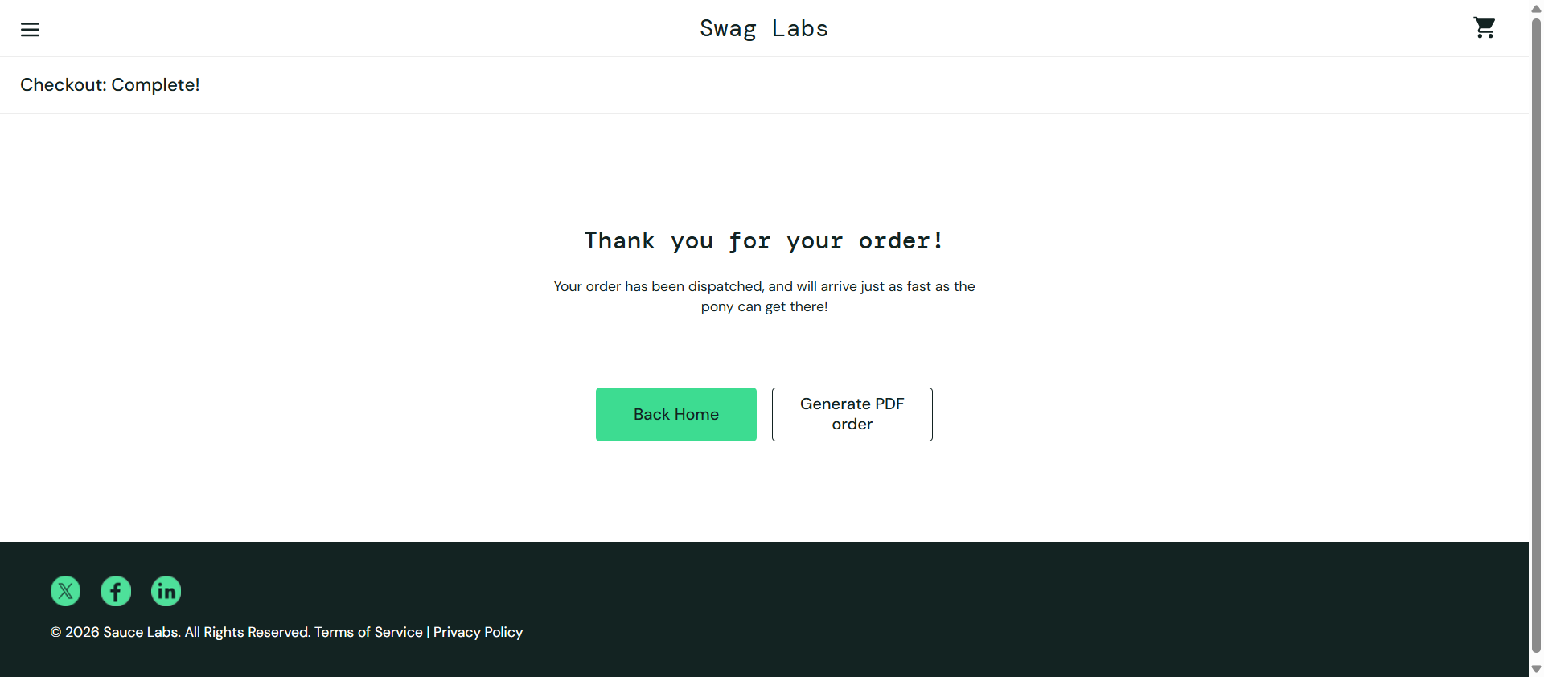
Step 16: 19Land_on_HomePage
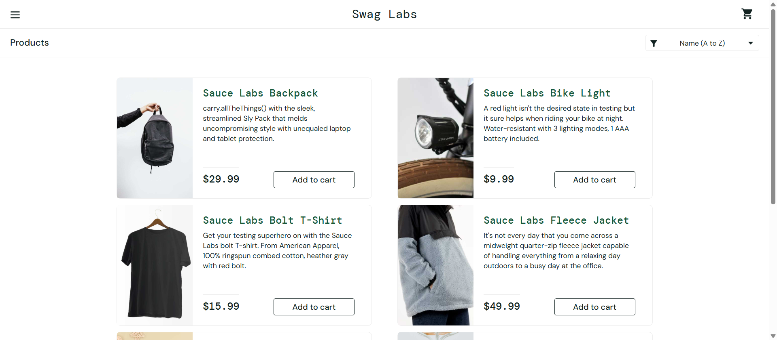
Step 17: 20Sorting
Step 18: 21Sorting_dropdown
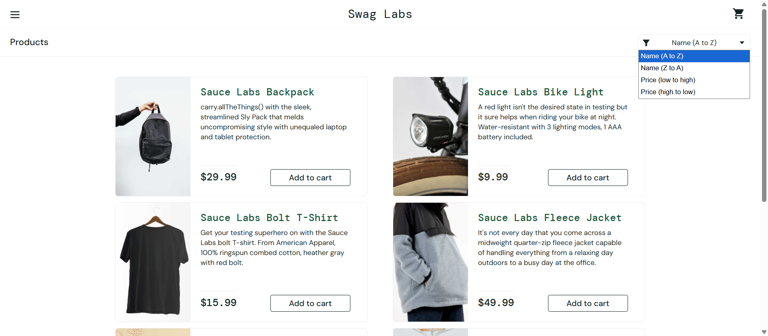
Step 19: 22Sorted_records1
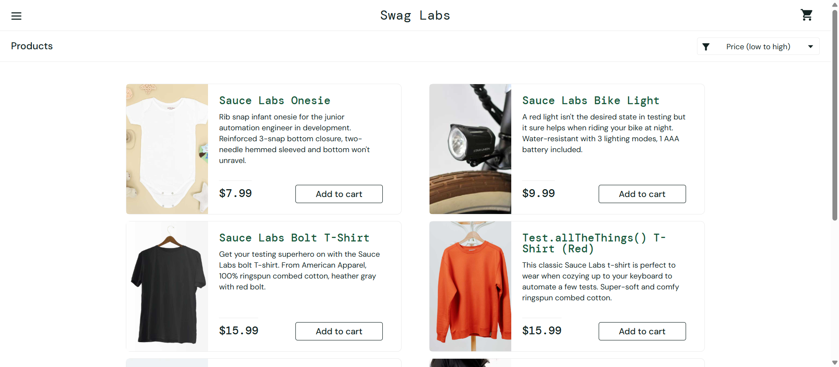
Step 20: 23Sorted_records2
Step 21: 20Sorting
Step 22: 21Sorting_dropdown
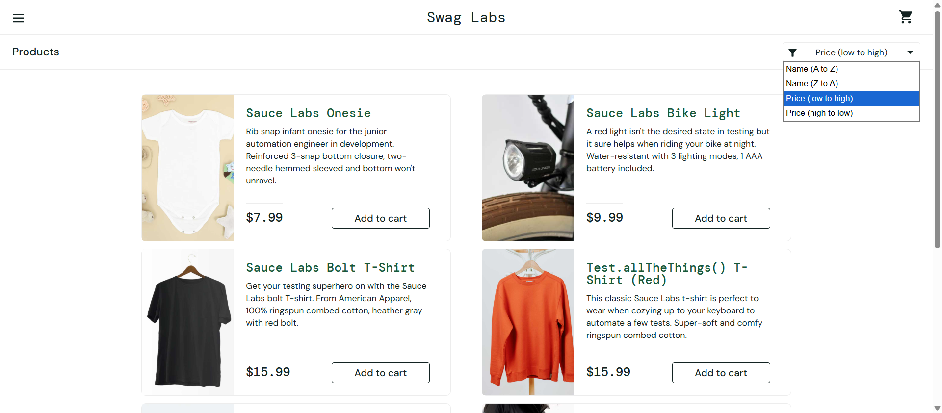
Step 23: 22Sorted_records1
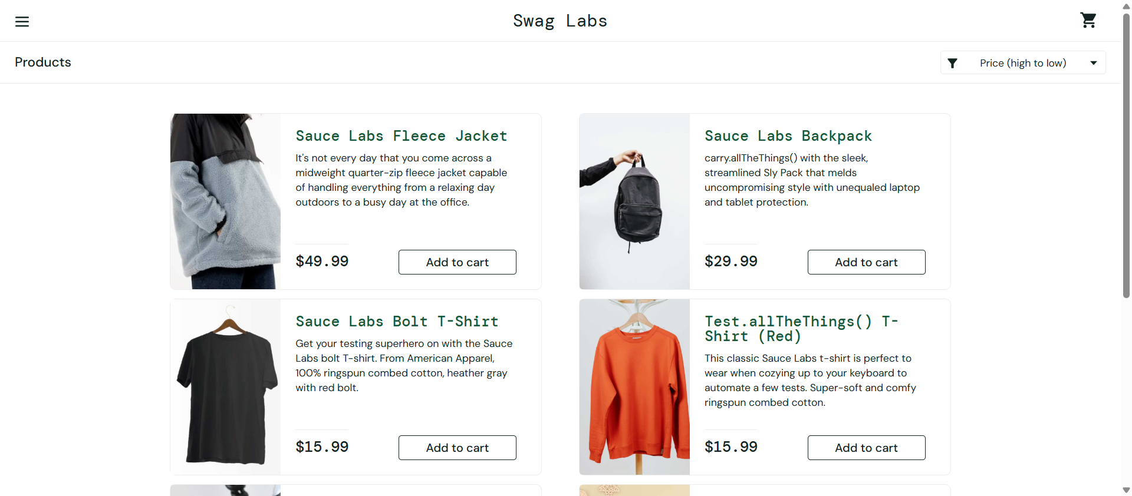
Step 24: 23Sorted_records2
Step 25: 20Sorting
Step 26: 21Sorting_dropdown
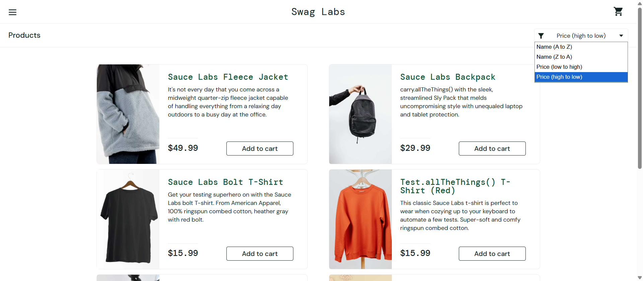
Step 27: 22Sorted_records1
Step 28: 23Sorted_records2
Step 29: Bottom
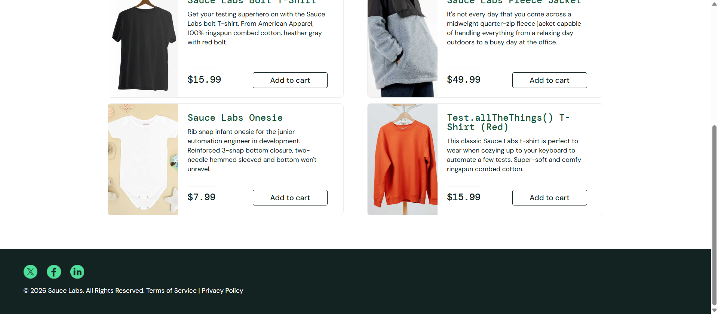
Step 30: Top
Step 31: 01LoginPage_Loaded successfully
Step 32: 02_Credentials_Username_Entered
Step 33: 03_Credentials_Password_Entered
Step 34: 04_Login
Step 35: 05Homepage_sidemenu
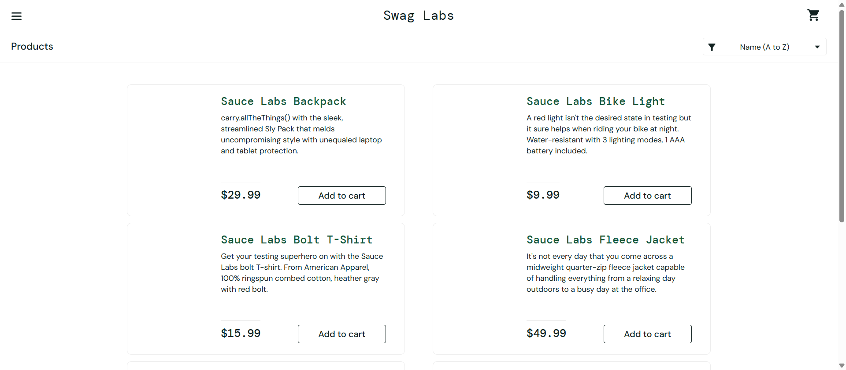
Step 36: 24Dynamic
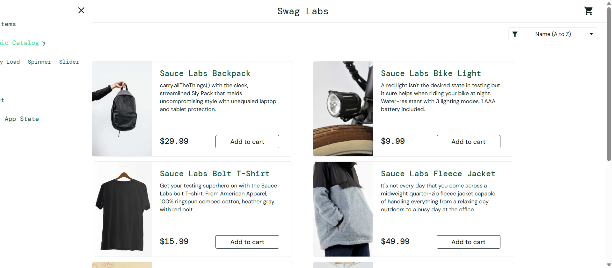
Step 37: 24Options
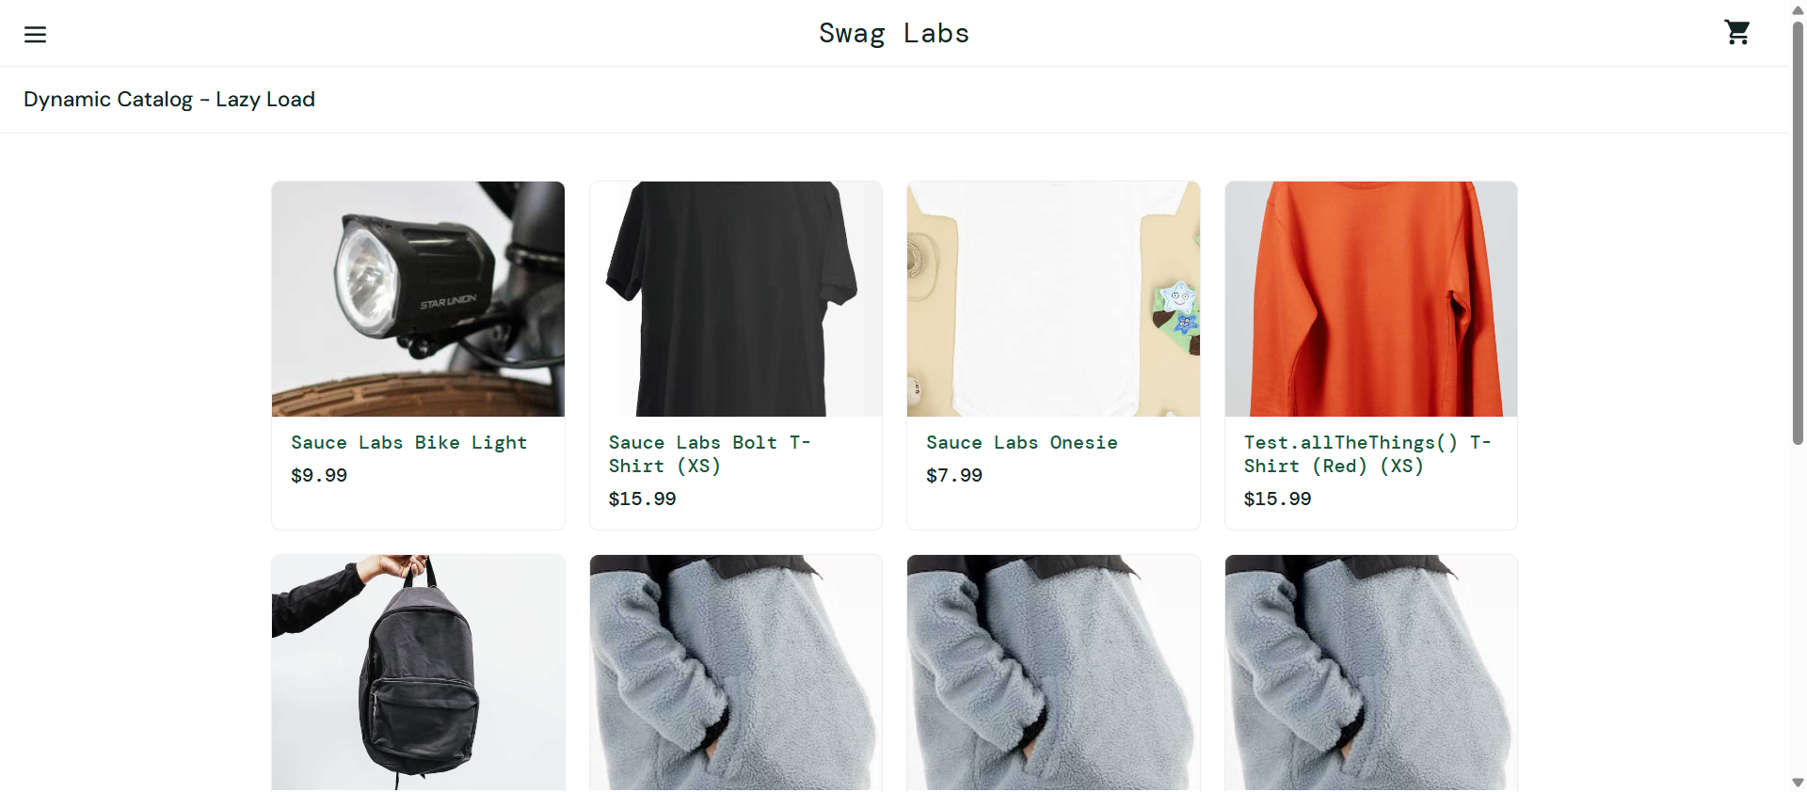
Step 38: 25DynamicPage
Step 39: 05Homepage_sidemenu
Step 40: opt
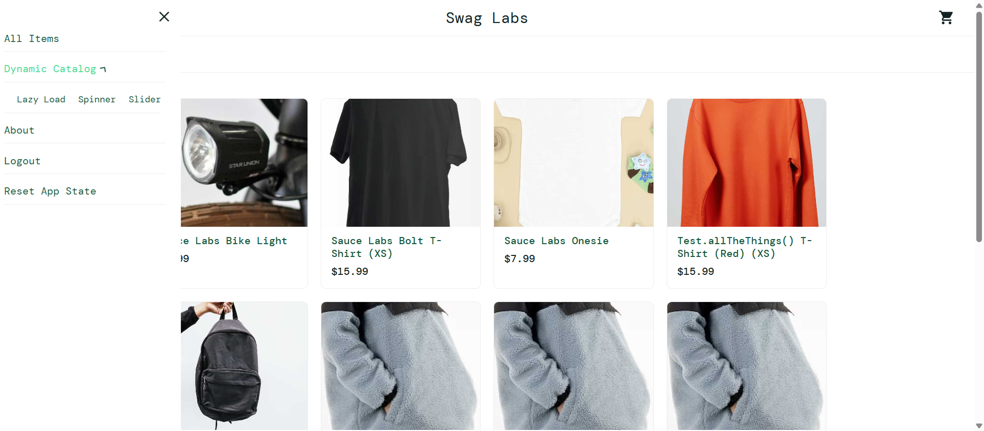
Step 41: opt
