Project Submission
Project Title: Trendy
Step 1
GIT fork and clone into local Machine
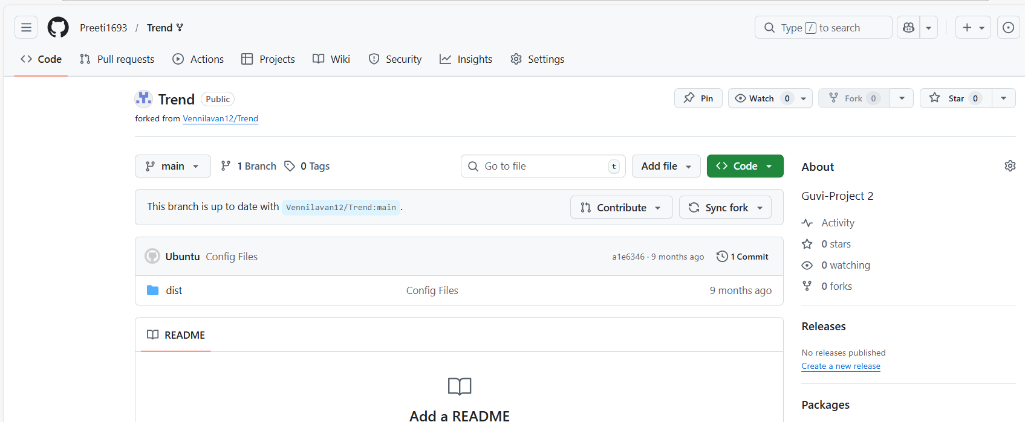
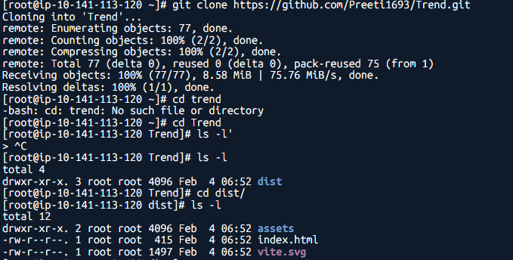
Step 2
Dockerfile, Jenkinsfile, main.tf, deployment.yaml, service.yaml files created
Dockerfile
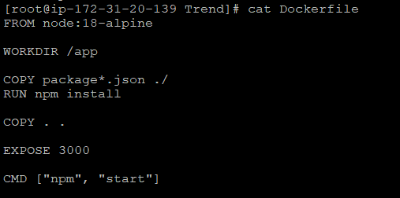
Jenkinsfile
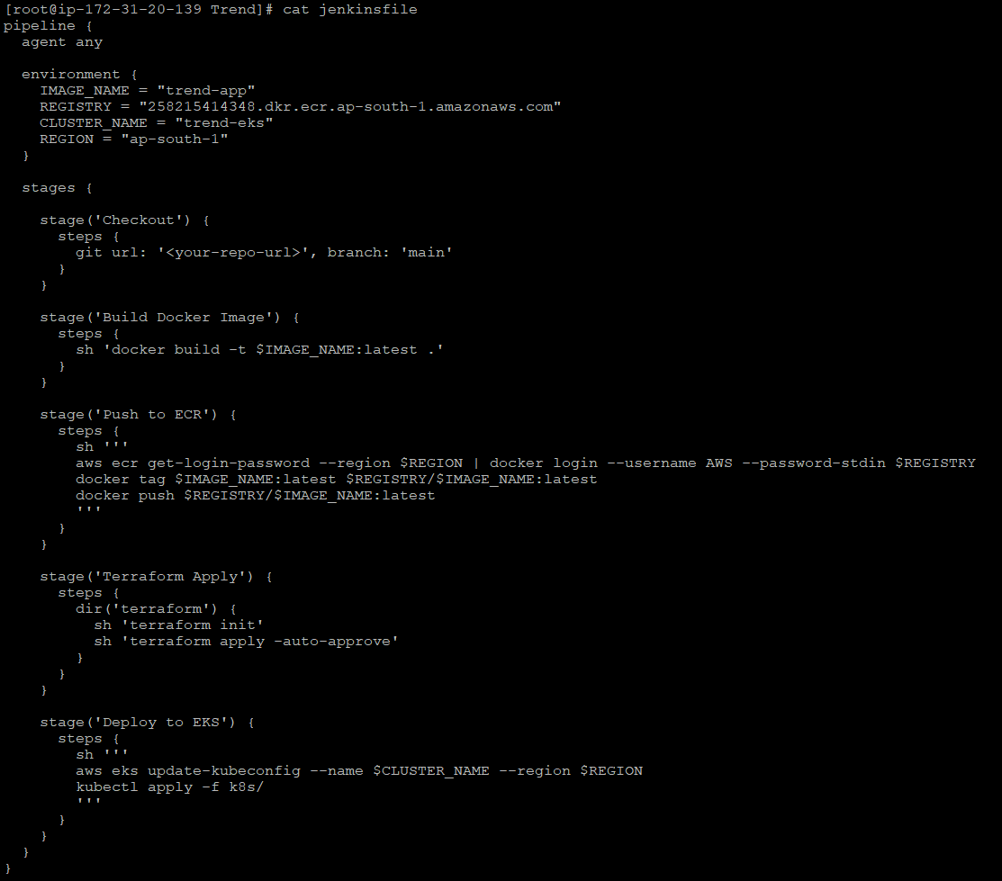
Deployment.yaml
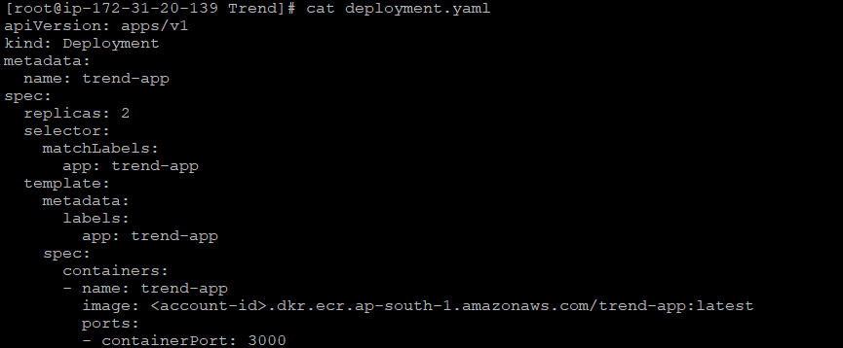

Service.yaml
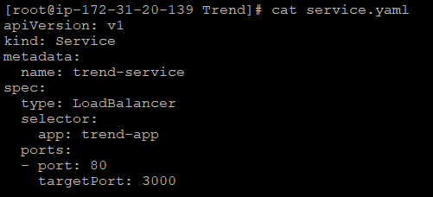
Main.tf
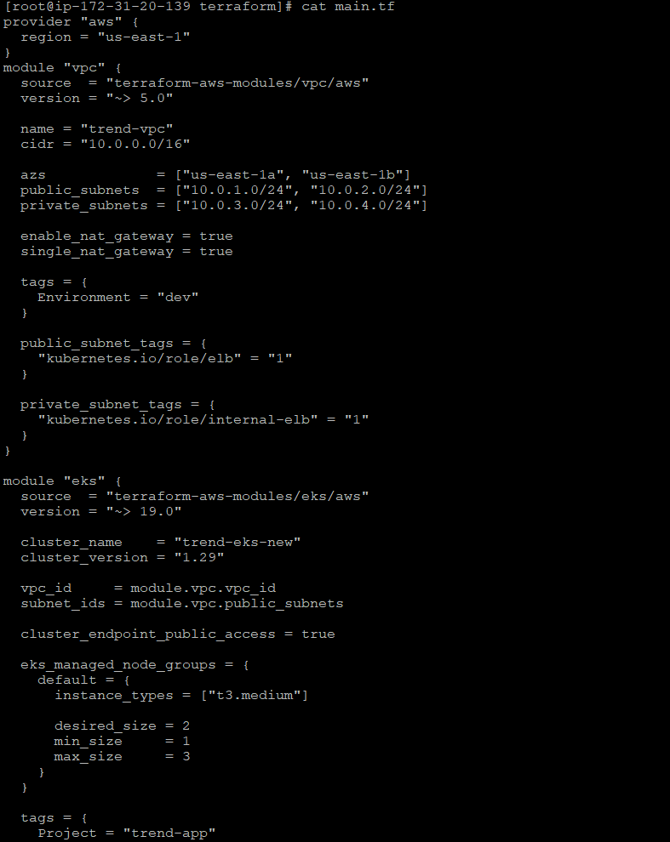
Step 3
AWS IAM user configuration
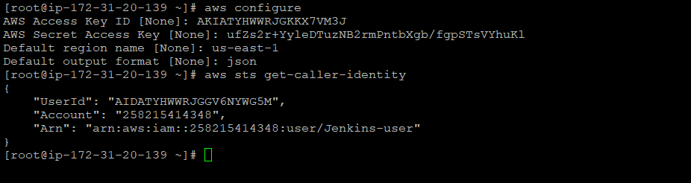
Step 8
Jenkins Pipeline created
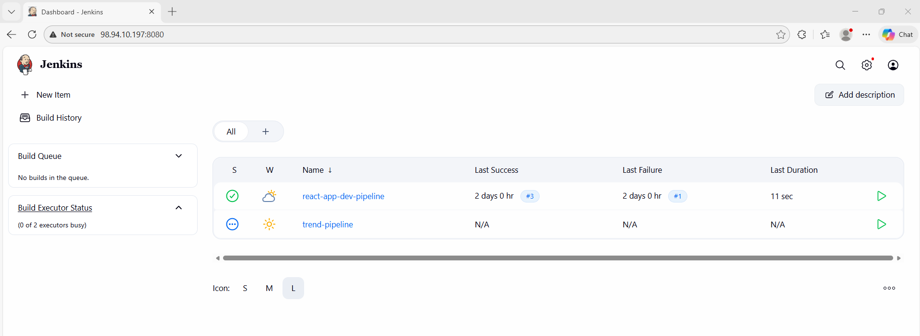
Step 9
Github webhook created
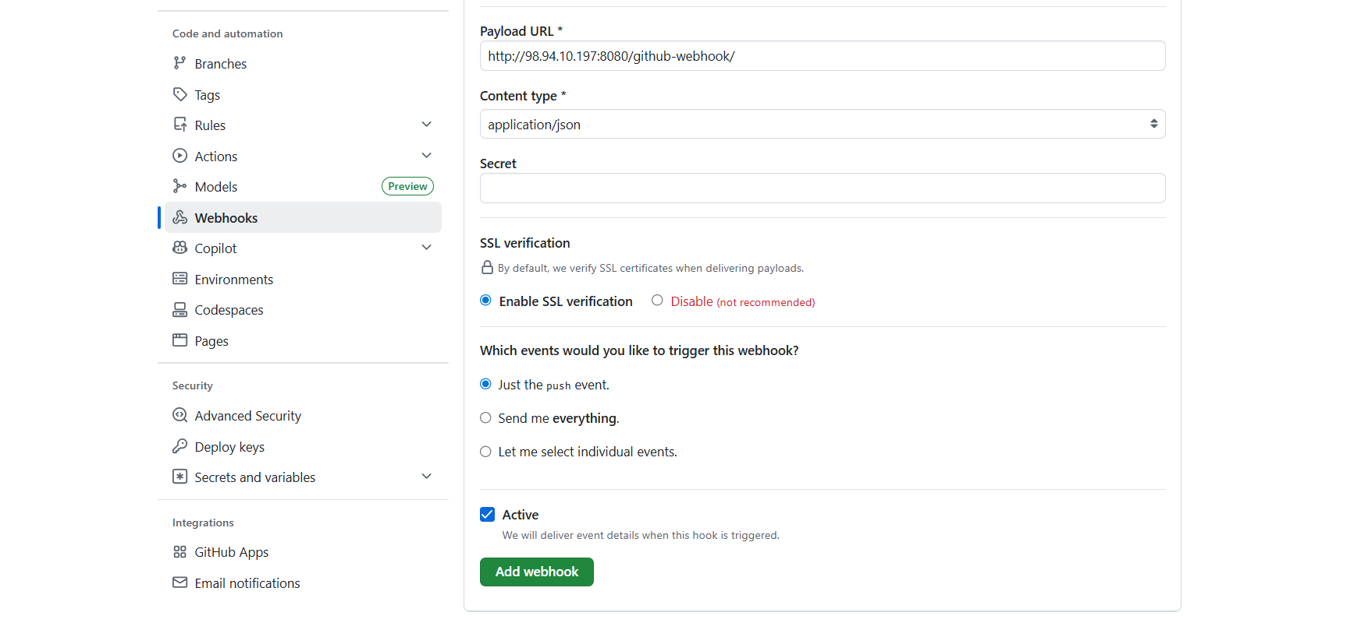

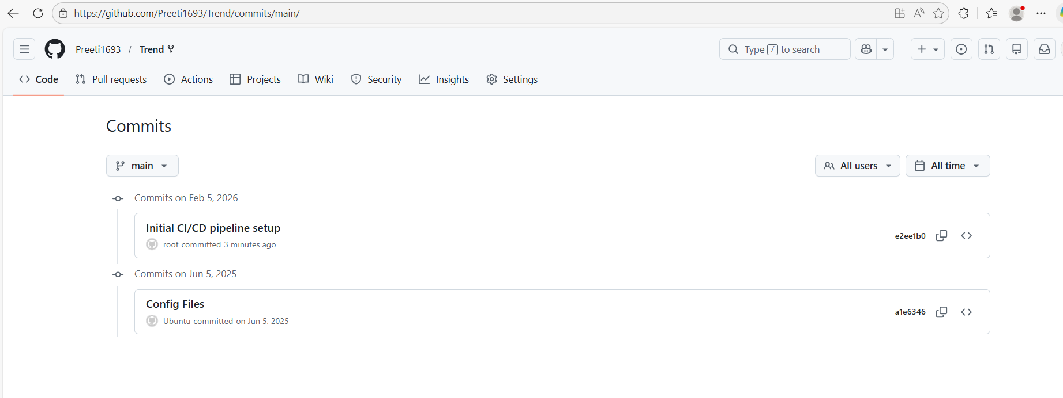
Step 10
CI/CD completed
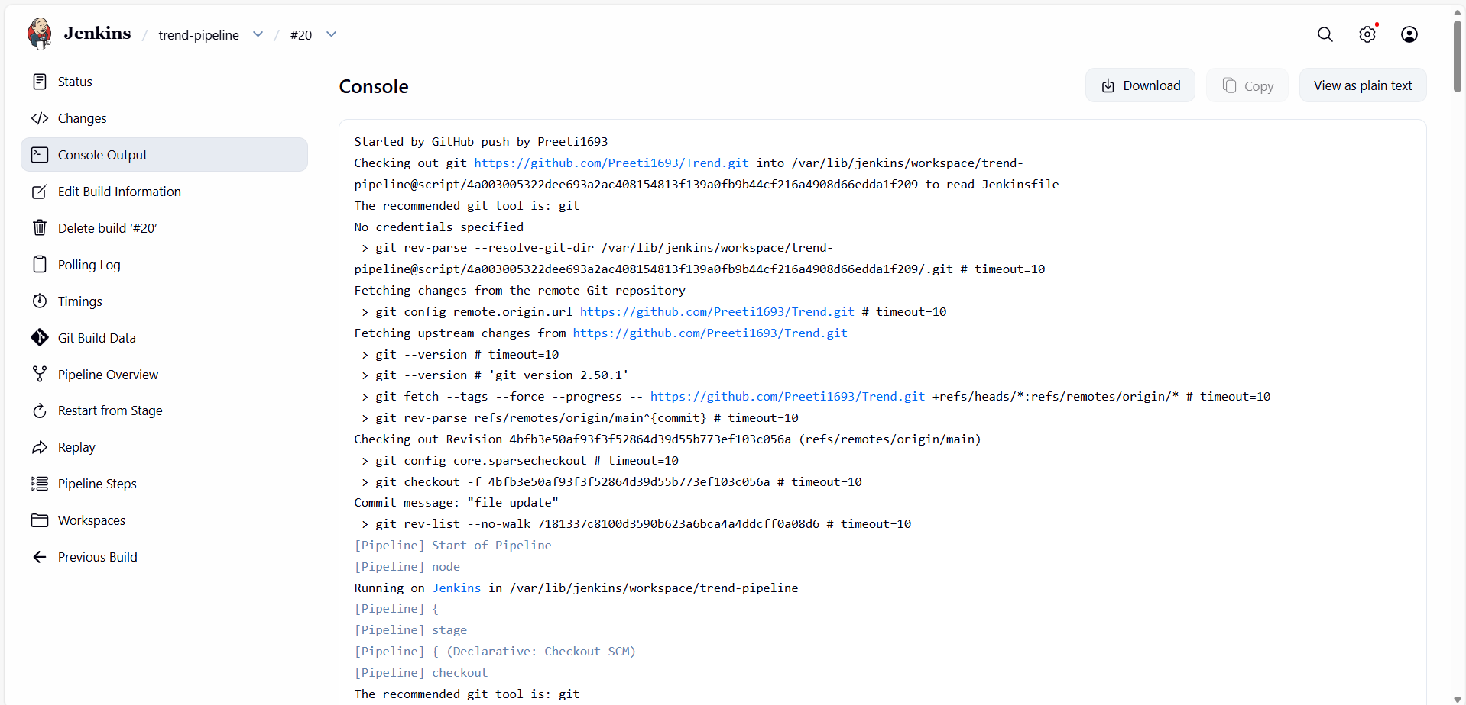
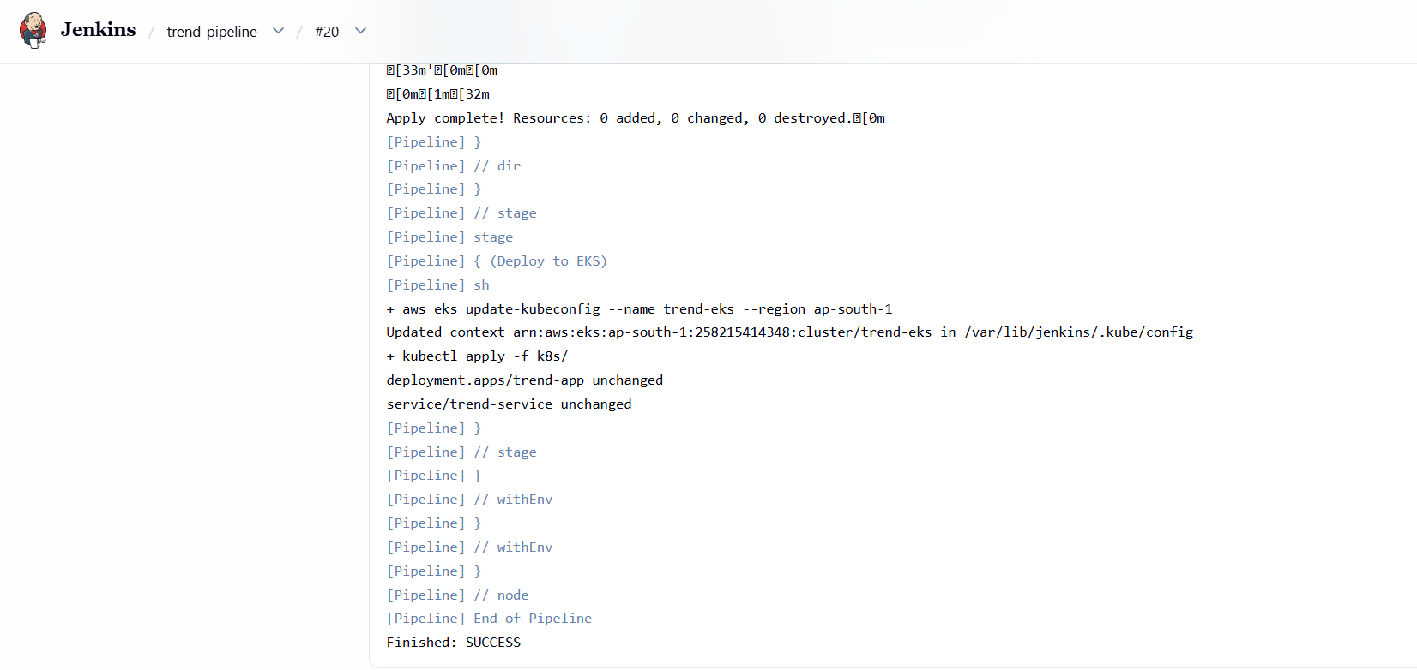
Step 11
Pod running healthy: Verification
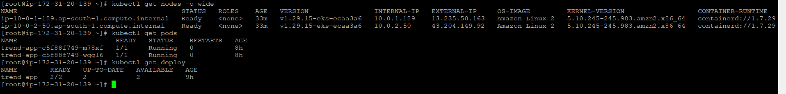
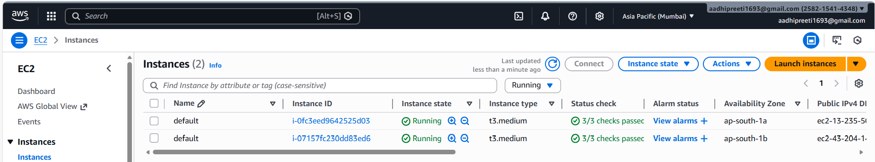

Step 12
Application port is targeting to port:3000 as per requirement

Step 13
Application is running on port 3000
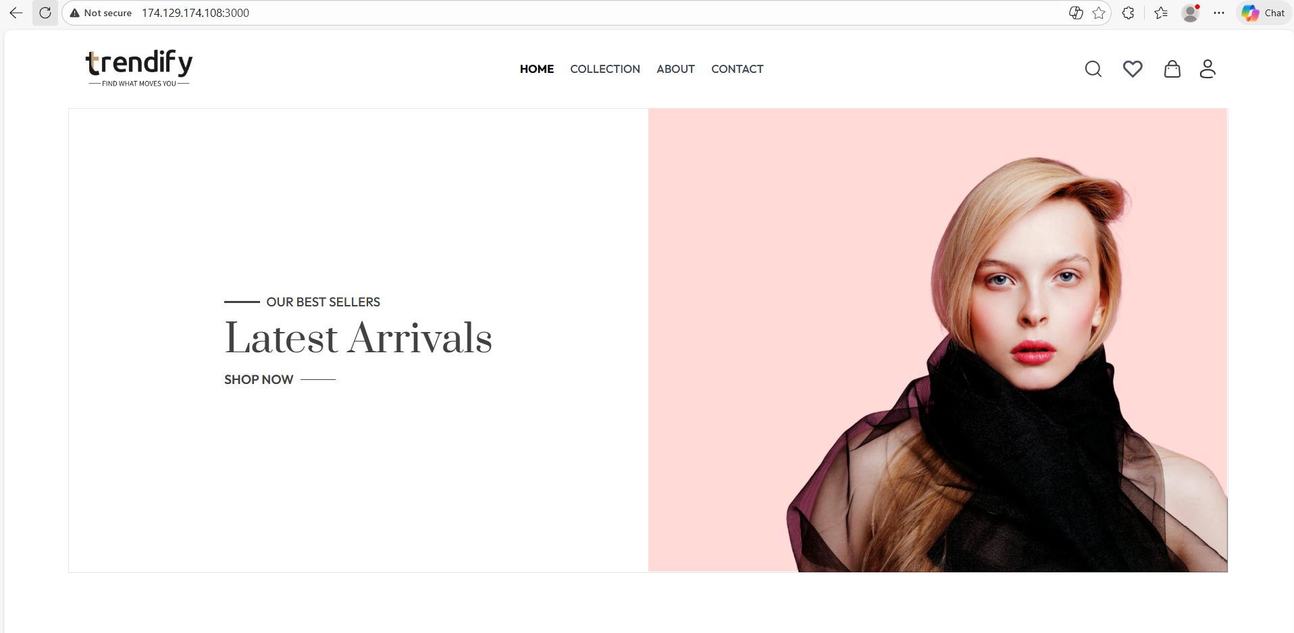

Step 14
Monitoring [Prometheus + Grafana]
