Task – 21 Prometheus and Grafana

Creating a Monitor Server
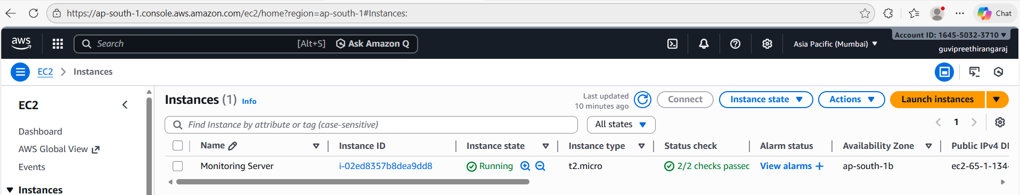

Creating Directories and files:
Downloading and installing Prometheus
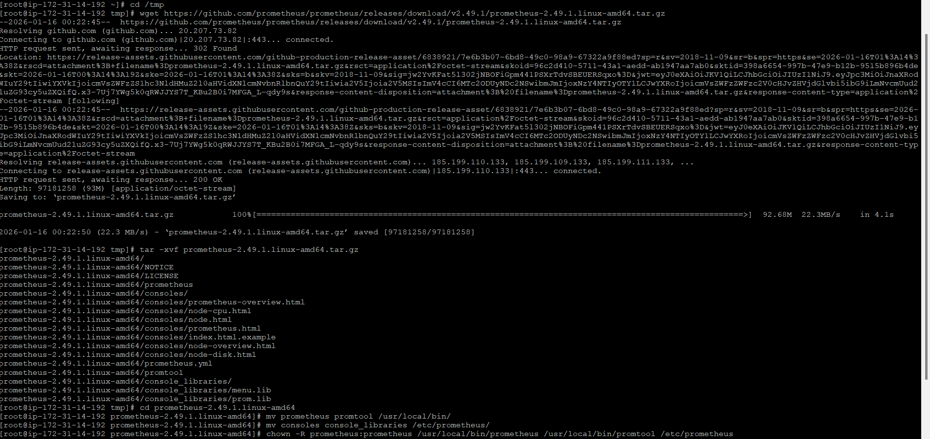
Configure Prometheus:
/etc/prometheus/prometheus.yml
global:
scrape_interval: 15s

scrape_configs:
- job_name: "prometheus"
static_configs:
- targets: ["localhost:9090"]

- job_name: "node_exporter"
static_configs:
- targets: ["localhost:9100"]
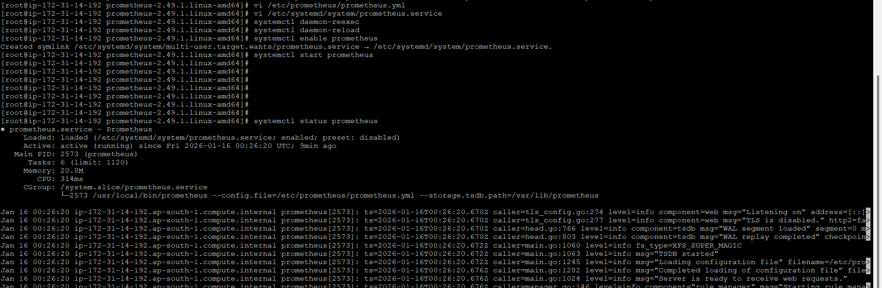

Prometheus Dashboard
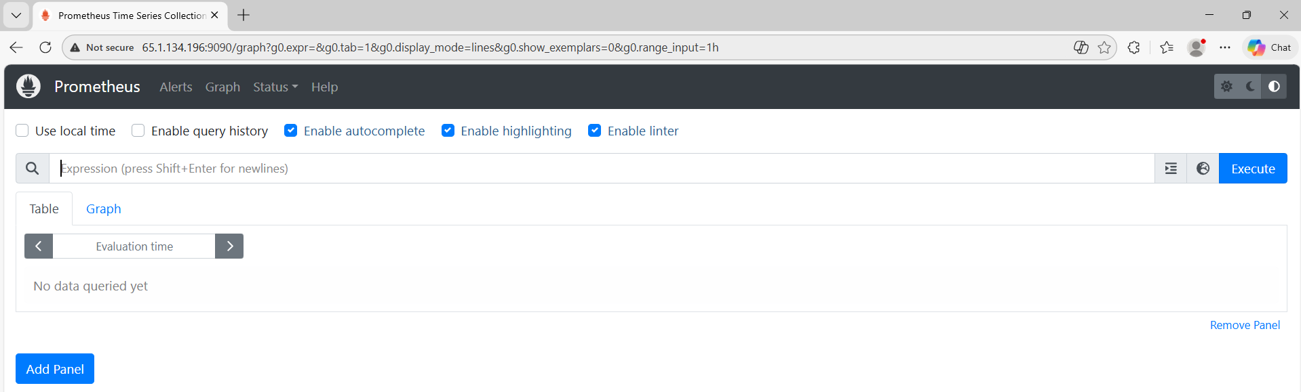

Install Node Exporter
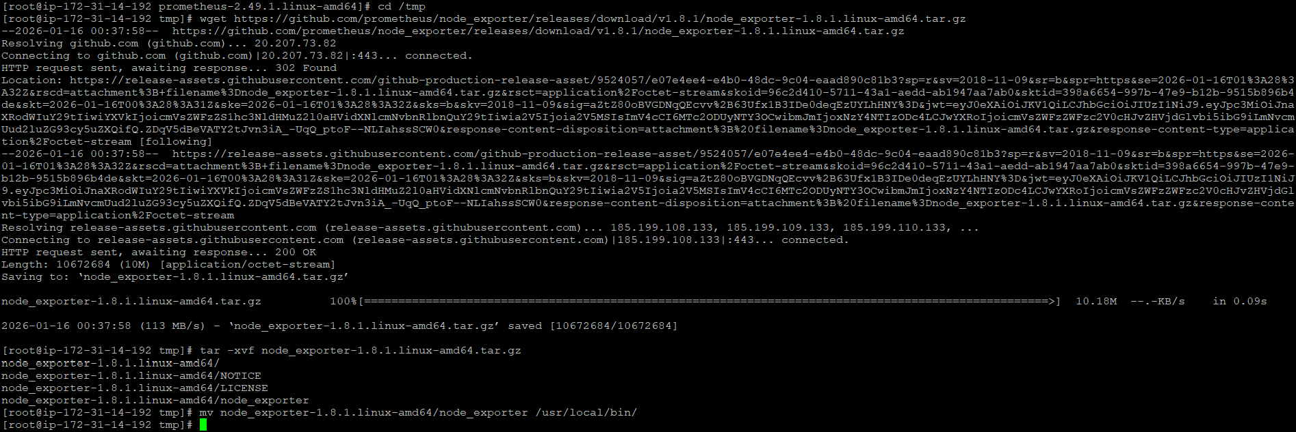

Node Exporter Metrics:
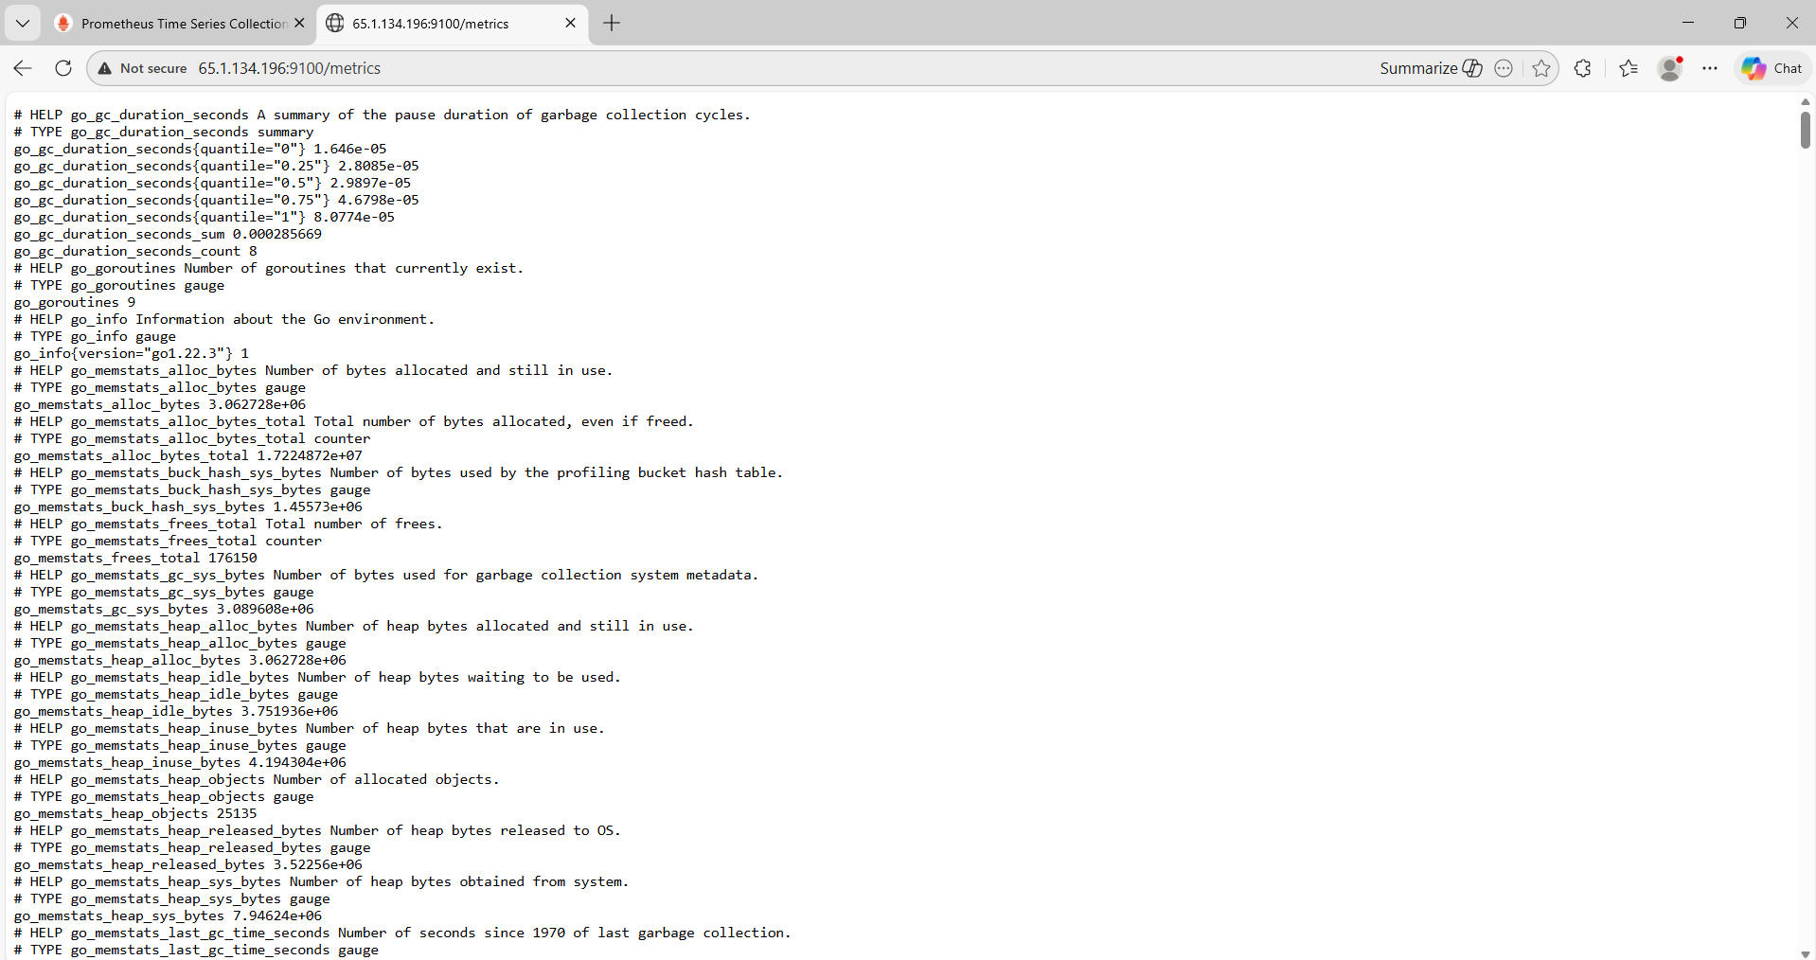

Install Grafana
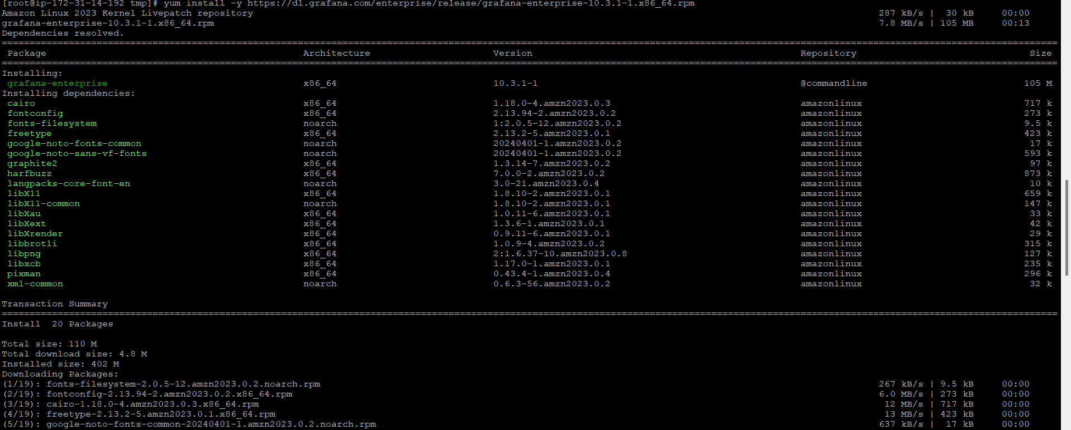
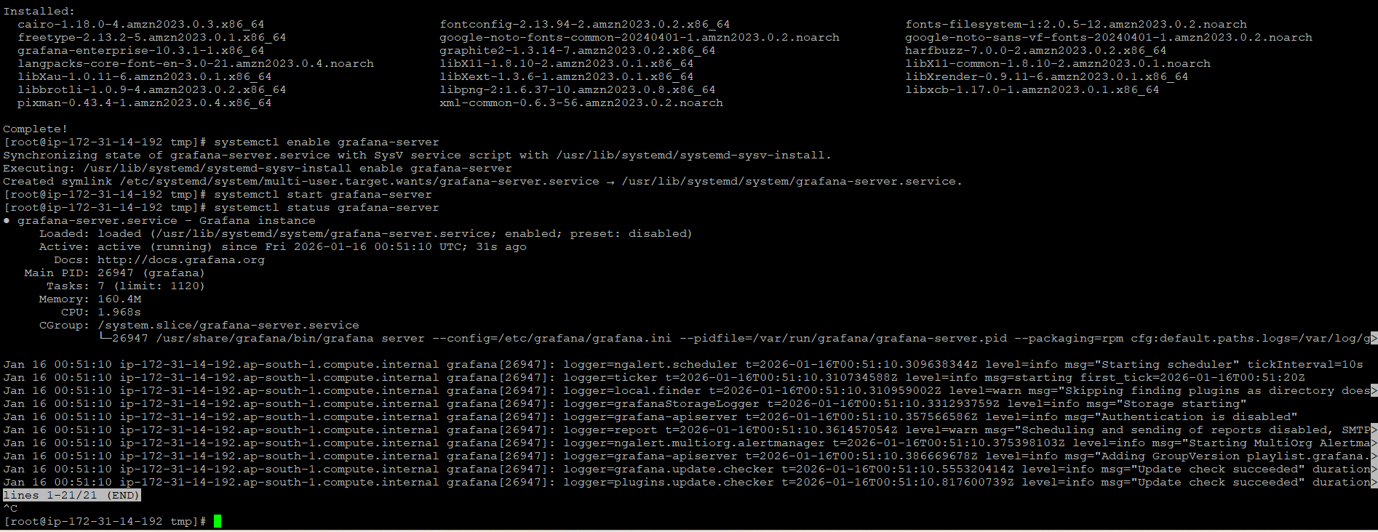

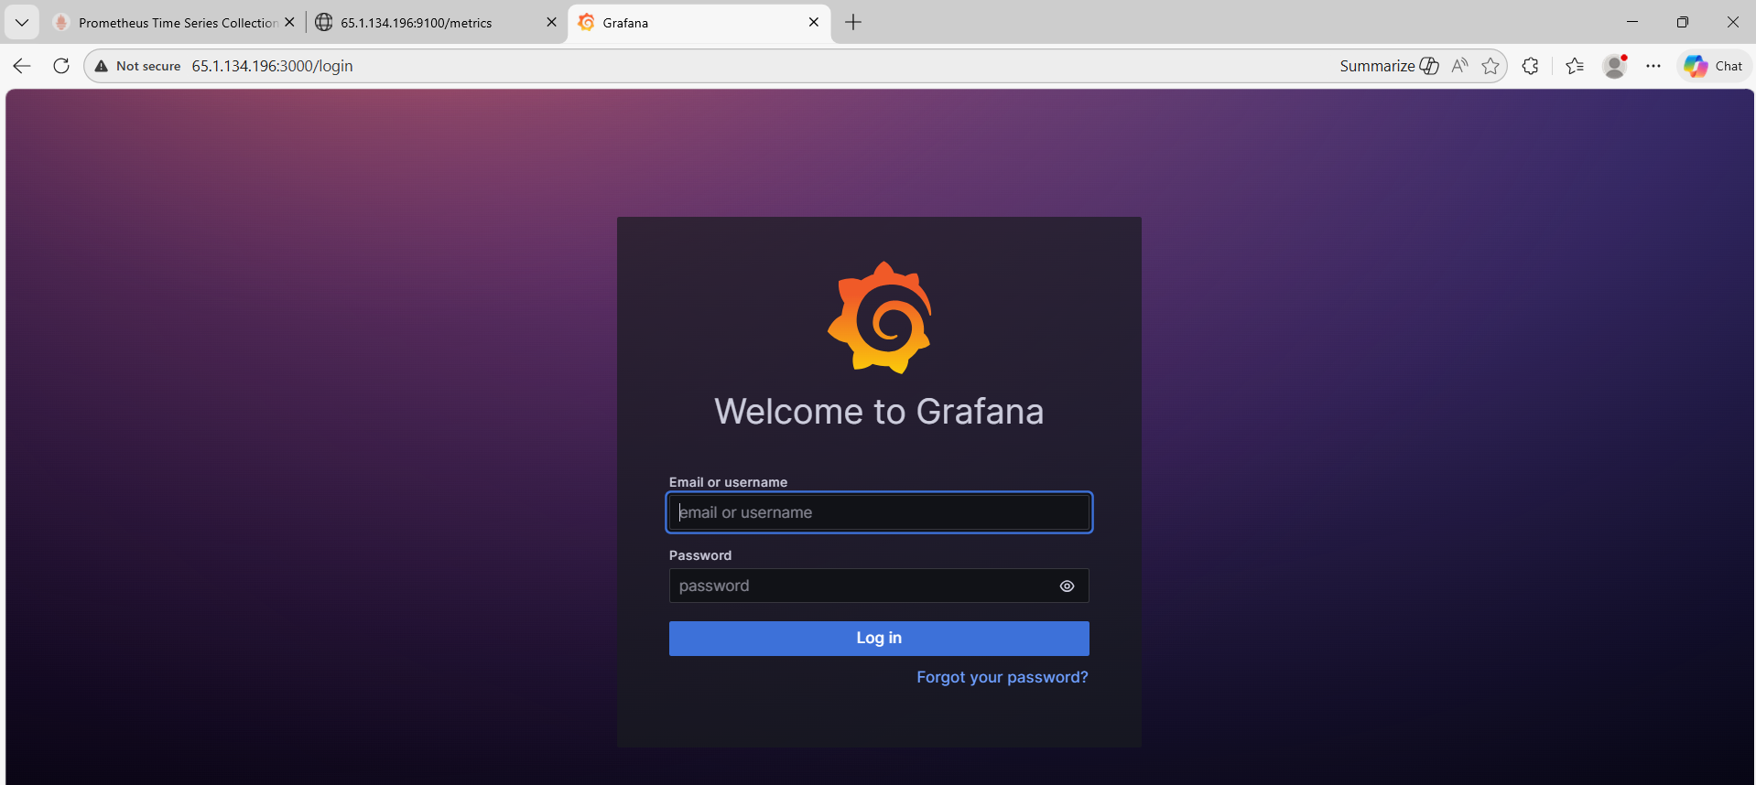

Connect Prometheus to Grafana
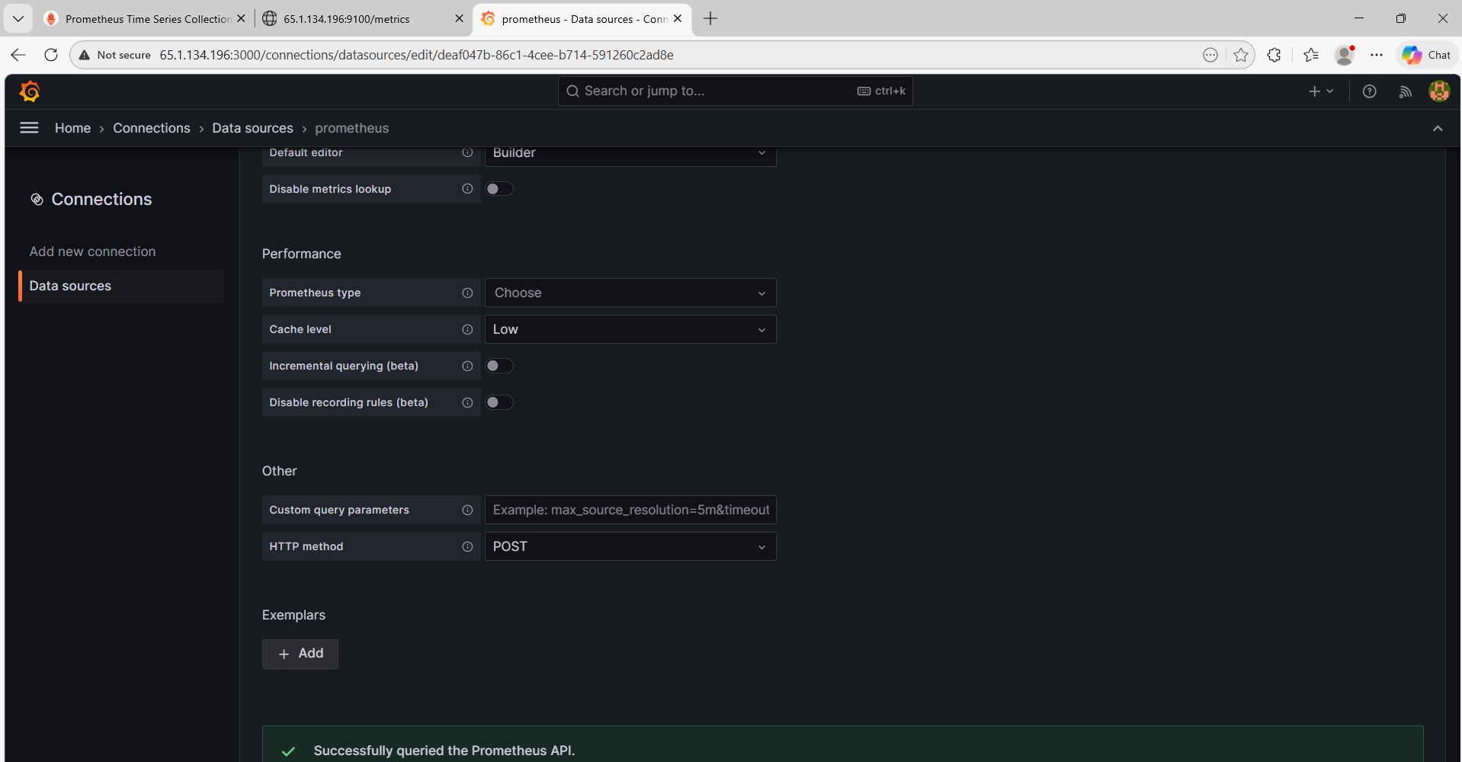

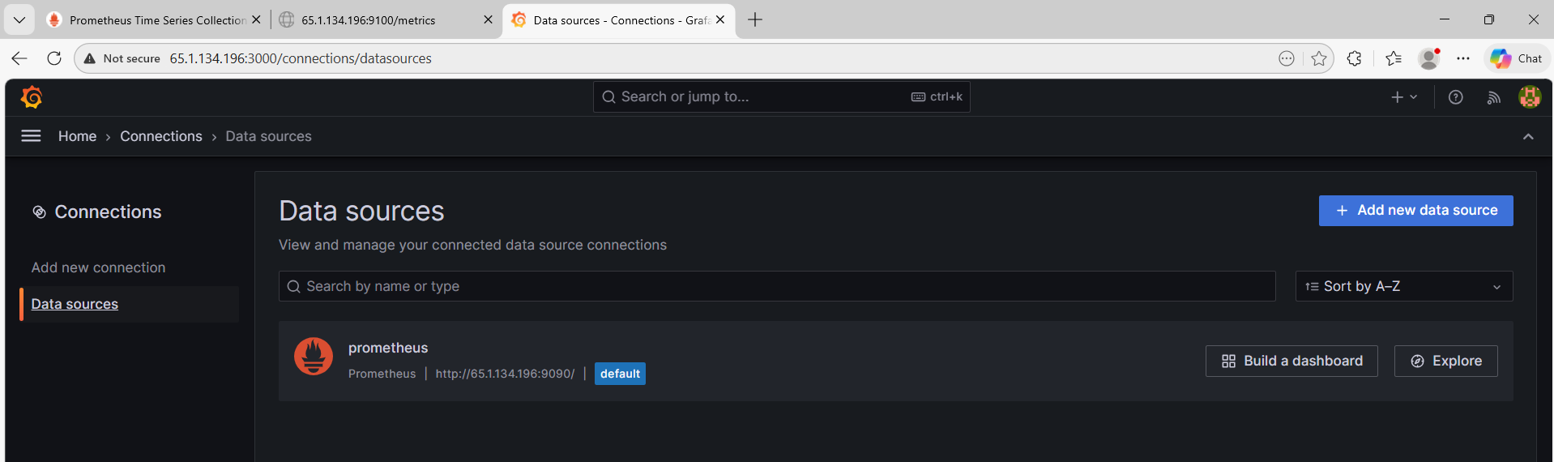

Dashboard Created
