**Topics: Descriptive Statistics and Probability**

1. **Look at the data given below. Plot the data, find the outliers and find out $μ, σ, σ^{2}$**

|  |  |
| --- | --- |
| **Name of company** | **Measure X** |
| Allied Signal | 24.23% |
| Bankers Trust | 25.53% |
| General Mills | 25.41% |
| ITT Industries | 24.14% |
| J.P.Morgan & Co. | 29.62% |
| Lehman Brothers | 28.25% |
| Marriott | 25.81% |
| MCI | 24.39% |
| Merrill Lynch | 40.26% |
| Microsoft | 32.95% |
| Morgan Stanley | 91.36% |
| Sun Microsystems | 25.99% |
| Travelers | 39.42% |
| US Airways | 26.71% |
| Warner-Lambert | 35.00% |

**Ans:**

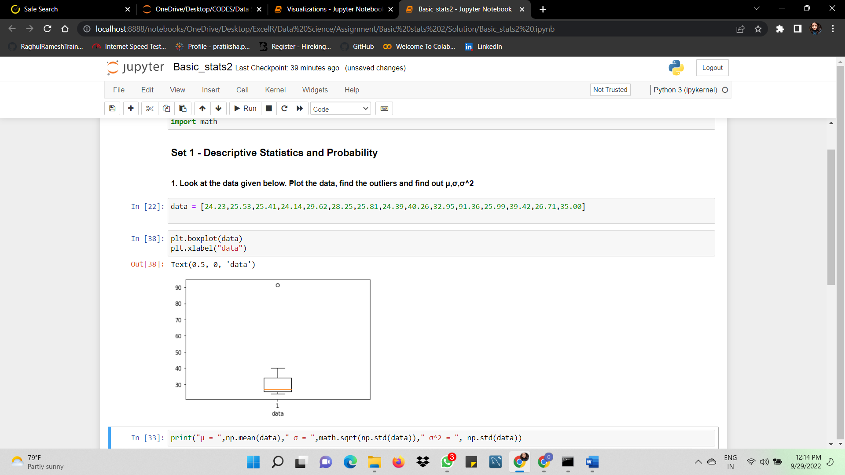

Outlier = 91.36%

μ = 33.27133

σ = 4.04608

σ2 = 16.37081

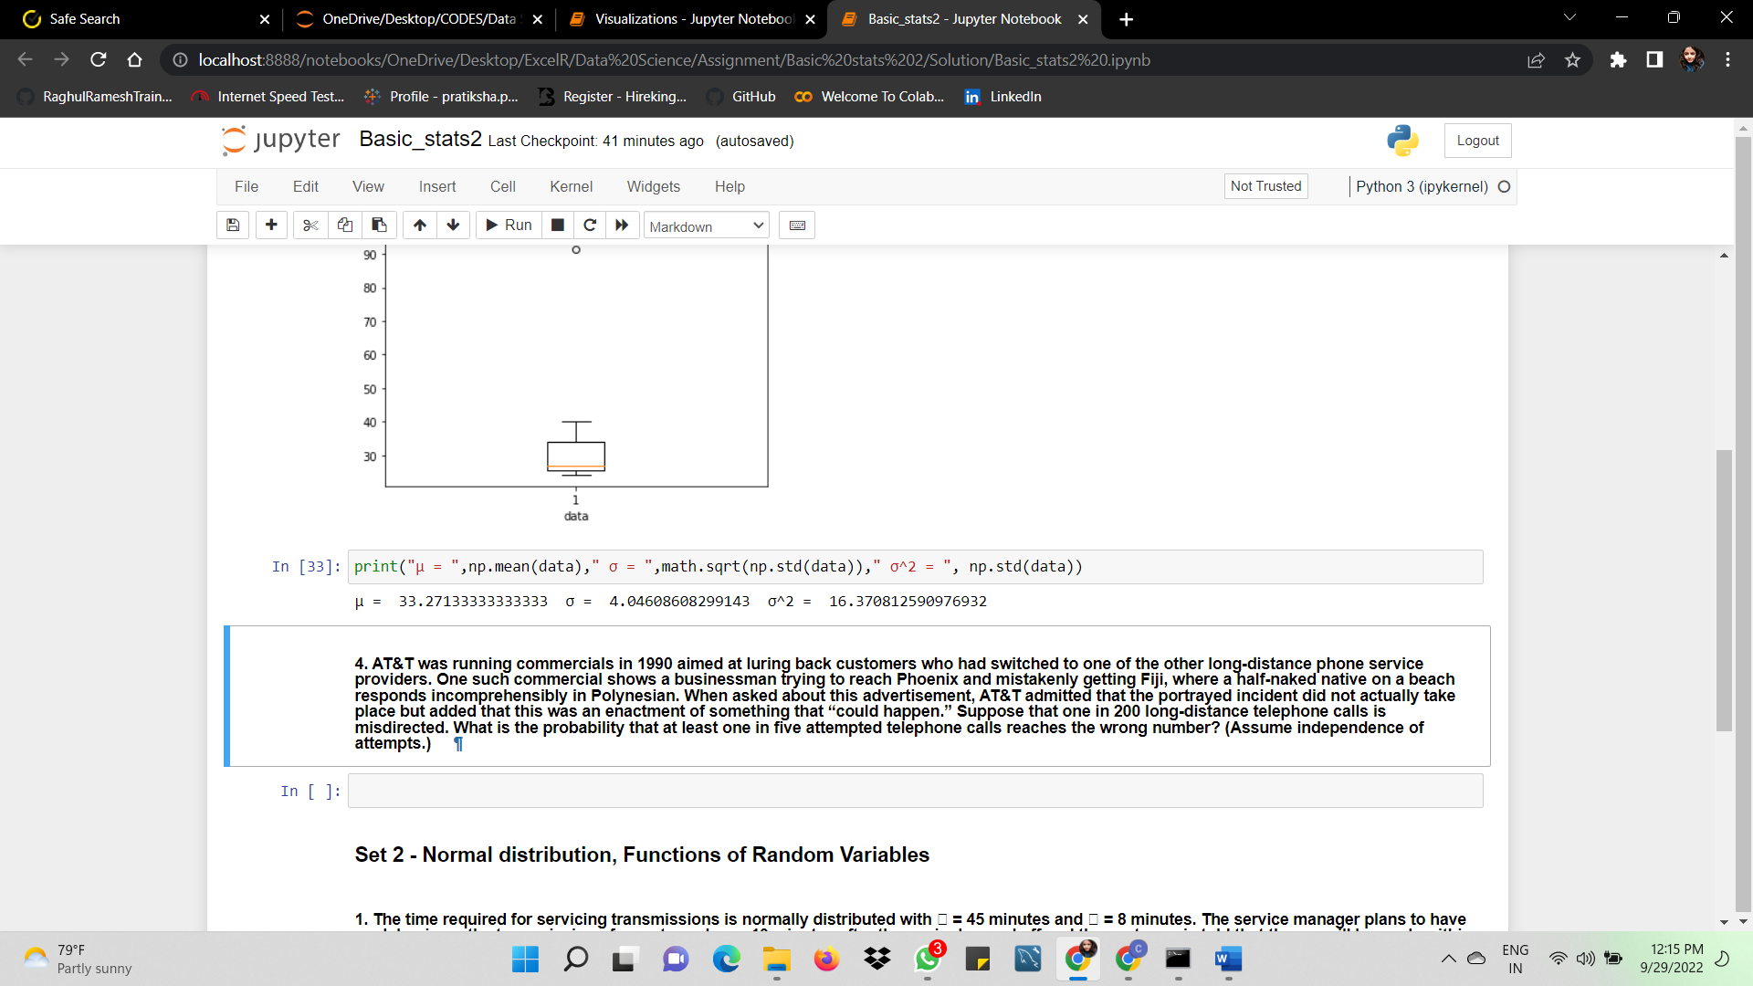



**Answer the following three questions based on the box-plot above.**

1. **What is inter-quartile range of this dataset? (please approximate the numbers) In one line, explain what this value implies.**

**Ans:** IQR = Upper quartile – Lower Quartile

= 12.5 – 5

= 7.5

IQR value indicates about how middle half of the data is spread. Larger the IQR more the spread in the central portion.

1. **What can we say about the skewness of this dataset?**

**Ans:** Since median is smaller than mean, the distribution curve is positive/right skewed.

1. **If it was found that the data point with the value 25 is actually 2.5, how would the new box-plot be affected?**

**Ans:** The outlierabove the upper whisker would have been moved to the Lower extreme indicating no outliers in the dataset.



**Answer the following three questions based on the histogram above.**

1. **Where would the mode of this dataset lie?**

**Ans:** Mode would lie in the range of 5-10, as max of datasets has 20 value.

1. **Comment on the skewness of the dataset.**

**Ans:** Positive/Right skewed

1. **Suppose that the above histogram and the box-plot in question 2 are plotted for the same dataset. Explain how these graphs complement each other in providing information about any dataset.**

**Ans:** Boxplot shows the count of outliers while the histogram can only depict the range.

1. **AT&T was running commercials in 1990 aimed at luring back customers who had switched to one of the other long-distance phone service providers. One such commercial shows a businessman trying to reach Phoenix and mistakenly getting Fiji, where a half-naked native on a beach responds incomprehensibly in Polynesian. When asked about this advertisement, AT&T admitted that the portrayed incident did not actually take place but added that this was an enactment of something that “could happen.” Suppose that one in 200 long-distance telephone calls is misdirected. What is the probability that at least one in five attempted telephone calls reaches the wrong number? (Assume independence of attempts.)**

**Ans:** Given,

Probability of getting a wrong number in 200, p = 1/200

Not getting a wrong number, q = 1 – (1/200) = 199/200

Number of calls, n = 5

Probabilty of getting atleast one wrong number = 1 – zero wrong number

= 1- P(x)

= 1 - ⁿCₓ pˣ qⁿ⁻ˣ

= 1 - ⁵C₀ (1/200) ⁰ (199/200) ⁵⁻⁰

= 1 - (199/200) ⁵

= 0.02475

1. **Returns on a certain business venture, to the nearest $1,000, are known to follow the following probability distribution**

|  |  |
| --- | --- |
| x | P(x) |
| -2,000 | 0.1 |
| -1,000 | 0.1 |
| 0 | 0.2 |
| 1000 | 0.2 |
| 2000 | 0.3 |
| 3000 | 0.1 |

1. **What is the most likely monetary outcome of the business venture?**

**Ans:** x = 2000 with the probability of 0.3

1. **Is the venture likely to be successful? Explain**

**Ans:** Since the outcome of negative returns is lower compared to positive returns, the venture is likely to be successful.

1. **What is the long-term average earning of business ventures of this kind? Explain**

**Ans:** Average value =(**-**2000*0.1)+(-1000*0.1)+(1000*0.2)+(2000*0.3)+(3000 *0.1)

= 800

1. **What is the good measure of the risk involved in a venture of this kind? Compute this measure?**

**Ans:** Risk implies getting negative returns = P(x=-2000) + P(x=-1000)

= 0.1 + 0.1 = 0.2