**Topics: Normal distribution, Functions of Random Variables**

1. **The time required for servicing transmissions is normally distributed with *μ* = 45 minutes and *σ* = 8 minutes. The service manager plans to have work begin on the transmission of a customer’s car 10 minutes after the car is dropped off and the customer is told that the car will be ready within 1 hour from drop-off. What is the probability that the service manager cannot meet his commitment?**
2. **0.3875**
3. **0.2676**
4. **0.5**
5. **0.6987**

**Ans:** Given,

μ = 45

σ = 8

X = 50

Z = (X - μ) / σ = (50 – 45) / 8 = 0.625

Probability of success = 0.7340 or 73.40%

Probability of failure = 1 – 0.7340 = 0.2676

1. **The current age (in years) of 400 clerical employees at an insurance claims processing center is normally distributed with mean *μ* = 38 and Standard deviation *σ* =6. For each statement below, please specify True/False. If false, briefly explain why.**
2. **More employees at the processing center are older than 44 than between 38 and 44.**

**Ans:** μ = 38

σ = 6

X = 44

Z = (X - μ) / σ = (44 – 38) / 6 = 1

P(X<44) = 0.8413 or 84.13%

P(X>44) = 1 – P(X<44) = 1-0.8413

= 0.1587 or 15.87%

P(38<X<44) = P(X<44) – P(X<38)

= 84.13 – 50

= 34.13%

Since the P(38<X<44) > P(X>44, implying percent of employee at the center who are between the age of 38 to 44 is greater than the percent of employee above 44. Hence the statement is False.

1. **A training program for employees under the age of 30 at the center would be expected to attract about 36 employees.**

**Ans:** μ = 38

σ = 6

X = 30

Z = (X - μ) / σ = (30 – 38) / 6 = -1.333

P(X<30) = 0.09126 = 9.12%

Total employees in the training under 30 = (9.12 * 400)/100 = 36.48

Hence the statement is True.

1. **If *X1* ~ *N*(μ, σ2) and *X*2 ~ *N*(μ, σ2) are *iid* normal random variables, then what is the difference between 2 *X*1 and *X*1 + *X*2? Discuss both their distributions and parameters.**

**Ans:** Given,

X1 ~ N (μ,σ2)

X2~ N (μ,σ2)

2X1 ~ X1 + X1 = N (μ+ μ, σ2 + σ2)

= N (2μ, 4σ2)

X1 + X2 = N (μ+ μ, σ2 + σ2)

= (2μ, 2σ2)

Here, the deviation in the first case increased 4 times the original value making it a dynamic dataset compared to the second case where the deviation value got doubled along with the mean value.

Difference between them = 2 *X*1 – (*X*1 + *X*2)

= N (2μ+2μ, 4σ2 + 2σ2)

= N (4μ, 6σ2)

1. **Let X ~ N(100, 202). Find two values, *a* and *b*, symmetric about the mean, such that the probability of the random variable taking a value between them is 0.99.**
2. **90.5, 105.9**
3. **80.2, 119.8**
4. **22, 78**
5. **48.5, 151.5**
6. **90.1, 109.9**

**Ans:** Given,

μ = 100

σ = 20

Probability of the random variable taking a value between a and b, P(X) = 0.99

Probability of the random variable not taking a value between a and b = 1 – P(X) = 0.01

Since a and b are symmetric about the mean,

Probability of random variable not taking a value below a = -0.005

Probability of random variable not taking a value above b= 0.005

Z for 0.005 = -2.5758

Z = (X - μ) / σ

X = Z (0.005) * σ + μ = 48.48 = a

X = Z (-0.005) * σ + μ = 151.516 = b

1. **Consider a company that has two different divisions. The annual profits from the two divisions are independent and have distributions Profit1 ~ N(5, 32) and Profit2 ~ N(7, 42) respectively. Both the profits are in $ Million. Answer the following questions about the total profit of the company in Rupees. Assume that $1 = Rs. 45**
2. **Specify a Rupee range (centered on the mean) such that it contains 95% probability for the annual profit of the company.**

**Ans:** (99.00810347848784, 980.9918965215122)

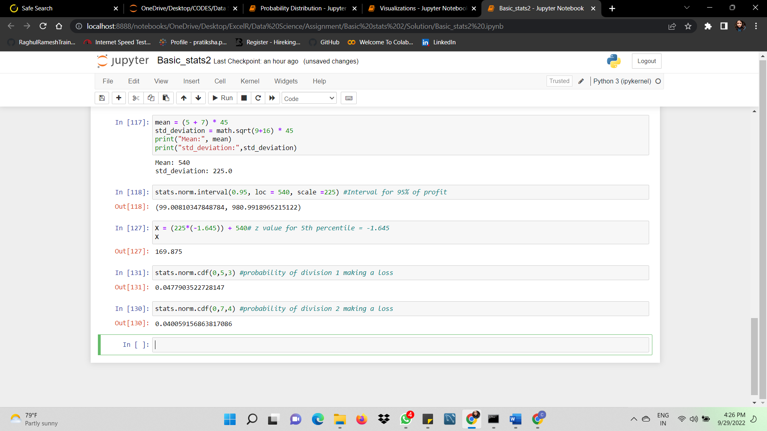

1. **Specify the 5th percentile of profit (in Rupees) for the company**

**Ans:** 169.875 Rs



1. **Which of the two divisions has a larger probability of making a loss in a given year?**

**Ans:** Division 1 has larger probability of making a loss compared to division 2 in the given year.

