1. Query all columns for all American cities in the **CITY** table with populations larger than 100000. The **CountryCode** for America is USA.

The **CITY** table is described as follows:

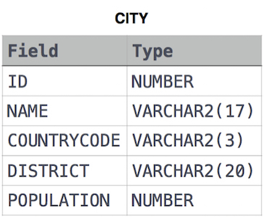

select *

from CITY

where POPULATION>100000 and COUNTRYCODE="USA";

2. Query the **NAME** field for all American cities in the **CITY** table with populations larger than 120000. The CountryCode for America is USA.

The **CITY** table is described as follows:  


select Name

from CITY

where POPULATION>120000 and COUNTRYCODE="USA";

3. Query all columns (attributes) for every row in the **CITY** table.

The **CITY** table is described as follows:  


select *

from CITY;

4. Query all columns for a city in **CITY** with the ID 1661.

The **CITY** table is described as follows:  


select *

from CITY

where ID=1661;

5. Query all attributes of every Japanese city in the **CITY** table. The **COUNTRYCODE** for Japan is JPN.

The **CITY** table is described as follows:  


select *

from CITY

where COUNTRYCODE="JPN";

6. Query the names of all the Japanese cities in the **CITY** table. The **COUNTRYCODE** for Japan is JPN.  
The **CITY** table is described as follows:  


select name

from CITY

where COUNTRYCODE="JPN";

7. Query a list of **CITY** and **STATE** from the **STATION** table.  
The **STATION** table is described as follows:  
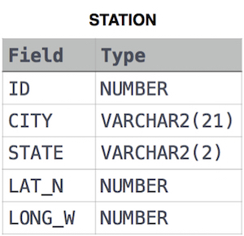

where **LAT_N** is the northern latitude and **LONG_W** is the western longitude.

SELECT CITY,STATE

FROM STATION;

**8.Weather Observation Station 3**

Query a list of **CITY** names from **STATION** for cities that have an even **ID** number. Print the results in any order, but exclude duplicates from the answer.  
The **STATION** table is described as follows:



where **LAT_N** is the northern latitude and **LONG_W** is the western longitude.

select distinct CITY

from STATION

where ID%2=0

# 9.Weather Observation Station 4

Find the difference between the total number of **CITY** entries in the table and the number of distinct **CITY** entries in the table.  
The **STATION** table is described as follows:



where **LAT_N** is the northern latitude and **LONG_W** is the western longitude.

For example, if there are three records in the table with **CITY** values 'New York', 'New York', 'Bengalaru', there are 2 different city names: 'New York' and 'Bengalaru'. The query returns , because

/*

Enter your query here.

*/

select count(CITY)-count(distinct CITY)

from STATION;

# 10. Weather Observation Station 5

Query the two cities in **STATION** with the shortest and longest *CITY* names, as well as their respective lengths (i.e.: number of characters in the name). If there is more than one smallest or largest city, choose the one that comes first when ordered alphabetically.  
The **STATION** table is described as follows:



where **LAT_N** is the northern latitude and **LONG_W** is the western longitude.

**Sample Input**

For example, **CITY** has four entries: **DEF, ABC, PQRS** and **WXY**.

**Sample Output**

ABC 3

PQRS 4

**Explanation**

When ordered alphabetically, the **CITY** names are listed as **ABC, DEF, PQRS,** and **WXY**, with lengths  and . The longest name is **PQRS**, but there are  options for shortest named city. Choose **ABC**, because it comes first alphabetically.

**Note**  
You can write two separate queries to get the desired output. It need not be a single query.

/*

Enter your query here.

*/

select city,length(city)

from station

order by length(city),city asc

limit 1;

select city,length(city)

from station

order by length(city) desc

limit 1;

ALTERNATE

/*

Enter your query here.

*/

select CITY,LENGTH(CITY)

from STATION

WHERE LENGTH(CITY)=

(SELECT min(lenGTH(CITY))

FROM STATION)

order by CITY ASC

LIMIT 1;

select CITY,LENGTH(CITY)

from STATION

WHERE LENGTH(CITY)=

(SELECT MAX(lenGTH(CITY))

FROM STATION)

order by CITY ASC

LIMIT 1;

# 11. Weather Observation Station 6

Query the list of CITY names starting with vowels (i.e., a, e, i, o, or u) from **STATION**. Your result cannot contain duplicates.

**Input Format**

The **STATION** table is described as follows:



where LAT_N is the northern latitude and LONG_W is the western longitude.

/*

Enter your query here.

*/

select distinct CITY

from STATION

where CITY regexp '^[aeiou]';

# 12. Weather Observation Station 7

Query the list of CITY names ending with vowels (a, e, i, o, u) from **STATION**. Your result cannot contain duplicates.

**Input Format**

The **STATION** table is described as follows:



where LAT_N is the northern latitude and LONG_W is the western longitude.

/*

Enter your query here.

*/

SELECT DISTINCT CITY

FROM STATION

WHERE CITY REGEXP '[aeiou]$';

# 13.Weather Observation Station 8

Query the list of CITY names from **STATION** which have vowels (i.e., a, e, i, o, and u) as both their first and last characters. Your result cannot contain duplicates.

**Input Format**

The **STATION** table is described as follows:



where LAT_N is the northern latitude and LONG_W is the western longitude.

select distinct CITY

from STATION

where CITY regexp '^[aeiou].*[aeiou]$';