Bi0s Hardware Tasks

## Name: N Preeti

## RegNo: BL.EN. U4AIE20037

1. bLink-it

Connect 8 LEDs with 8 GPIO pins of Arduino UNO such that those LEDs should blink one after another with 1 second’s delay using [TinkerCAD](https://www.tinkercad.com/dashboard) platform.

**For ex:**

10000000

01000000

00100000

00010000

…..

where 1 represents a turned-on LED (glowing) and 0 represents turned off LED.

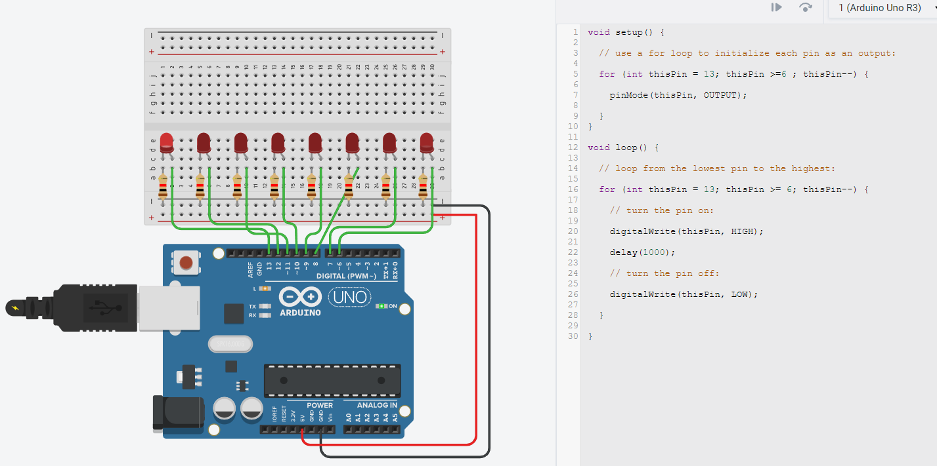

General purpose input output (GPIO) is digital pin of an IC. It can be used as input or output for the devices.

Anode of 8 LED’s connected to the GPIO’s of Arduino. For loop created for all the pins connected in GPIO’s such that the LED’s blinks with a delay of 1000ms(1s).

1. devhack

**Use the values obtained from below to find the flag.**

**a= (ABCD1110) decimal**

**Why don’t you try lighting up the bulb? ;-)**

**b= (EBXACDYZ)decimal**

**Go to the link given below and find a way to use the above values obtained and get the flag.**

Firstly, to light up the bulb, I considered the total output to be 1.

Calculated values of a and b manually. In a, ABCD were found out whose values were 1, 0, 0 and 1 respectively and binary was converted into decimal.

Num a= 158

Similarly, for number b, B, Y and Z values are 1, 1, 0 respectively were found with given values of A, X, C, D, E.

Num b= 206

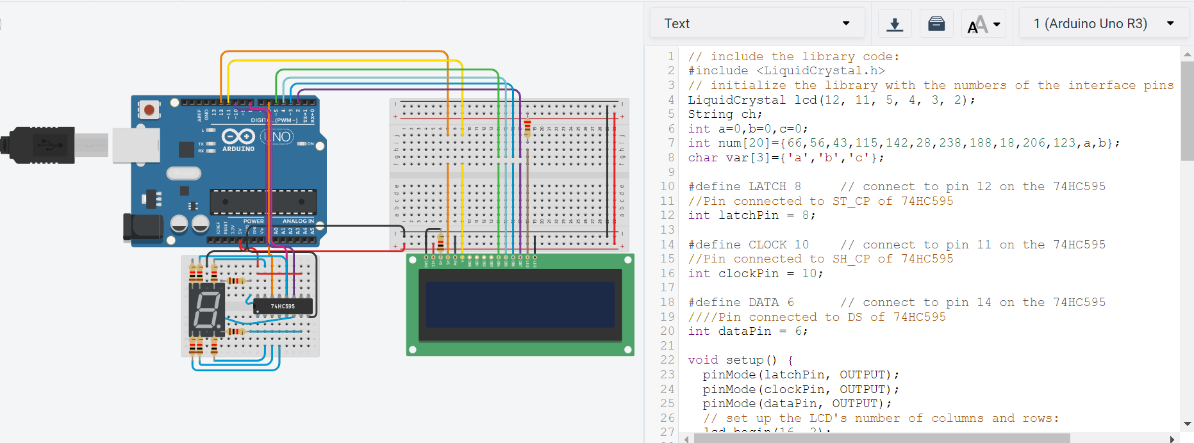

Latch, clock and data are defined and connected respectively. 74HC595 is a shift register which works on Serial IN Parallel OUT protocol. Here the order to shift out the bits is LSBFIRST (Least Significant Bit First).

FLAG= PԀEP

TINKERCAD files link

1. <https://www.tinkercad.com/things/k8H2vco8b8X>
2. https://www.tinkercad.com/things/eGqHoD6TRgy