KAVACH: System Architecture
A predictive NetJEPA and blockchain shield for India's critical networks · Team NetRunners SIH 2026 · SIH26153 · NTRO
1 Purpose, Scope and Quality Goals
KAVACH is an offline, world-model-based intrusion forecasting system. It ingests flow-level and packet-level traffic, learns how network state evolves over time, P(S_{t+1} | S_{t}), forecasts attacker progression K steps ahead, maps behaviour to MITRE ATT&CK stages, explains every prediction, and records every decision on a tamper-evident ledger.
Users: SOC analysts, CISOs and CII operators (NCIIPC sectors). Input: PCAP / flow CSV. Output: risk timeline, stage, forecast, explanation, response plan.
Quality goals (priority order)
- Predictive: forecast attacks before escalation, not just classify them.
- Explainable: no black-box output; every alert carries evidence.
- Sovereign & offline: air-gapped, CPU-only, zero cloud calls.
- Trustworthy: tamper-evident decisions, models and training data.
- Proportionate security: controls scale with network classification.
2 High-Level Architecture: Processing Pipeline and Tiered User Flow
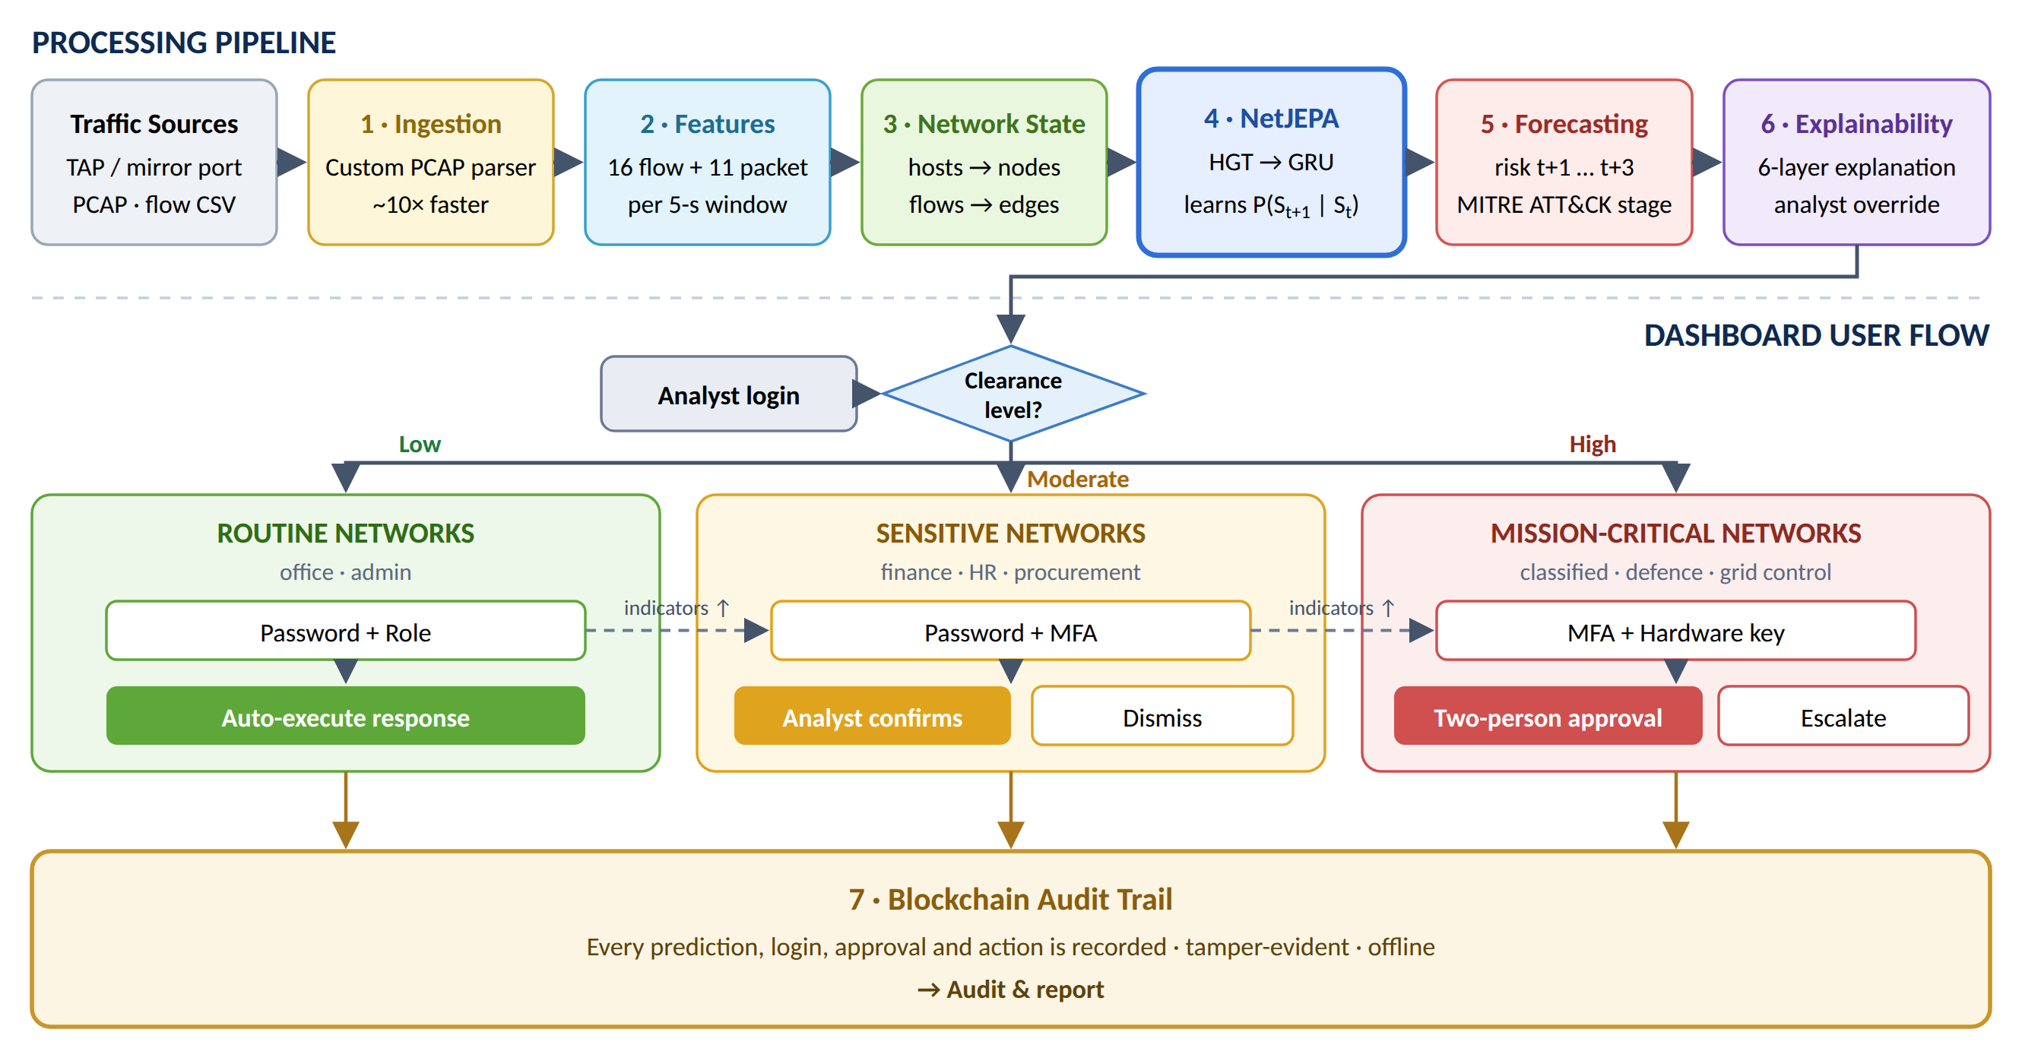
Figure 1. The processing pipeline scores every 5-second window; the dashboard user flow routes each alert by clearance level, and every action is recorded on the ledger.
3 Runtime View
- Parse (ingestion): packets are decoded (IPs, ports, flags, TTL, window, fragments, payload, retransmissions) into 5-s windows; flow statistics use IPFIX-style timeouts so both levels describe the same slice.
- Represent: each window becomes a heterogeneous graph with a 29-value state vector; the previous two windows are held as context.
- Encode & predict: NetJEPA produces z_{t} and a Gaussian over z_{t+1}; 64 Monte-Carlo samples are rolled 3 steps ahead.
- Score: outputs calibrated risk, ATT&CK stage and forecast band for now and each future step.
- Explain & respond: explains the actual decision path and generates a prioritised response plan.
- Route by clearance: sends each alert to its zone's dashboard, where the tier sets the next action.
- Record & stream: the result is chained to the ledger by risk tier, stored, and streamed live to the dashboard over WebSocket. The analyst's verdict is chained as well.

4 NetJEPA World Model: Training and Inference
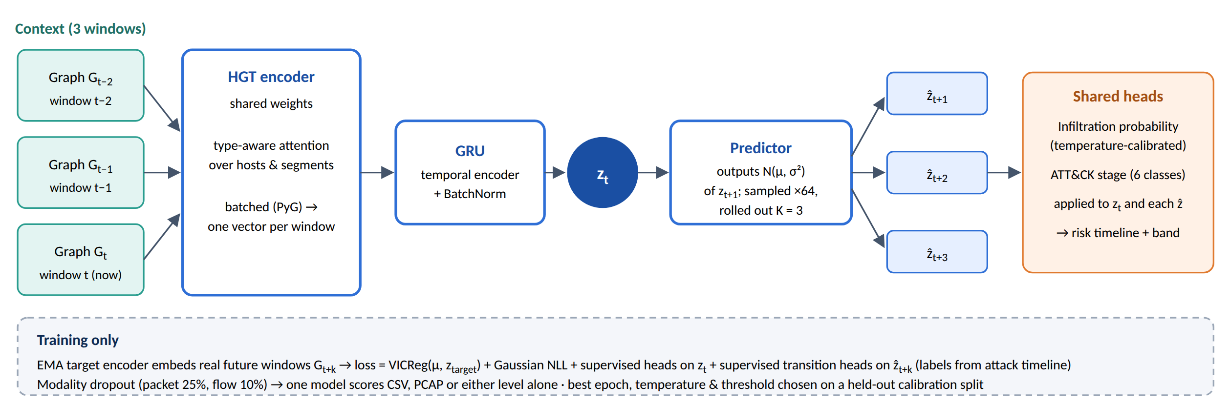
Figure 2. NetJEPA learns P(S_{t+1} | S_{t}) in latent space and forecasts by rolling its own predictions forward.
5 Key Architecture Decisions
Decision | Choice | Rationale
State | Graph per 5-s window | Keeps host-to-host structure
Dynamics | JEPA latent prediction (HGT + GRU) | Learns P(S_{t+1}|S_{t}) on CPU
Uncertainty | Gaussian predictor + Monte-Carlo | Reliable confidence bands
Training | VICReg + NLL + supervised transitions | Forecasts as accurate as detection
Access | One node per classification tier | Security scales with sensitivity
Trust | Hash-chain ledger + Merkle batching | Air-gap native, multi-site ready
Deployment | Passive TAP, CPU-only, on-prem | No traffic-path risk, no GPU or cloud
6 Cross-Cutting Concerns
- Security: no outbound calls; header and statistics only (no payload); raw traffic never leaves the node.
- Integrity: every prediction, model load (weights hashed), training manifest and analyst action is hash-chained; any edit or deletion is detected on verification.
- Model safety: incompatible checkpoints are refused; training data is verified against its chained manifest; a model is auto-rolled back if its FPR on reviewed alerts exceeds 2× its predecessor's.
- Feedback poisoning: analyst verdicts are audited for suspicious volume, pattern and timing before retraining.
- Compliance: NCIIPC CII mandate (IT Act s.70A), CERT-In 6-hour reporting (explainable, timestamped records), DPDP Act 2023 data minimisation.
- Reproducibility: fixed seeds, config saved per checkpoint, 104 automated tests, one-command benchmark suite.
7 Technology Stack
Layer | Technology | Why
AI model | NetJEPA (PyTorch) | Forecasts attacks, not just classifies them; runs on CPU
Graph learning | PyTorch Geometric (HGT) | Models how hosts connect
Ingestion | Custom PCAP parser | ~10× faster than Scapy
Explainability | IG, SAE, tuned lens, probes | Explains the model's actual reasoning
Ledger | Hash chain + Merkle, smart contracts | Tamper-evident, fully offline
Backend / UI | FastAPI, React + TypeScript, CLI | Live dashboard, no external calls
Storage | SQLite (WAL) | Serverless, suited to air-gapped nodes
8 Validation Summary and Known Limitations
0.86 vs 0.49  F1 vs logistic-regression baseline | 6.3% vs 29%  false-positive rate | 0.96–0.97  forecast AUC, 1–3 windows ahead | 0.87 vs 0.62  F1, flow+packet vs flow only
Held-out, time-split validation on 8,043 windows of CIC-IDS-2017 (flows + raw PCAP). Limitations: leave-one-family-out tests show strong transfer to related families (unseen DDoS AUC 0.98) but weaker detection of dissimilar ones (PortScan AUC 0.58). Small feature perturbations can flip some detections. Lateral movement and exfiltration are rare in public data. Mitigations: rule and per-host baseline ensemble, adversarial training, and cross-dataset training on CSE-CIC-IDS-2018, CTU-13 and site traffic.

