A color-coded map of the world’s most and least emotional countries

[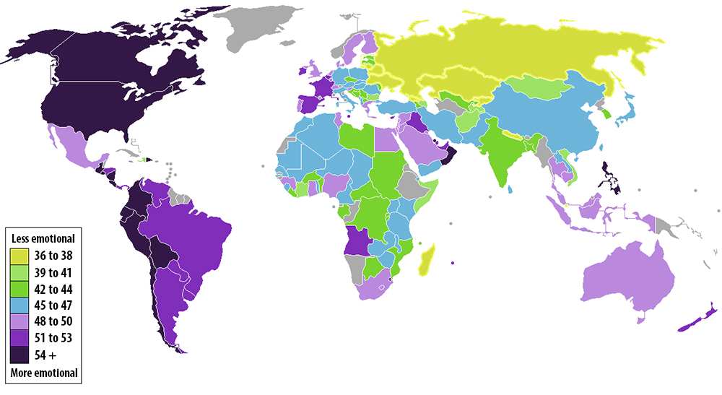](http://www.washingtonpost.com/blogs/worldviews/files/2012/11/emotional-map2.jpg)

A map of the world's countries by most and least emotional.