Create a simple script file and push it to repo. Create a project in Jenkins connected to your GitHub repository. When a commit is made to your repo, automatically build must get triggered from Jenkins and the output must be shared to me via email.

Note: As part of task1 – Jenkins connection snapshots are placed. Continuing this task from there on.
- Creating a Script file
mkdir GuviJenkins
cd guvijenkins
vim script.sh
#!/bin/bash
echo "Build triggered successfully!"
date
uname -a
chmod +x script.sh

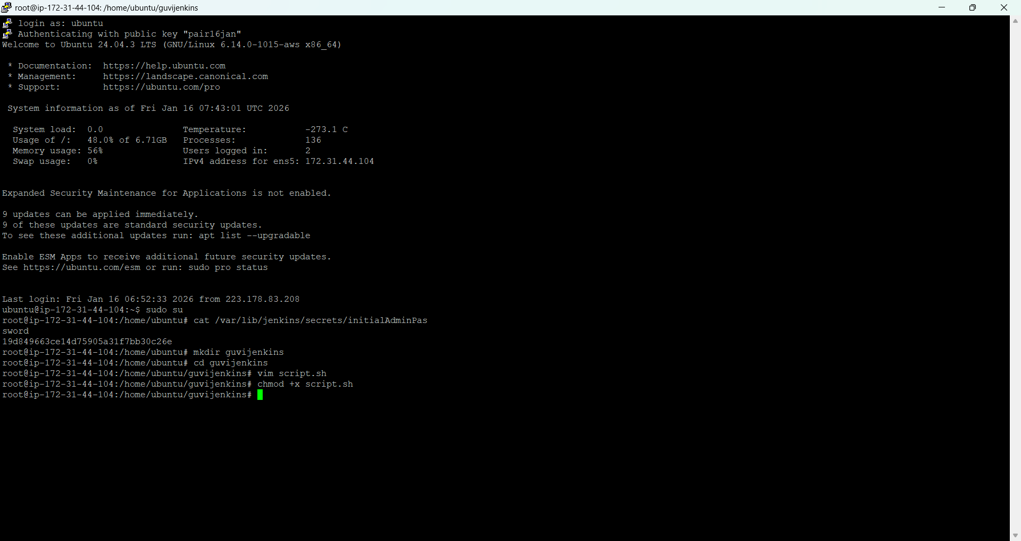

- Push it to githubrepository

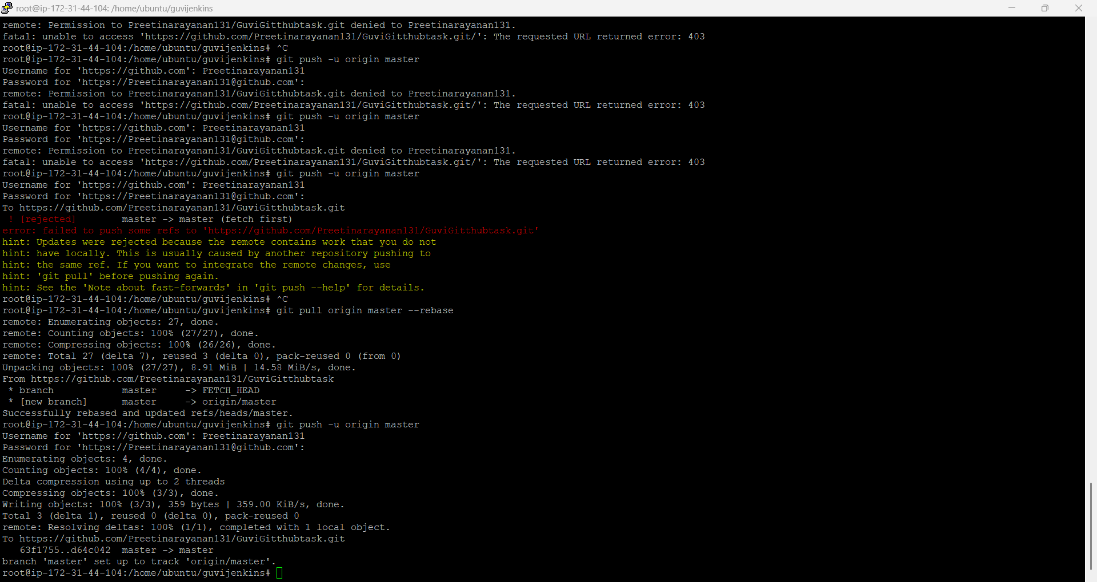

Create a freestyle project in Jenkins
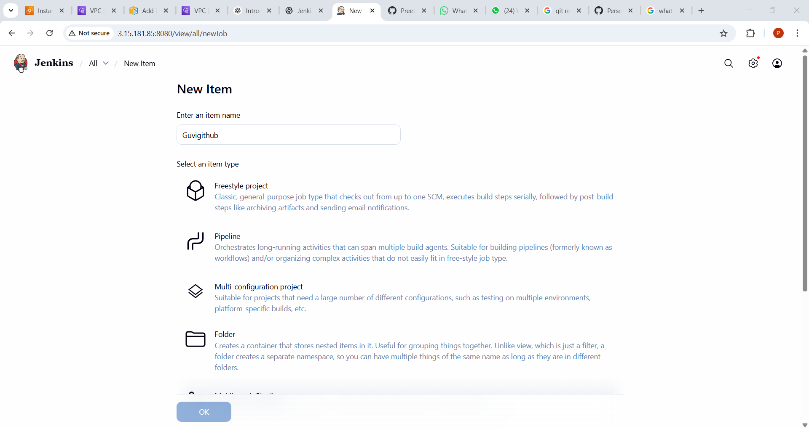

Connect Jenkins to GitHub

Create Github credentials as secret text

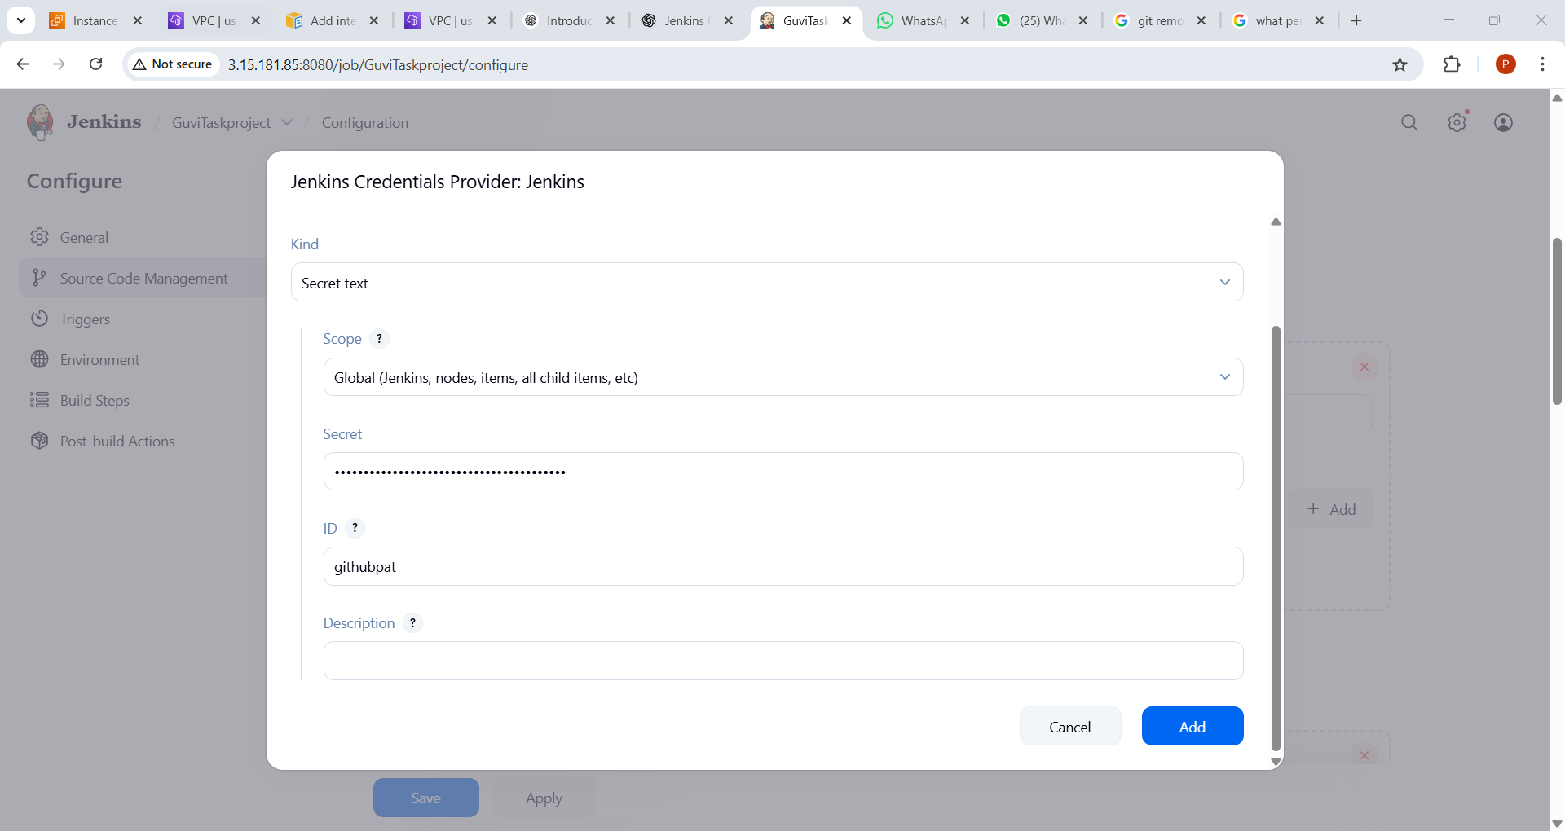

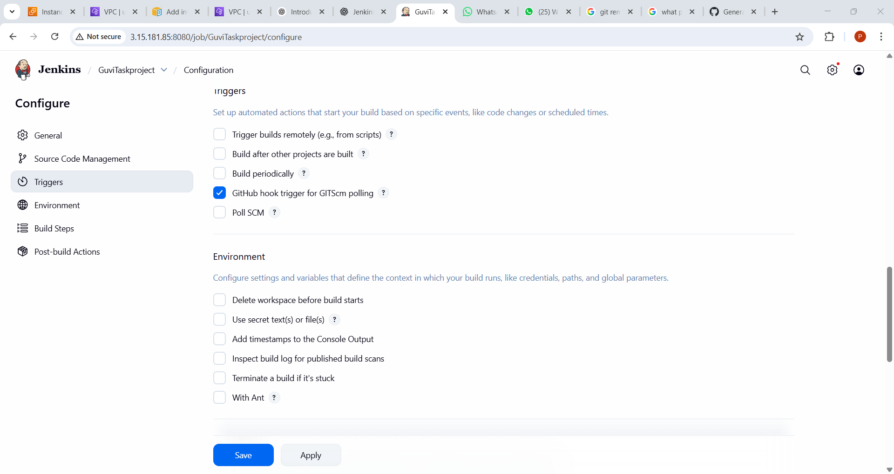

Configure webhook

Go to your GitHub repository → Settings → Webhooks → Add webhook.
Payload URL: http://<JENKINS_SERVER_URL>/github-webhook/
• Content type: application/json
• Trigger: Just the push event
• Save webhook.

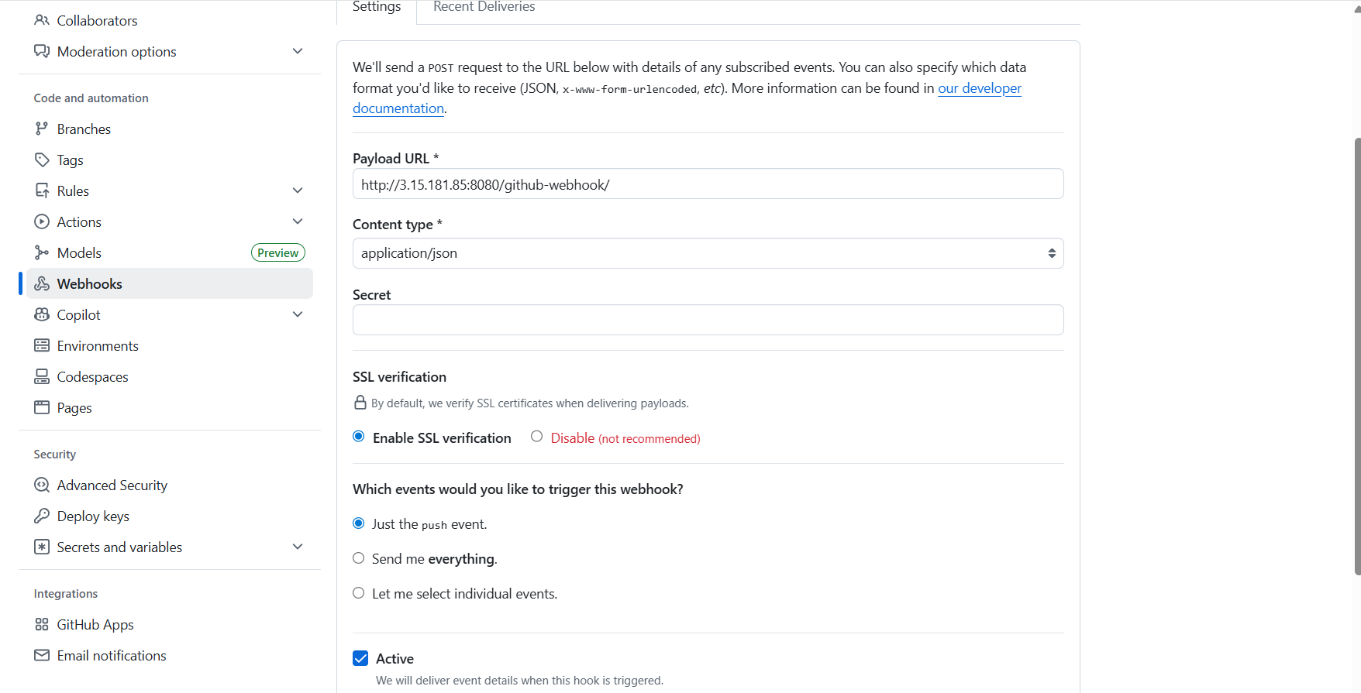

Configuring mail

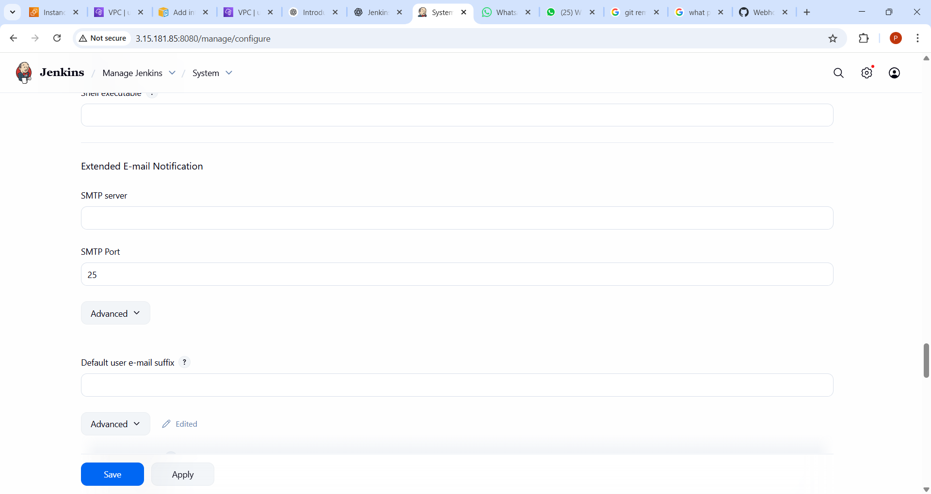

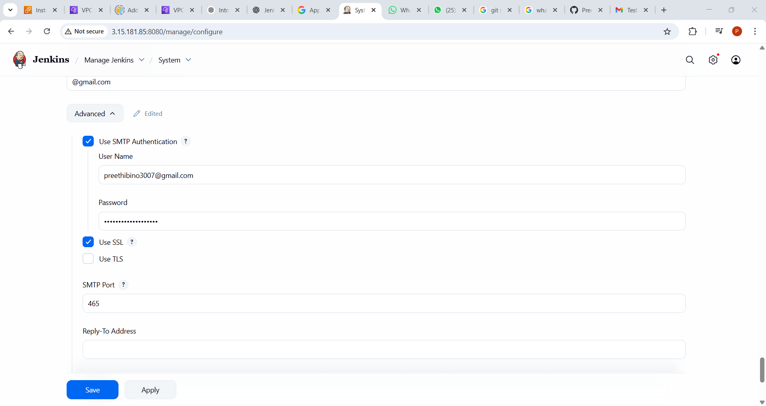

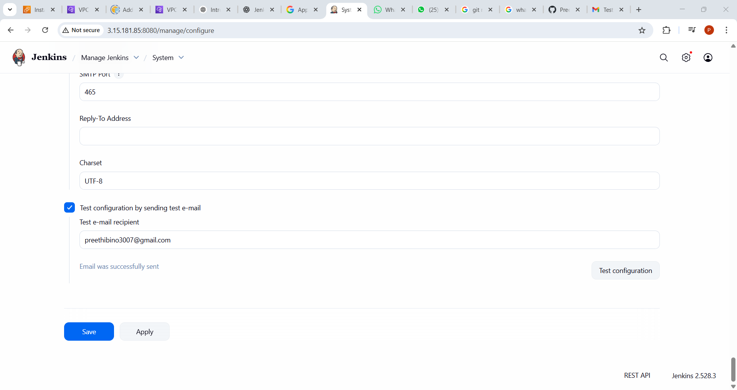

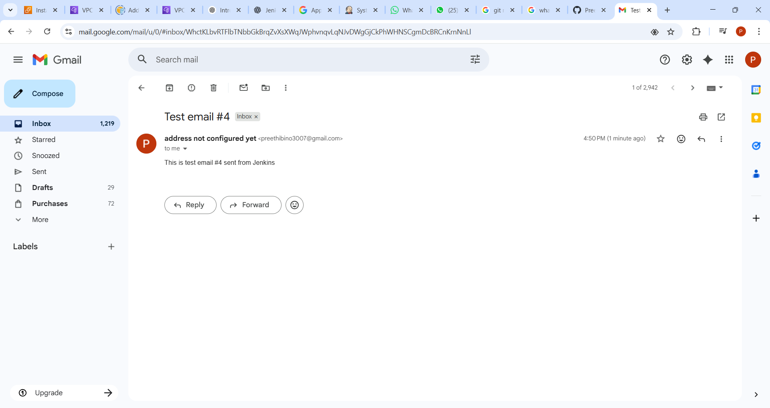

Post build actions
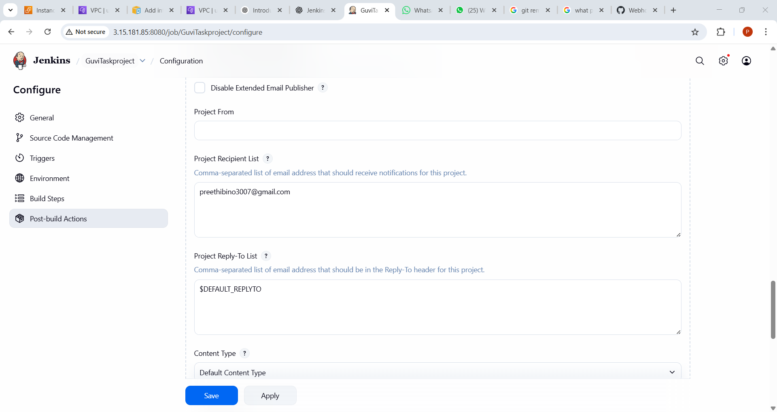

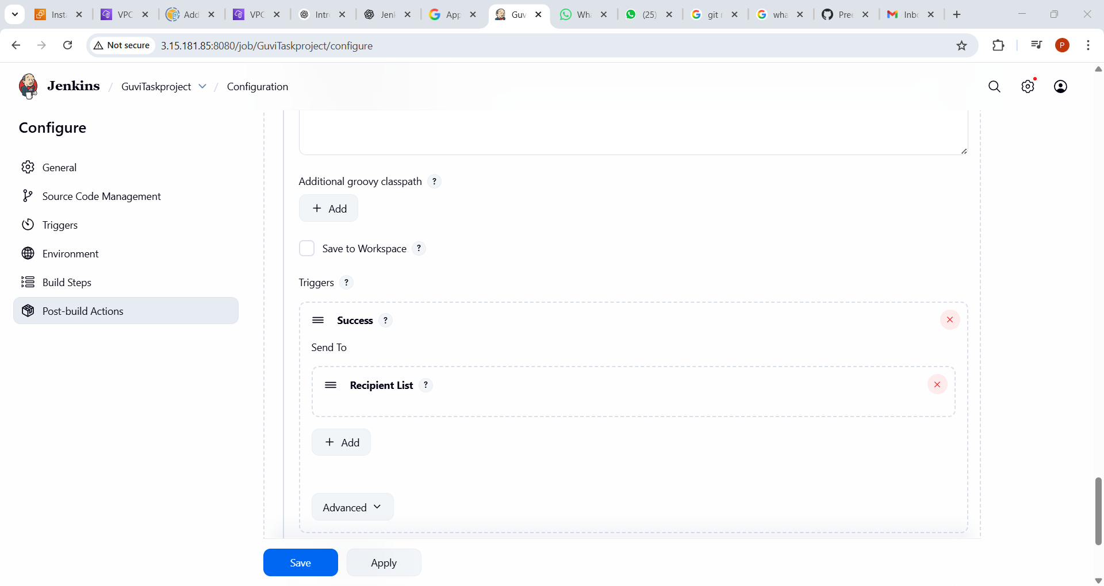

Run script.sh

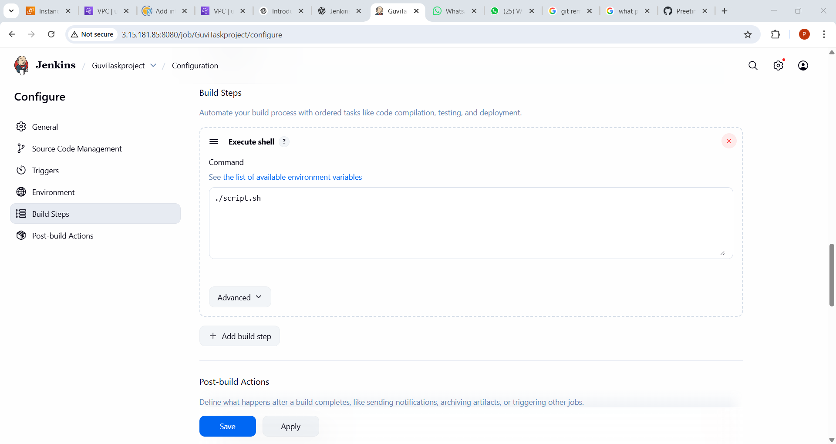

Trigger Build Manually and check console

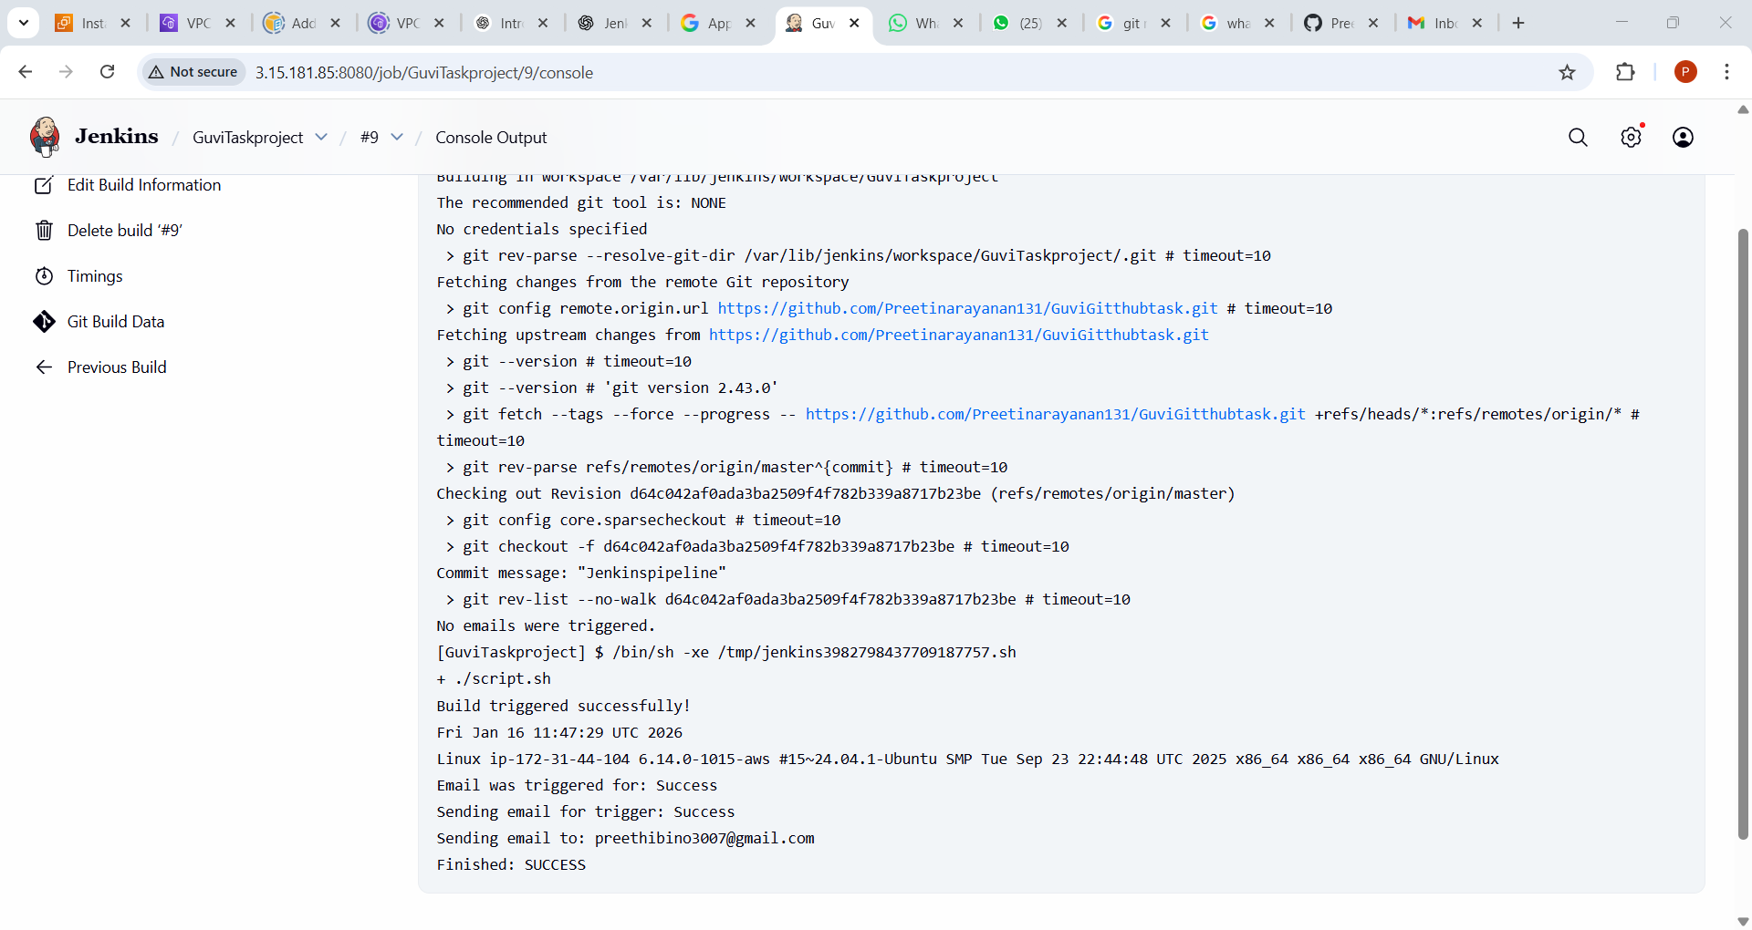

Mail after build success
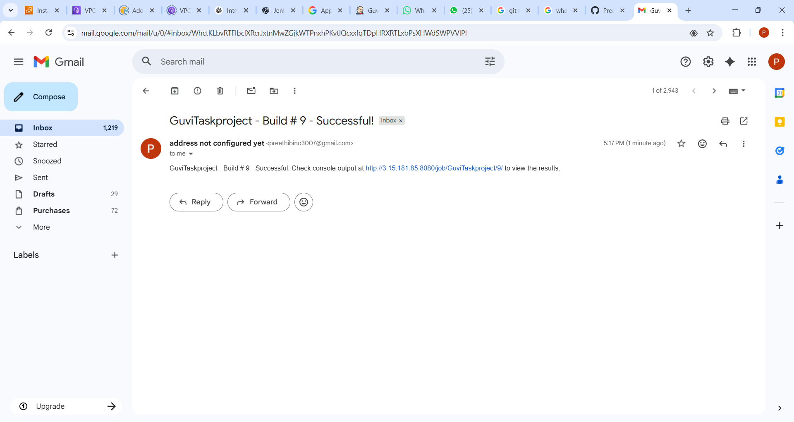

Edit the script.sh
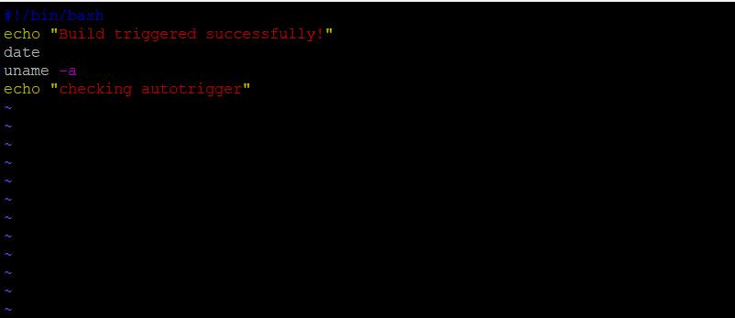

Webhook delivered
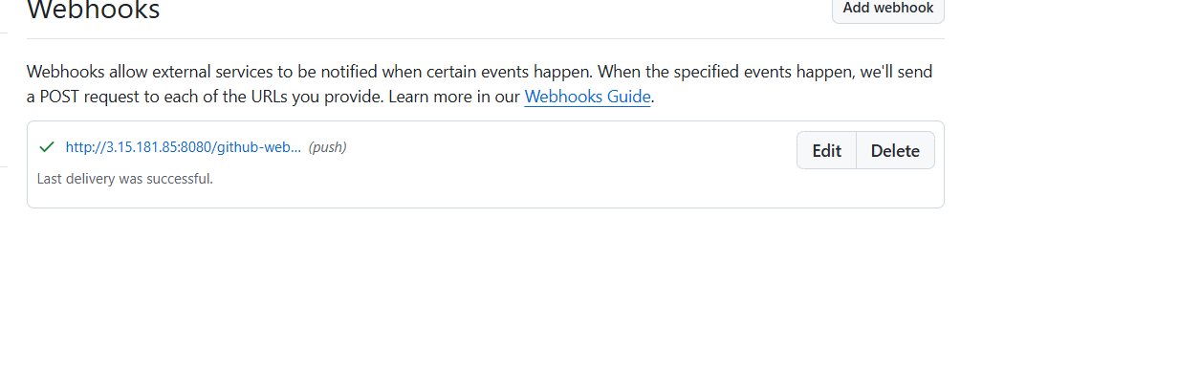
Task got triggered

