Install docker on EC2 and explore the docker commands (docker images, containers, volumes, network)

Launch EC2- ubuntu instance
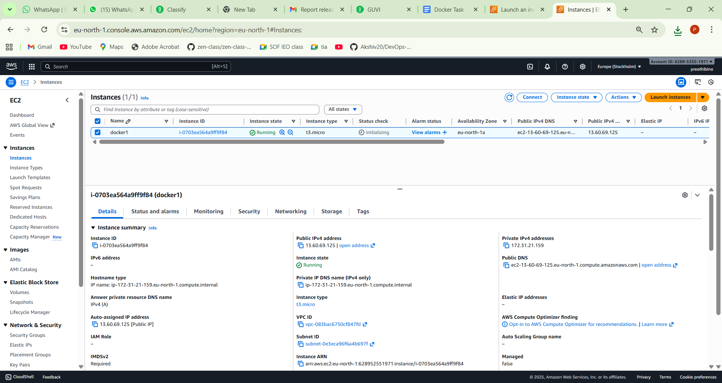

Default username is Ubuntu – apt-get update
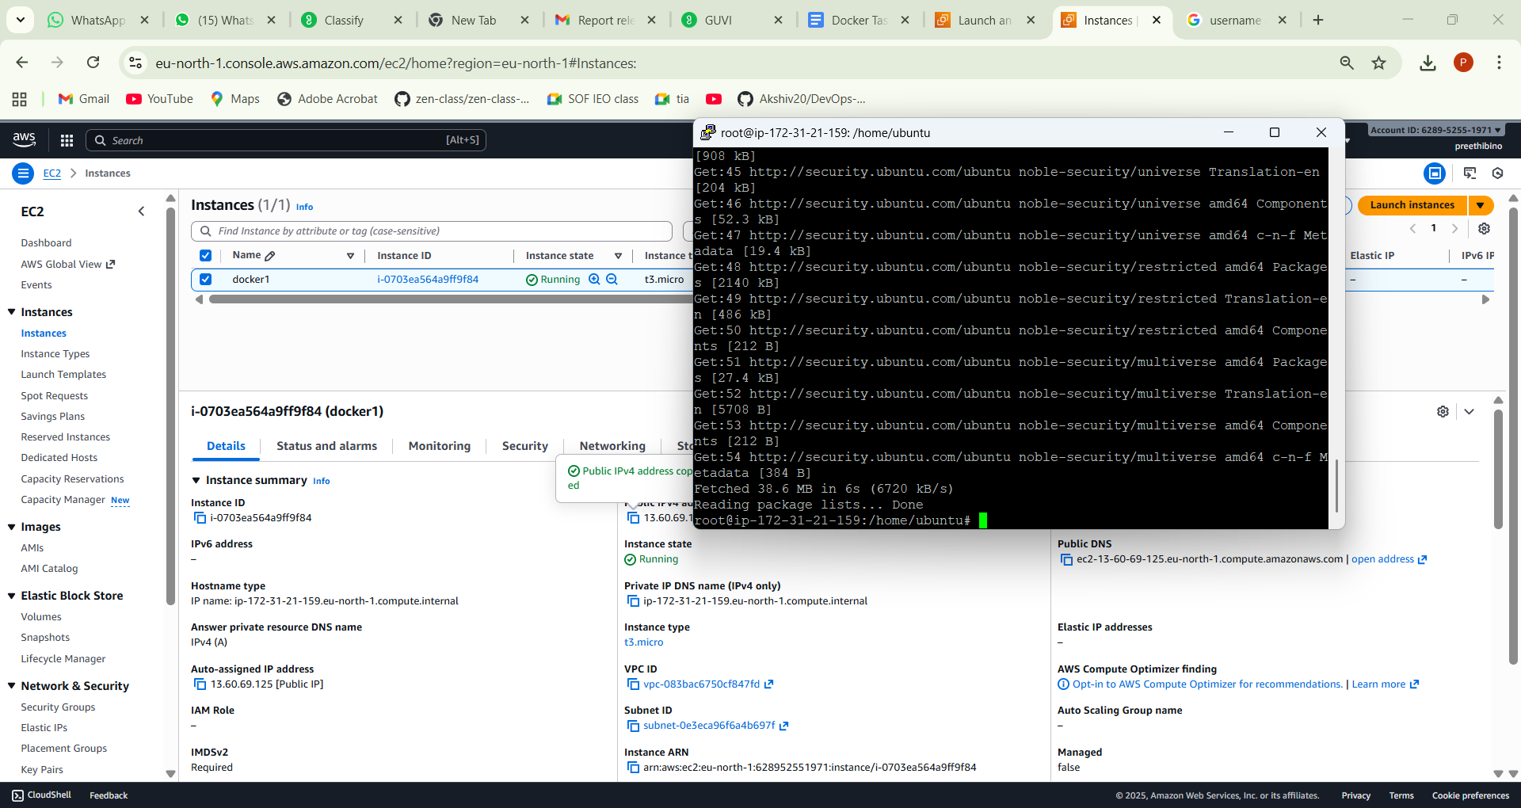
Install docker apt-get install docker.io -y
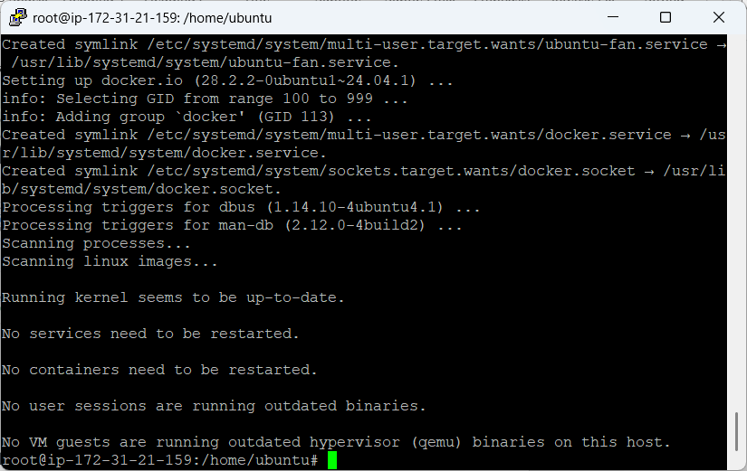

To confirm installation docker version command is used
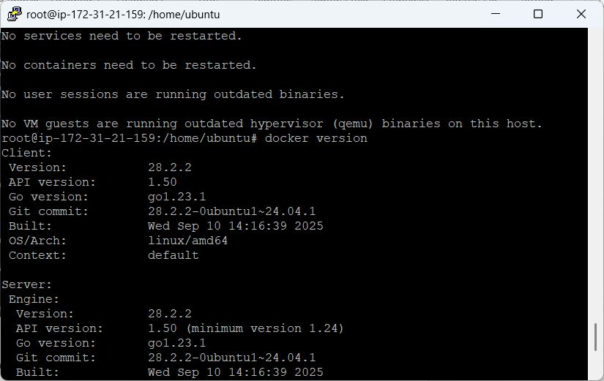
Public docker image is taken using docker pull httpd
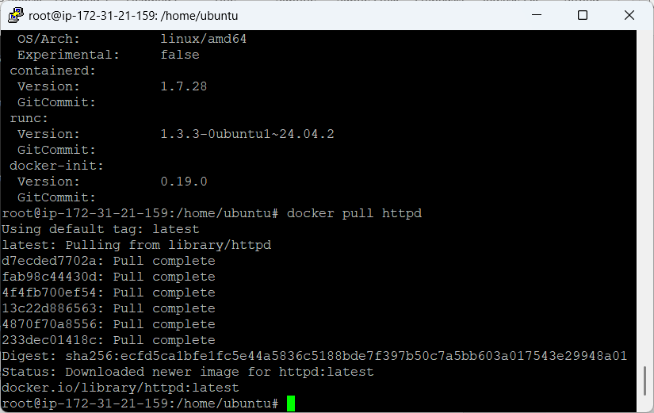

docker images, containers, volumes, network)
run docker images to view the images
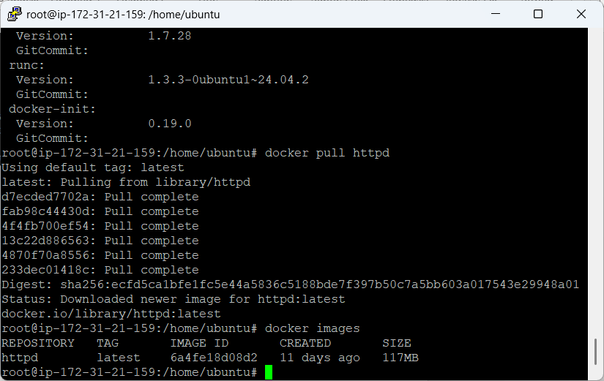

Containers – to Install container, use following command - docker run -itd --name apachecontainer -p "8090:80" httpd
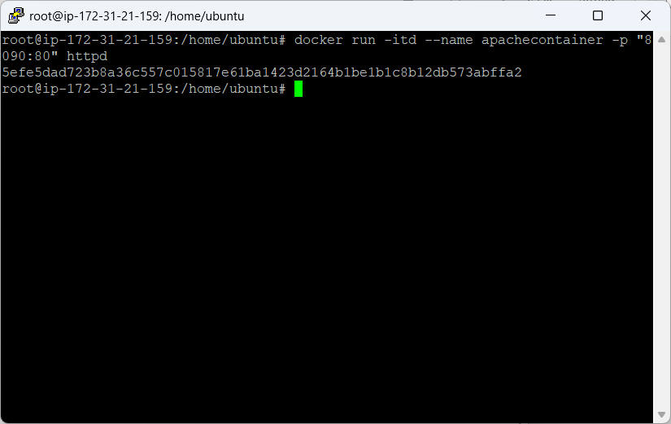

Docker ps will be used to view the list of containers
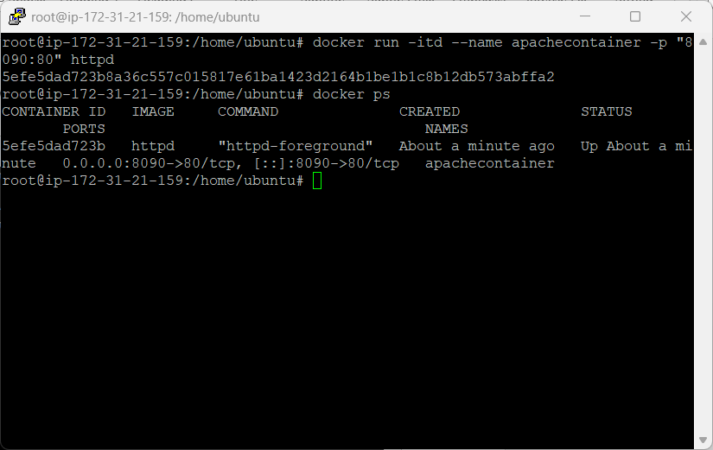
Start and stop a container using
docker start 5efe5dad723b , docker stop 5efe5dad723b Remove containers using docker rm 5efe5dad723b
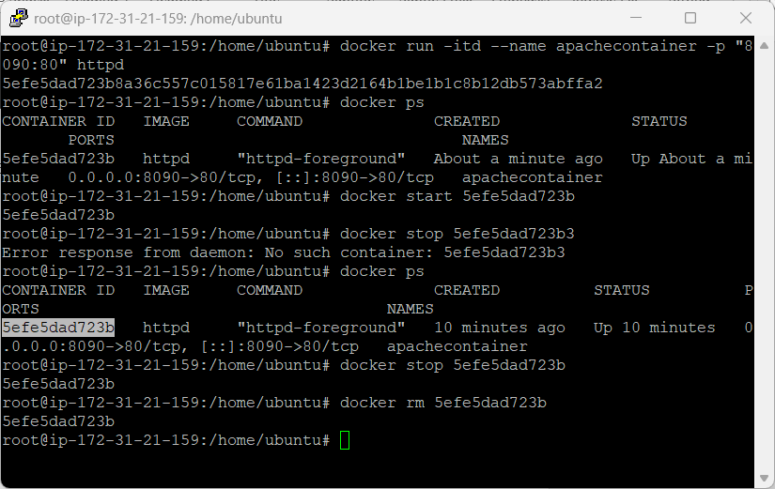

To work inside docker below command is used docker exec -it 5df2effaa683 /bin/bash
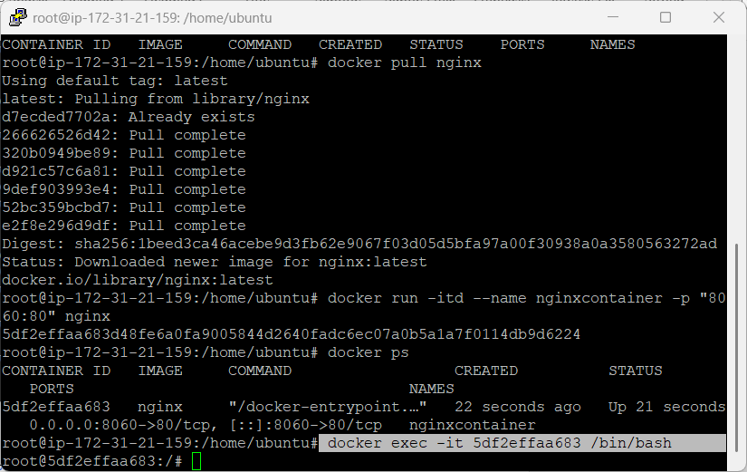
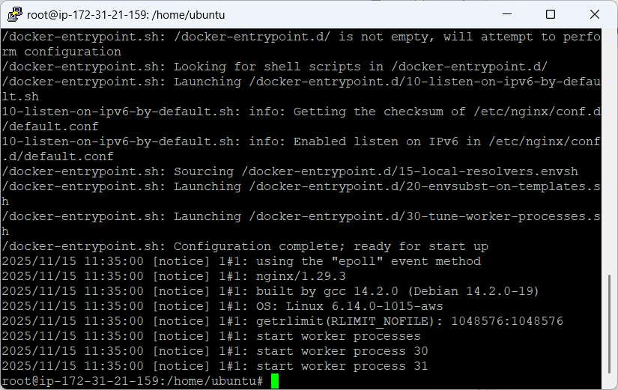

Volume- create a volume docker volume create preethiguvi , to see the path -docker inspect preethiguvi
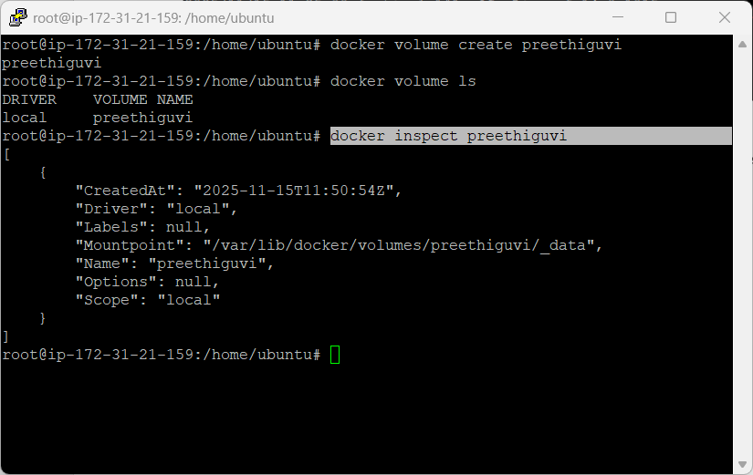
Move inside the path
/var/lib/docker/volumes/preethiguvi/_data and to launch container into the path
docker run -d -it --name=preethiguvi --mount source=preethiguvi,destination=/usr/local/apache2/htdocs httpd:2.4)
[/usr/local/apache2/htdocs=This will act like a backup path; httpd=launching Apache from hub]
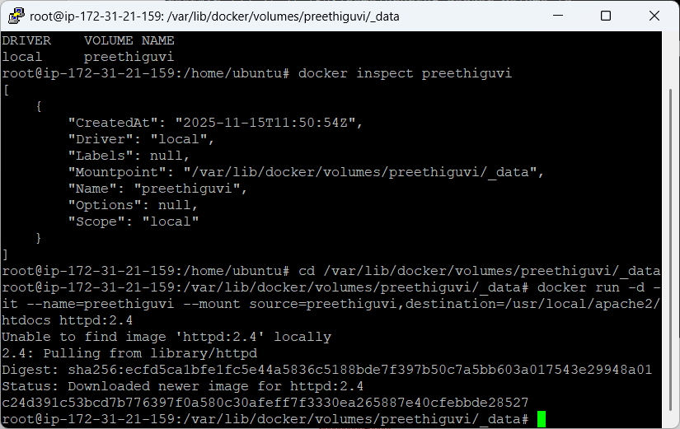
create an empty file (p1.txt) Open the container (docker ps). Now, execute the container with all the changes (docker exec -it c24d391c53bc /bin/bash) Move inside the path (cd htdocs) Now, list the folder (ls -ltr)

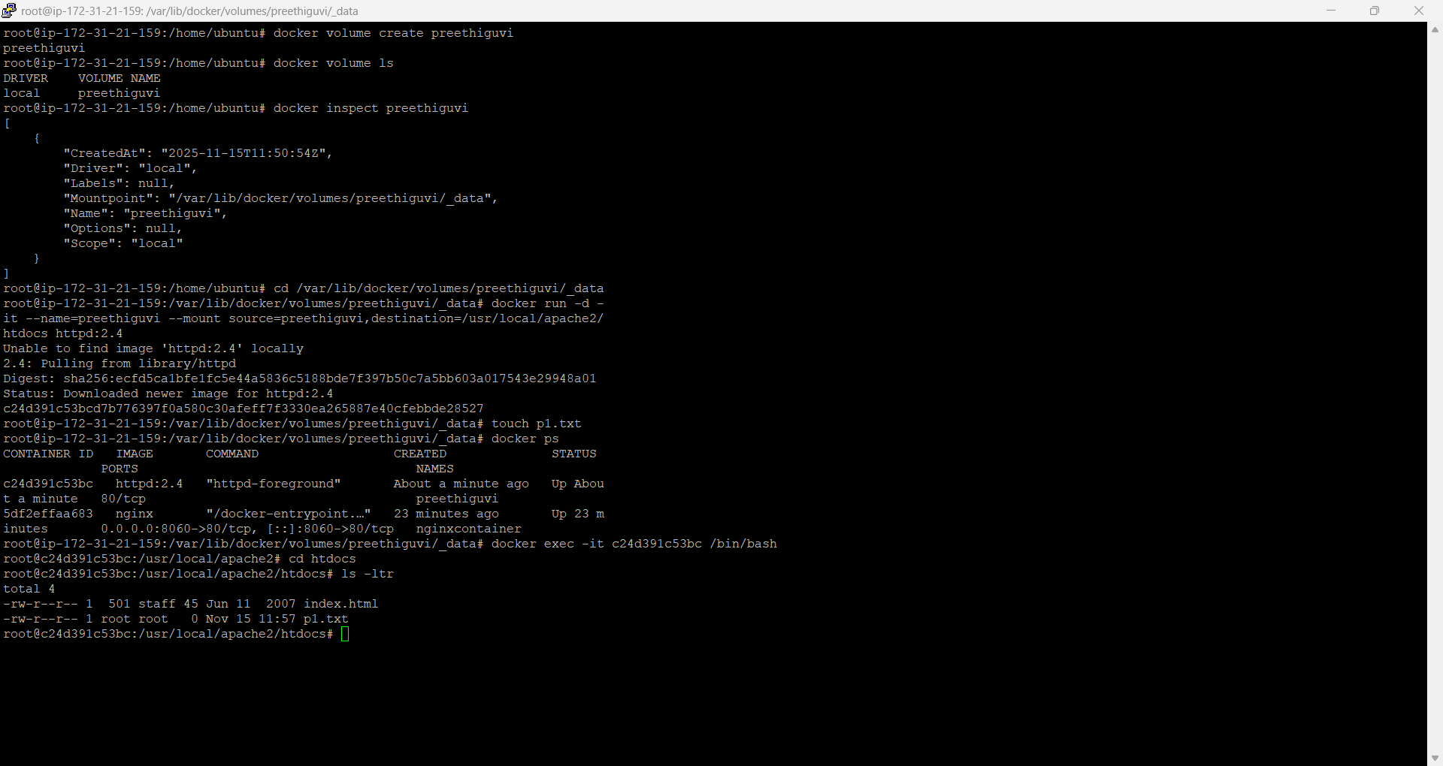
create an empty file inside the container (touch t2.txt) Now, exit from the container (exit)List inside the local directory (ls -ltr)
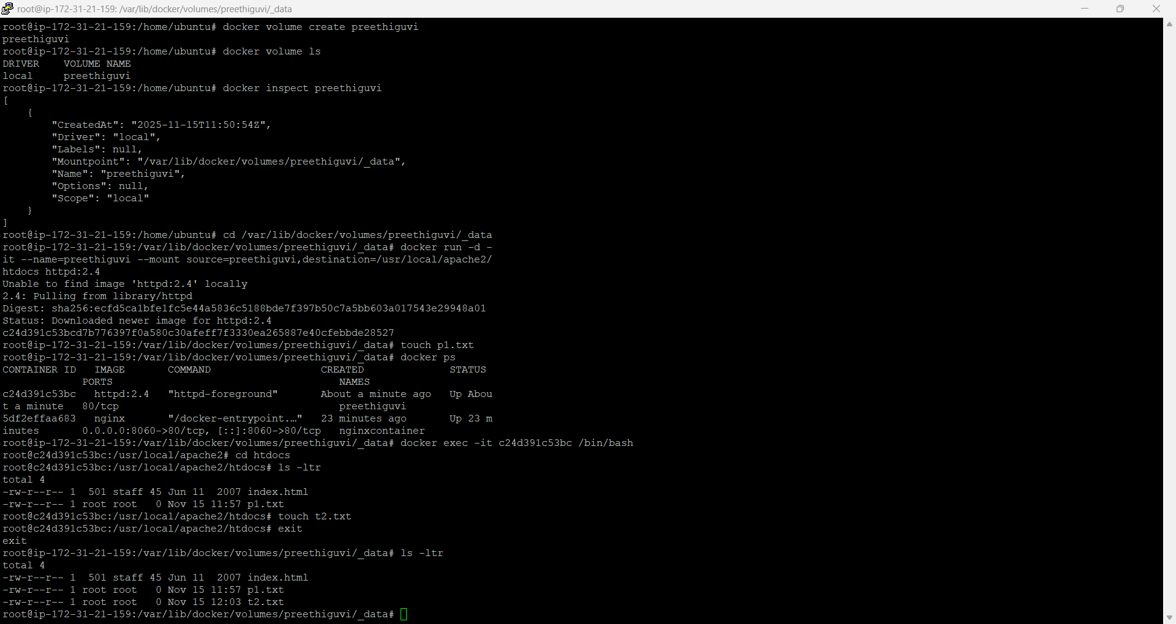
Docker – Network
Docker network ls – lists the network available, create a network docker network create --driver bridge preethinet
docker network ls will list the network created. To run docker in our own network command docker run -it -d --name contain1 --network preethinet alpine
