Create IAM User for EKSCTL

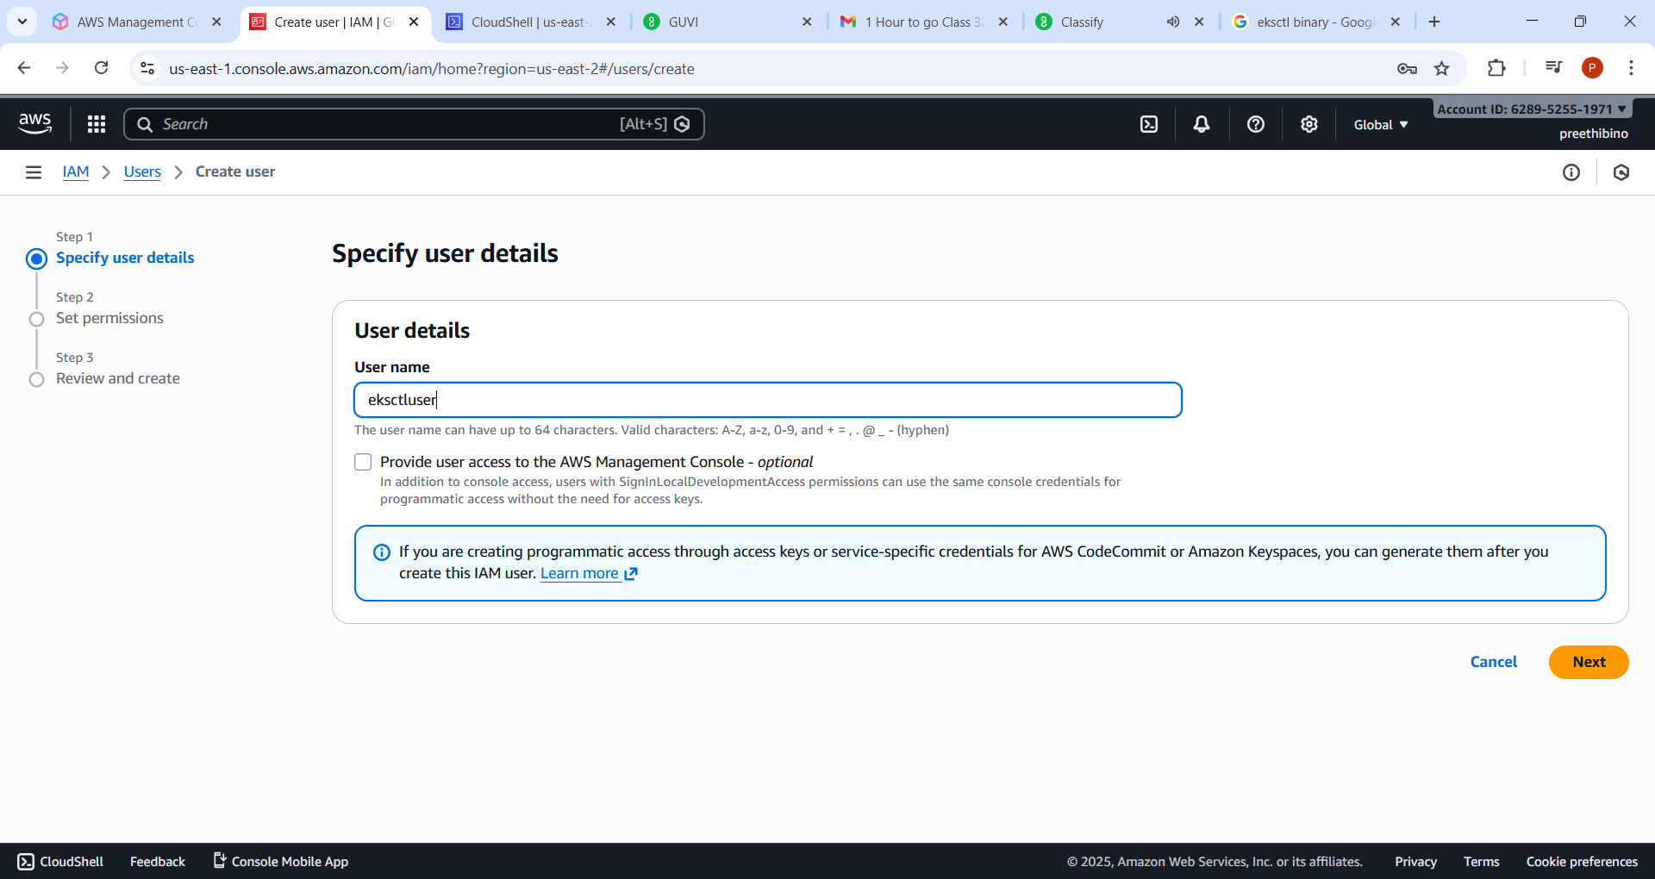

Attach IAM full access,EC2 full access,vpcfull access,cloudformation,eks
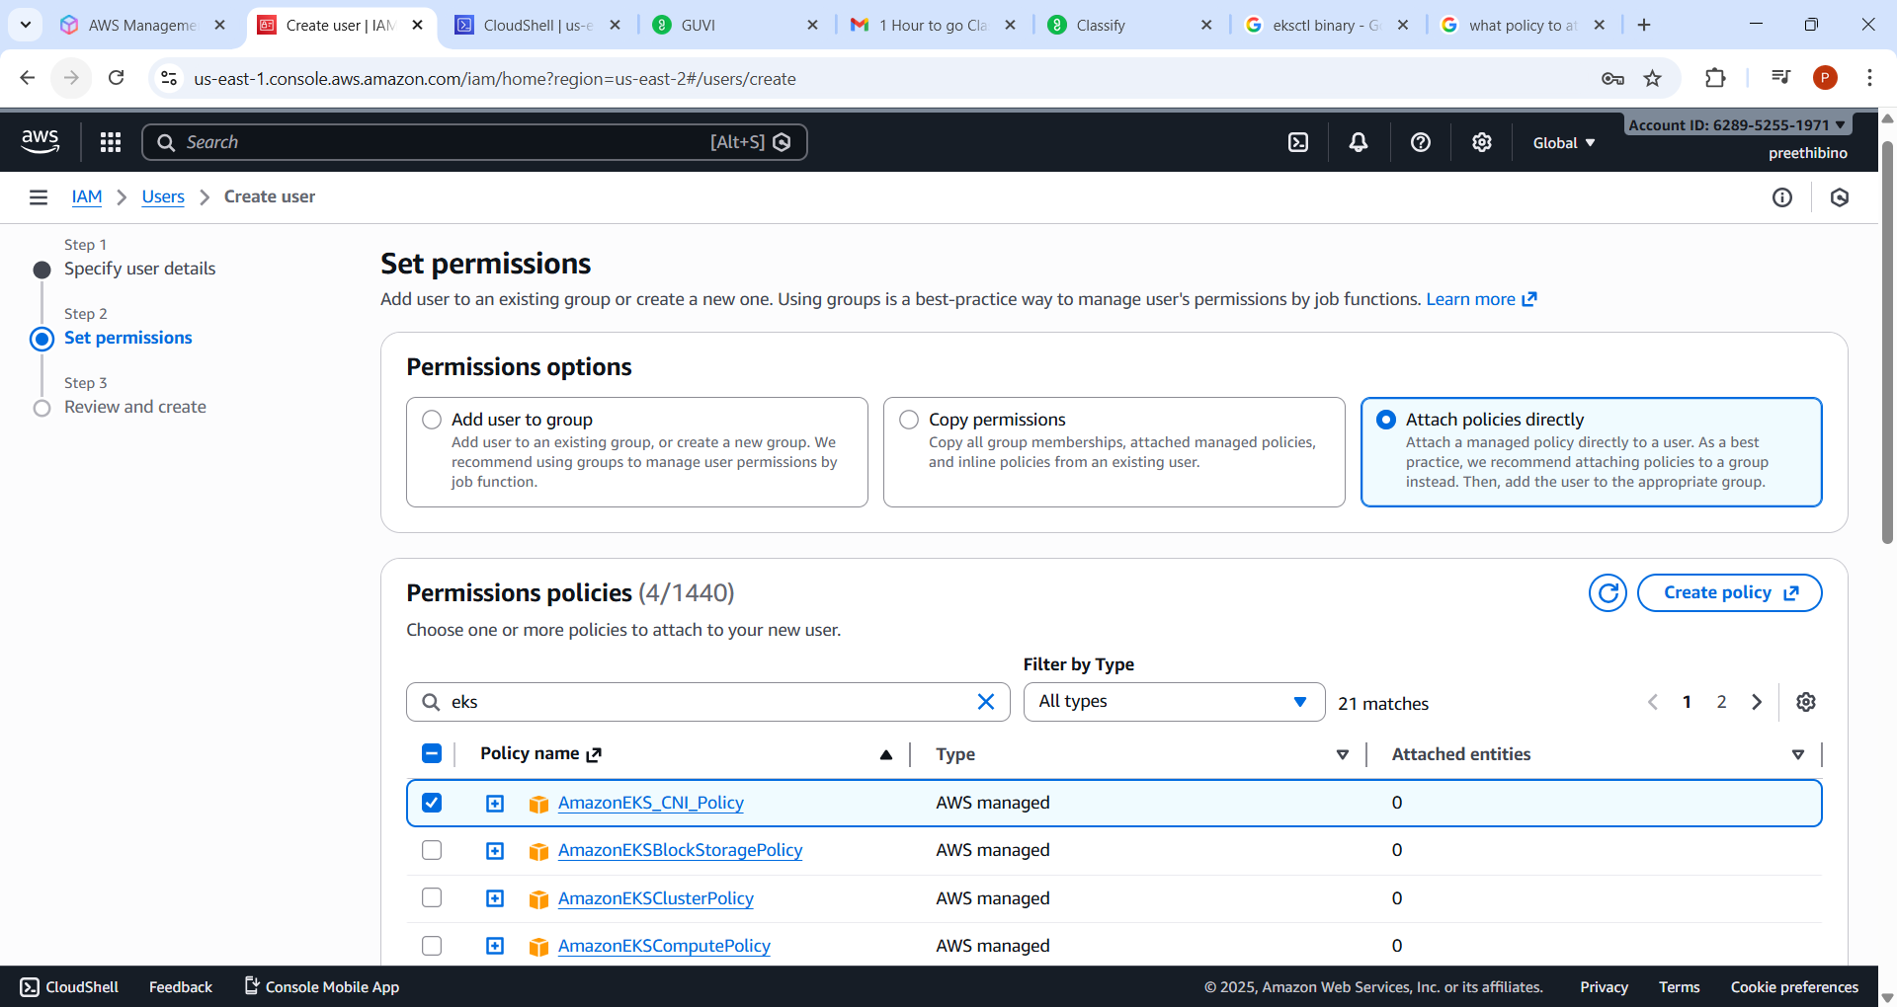

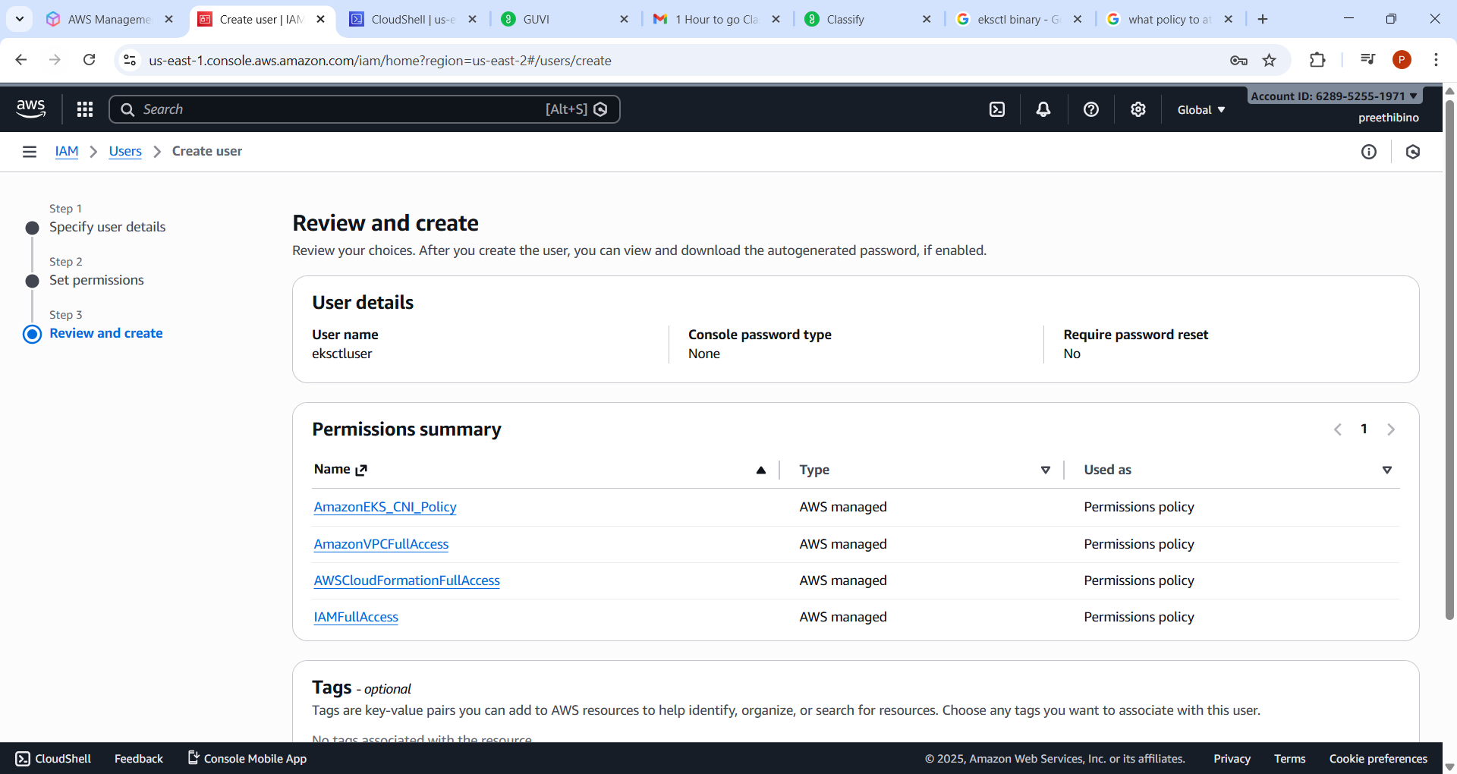

create access key for CLI alone
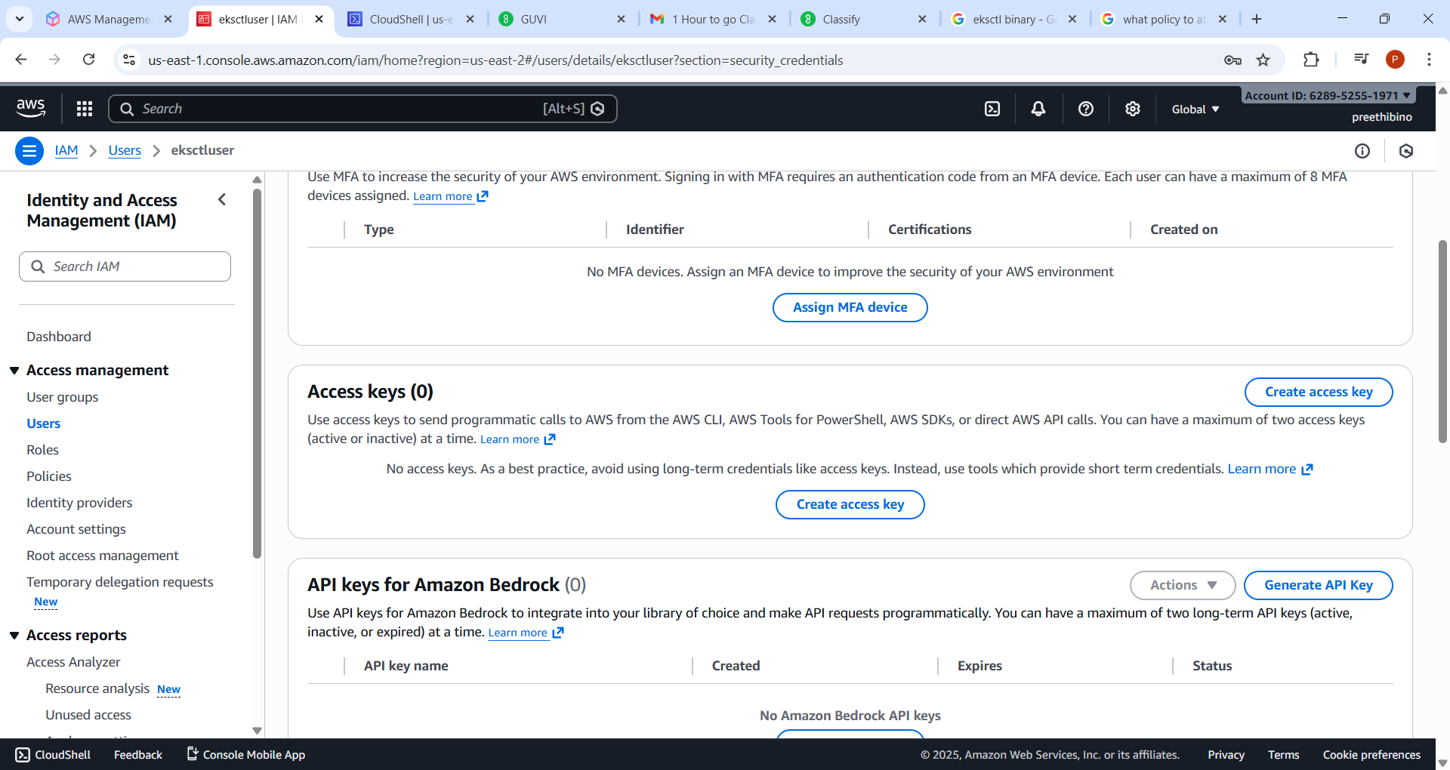
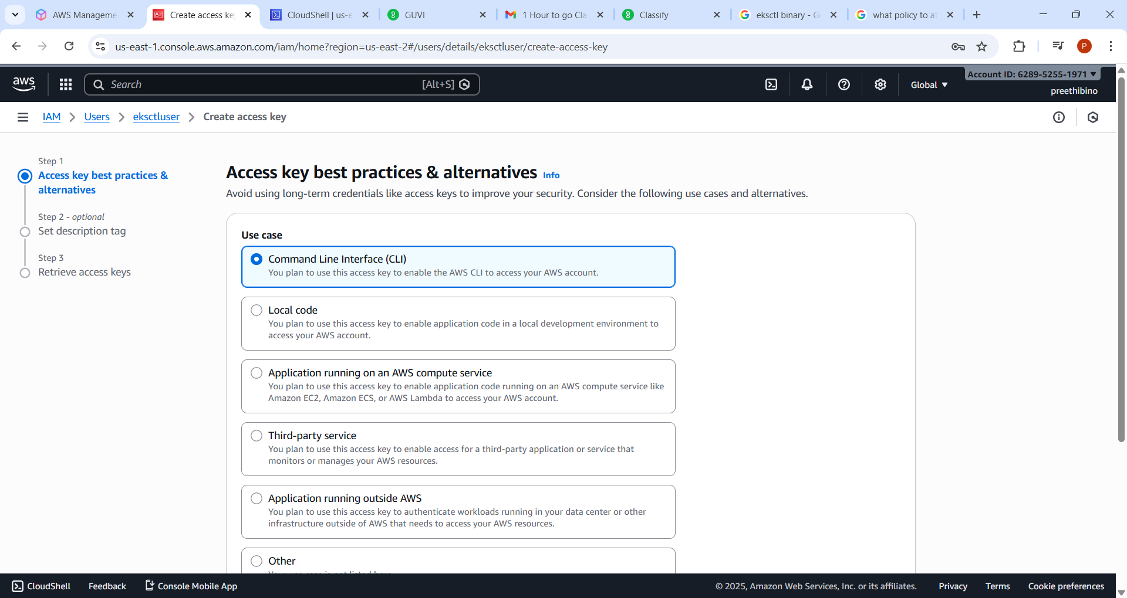

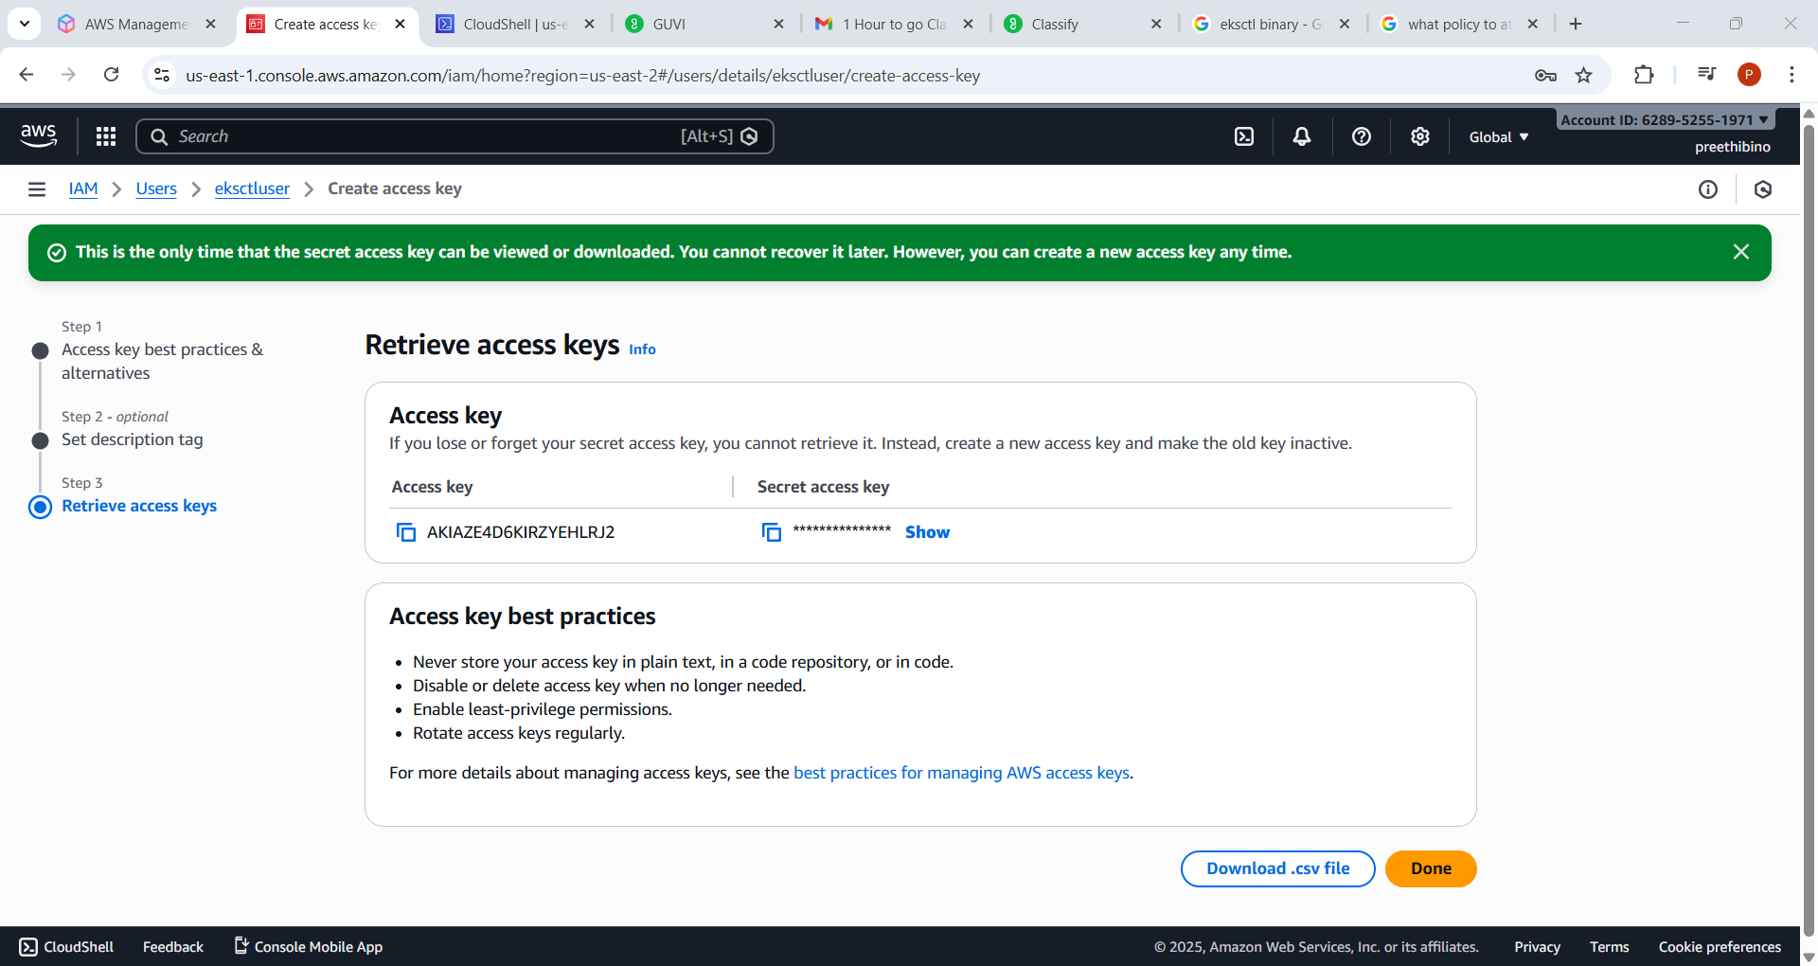

Login to cloud shell as this IAM user
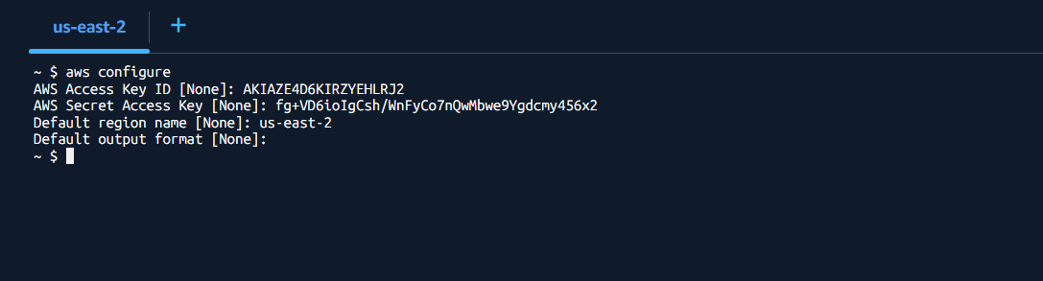
Curl command to create EKS cluster
curl --silent --location "https://github.com/eksctl-io/eksctl/releases/latest/download/eksctl_$(uname -s)_amd64.tar.gz" -o eksctl.tar.gz
ll
tar -xzf eksctl.tar.gz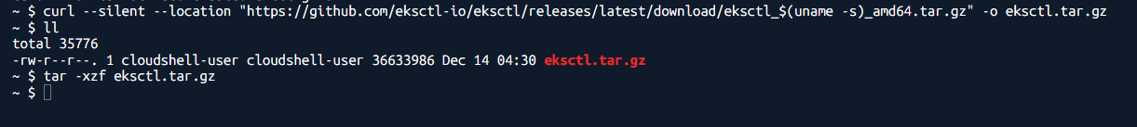

Move it to the executable path
sudo mv eksctl /usr/local/bin

Create a cluster with command
eksctl create cluster \
--name demo-cluster \
--region eu-north-1 \
--nodegroup-name demo-nodes \
--node-type t3.medium \
--nodes 2

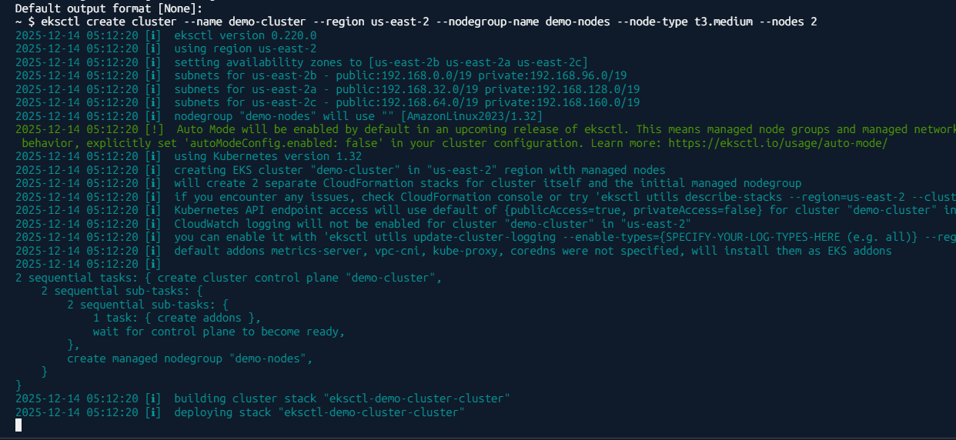

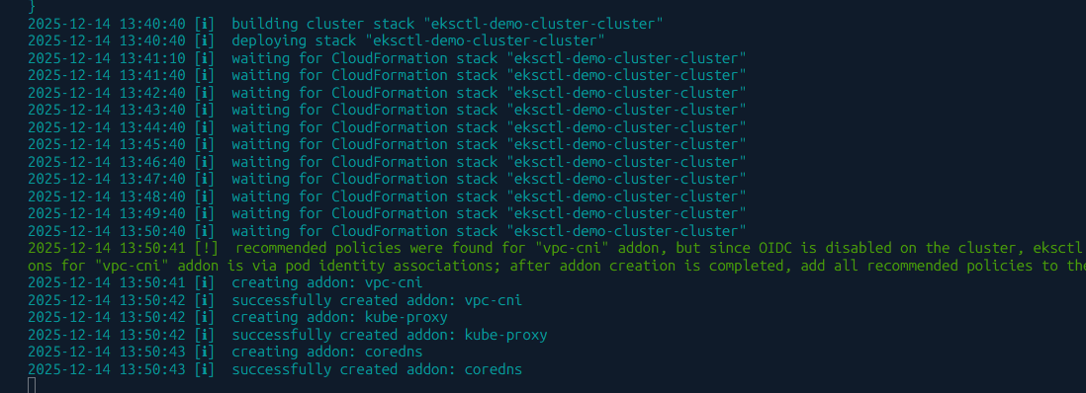

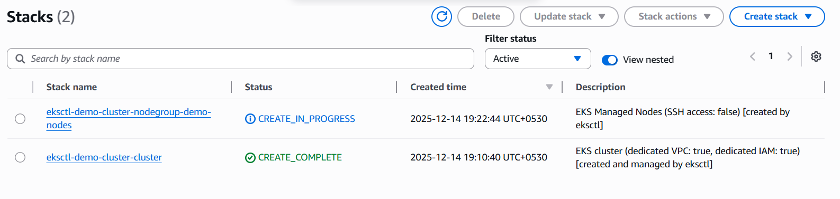

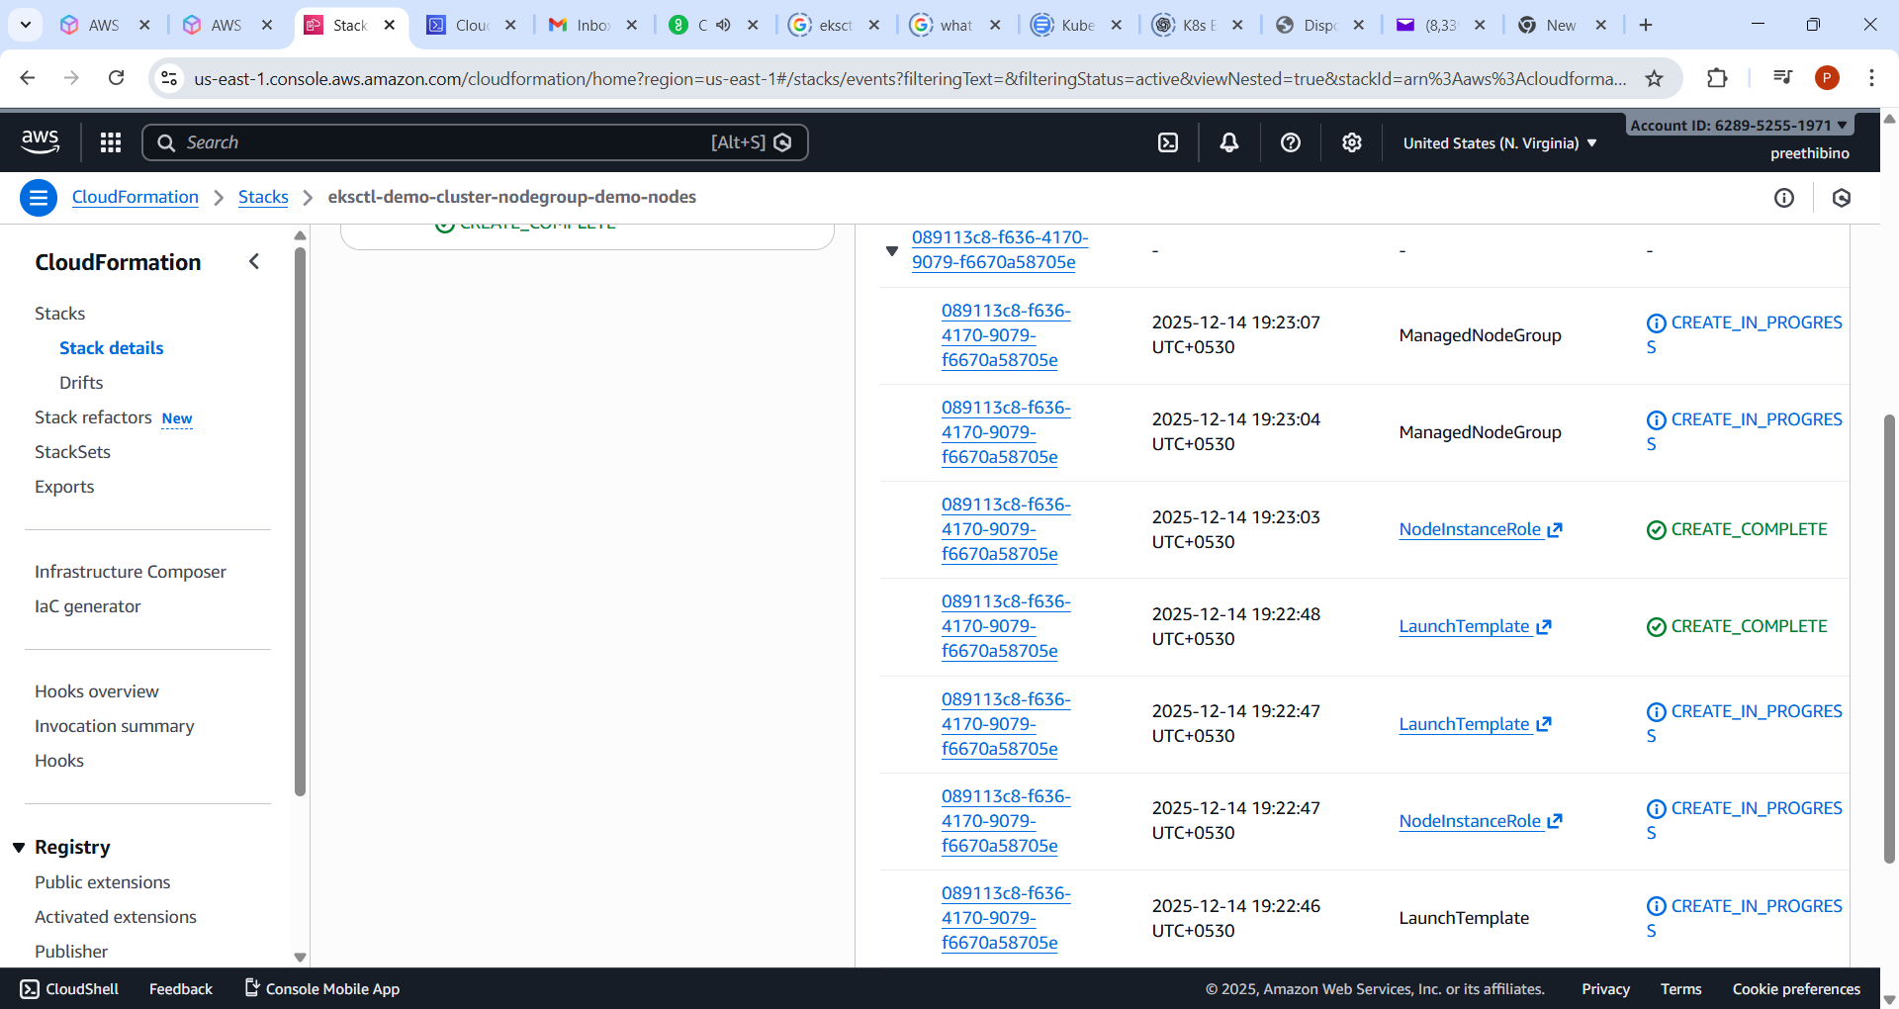
T3.medium couldn’t be created, due to free tier issue. Created
eksctl create cluster \
--name demo-cluster \
--region us-east-1 \
--nodegroup-name demo-nodes \
--node-type t3.small \
--nodes 1 \
--nodes-min 1 \
--nodes-max 2 \
--managed

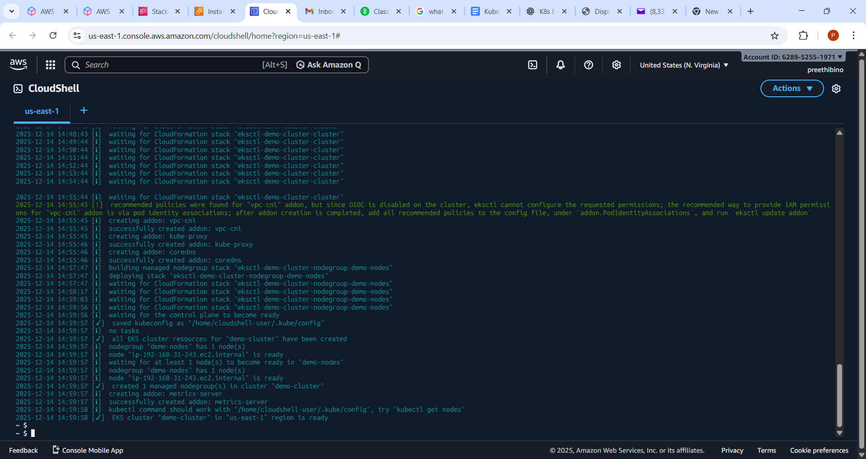

kubectl create deployment nginx --image=nginx

kubectl expose deployment nginx --type=LoadBalancer --port=80

kubectl get svc

Added inbound security group
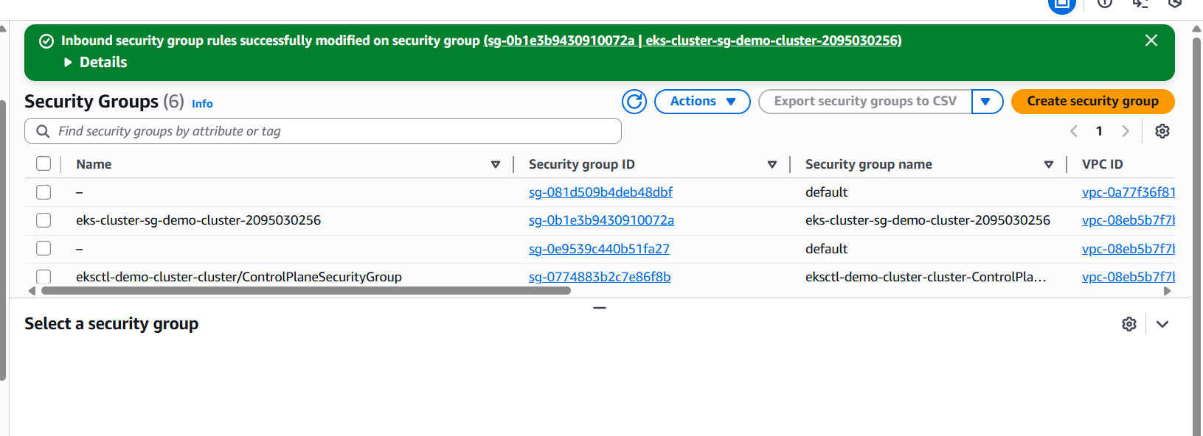

Load the external adderss
http://a38728776f8c34335a6809ba1431f6c4-1219581915.us-east-1.elb.amazonaws.com/

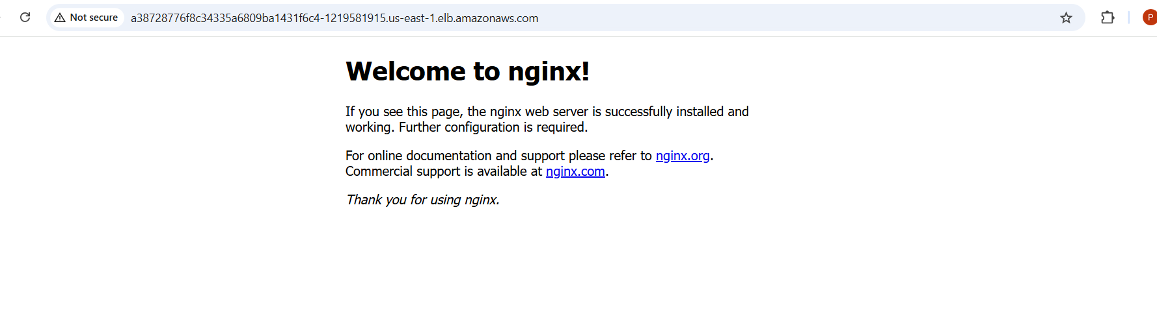

Delete
eksctl delete cluster --name demo-cluster --region us-east-1
