Establish a new directory, populate it with script files, initiate an empty repository on GitHub, convert the local directory into a Git repository, and link it to GitHub for pushing the code into the repository.Perform merge, rebase, stash commands in following github repo.

Logged into Linux via – aws and installed Git in the Linux machine
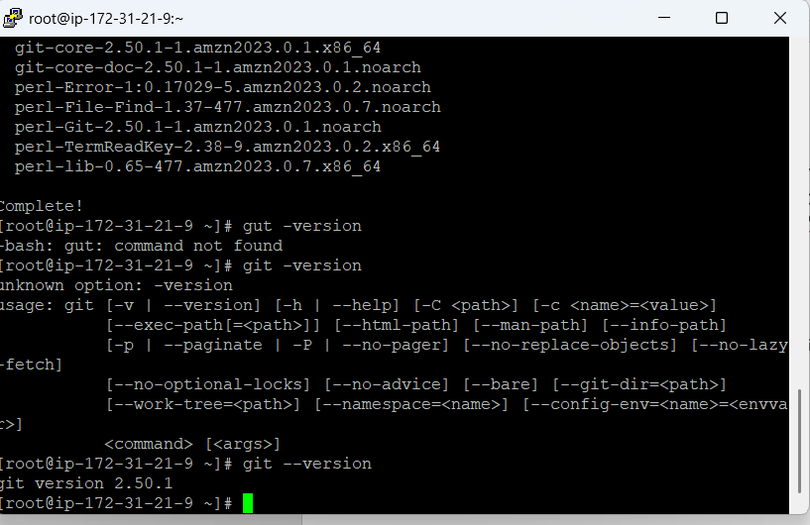

Created a new directry in the linux machine

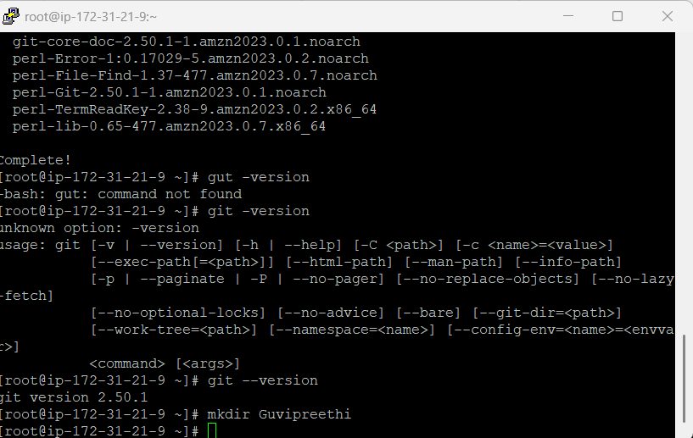

Initializing empty Git repository—( this is the local repository)
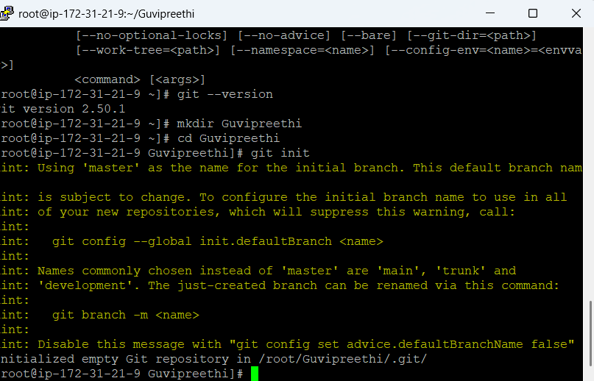

Connected to WINSCP, to move files from local to my EC2 machine

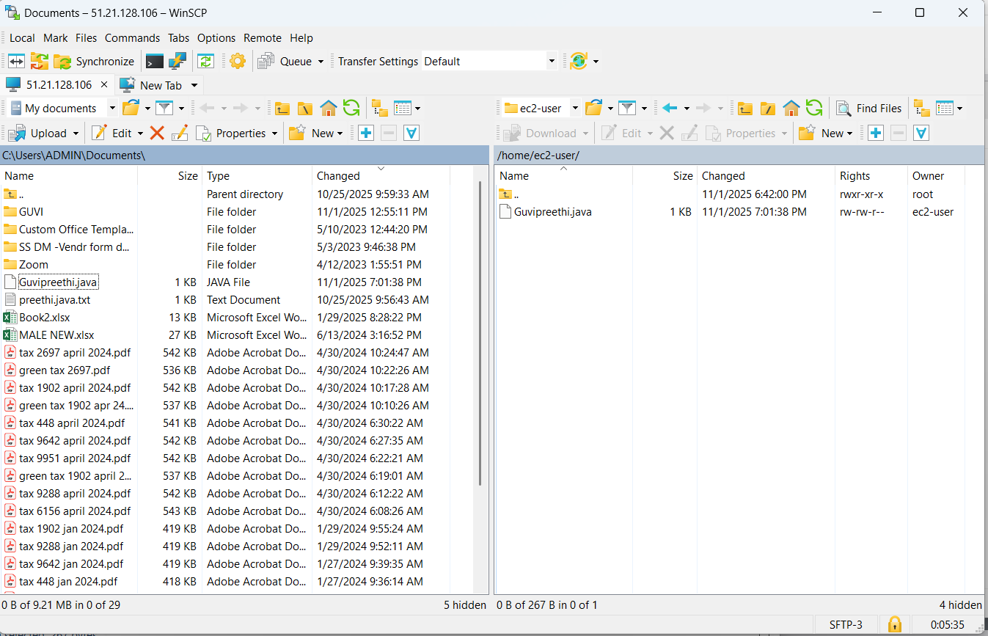

Moved the file to the git directory
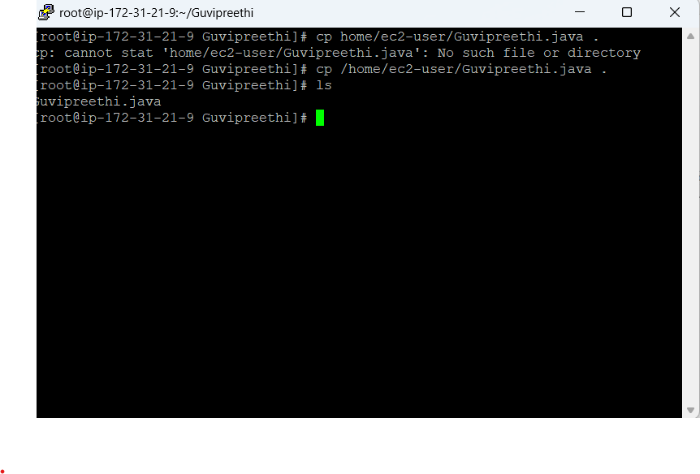
Moved code to staging repository
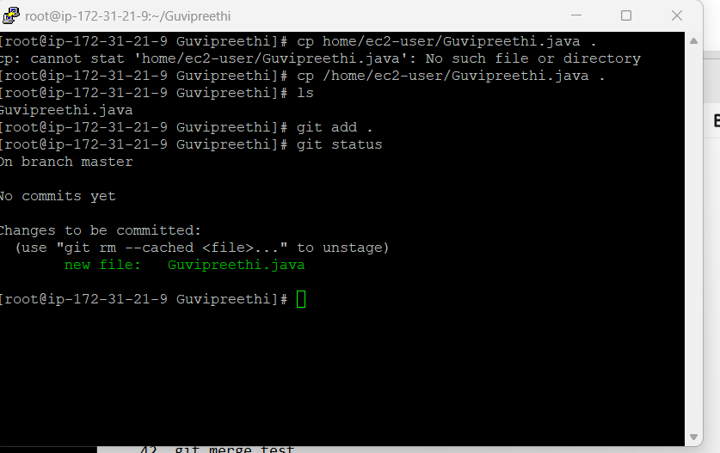

Moved the code to local repository

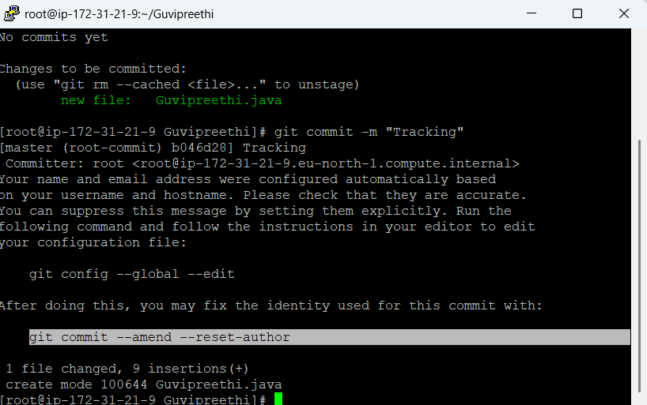
Create a new remote repository
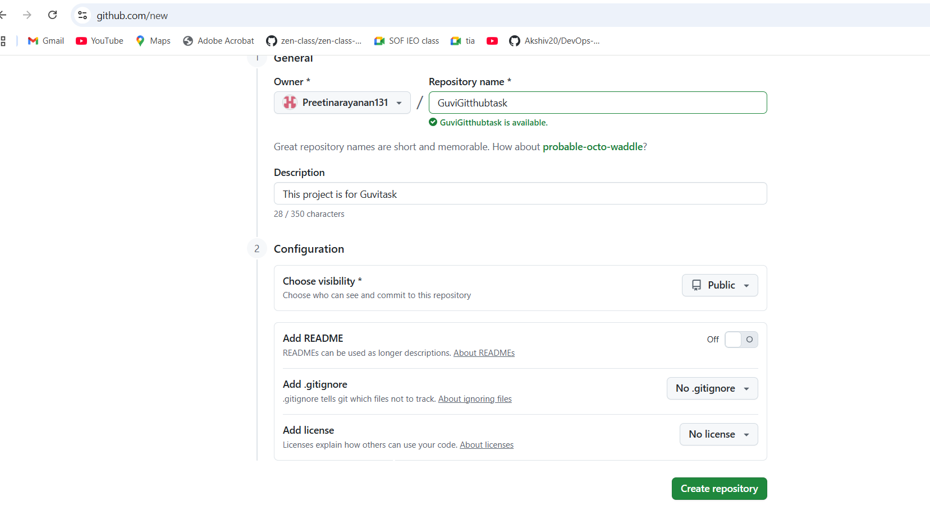
Added remote repository to ec2 machine
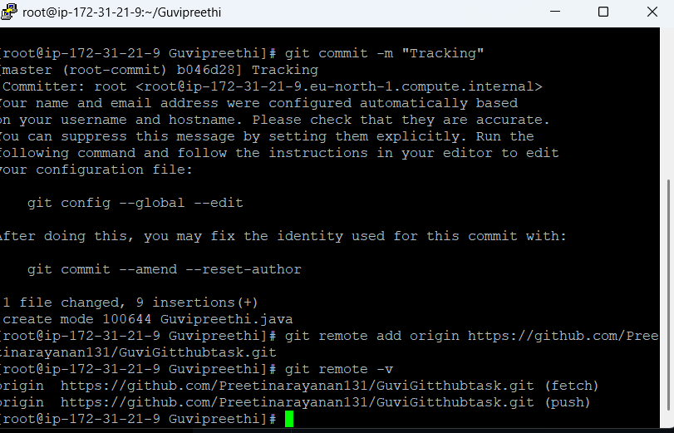
Adding github configurations
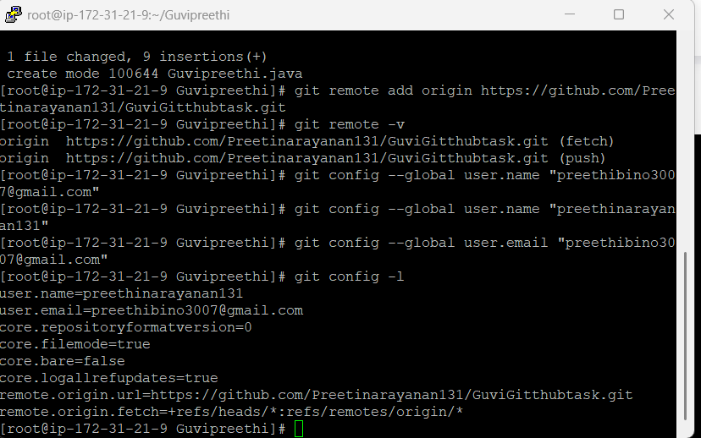

To login – Personal Access Token need to be generated
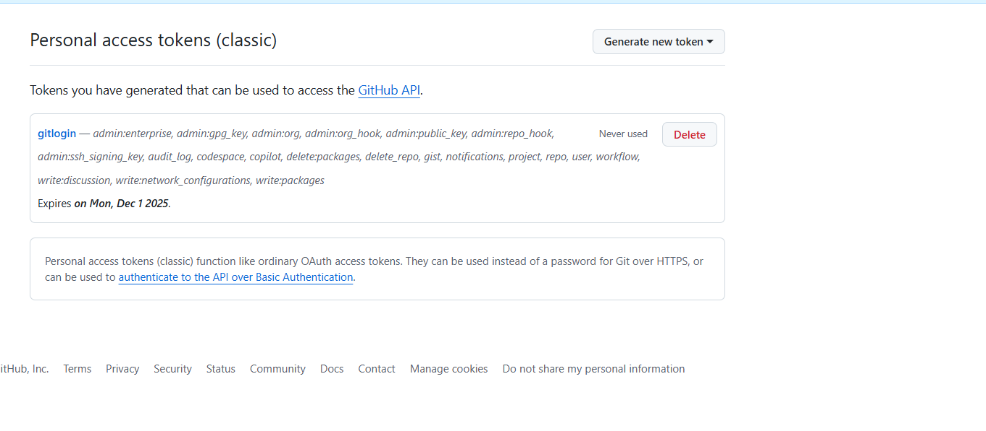
Pushed from staging repository to remote repository
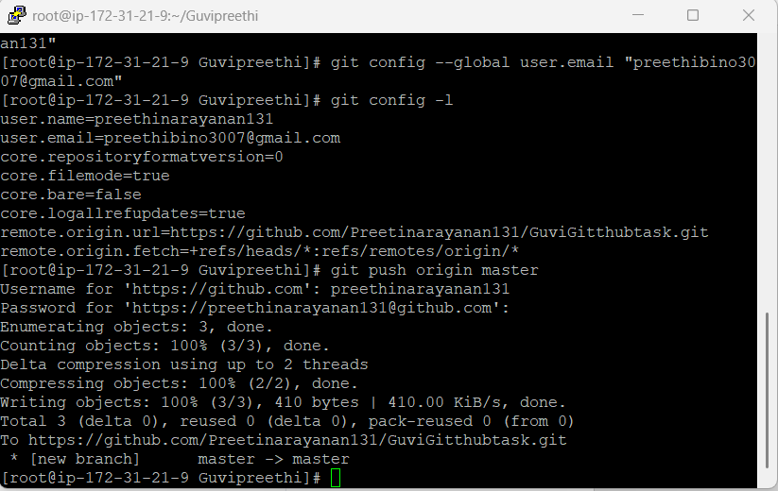

Githhub
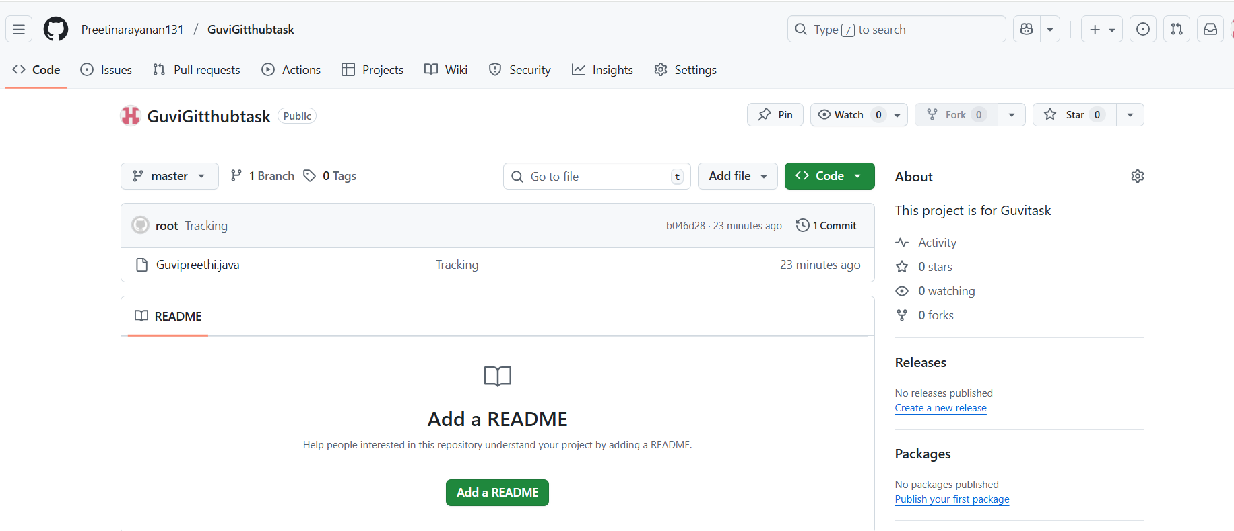

Created a branck task and checkout to task
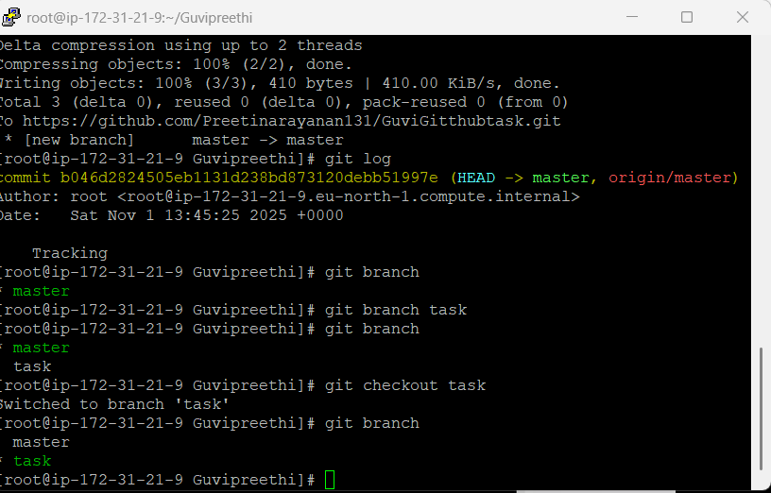
We can create and switch using another command git switch -c task – here task branch will be created and switched to task simultaneously.
For the first branch , all commits in master will be moved .
Making changes in the Task branch- file
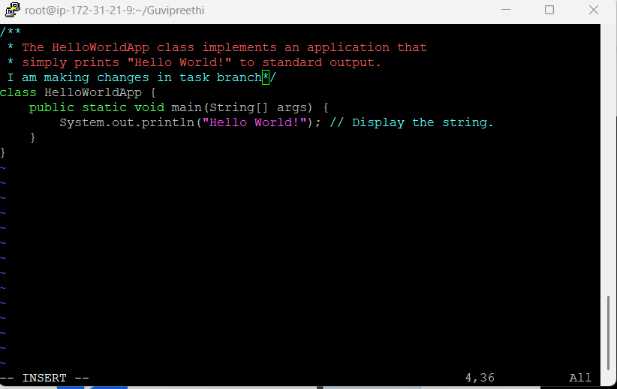

Merge the test to master
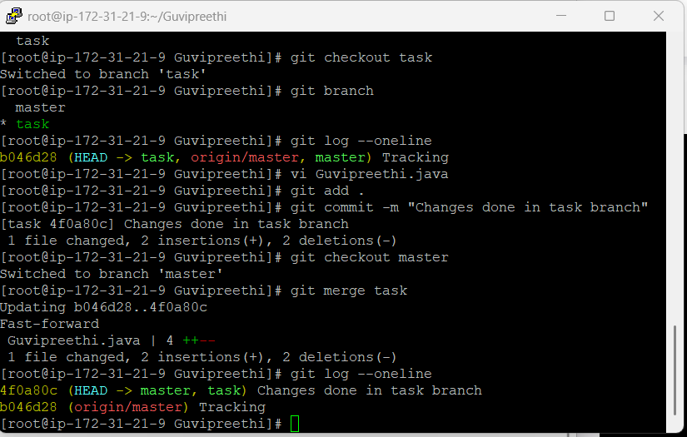

Stash -
Having changes in Working directoy, but want to push the changes at later point of time.
Git stash will work after first commit only

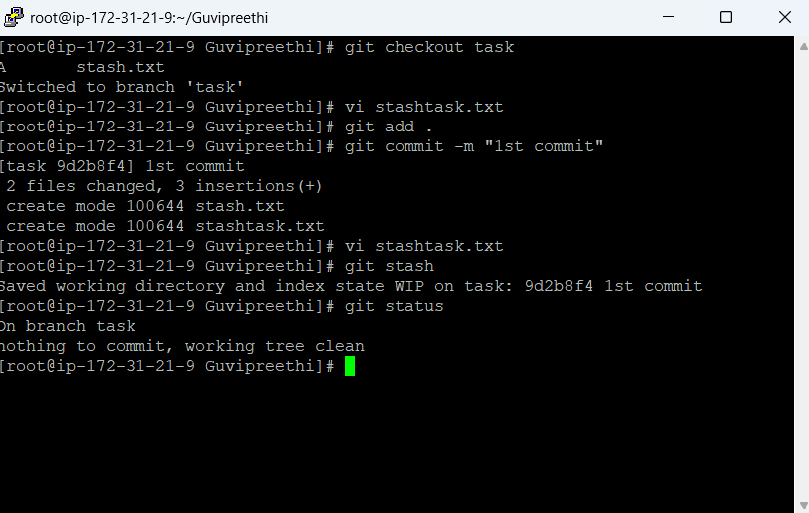
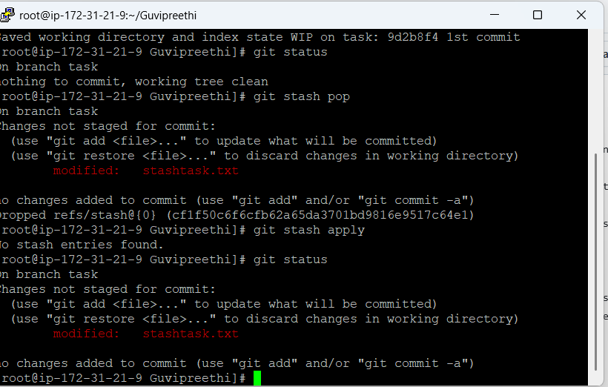

Rebasing Master:

