Launch jenkins and explore creating projects and users.

Connected to EC2- ubuntu Console:
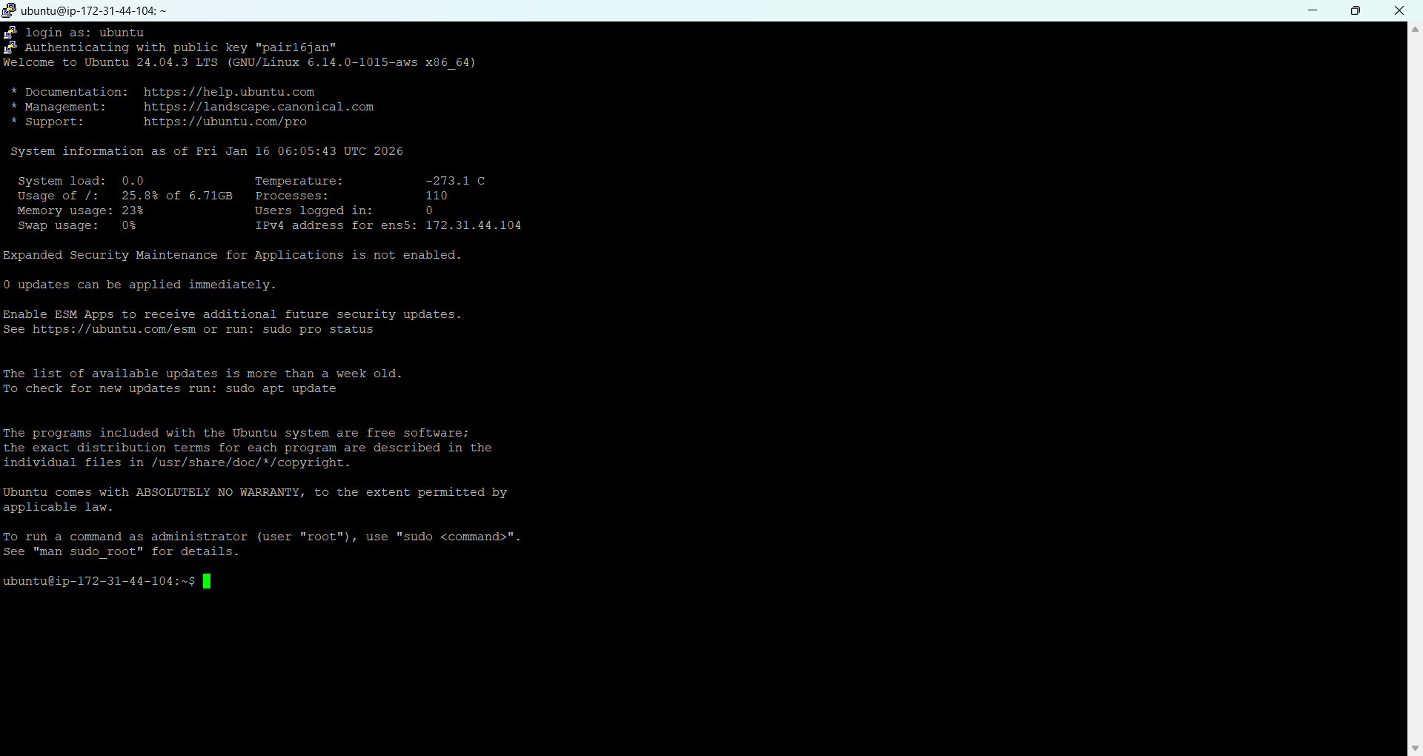
sudo apt-get update
sudo apt-get upgrade -y
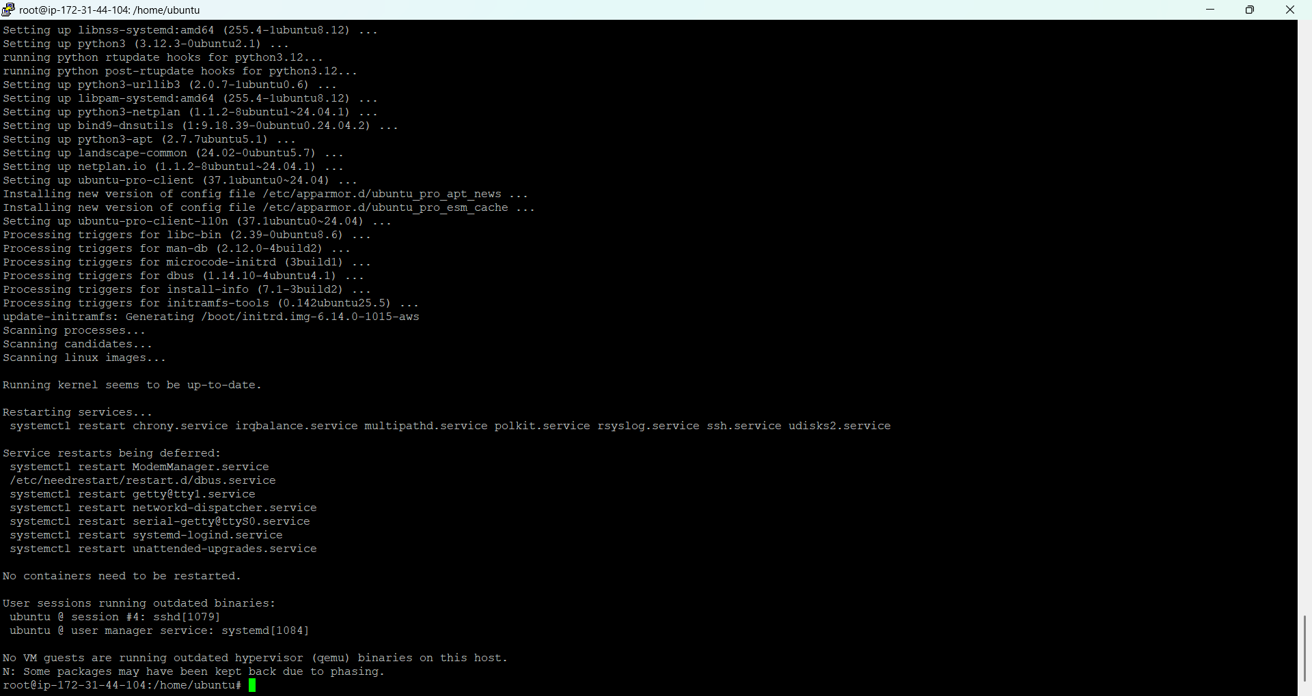
Install Java on Ubuntu server.
sudo apt-get install default-jdk -y
java -version

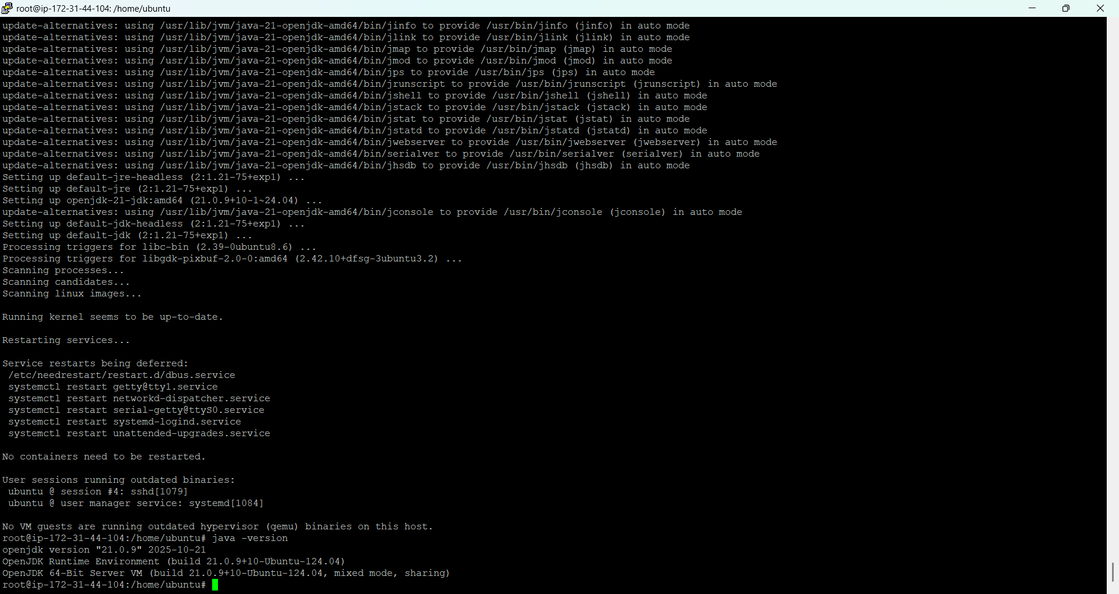

3. Install Jenkins on Ubuntu server.
wget -q -O - https://pkg.jenkins.io/debian-stable/jenkins.io.key | sudo apt-key add –
sudo sh -c 'echo deb [trusted=yes] https://pkg.jenkins.io/debian-stable binary/ > \
/etc/apt/sources.list.d/jenkins.list'
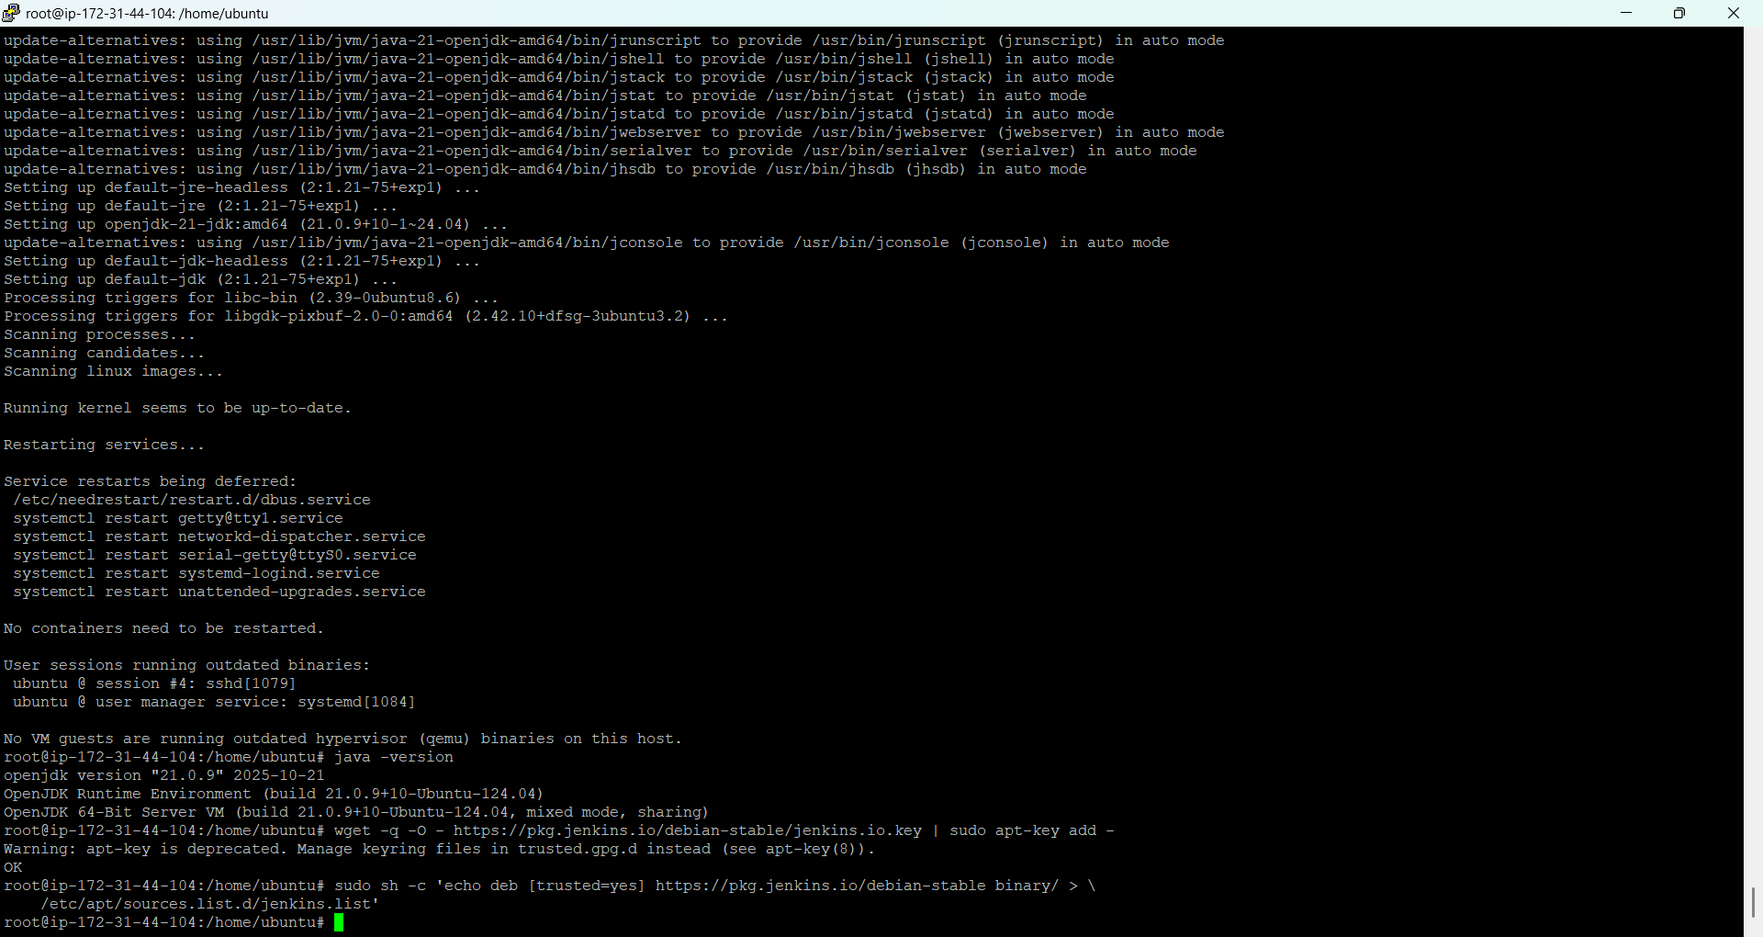
sudo apt-get update

sudo apt-get install jenkins -y

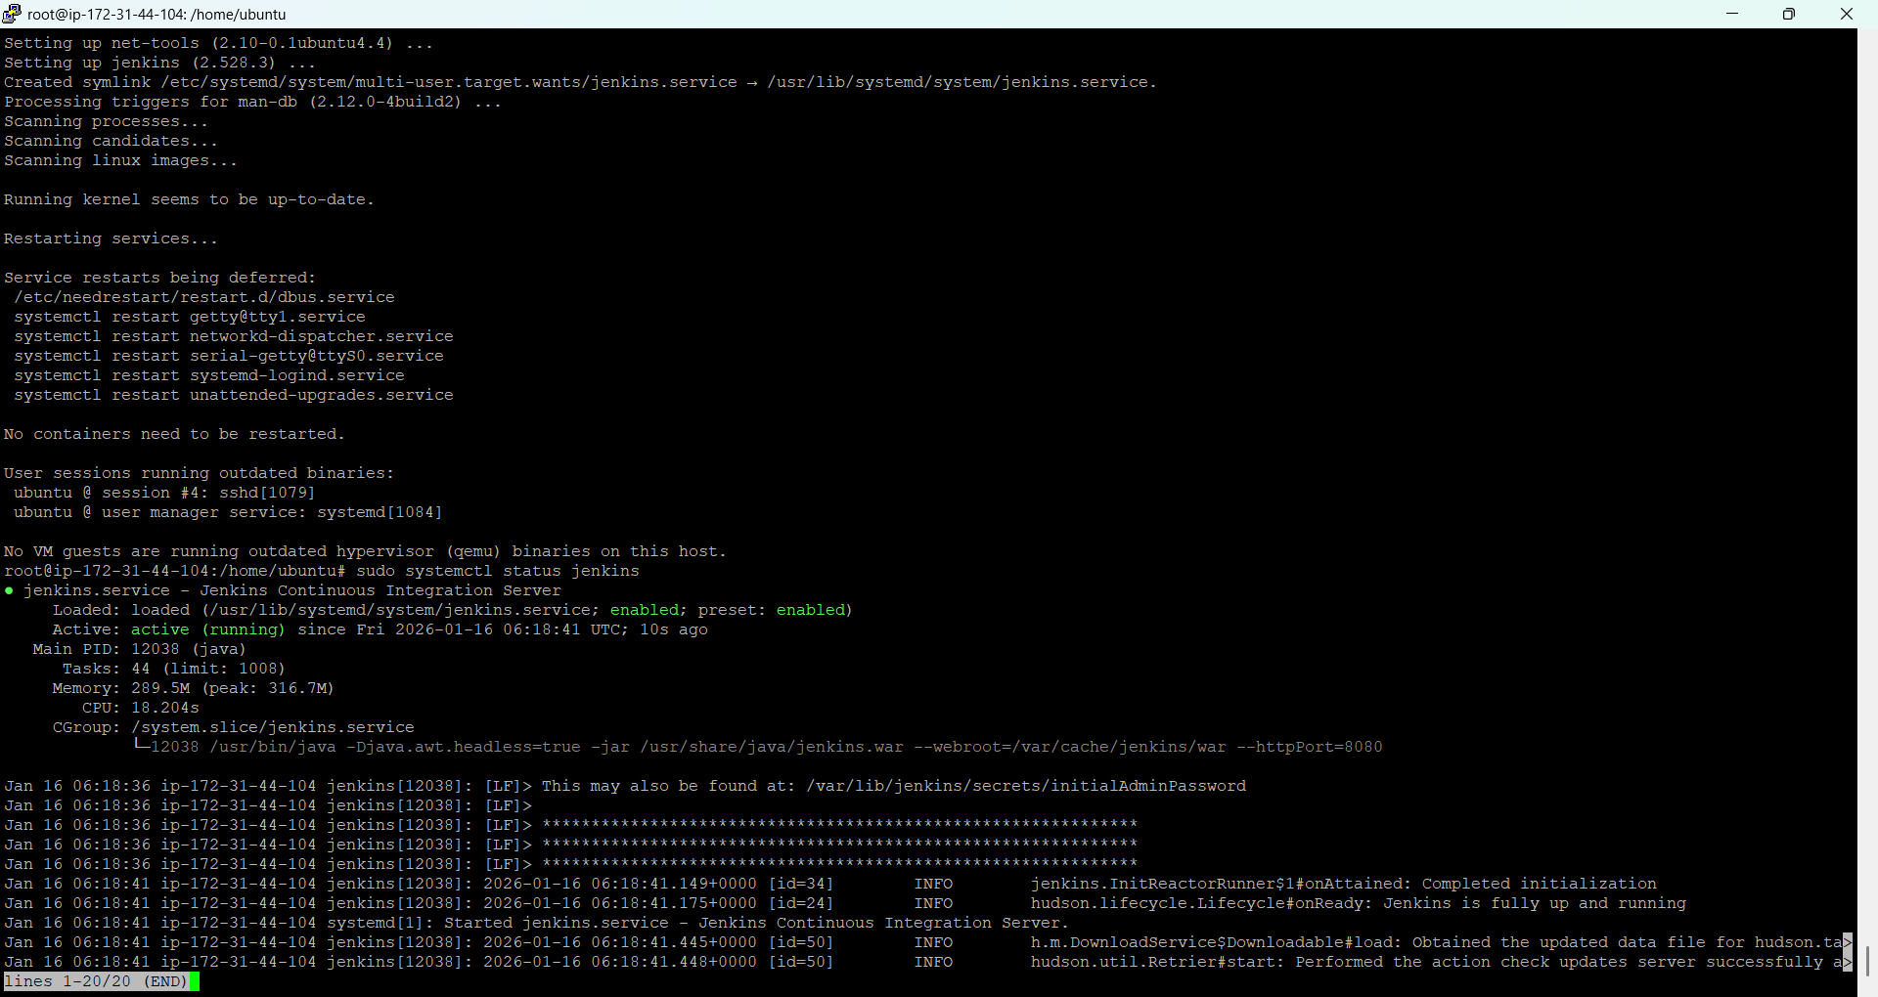
- ps -ef | grep Jenkins
get the machine public ip and open it on the browser and launch the Jenkins URLS in the browser:-
<ubuntu_ip_address>:8080

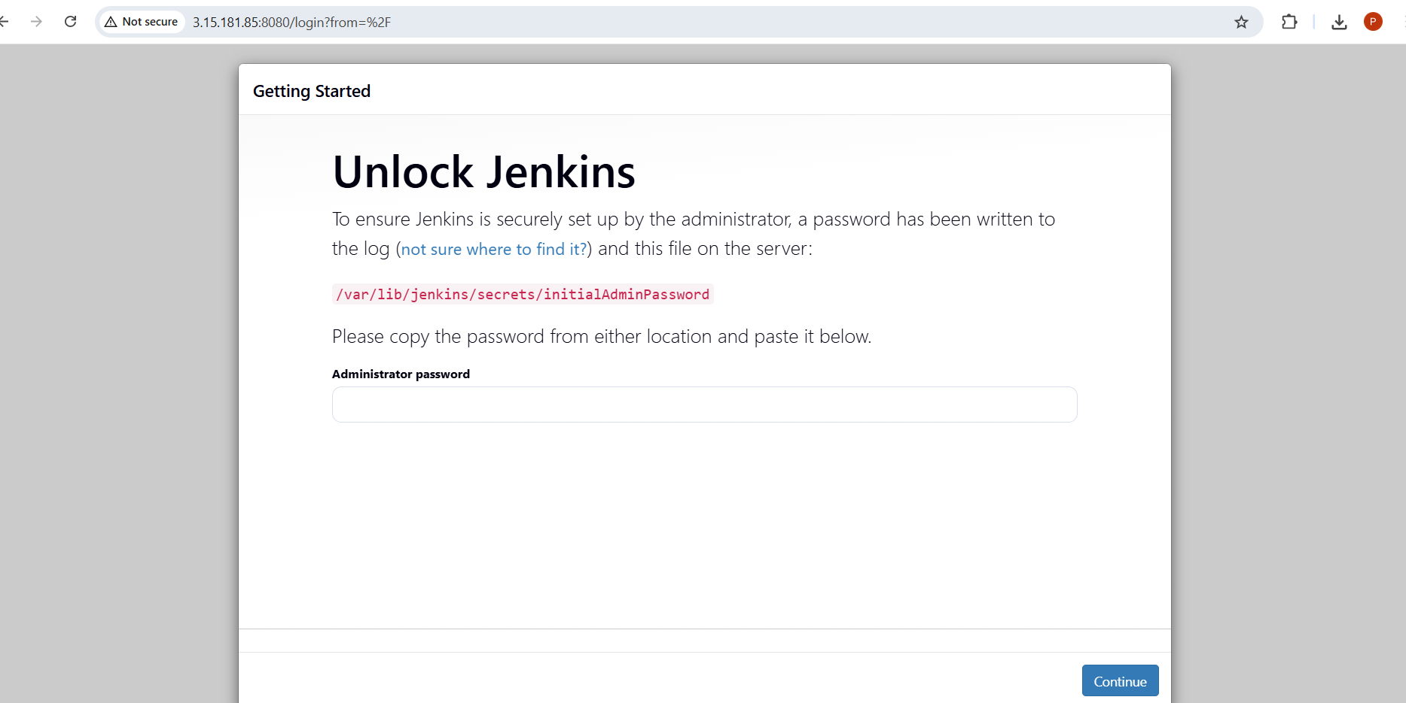
cat /var/lib/jenkins/secrets/initialAdminPassword
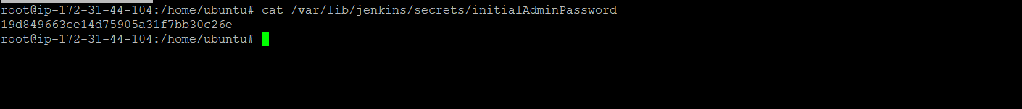

19d849663ce14d75905a31f7bb30c26e

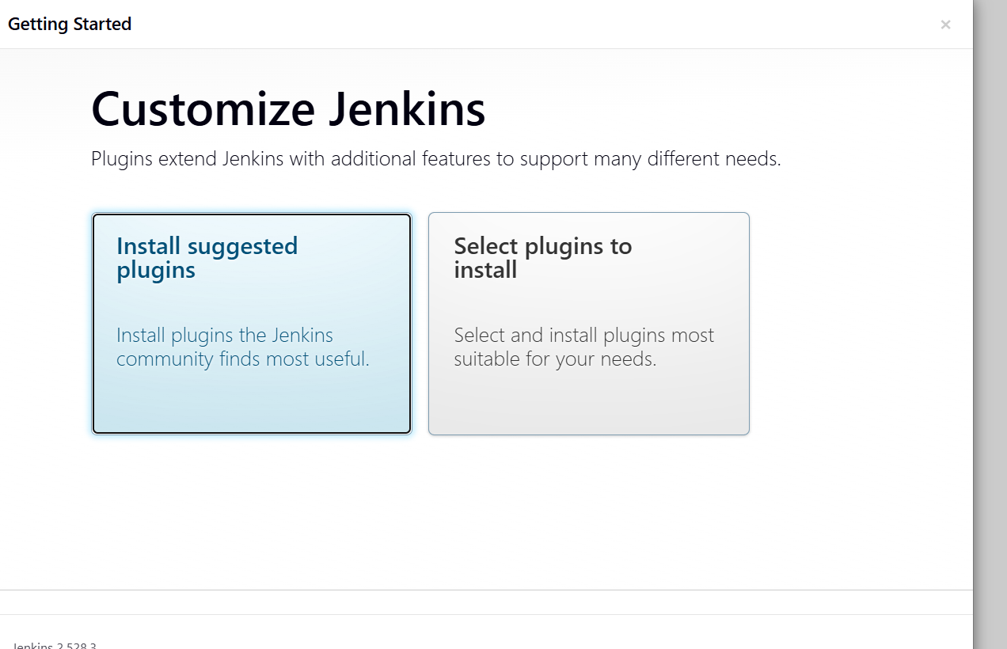

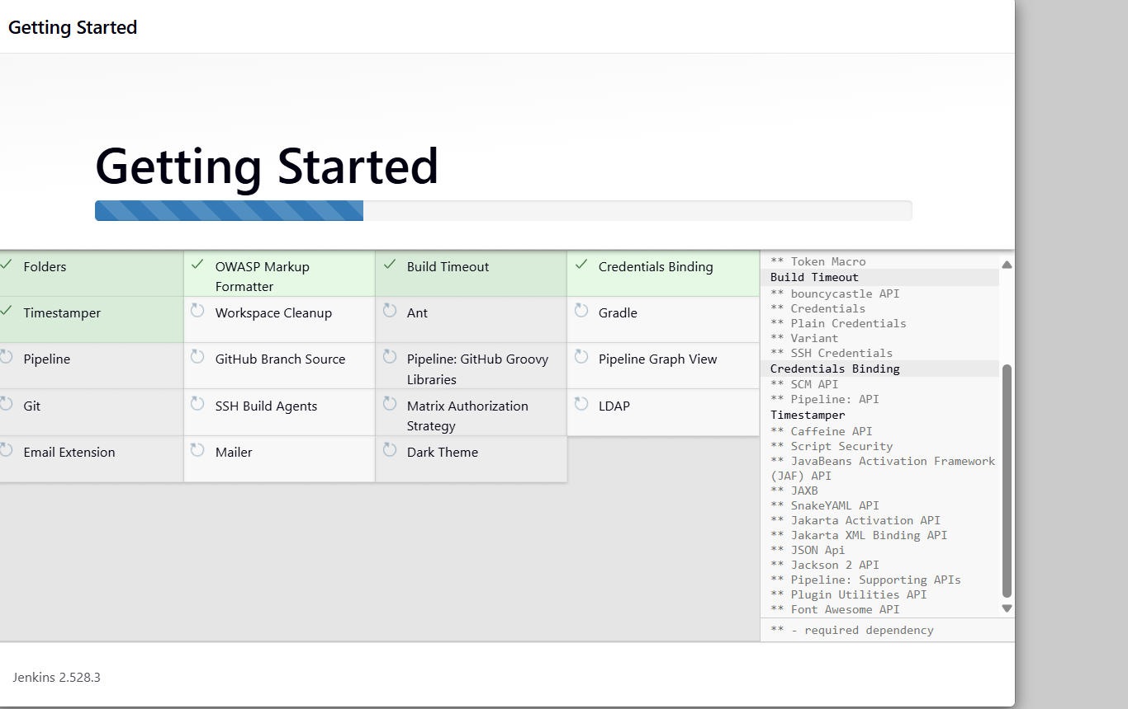

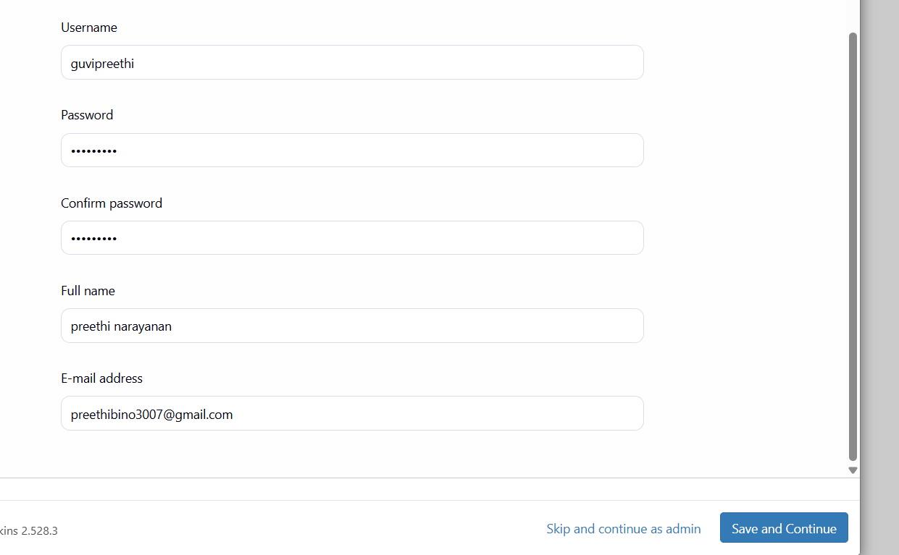

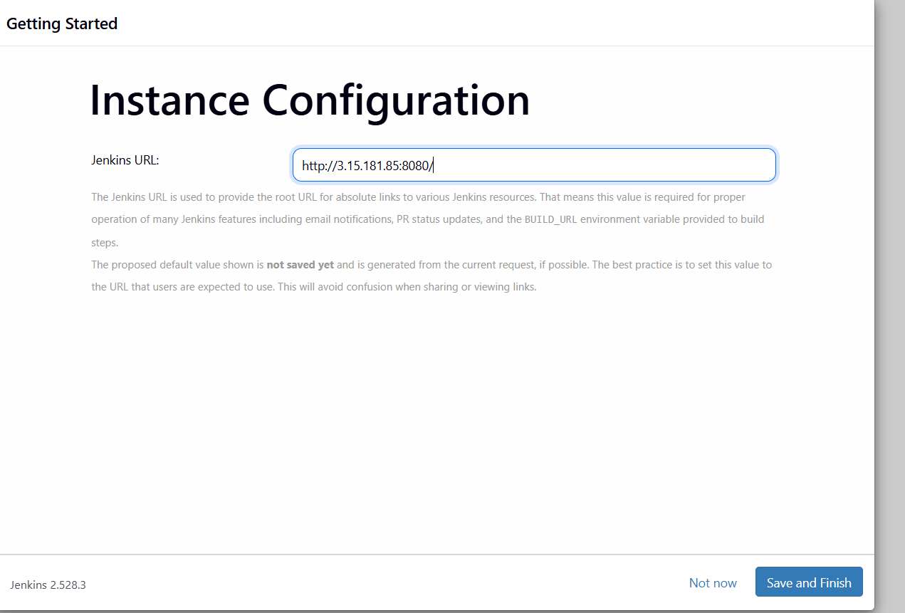

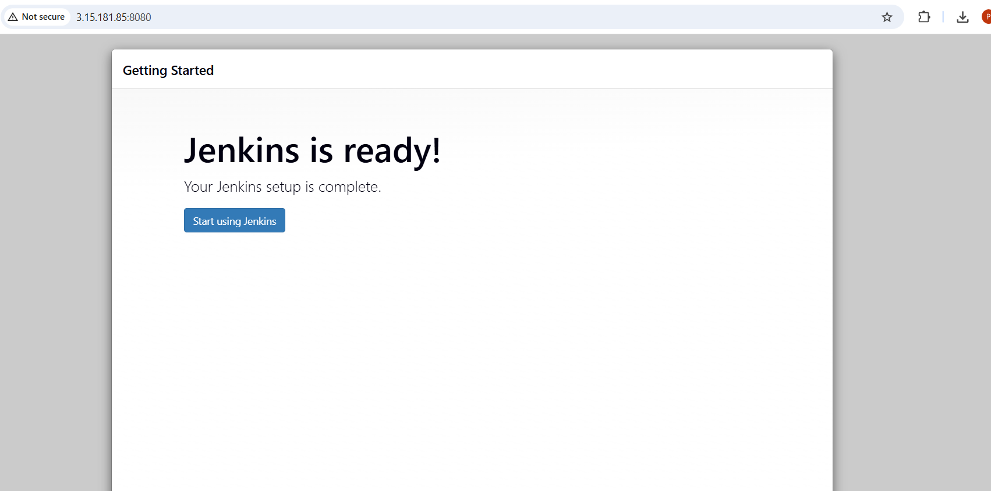

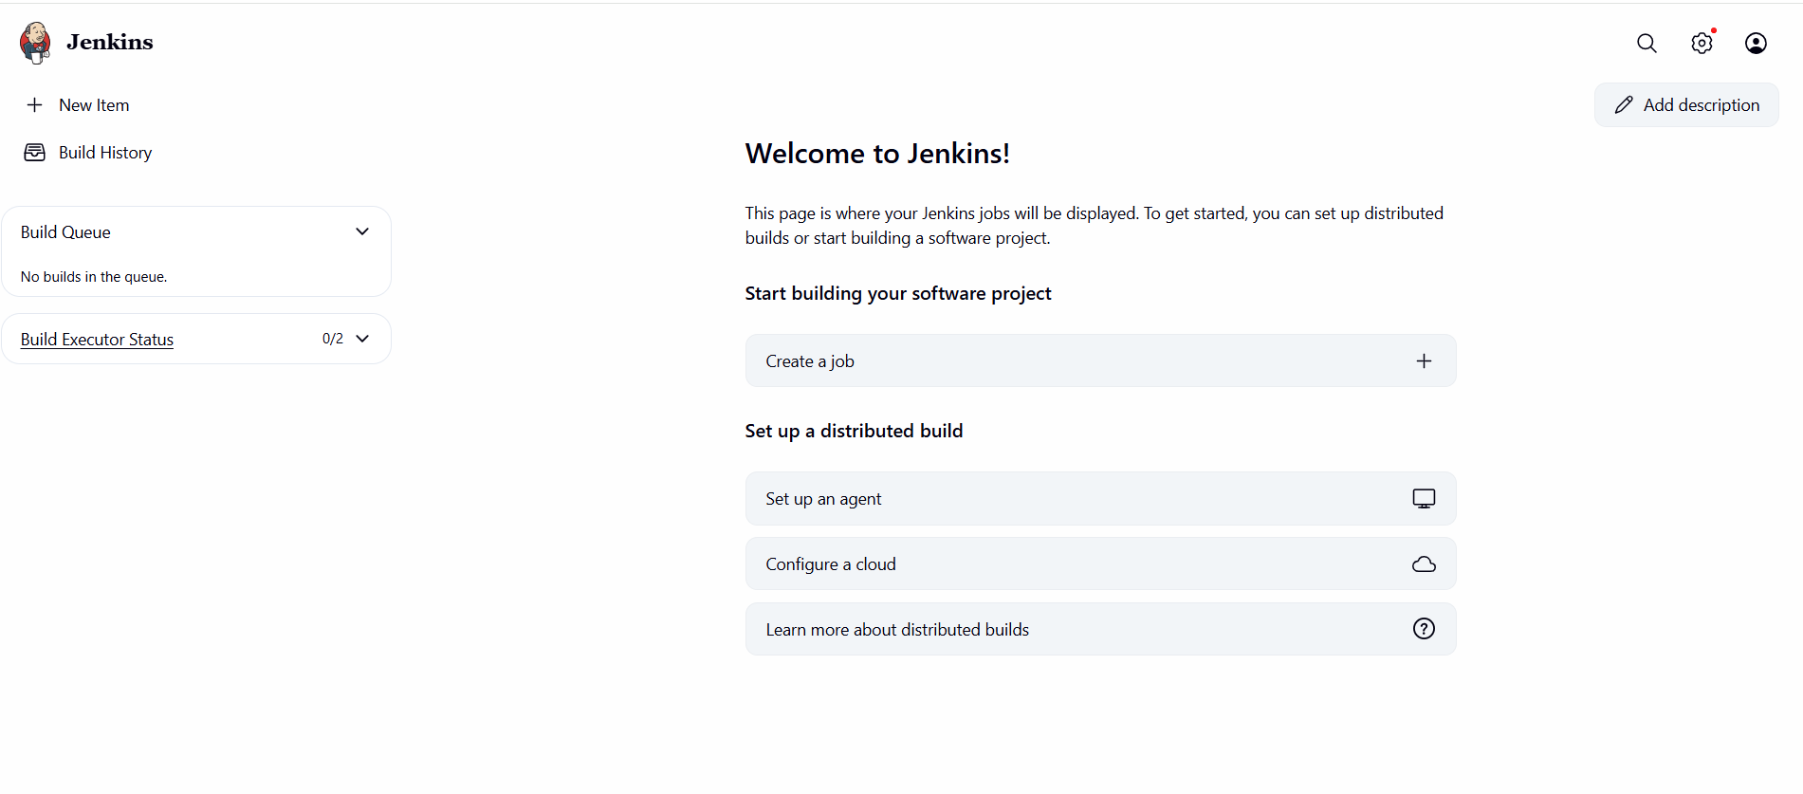

Create new Job

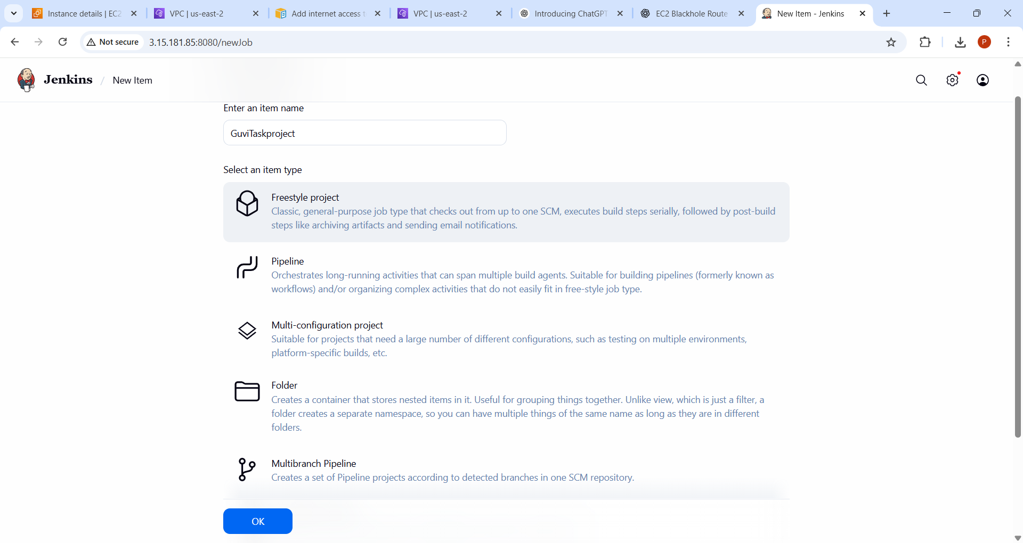

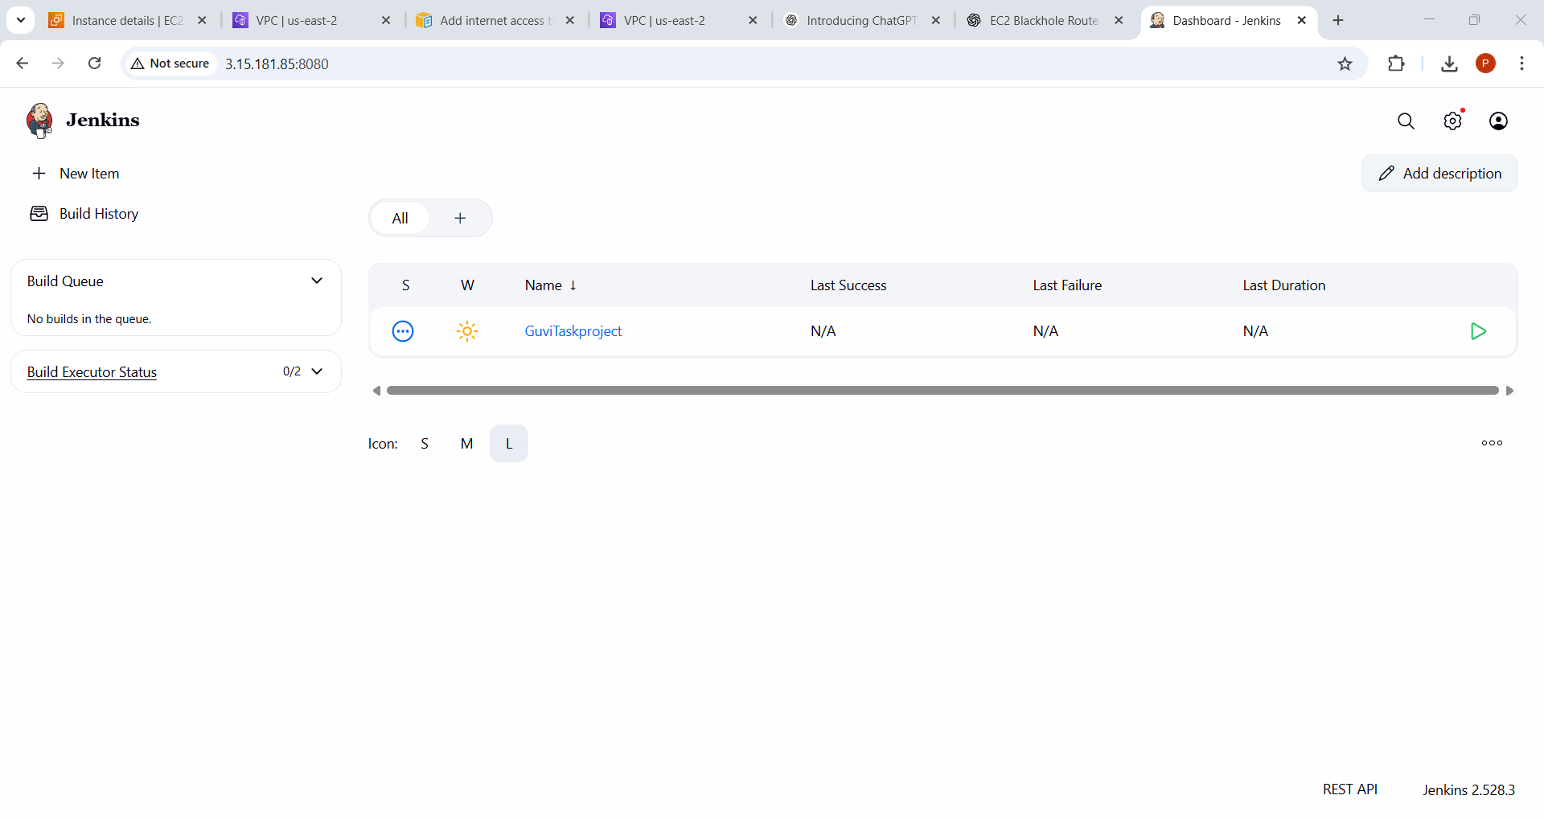
Create users
