Minikube

To Install Minikube – Docker should be installed as First step
First install docker
Sudo apt install docker-io
Sudo systemctl start docker
Sudo systemctl enable docker
sudo apt install -y apt-transport-https ca-certificates curl
curl -s https://packages.cloud.google.com/apt/doc/apt-key.gpg | sudo apt-key add -echo"deb https://apt.kubernetes.io/kubernetes-xenial main" | sudo tee /etc/apt/sources.list.d/kubernetes.list
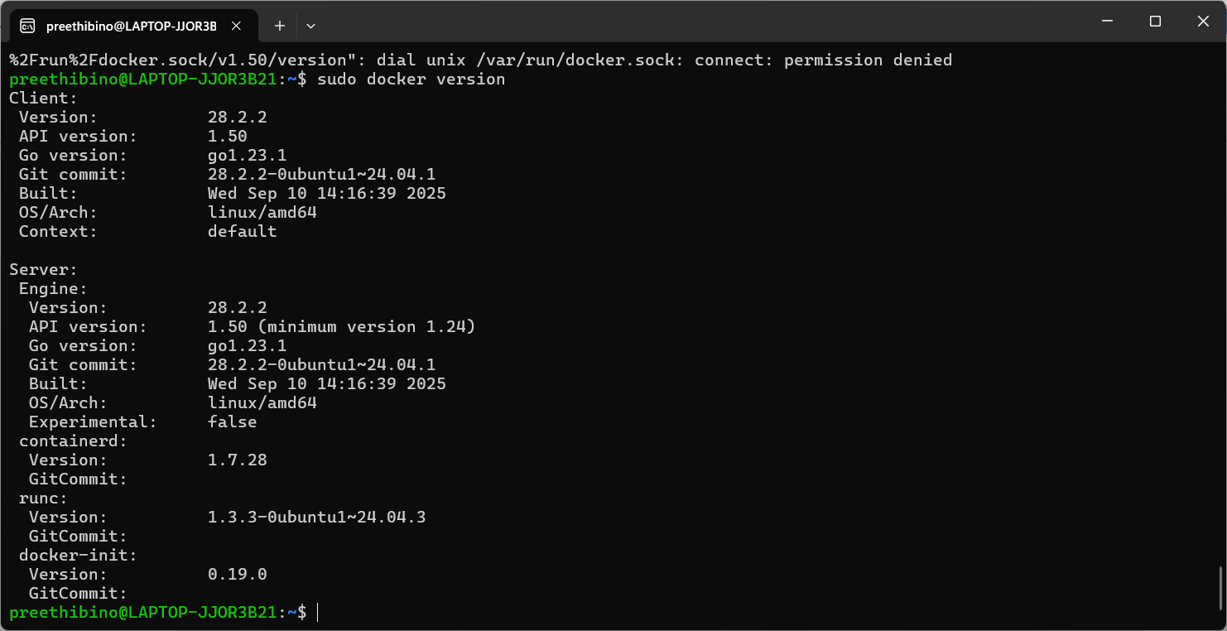

Install Kubectl using below command
Sudo snap install kubectl –classic
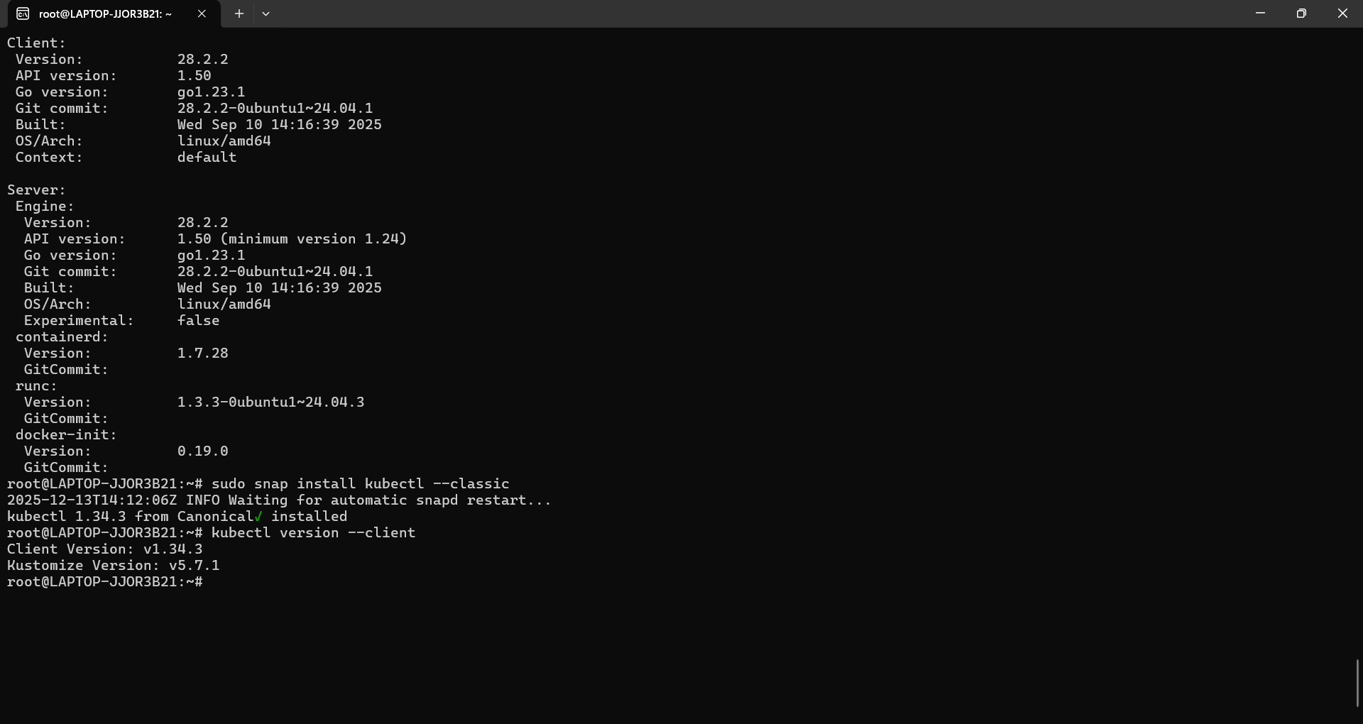

Step 3. MiniKube Installation
curl -LO https://storage.googleapis.com/minikube/releases/latest/minikube-linux-amd64
sudo install minikube-linux-amd64 /usr/local/bin/minikube
minikube version
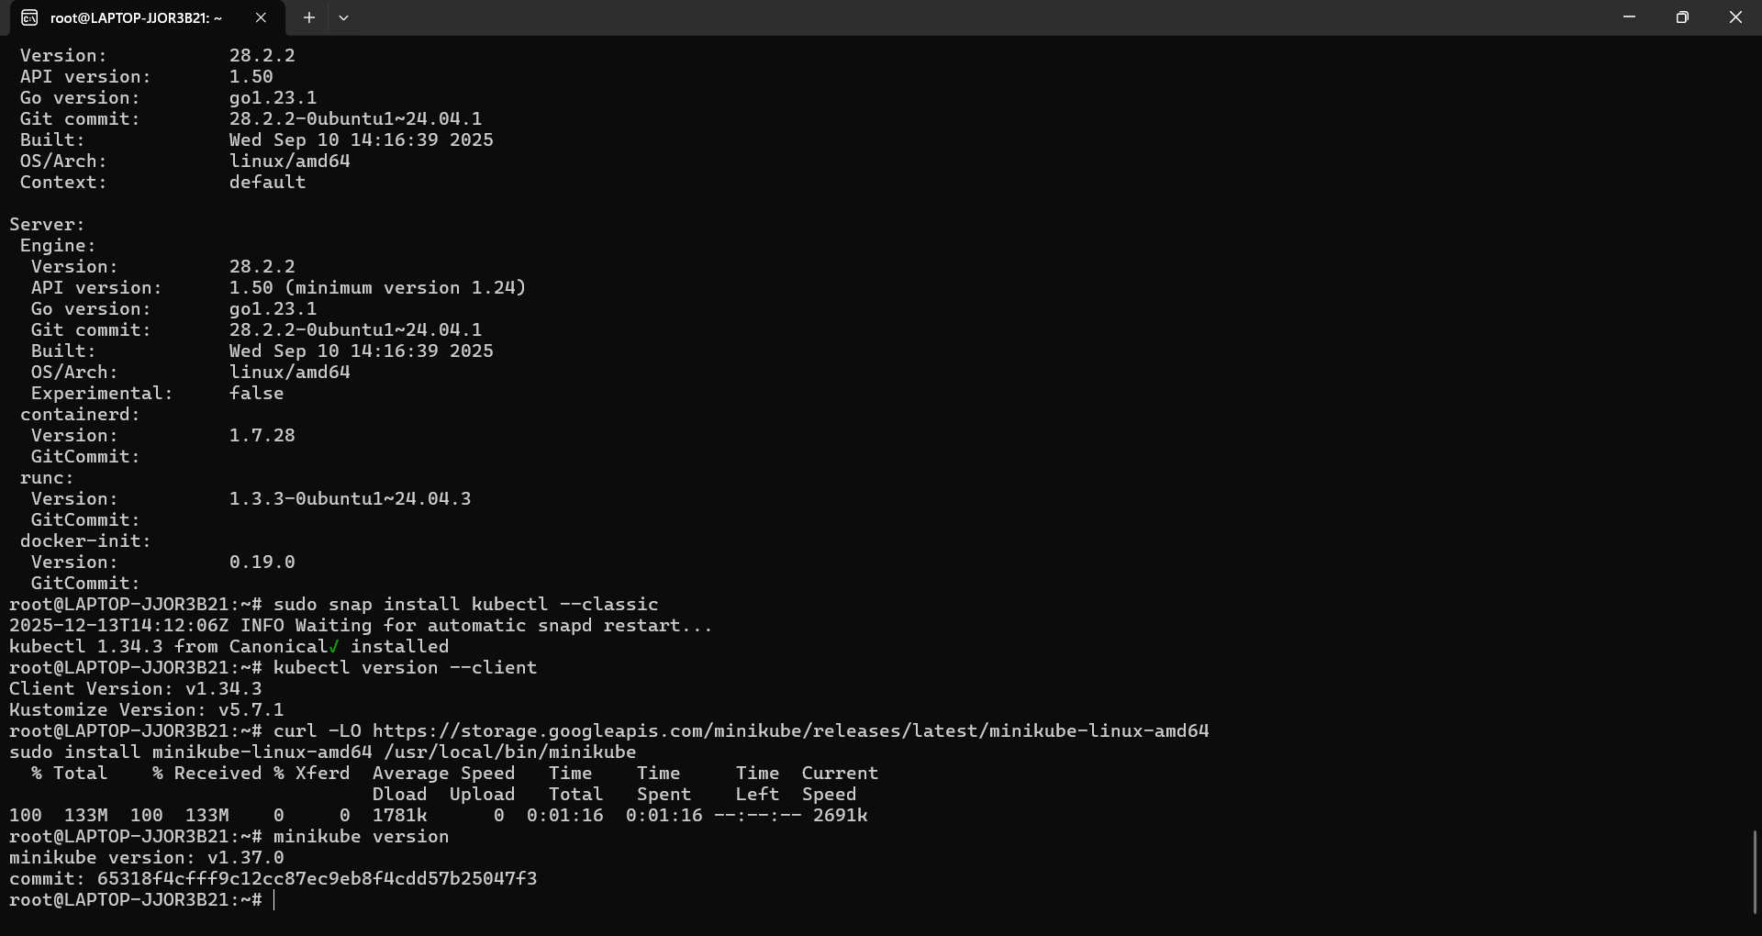

Start the minikube using docker driver.
Minikube start –-driver=docker –-force
Minikube status
Kubectl clusterinfo
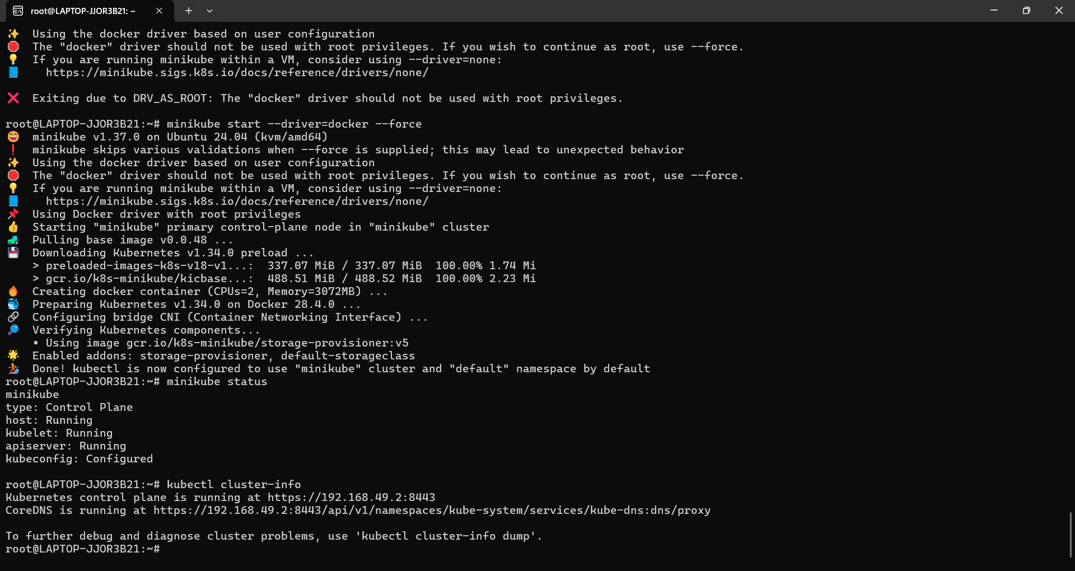
Kubectl config view
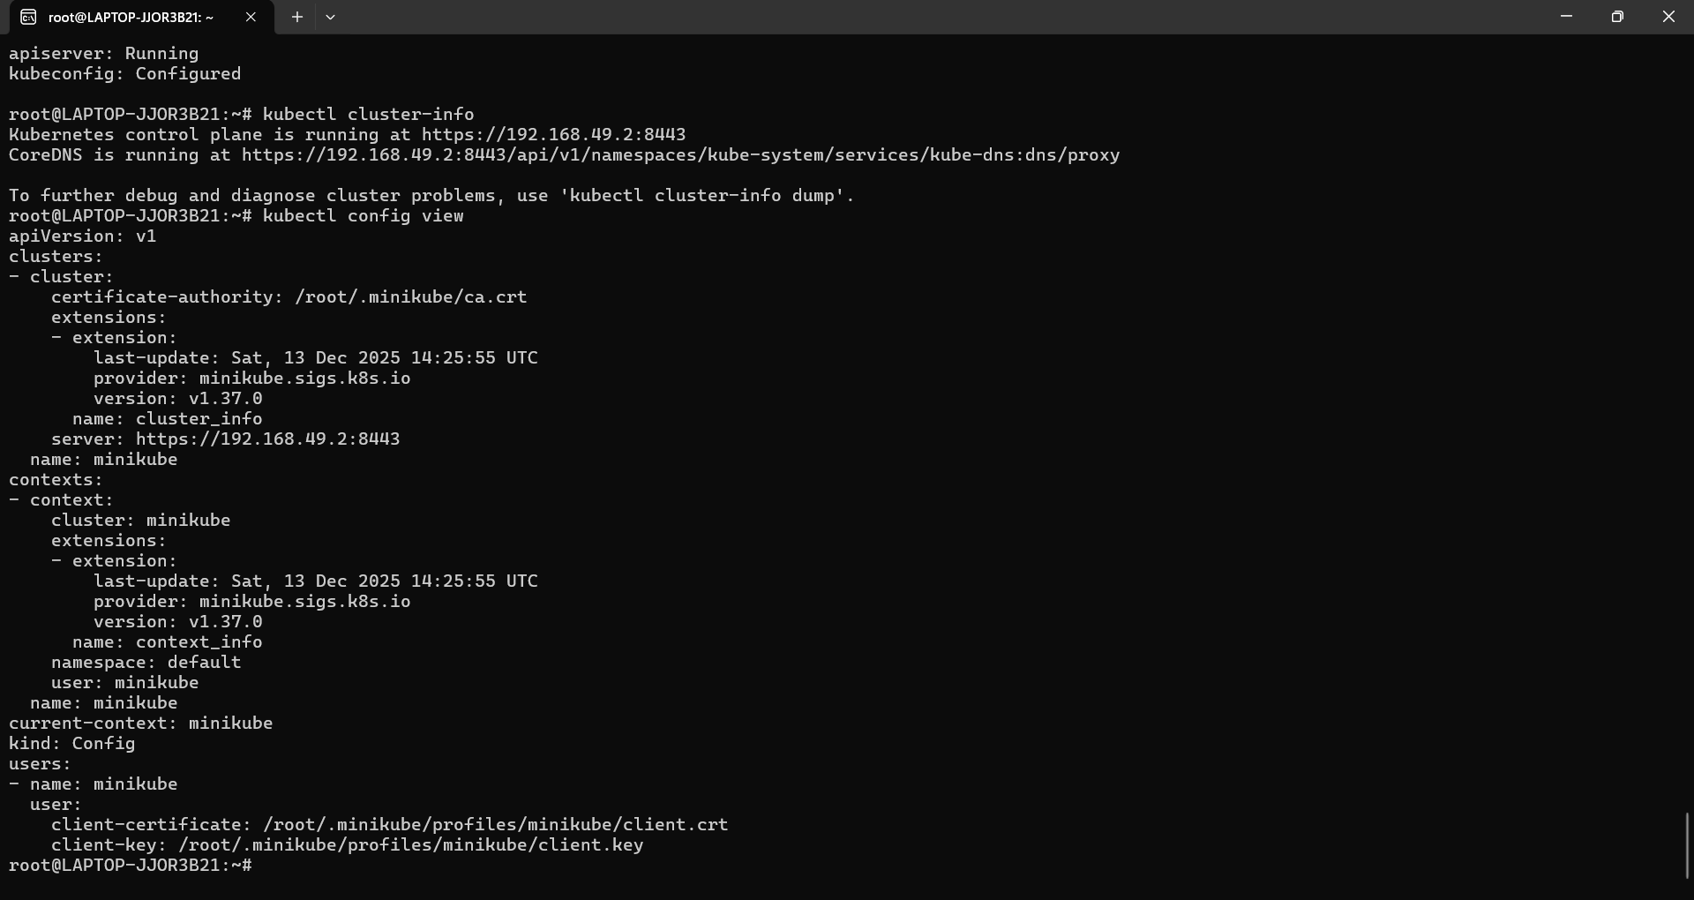

Kubectl get nodes
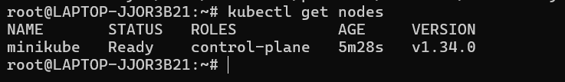

Understand Default namespaces:
Kubectl get namespaces
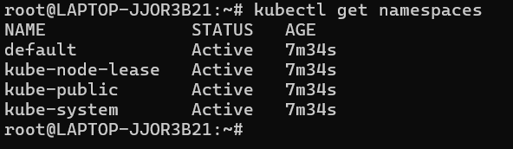

Create a namespace:
kubectl create namespace guvitask
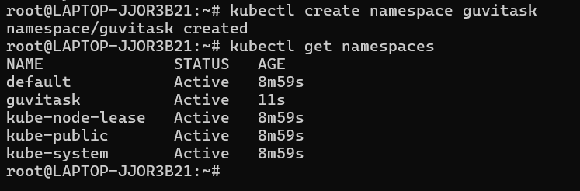
Create yaml File and create namespace
Vi minitask.yaml
apiVersion: v1
kind: Namespace
metadata:
name: minitask
kubectl apply -f minitask.yaml

View the namespace details:
Kubectl describe namespace minitask
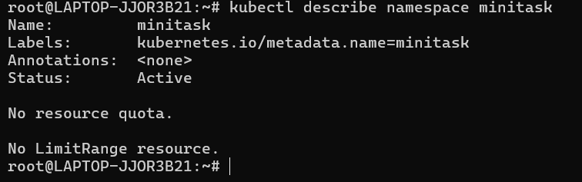
Create a pod in minitask namespace
kubectl run nginx-pod --image=nginx -n minitask
kubectl get pods
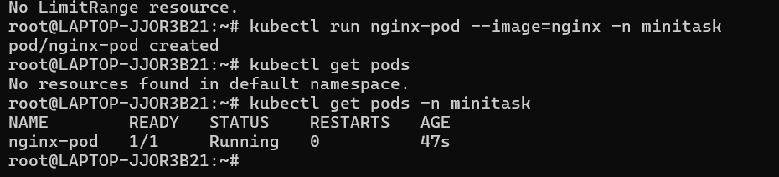

Delete a namespace:
