Create a custom docker image for nginx and deploy it using docker compose, where the volume bind mount should be at /var/opt/nginx location. Push the created custom docker image to your docker-hub.
- Create a Project folder and move inside the project folder
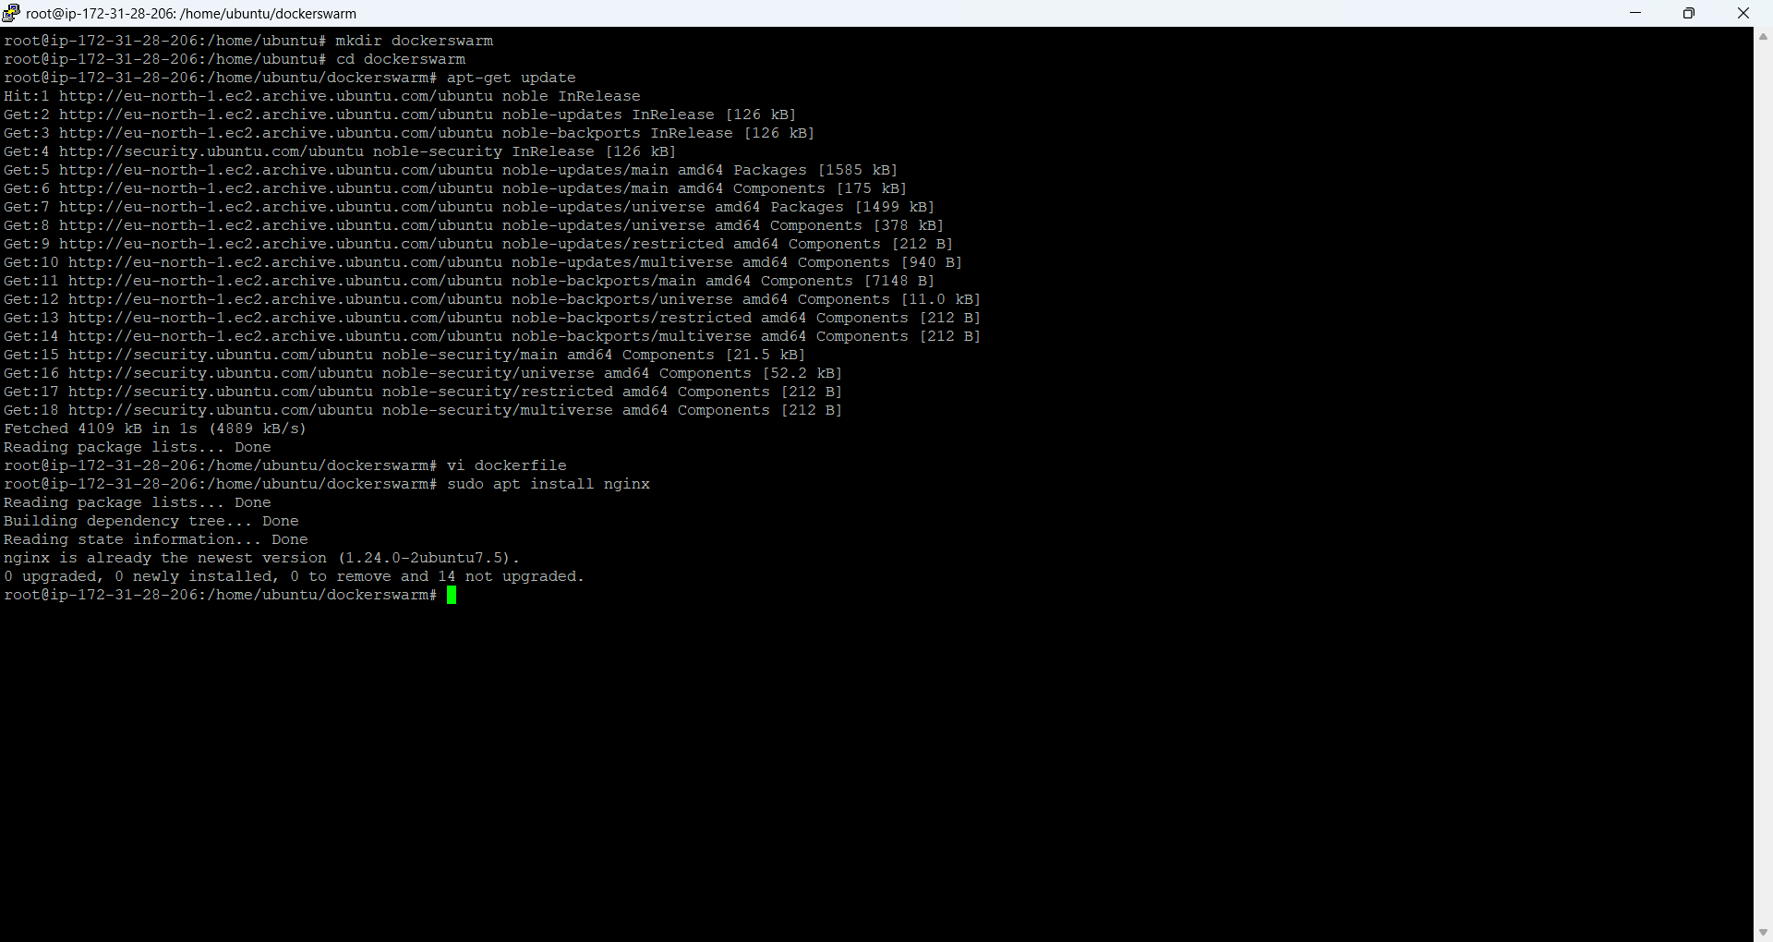
- Create a dockerfile and index.html file
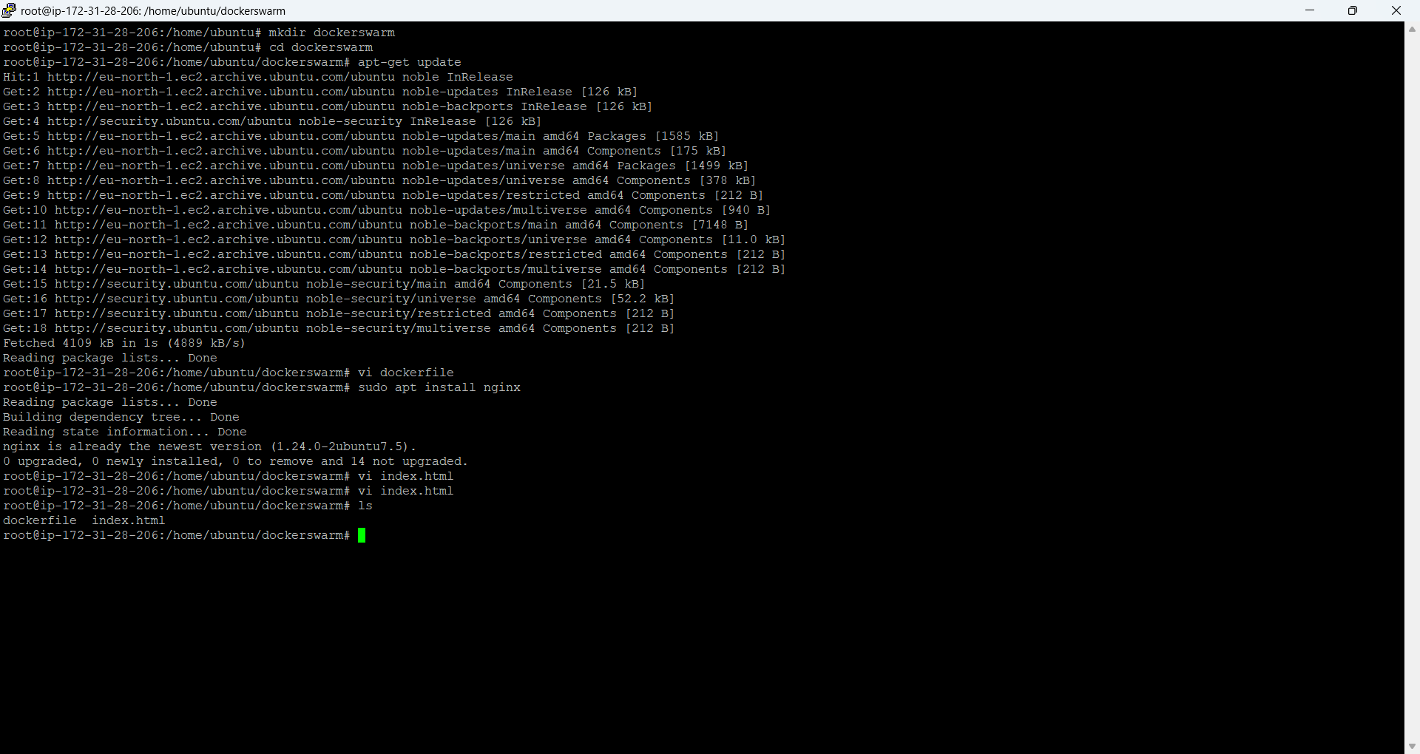
- Create a custom image using docker command below
docker build -t preethibino/custom-nginxtask .

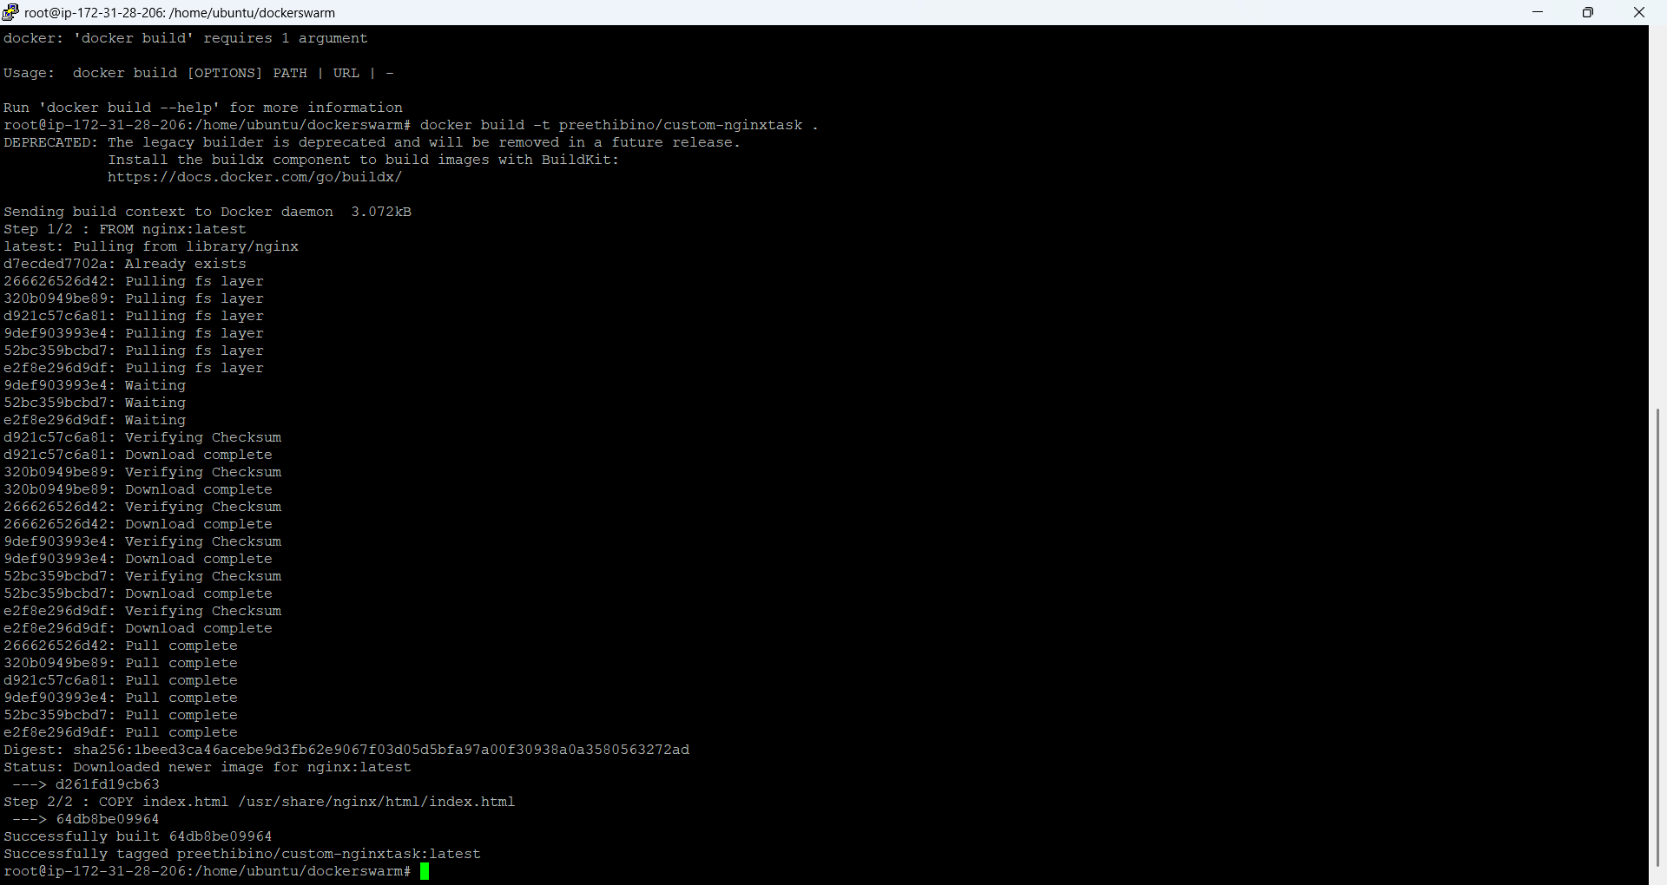

Check the image locally:
docker run -p 8080:80 preethibino/custom-nginxtask
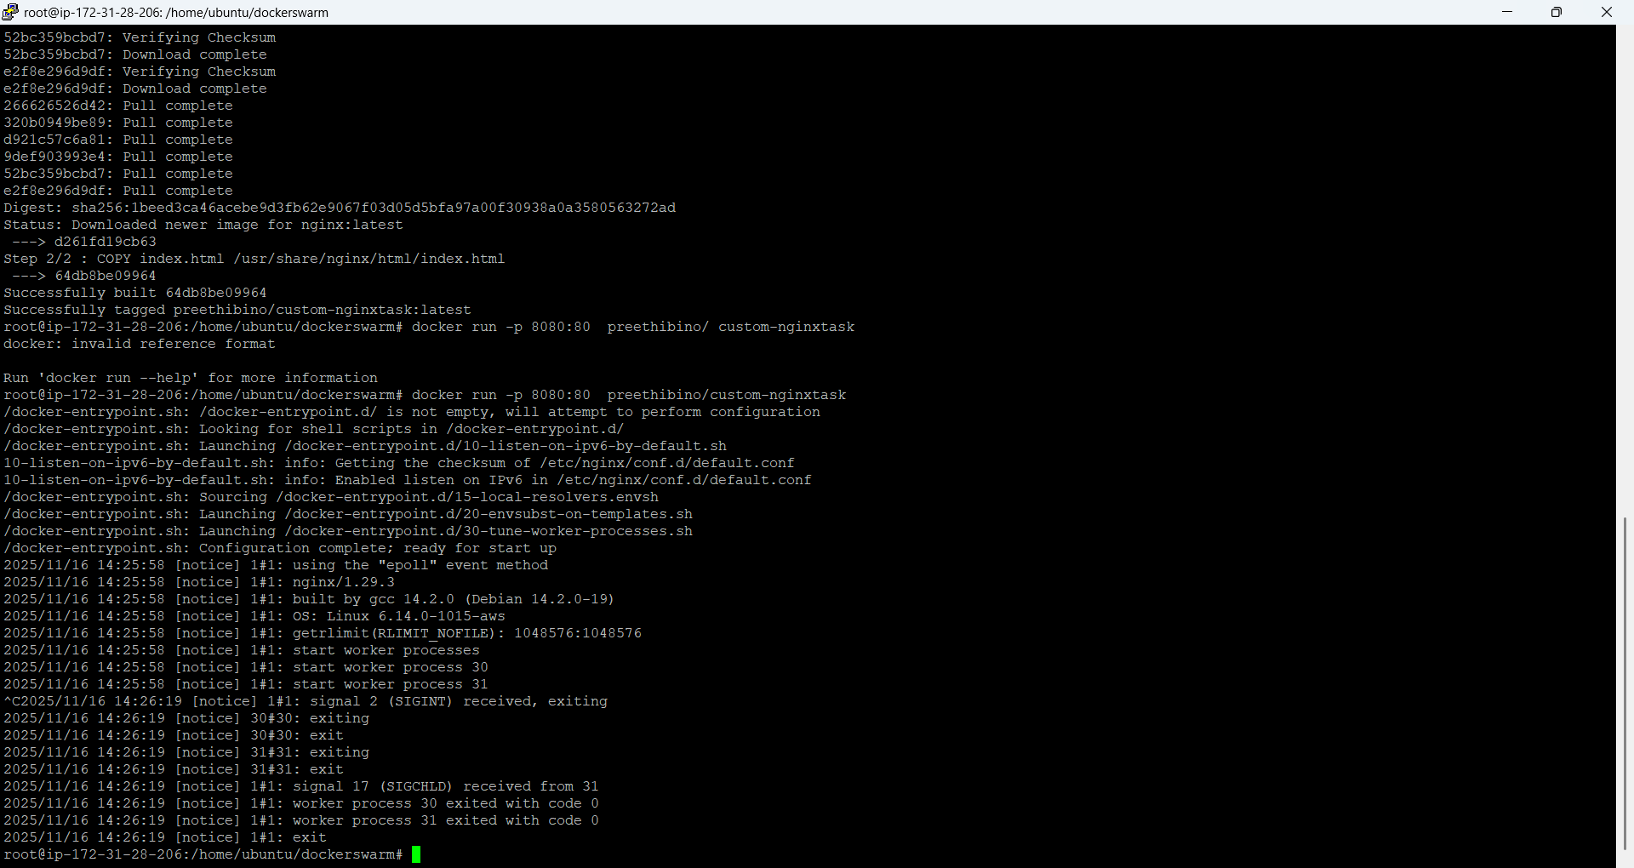

Create a compose file and login to docker - Bind mount is at /var/opt/nginx inside the container.

version: "3.9"

services:
nginx:
image: preethibino/custom-nginxtask
container_name: custom-nginxtask
ports:
- "8080:80"
volumes:
- ./data:/var/opt/nginx
restart: always
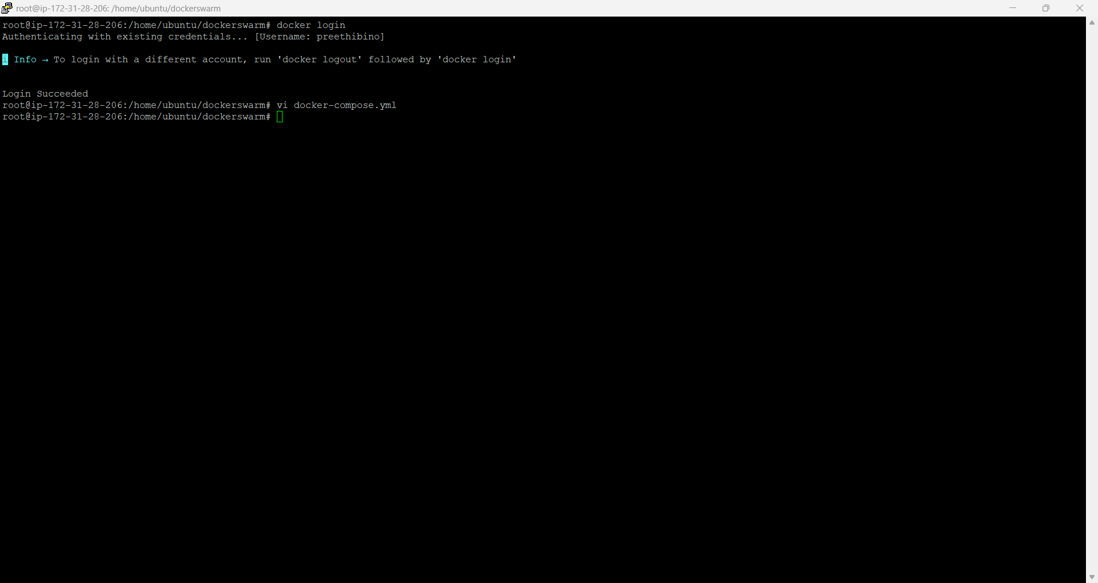

docker push preethibino/custom-nginxtask
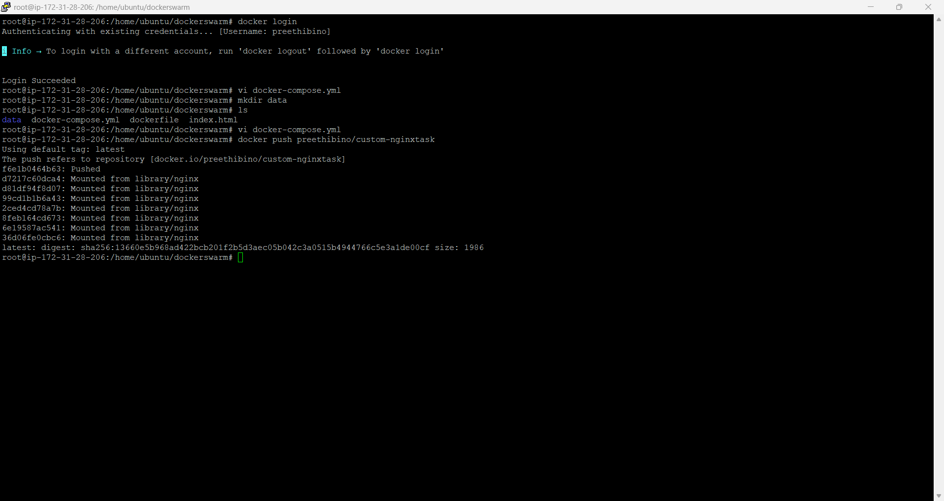

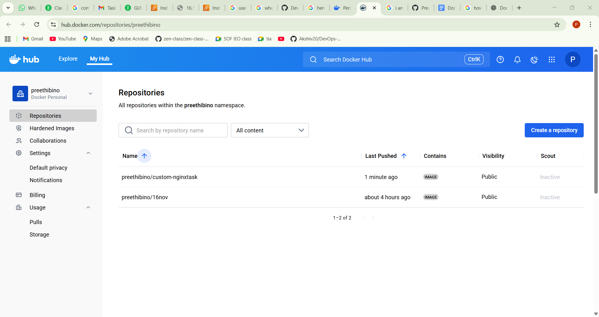

Deploy using docker-compose up -d

