Launch an EC2 instance (Linux and Windows) along with a web server. Then, create an EBS volume of 5 GB, attach it to an EC2 machine (Linux and Windows), and take a snapshot. Finally, create an EBS volume using the taken snapshot.

**AWS Management Console → EC2 → Instances → Launch Instance**.

AMI (Amazon Machine Image)- **Amazon Linux 2**.

• Choose instance type (e.g. t2.micro if Free Tier).

• Configure:

* Key Pair → Select/create.
* Security Group → Allow **SSH (22)** and **HTTP (80)**.

• Storage → Default root volume is usually 8 GB.

• Launch instance.

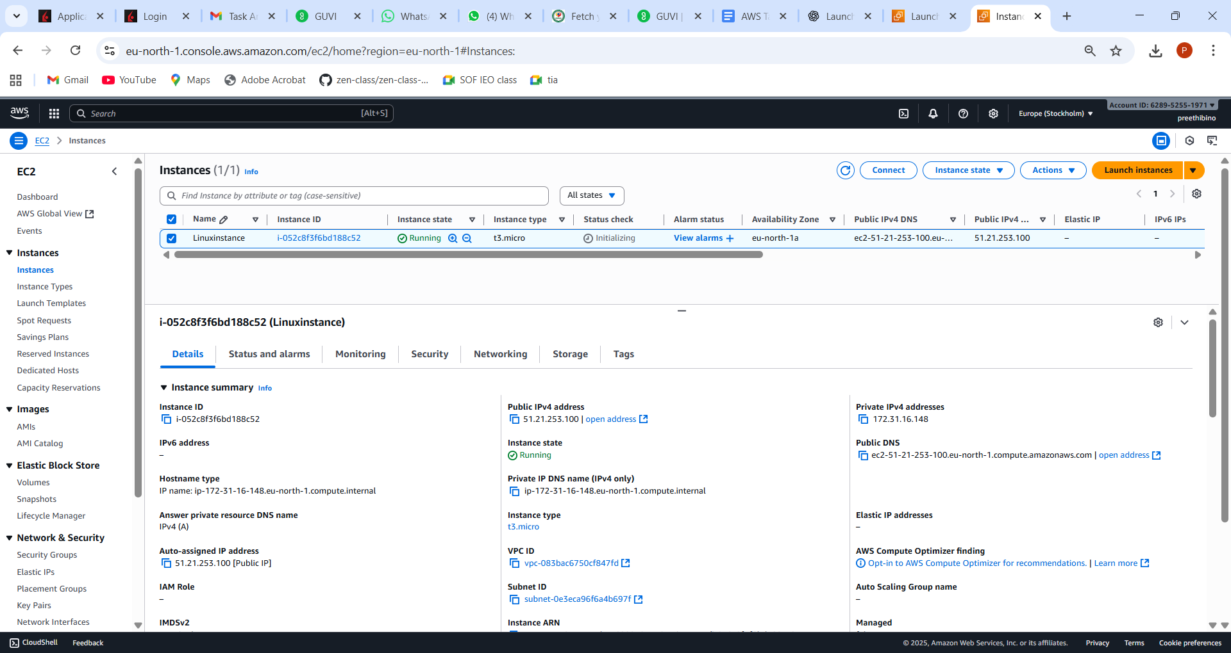

Connect t Linux and installed httpd

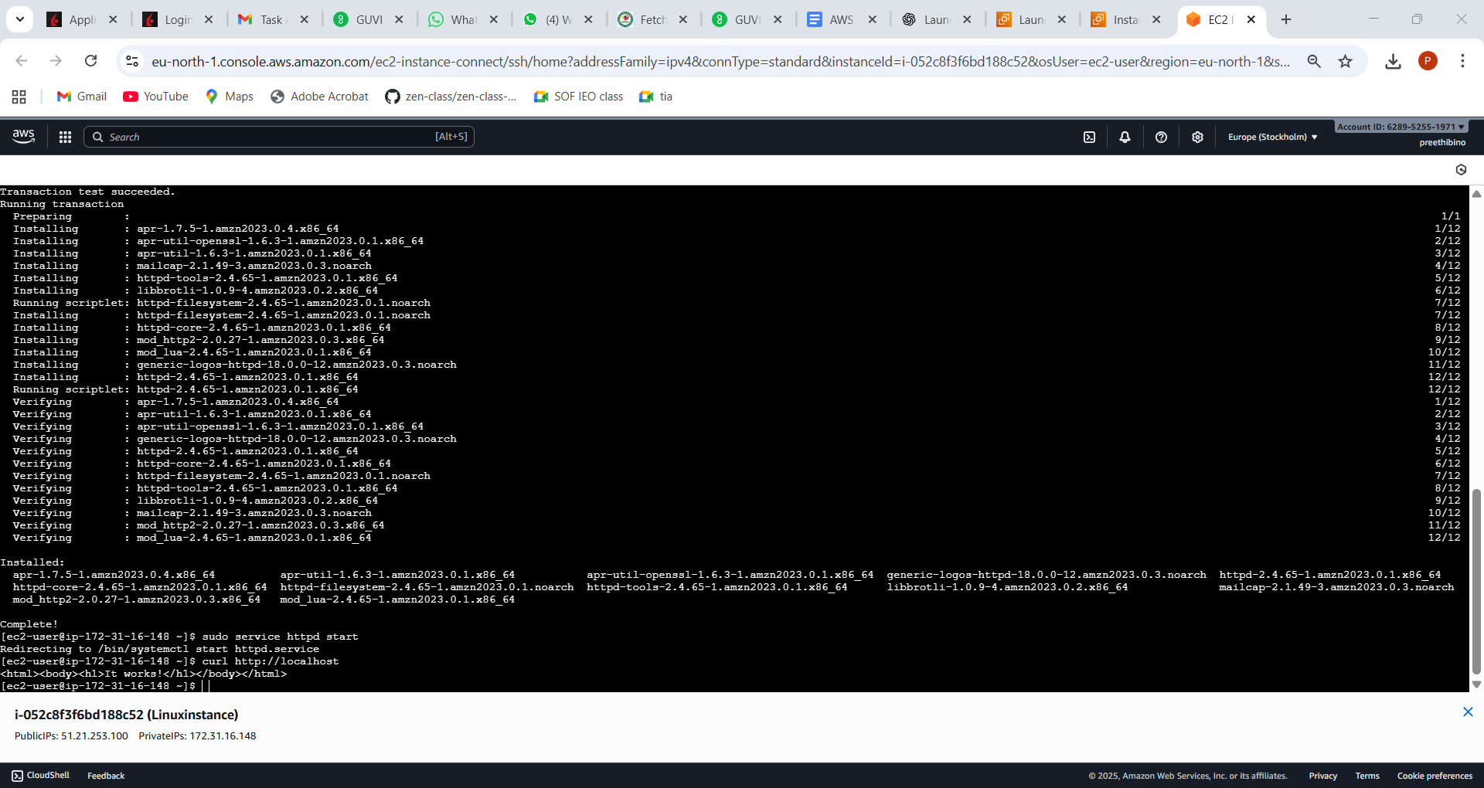

Launch Windows

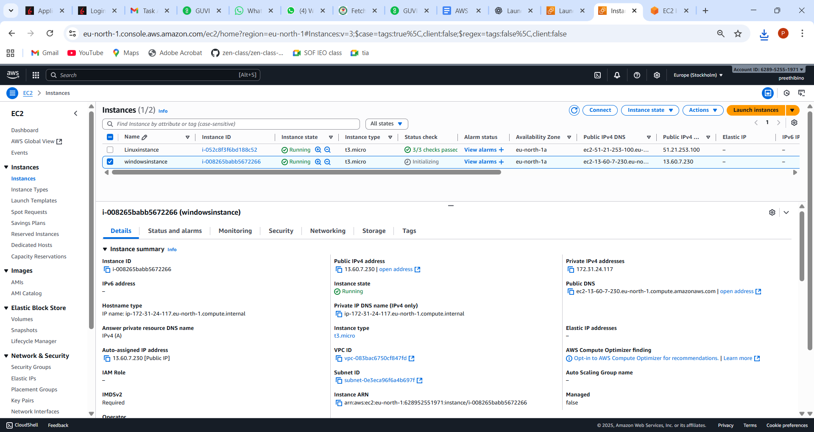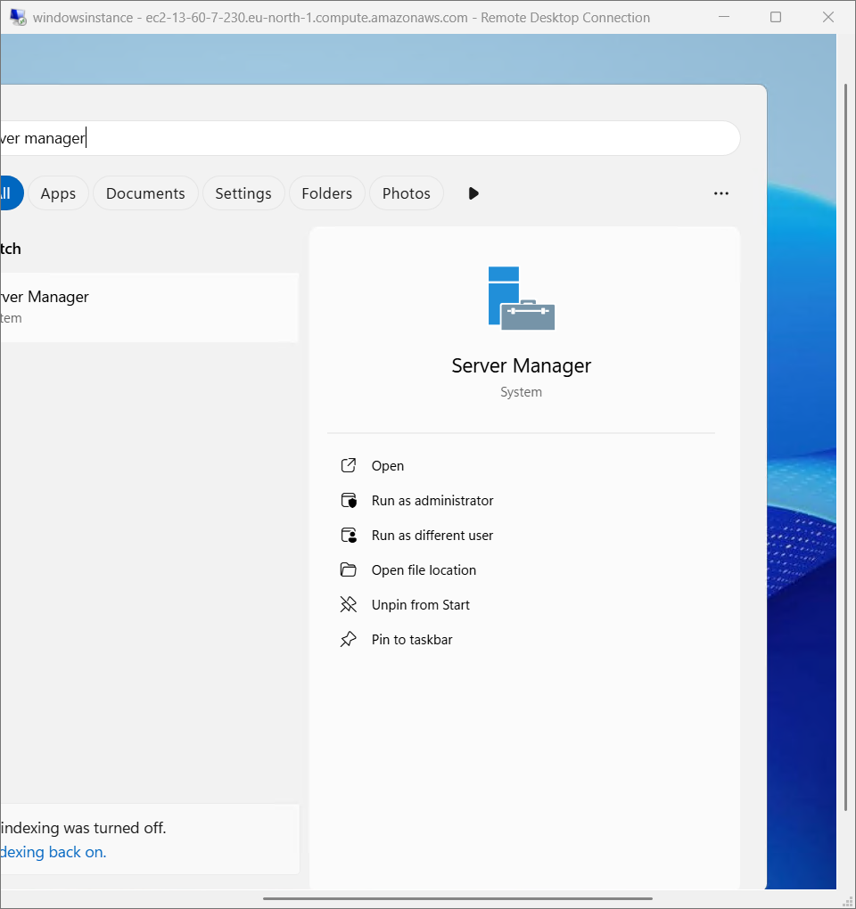

**Web Server (IIS)** → Install.

• Navigate to C:\inetpub\wwwroot\index.html and update content:

<h1>Hello from Windows EC2</h1>

• Open browser → http://<Public_IP> should display the page.

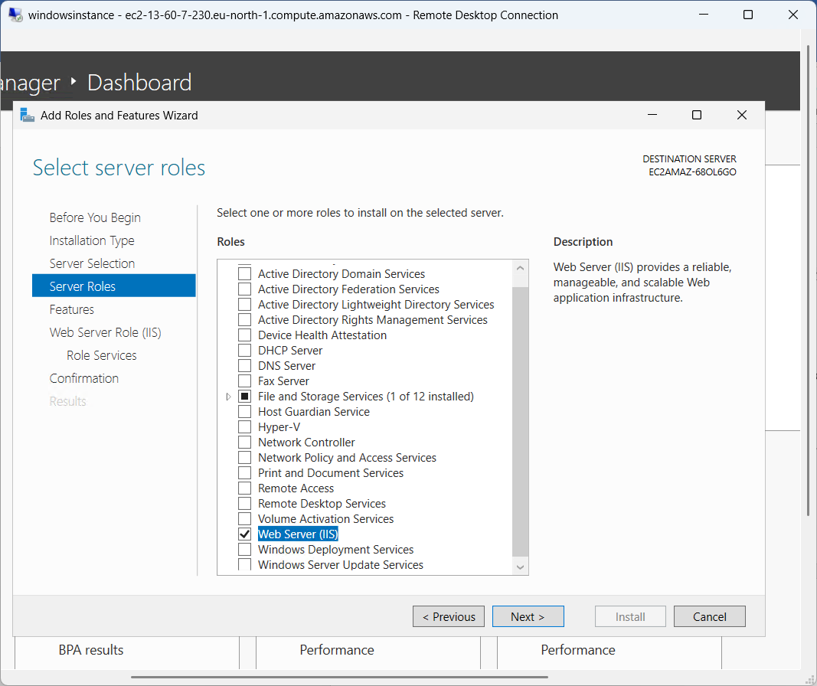

Create Volume

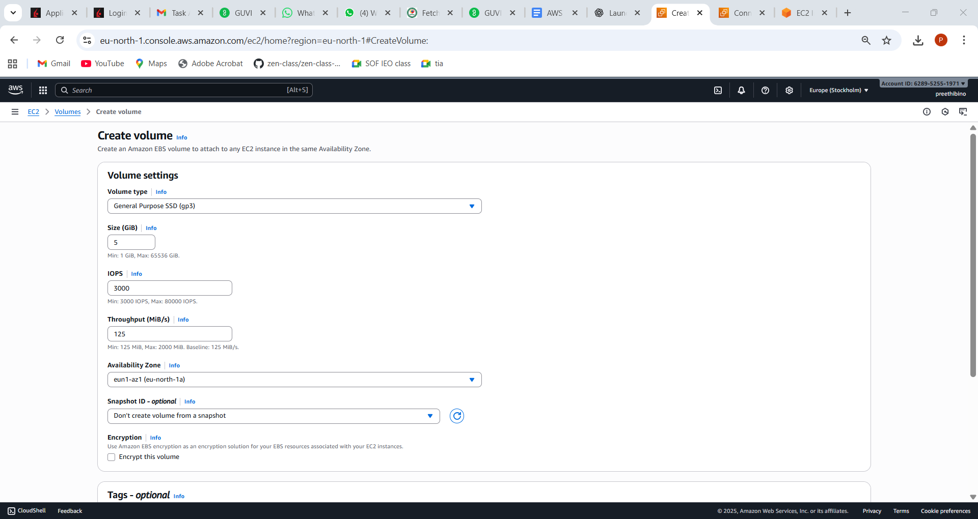

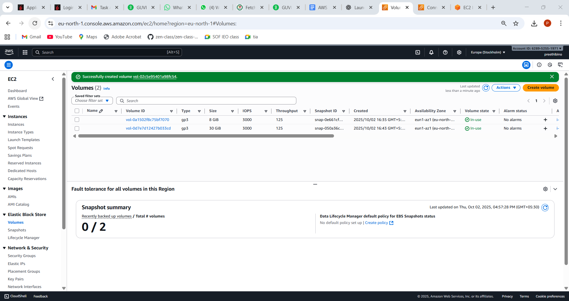

Attach linux instance

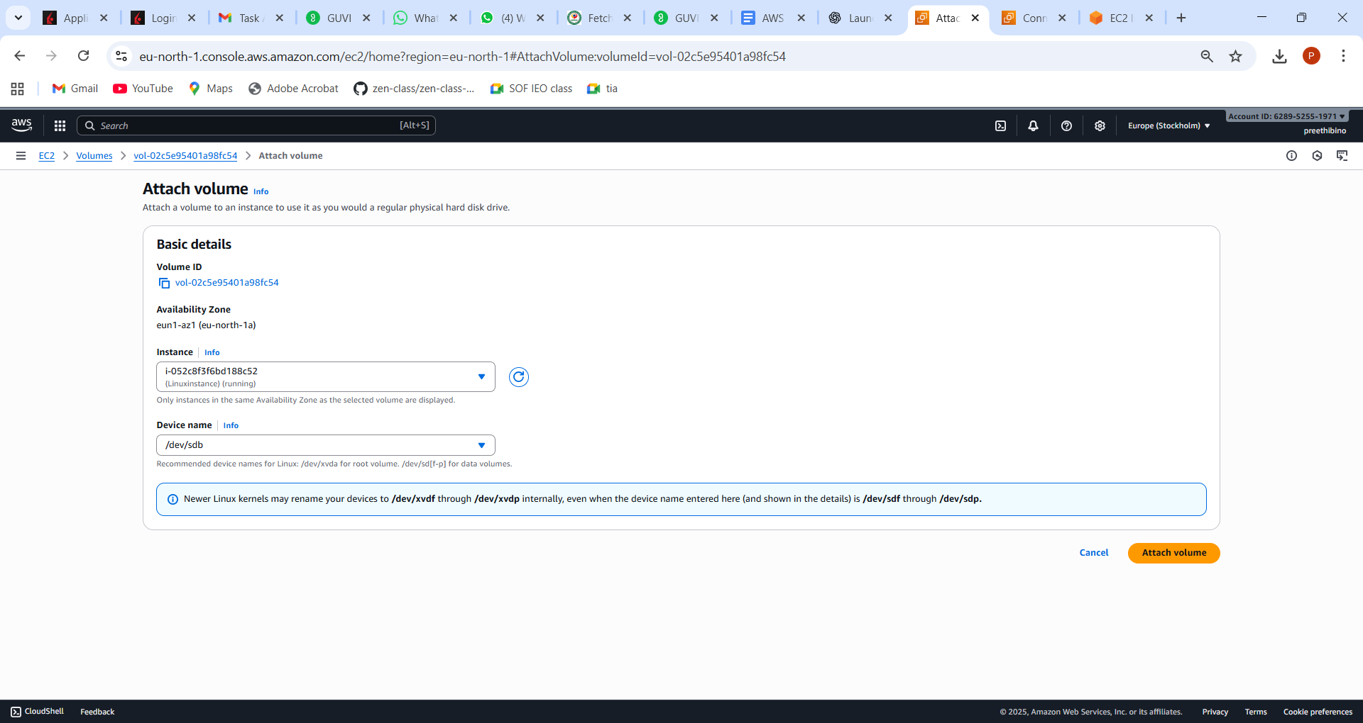

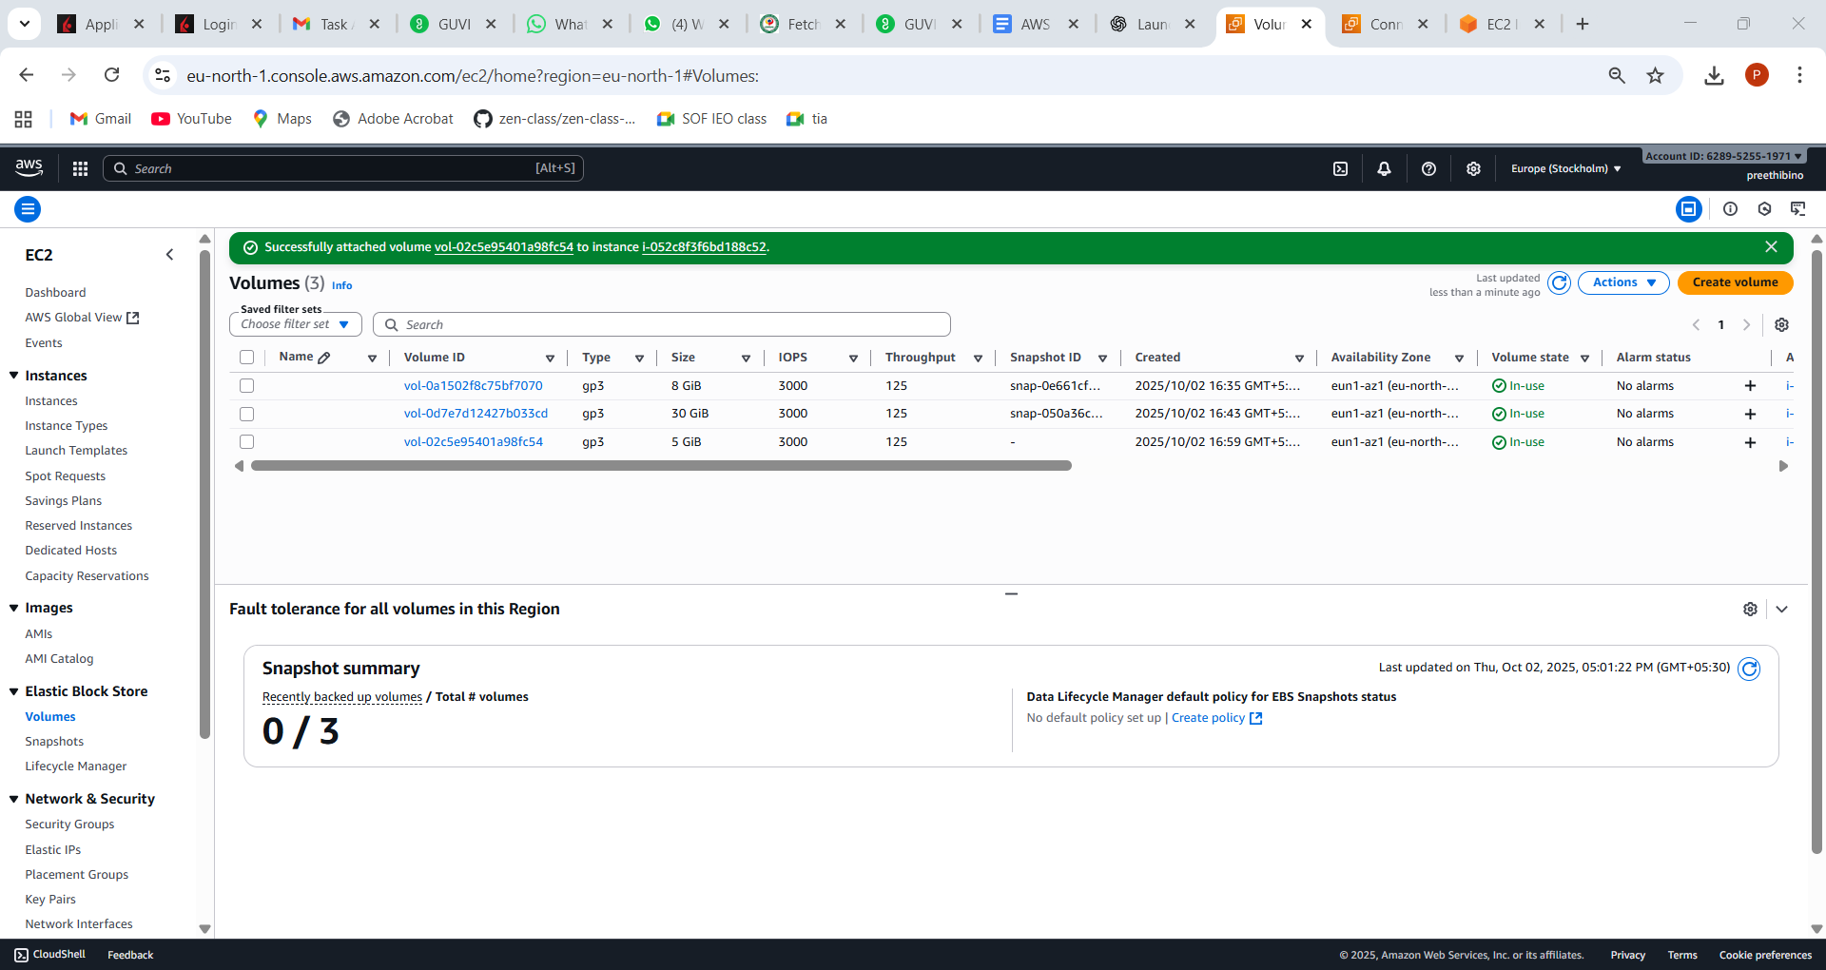

Lsblk lists the volume

sudo mkfs -t xfs /dev/

sudo mkdir /data

sudo mount /dev/xvdf /data

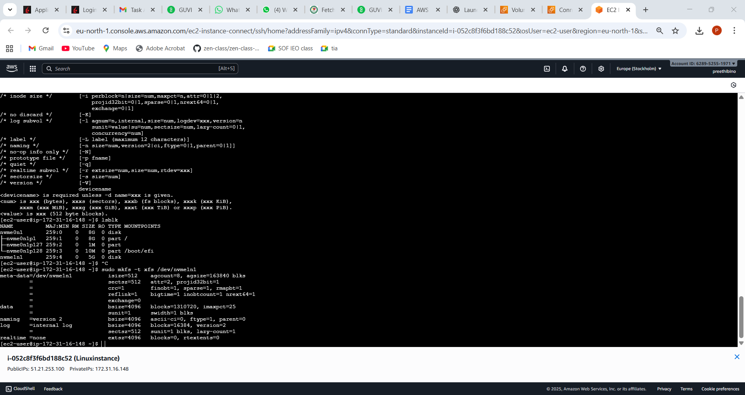

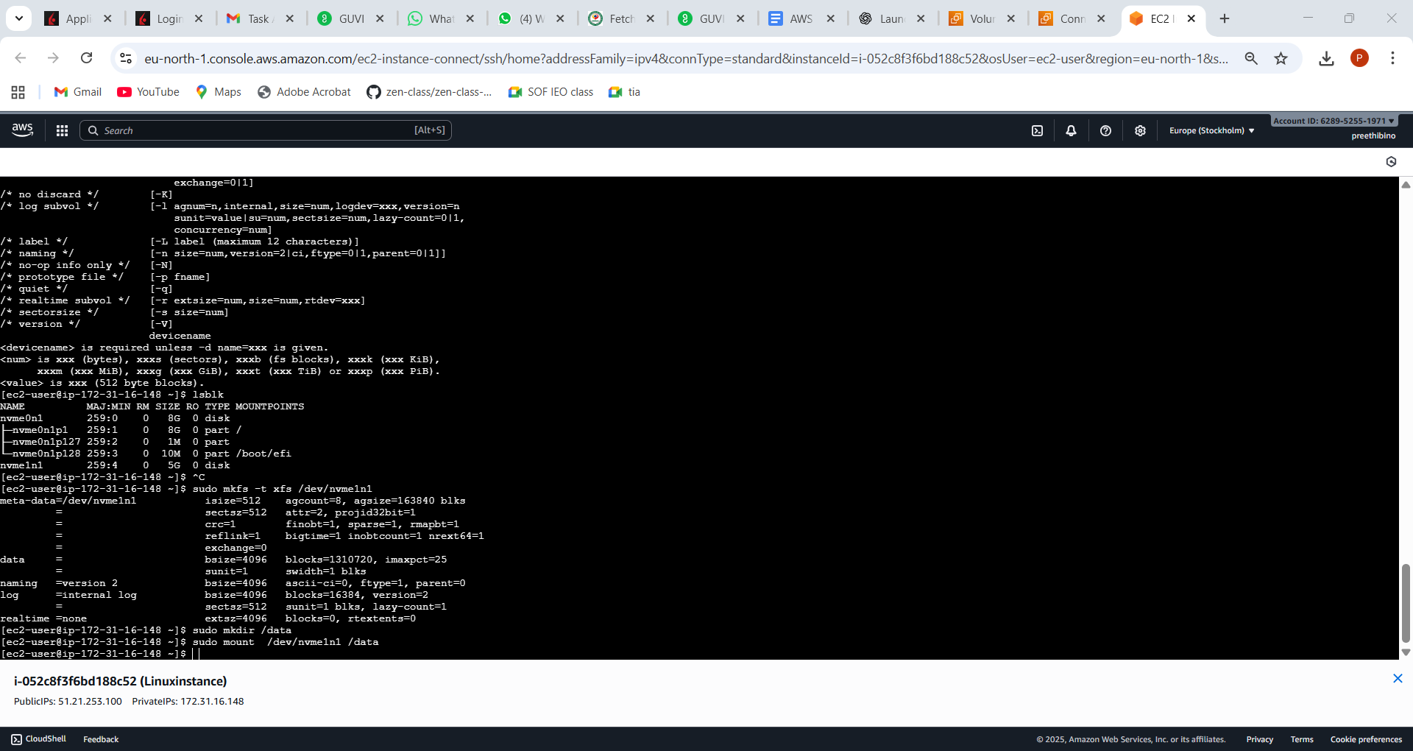

Attaching volume to windows

• Select Volume → **Attach to Windows instance**.

• Open **Disk Management** in Windows

• Initialize disk → Create New Simple Volume → Assign Drive Letter (e.g., D:) → Format (NTFS).

Note—Windows instance didn’t launch – hence providing steps for windows

Create snapshot

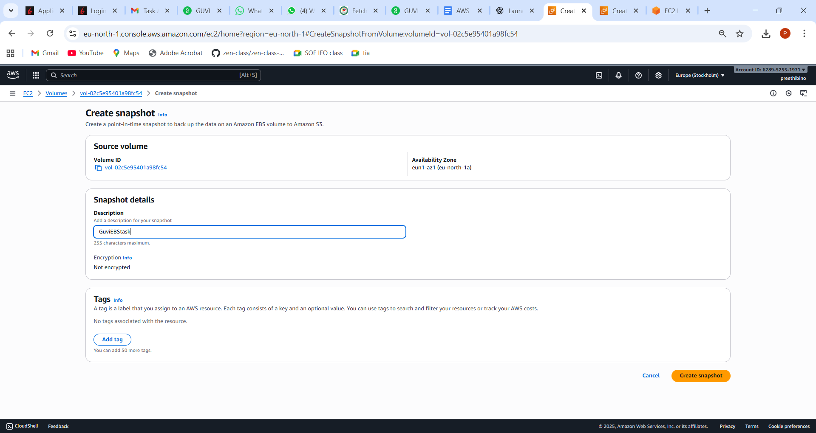

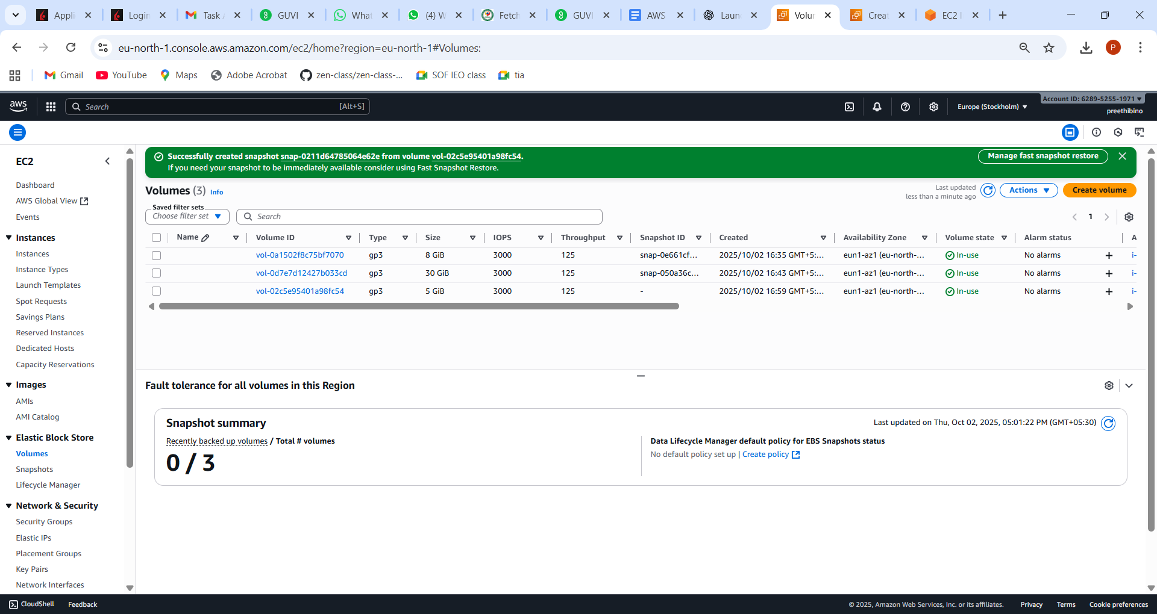

**Create New EBS Volume from Snapshot**

1. Go to **Snapshots → Select snapshot → Actions → Create Volume**.
2. Choose size (≥ snapshot size, e.g., 5 GB).
3. Choose same Availability Zone as your target instance.
4. Create → Attach it to another instance (Linux or Windows).
5. Mount/format it as before.

