**Question 2.** The odds of Kobe making a shot decrease with respect to the distance he is from the hoop. If there is evidence of this, quantify this relationship. (CIs, plots, etc.)

To answer this, we need to model for shot_made_flag agaist distance. In this scenario, we will model for shot kobe does not make. (shot_made_flag = 0).

Let us look at it visually first, the below two charts, we can see for all the shots attempted no shots were successfully made for distance > 50 ft.

Figure 2.1 left: shot_made Vs shot_distance. right: shot_not_made Vs shot_distance.

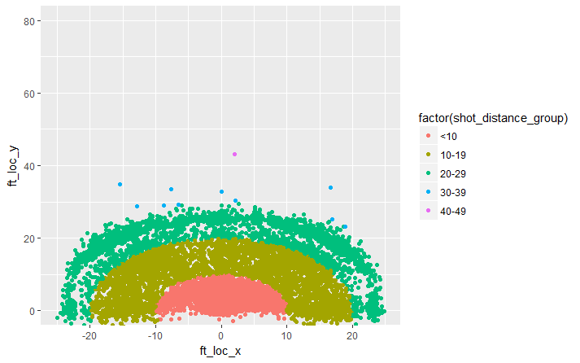 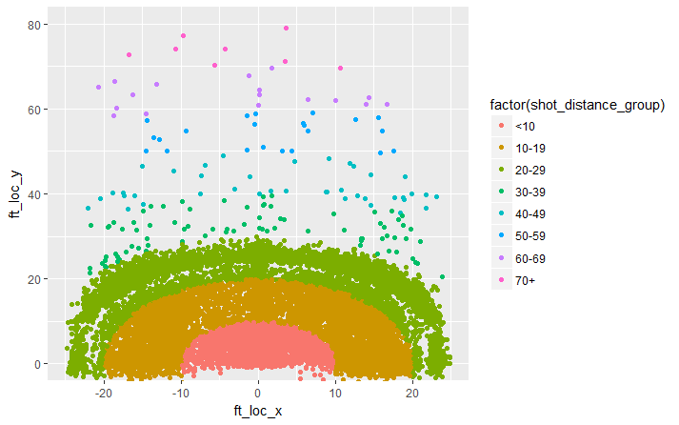

Let us continue to build the model. With shot_made as dependent and shot_distance as independent variable.

**Model assumptions**:

1. The dependent variable is binary, in our case it is shot_made_flag 0/1.
2. The observations are independent.
3. Looking at Hosmer and Lemeshow with p-value < 0.0001, we reject the null hypothesis. The null hypothesis is that the data is a good-fit to the model.

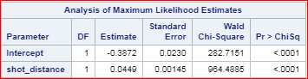

Although, this is not a good-fit model based on Hosmer and Lemeshow , we see that maximum likelihood estimate shows shot_distance is statistically significant and has impact on shot made flag. Hence, we proceed with this model for our interpretation.

**Conclusion:** The odds ratio (for shot_made = 0) to shot distance = 1.046, indicating the odds of not making the shot increases by 1.046 times as each unit (1 ft) increase in shot_distance.