Feature
Feature: Test Orange HRM Login Functionality
Scenario: Successful login with valid credentials
Given I am on the Orange HRM login page
When I enter valid username and password
And I click on the login button
Then I should be redirected to the dashboard page
Test Runner
package runner;
import io.cucumber.junit.Cucumber;
import io.cucumber.junit.CucumberOptions;
import org.junit.runner.RunWith;
@RunWith(Cucumber.class)
@CucumberOptions(features = "C:\\Users\\Preetish\\IdeaProjects\\Bangalore_Testing\\src\\main\\java\\featurefiles",
glue = {"stepDefinition"},
plugin = {"pretty", "html:target/cucumber-reports"},
monochrome = true
)
public class TestRunner {
}
stepDefinition
package stepDefinition;
import io.cucumber.java.en.Given;
import io.cucumber.java.en.Then;
import io.cucumber.java.en.When;
import io.github.bonigarcia.wdm.WebDriverManager;
import org.openqa.selenium.By;
import org.openqa.selenium.WebDriver;
import org.openqa.selenium.chrome.ChromeDriver;
public class OrangeHrmLogin {
public static WebDriver driver;
@Given("I am on the Orange HRM login page")
public void i_am_on_the_orange_hrm_login_page() {
WebDriverManager.chromedriver().setup();
driver = new ChromeDriver();
driver.manage().window().maximize();
driver.navigate().to("https://opensource-demo.orangehrmlive.com/web/index.php/auth/login");
}
@When("I enter valid username and password")
public void i_enter_valid_username_and_password() {
driver.findElement(By.name("username")).sendKeys("Admin");
driver.findElement(By.name("password")).sendKeys("admin123");
}
@When("I click on the login button")
public void i_click_on_the_login_button() {
driver.findElement(By.xpath("//button[@type='submit']")).click();
}
@Then("I should be redirected to the dashboard page")
public void i_should_be_redirected_to_the_dashboard_page() {
driver.findElement(By.xpath("//h6[text()='Dashboard']")).isDisplayed();
String title= driver.getTitle();
System.out.println(title);
// driver.close();
}
}
Feature File
===========
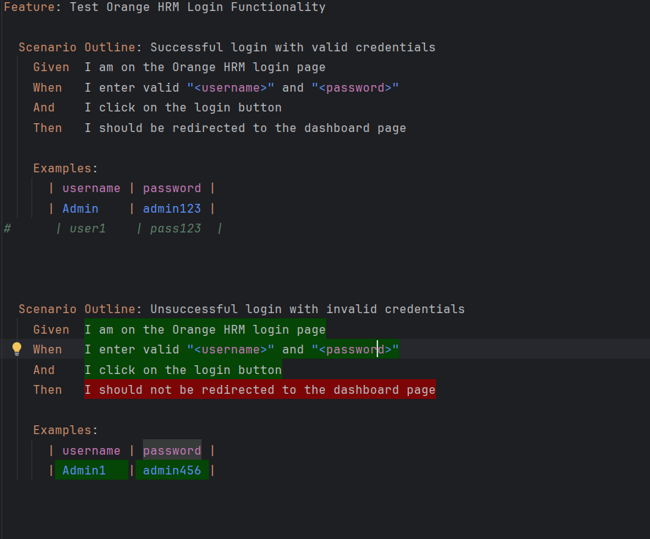

MyHooksclass in separate package
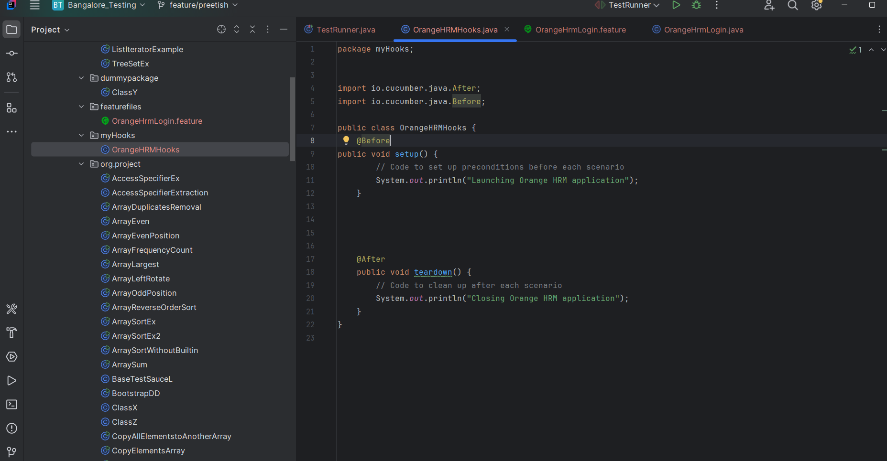
StepDefinition
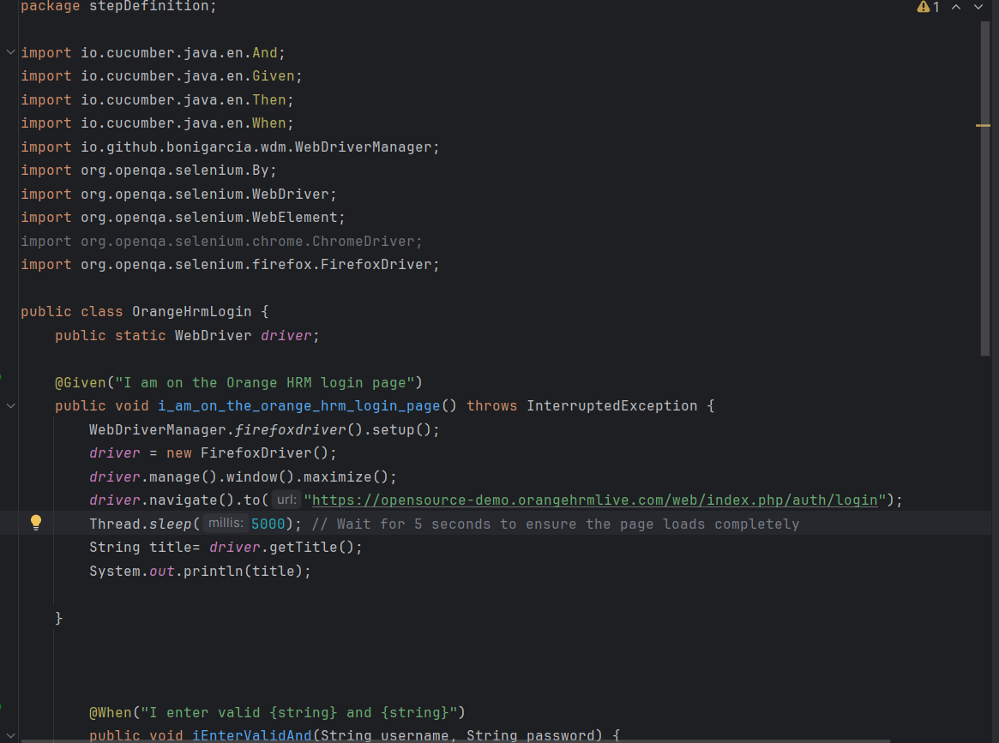
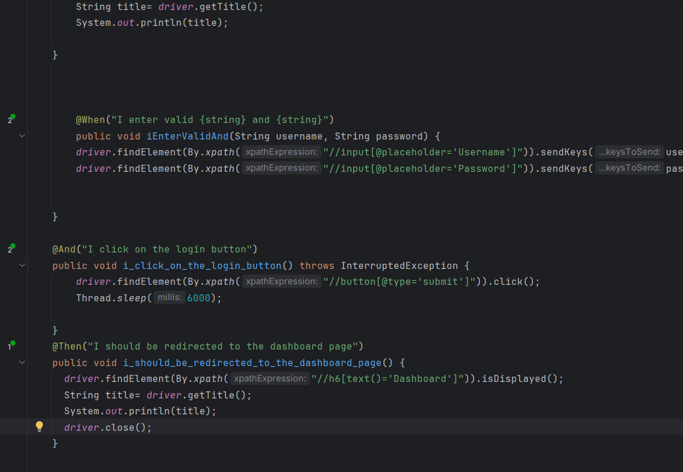
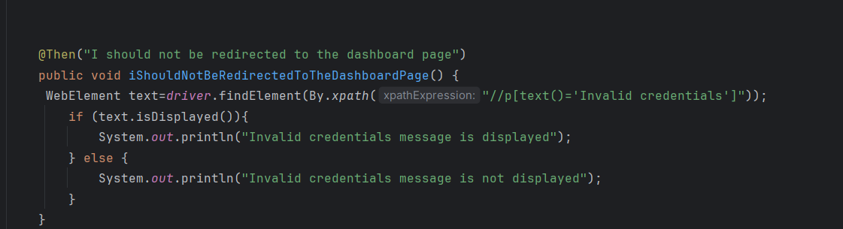
TestRunner
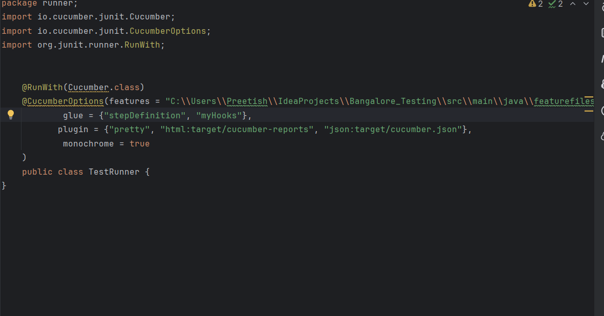
We can run multiple @Before and @After but we can give it order of execution
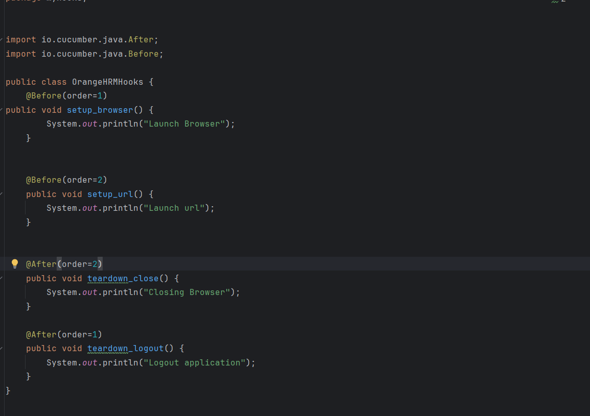
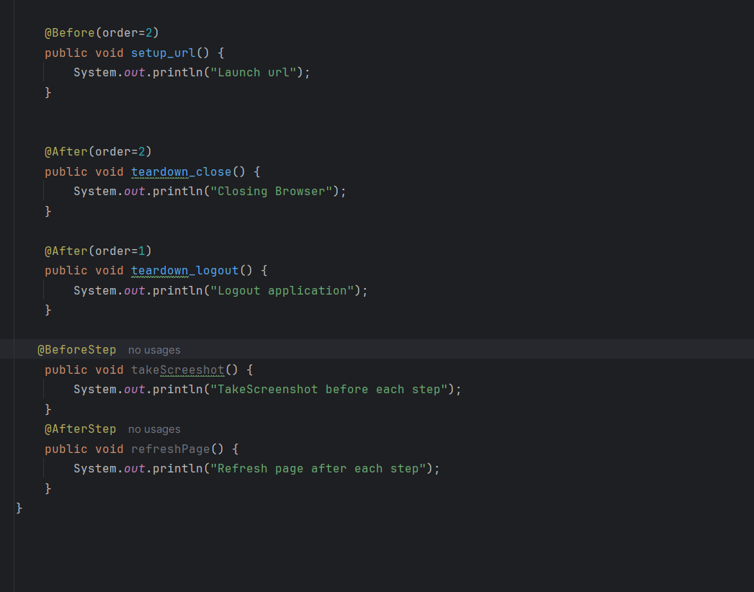
O/p-
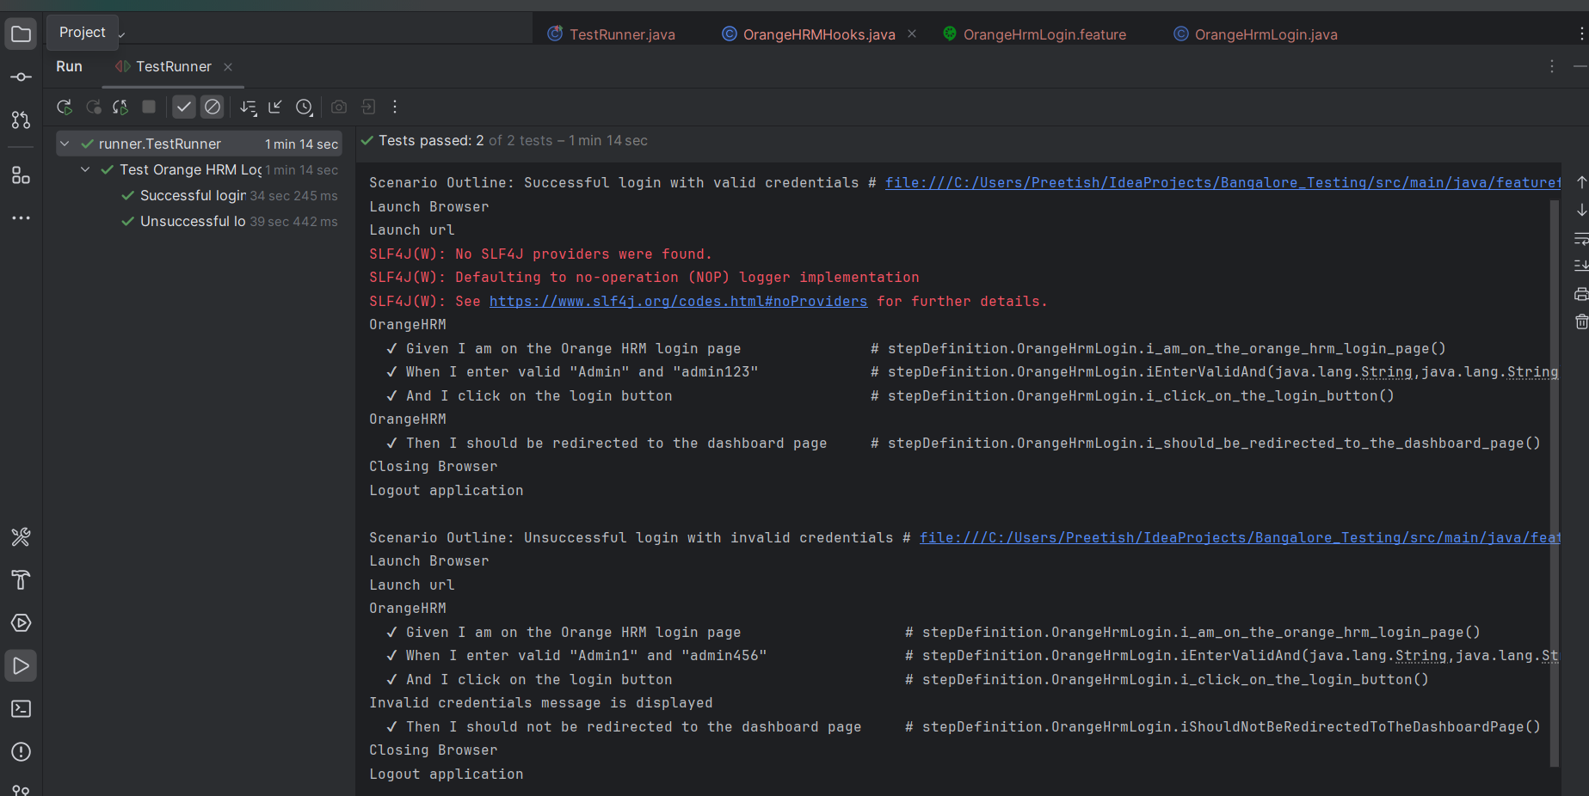
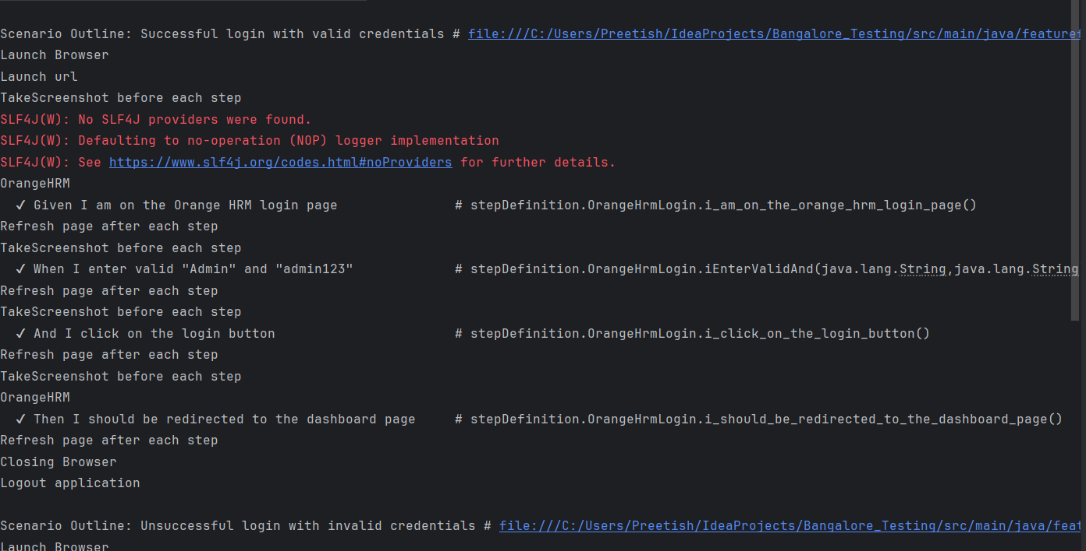
Tags with cucumber hooks
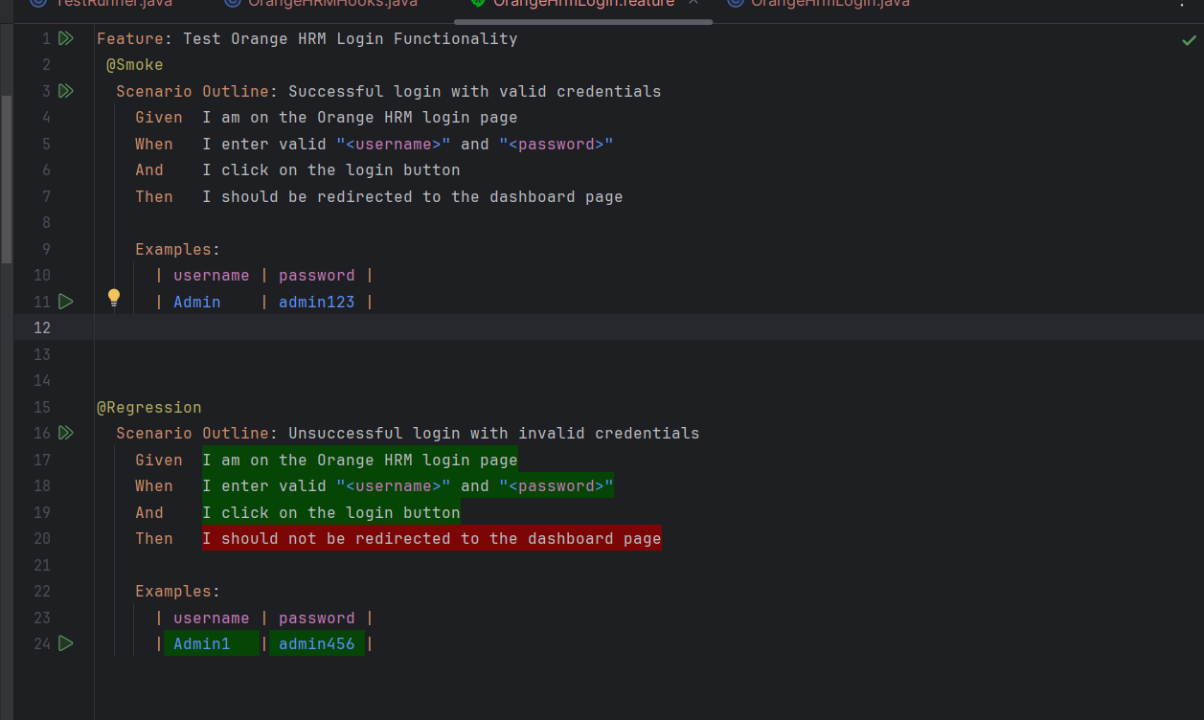
HooksClassfile
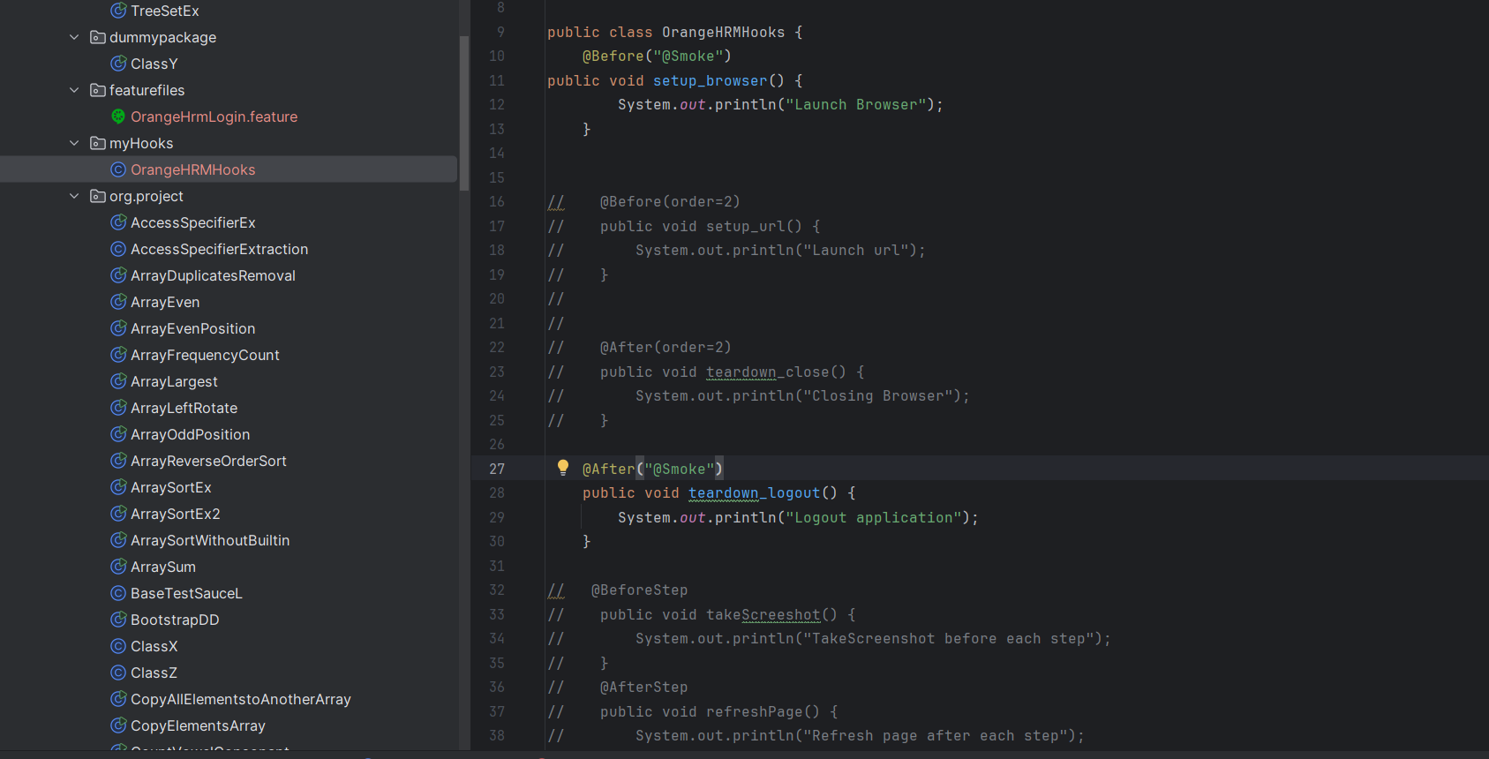
Runner
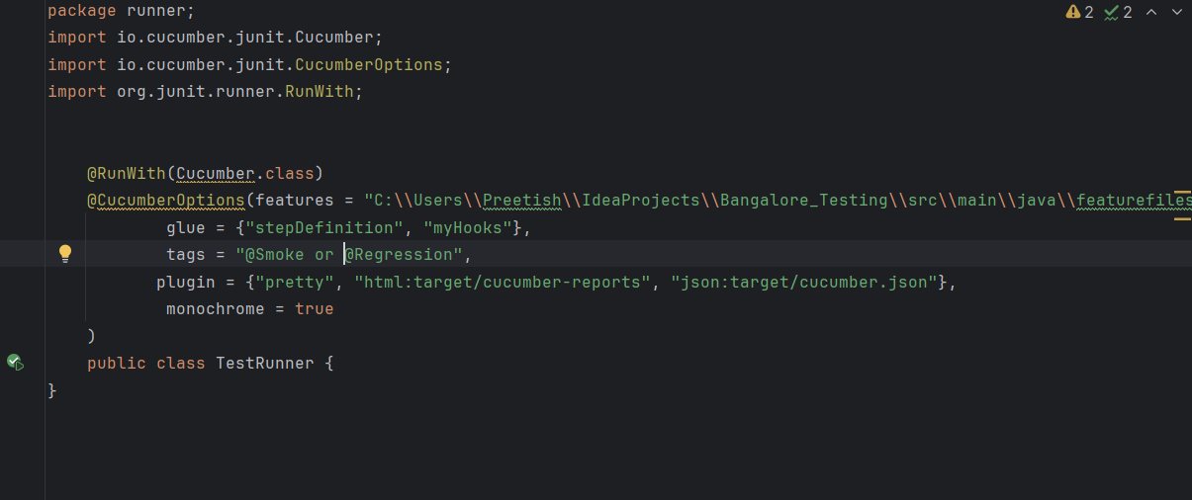

O/-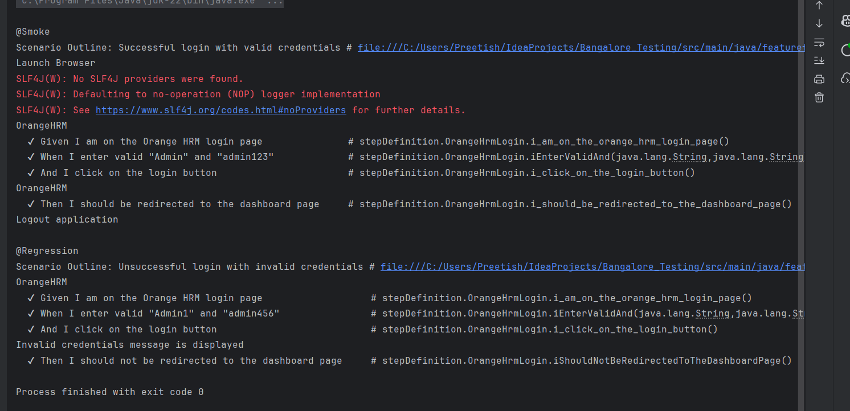
Different Types of Hooks in cucumber
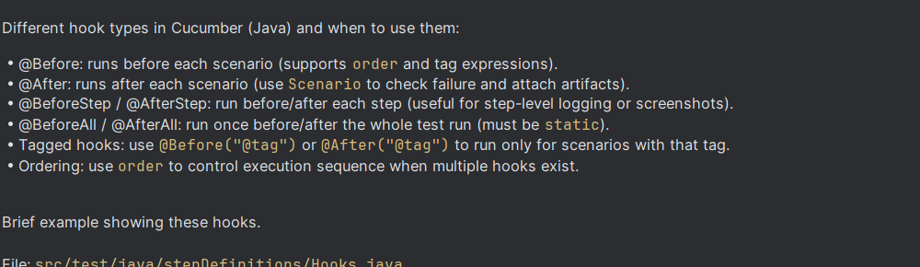
package stepDefinitions;
import io.cucumber.java.*;
import io.cucumber.java.Scenario;
import org.openqa.selenium.*;
import org.openqa.selenium.chrome.ChromeDriver;
import io.github.bonigarcia.wdm.WebDriverManager;
public class Hooks {
public static WebDriver driver;
@BeforeAll
public static void beforeAll() {
System.out.println("BeforeAll: global setup (runs once)");
}
@Before(order = 1)
public void beforeScenario(Scenario scenario) {
System.out.println("Before: starting scenario -> " + scenario.getName());
WebDriverManager.chromedriver().setup();
driver = new ChromeDriver();
driver.manage().window().maximize();
}
// Tagged hook: runs only for scenarios tagged with @db
@Before("@db")
public void beforeDbScenario() {
System.out.println("Before: DB setup for @db scenarios");
}
@BeforeStep
public void beforeStep(Scenario scenario) {
System.out.println("BeforeStep: scenario -> " + scenario.getName());
}
@AfterStep
public void afterStep(Scenario scenario) {
System.out.println("AfterStep: scenario -> " + scenario.getName());
}
@After(order = 1)
public void afterScenario(Scenario scenario) {
if (scenario.isFailed() && driver != null) {
byte[] screenshot = ((TakesScreenshot) driver).getScreenshotAs(OutputType.BYTES);
scenario.attach(screenshot, "image/png", "failure-screenshot");
}
if (driver != null) {
driver.quit();
driver = null;
}
System.out.println("After: finished scenario -> " + scenario.getName());
}
@AfterAll
public static void afterAll() {
System.out.println("AfterAll: global teardown (runs once)");
}
}
BackGround
It is a Step or a group of steps that are common to all the scenarios in a feature
>it is defined once in feature
>Runs before every scenario of the feature
Why use background?
>To avoid repeating the common steps in every scenario
>For better readability and maintenance
When to use Background?
>Whenever there is common repeating steps in feature
>When you want the common steps to be visible to the readers
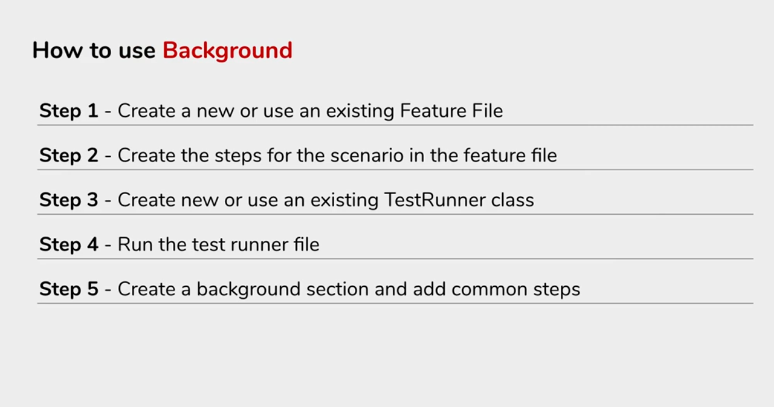
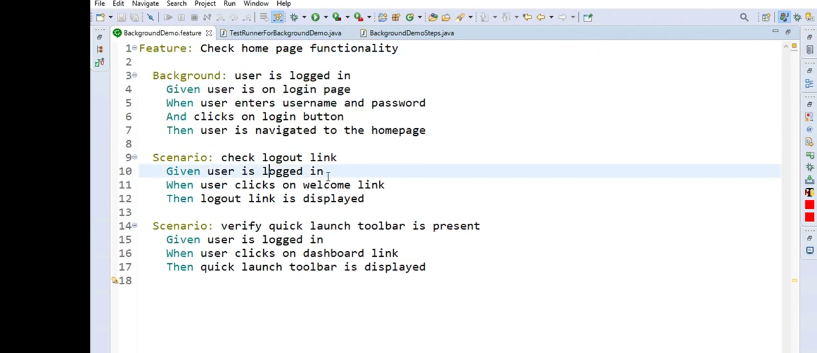
Note:-Here Given user is on login page is common for all scenarios so , I am removing it from scenario and creating a Background and writing my login steps inside it so that for each scenario it will be common and reusable
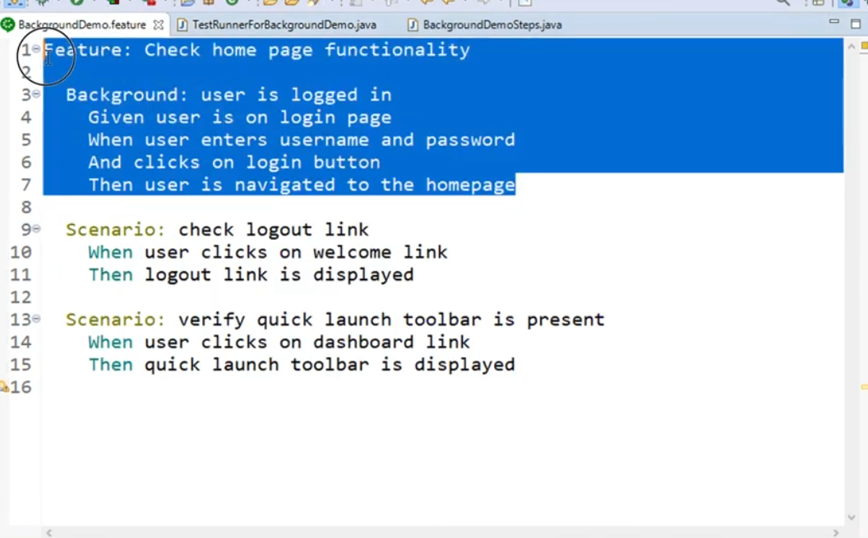
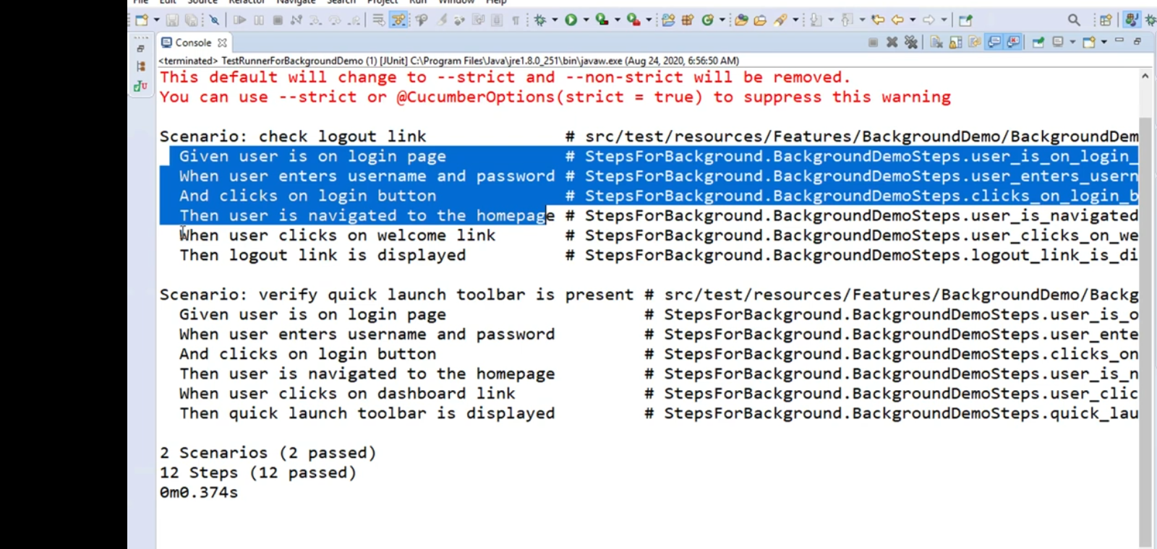
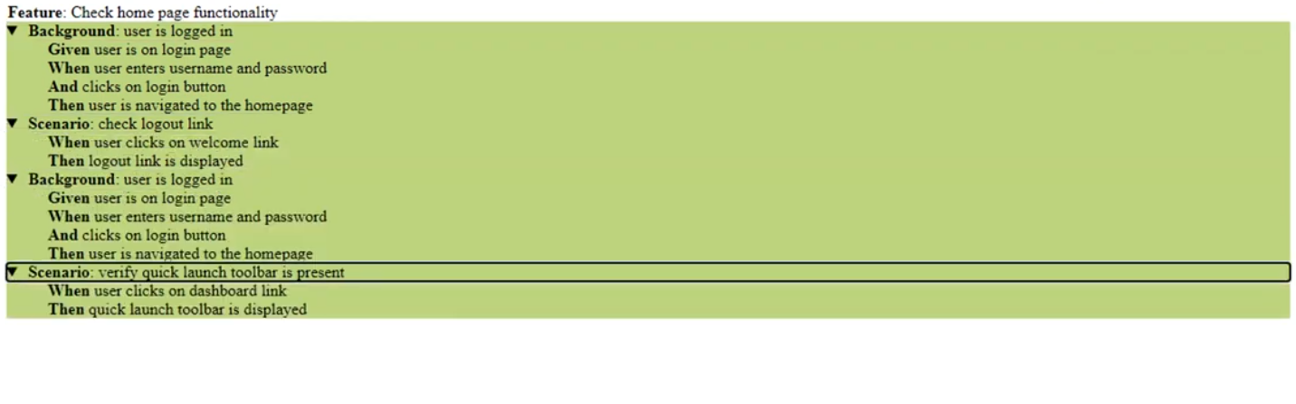
Differentiate between Background/Hook/Tags in cucumber
Hooks
Purpose: setup/teardown code executed by Cucumber (e.g., start/quit browser, capture screenshots).
Scope & timing: run before/after scenarios or steps (annotations: @Before, @After, @BeforeStep, @AfterStep, @BeforeAll, @AfterAll).
Control: can use order and tag expressions (e.g., @Before(order = 1), @Before("@db")).
Use-case: programmatic actions that must run around scenarios/steps.
Background
Purpose: shared Gherkin steps placed at the top of a feature file to avoid repetition.
Scope & timing: runs automatically before every Scenario (and Scenario Outline) in that feature file only.
Control: no programmatic ordering; plain Gherkin steps only.
Use-case: common preconditions expressed as Given steps (e.g., user logged in).
Tags
Purpose: labels applied to Feature or Scenario to group, filter, or target behavior.
Scope & timing: affect which scenarios run (via runner/CLI) and can target tagged hooks or test selection.
Control: used in runner/CLI to include/exclude scenarios and in hooks (@Before("@tag")).
Use-case: run subsets (smoke, regression), apply tagged setup/teardown, parallel selection.
Feature File
# Feature file (example.feature)
Feature: Example feature
@smoke
Background:
Given the application is up
And the user is on the login page
@login @db
Scenario: Successful login
When the user enters valid credentials
Then the user sees the dashboard
Stepdefn
// Java hooks class (Hooks.java)
// Brief: shows a global @Before, a tagged @Before("@db"), and an @After that captures screenshots on failure.
package stepDefinitions;
import io.cucumber.java.*;
import org.openqa.selenium.*;
import io.github.bonigarcia.wdm.WebDriverManager;
import org.openqa.selenium.chrome.ChromeDriver;
public class Hooks {
public static WebDriver driver;
@BeforeAll
public static void beforeAll() {
// runs once before all scenarios
System.out.println("Global setup");
}
@Before(order = 1)
public void setUp(Scenario scenario) {
// runs before each scenario
WebDriverManager.chromedriver().setup();
driver = new ChromeDriver();
driver.manage().window().maximize();
}
@Before("@db")
public void dbSetup() {
// runs only for scenarios tagged with @db
System.out.println("DB setup for @db scenarios");
}
@After
public void tearDown(Scenario scenario) {
// runs after each scenario; attach screenshot on failure
if (scenario.isFailed() && driver != null) {
byte[] screenshot = ((TakesScreenshot) driver).getScreenshotAs(OutputType.BYTES);
scenario.attach(screenshot, "image/png", "failure-screenshot");
}
if (driver != null) {
driver.quit();
driver = null;
}
}
@AfterAll
public static void afterAll() {
// runs once after all scenarios
System.out.println("Global teardown");
}
}

