git init — Initializes a new Git repository in your current directory.
Bash
git init
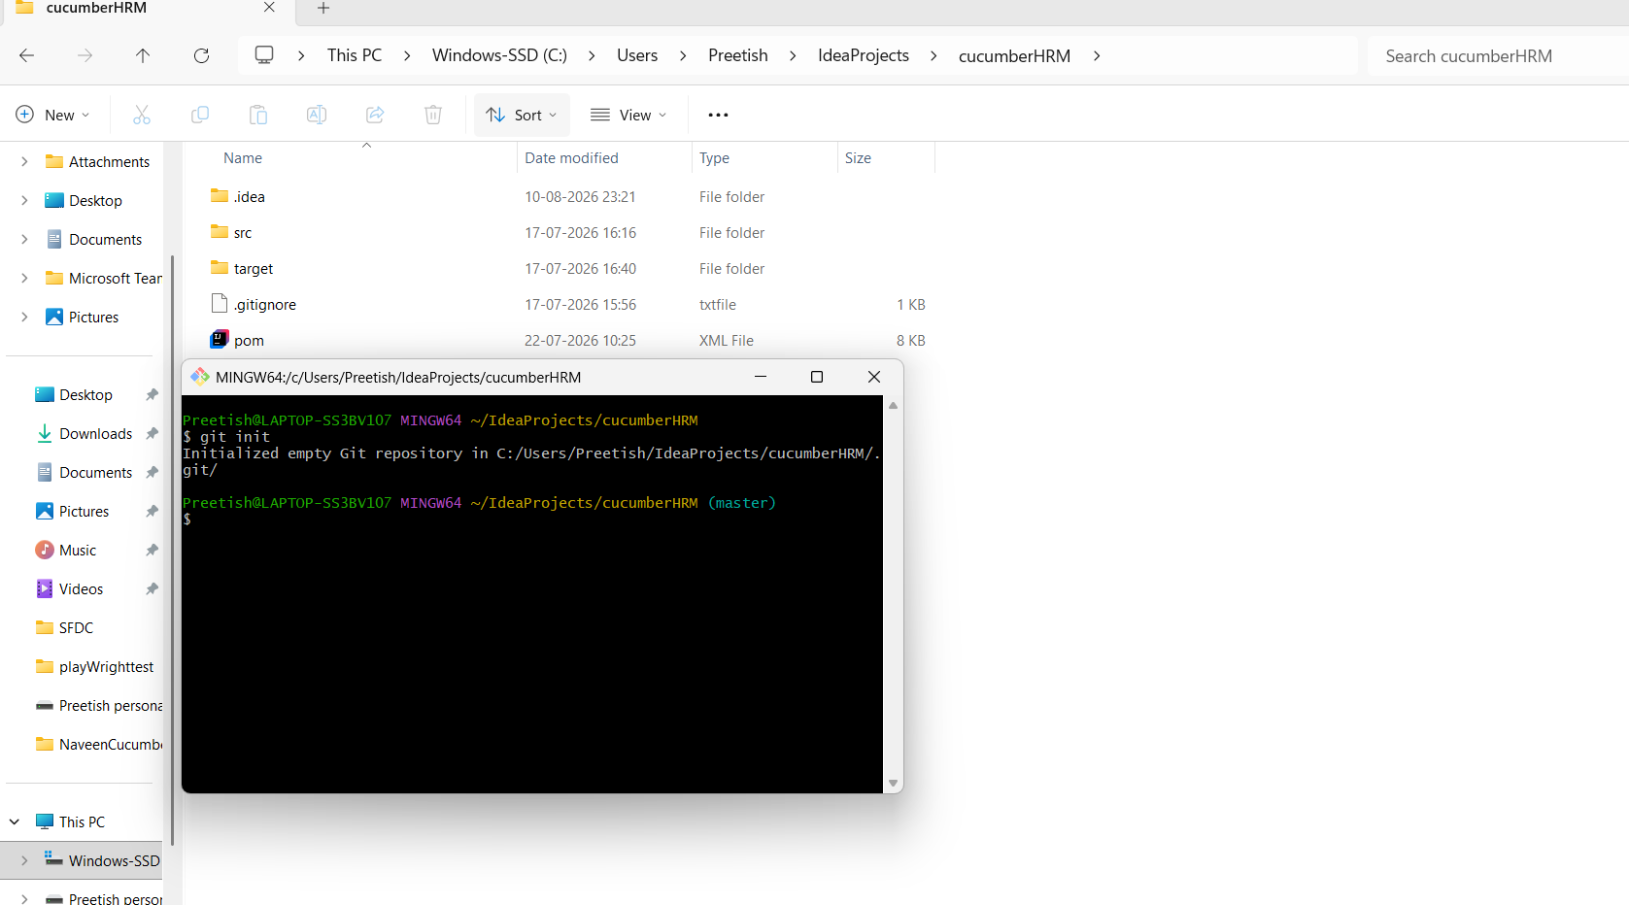
git clone <url> — Copies an existing remote repository to your local machine.
Bash
git clone https://github.com/user/repository.git

Git add remote repository github url to connect with your local git
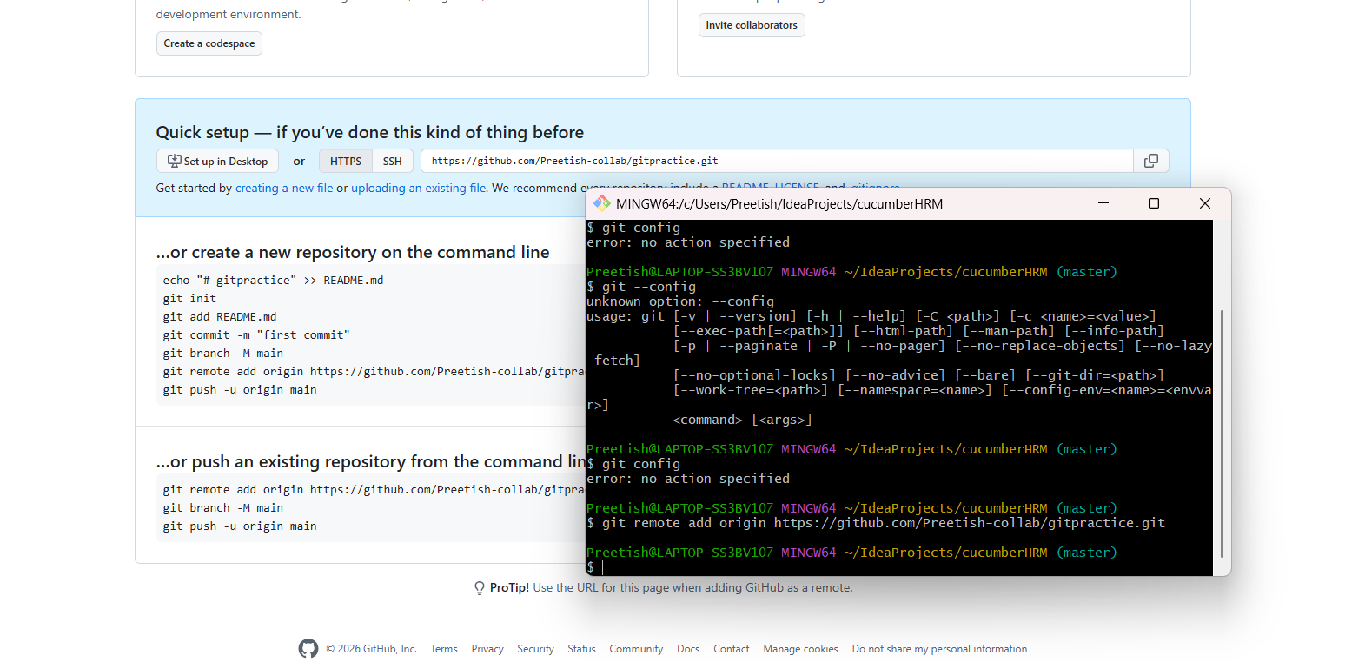
Configuring Settings
- git config — Sets your username and email for commit attribution.
Bash
Set Global Identity (Recommended)
git config --global user.name "Your Name"
git config --global user.email "you@example.com"
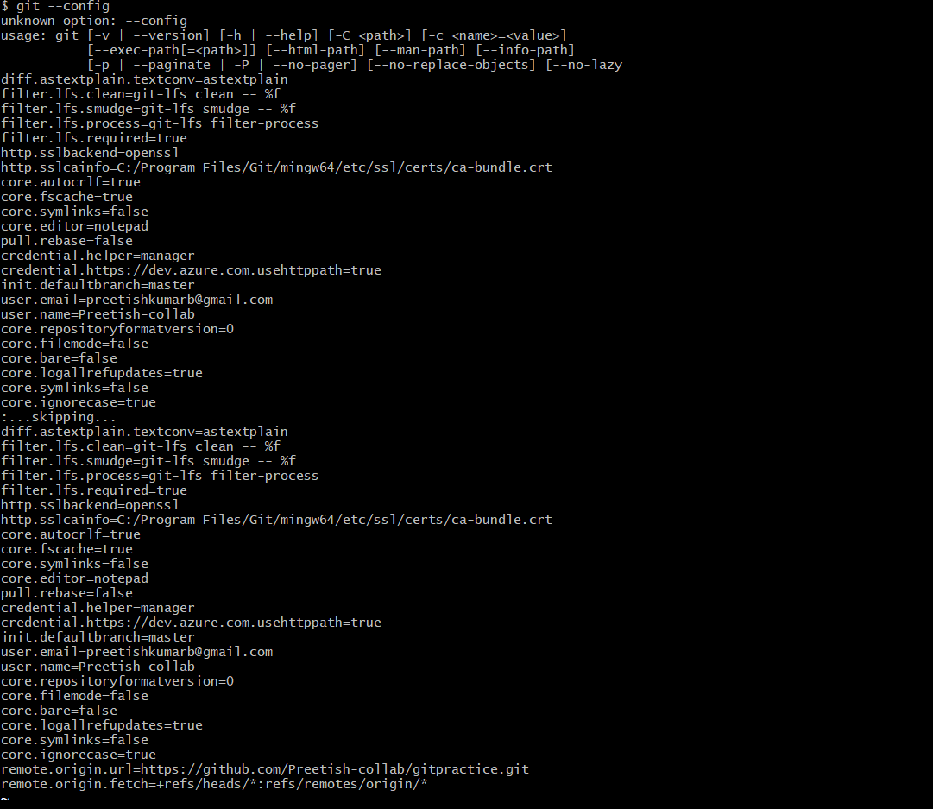
Set Local Identity (Per Repository)
git config user.name "Your Name"
git config user.email "your_email@example.com"
View all settings: git config –list
Staging & Committing Changes
- git status — Shows the state of the working directory and staging area (modified, untracked, staged files).
Bash
git status
- git add <file> — Adds files from the working directory to the staging area.
Bash
git add index.html # Add a single file
git add . # Add all changed files
- git commit -m "<message>" — Saves staged snapshots to the project history with a descriptive message.
Bash
git commit -m "Fix navigation bar responsiveness"
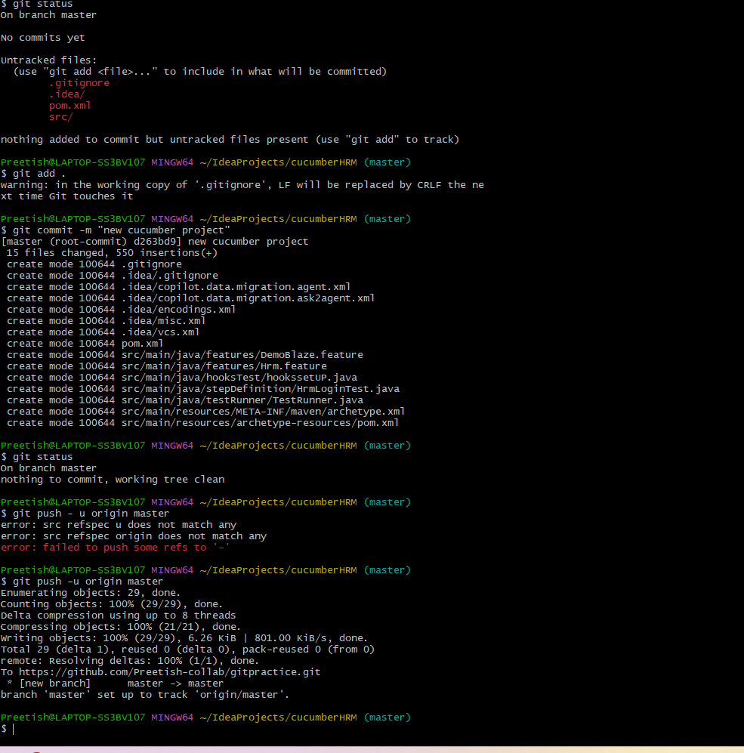
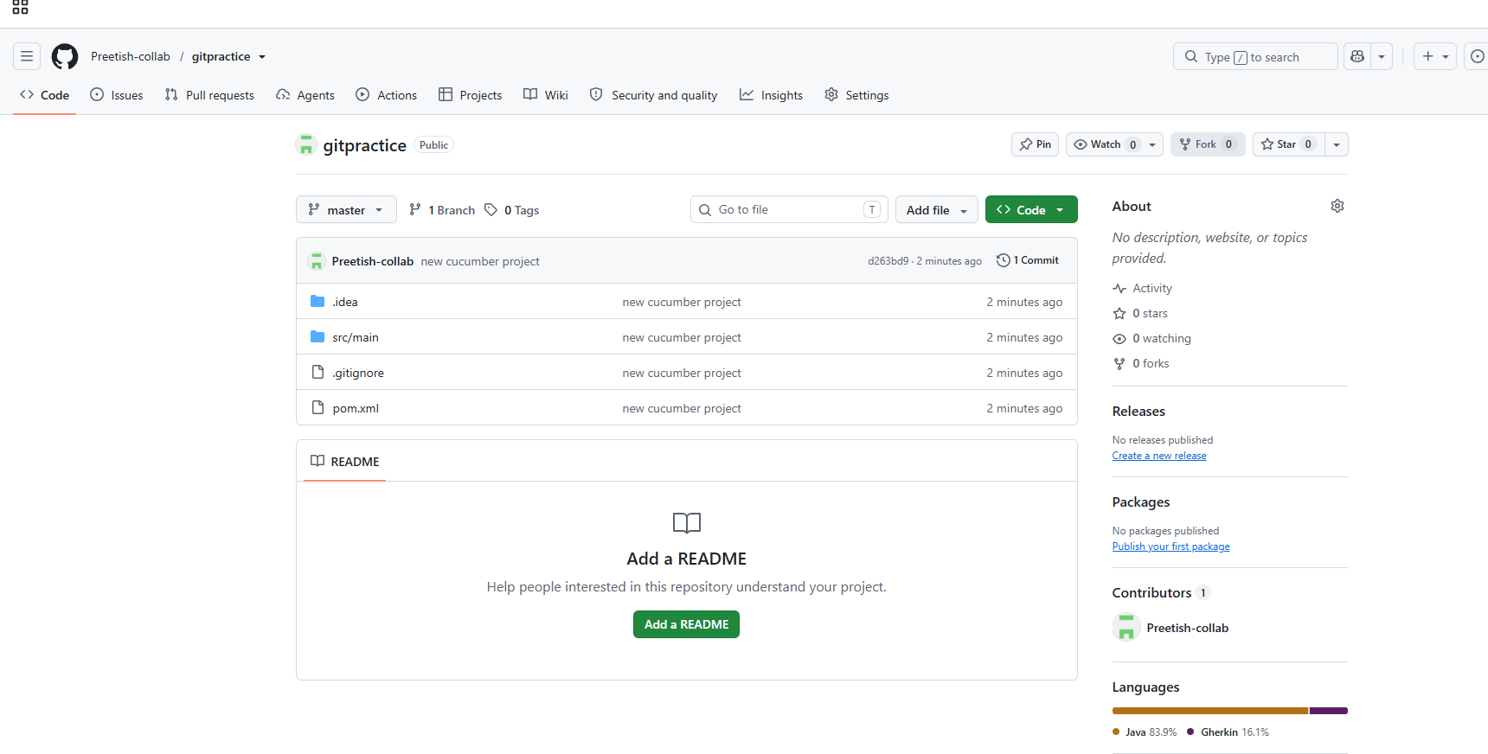
Inspecting & Comparing
- git log — Displays the commit history for the current branch.
Bash
git log --oneline # View condensed commit history
- git diff — Shows file changes that are not yet staged.
Bash
git diff
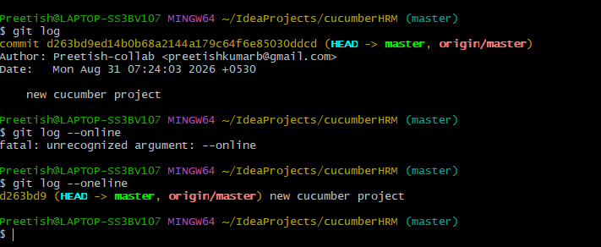
Branching & Merging
- git branch — Lists, creates, or deletes branches.
Bash
git branch # List local branches
git branch feature-login # Create a new branch named 'feature-login'
git branch -d feature-login # Delete a branch
- git checkout <branch> / git switch <branch> — Switches to a specified branch.
Bash
git switch feature-login
git checkout -b new-feature # Create and switch to a new branch in one command
- git merge <branch> — Combines history from the specified branch into your active branch.
Bash
git switch main
git merge feature-login
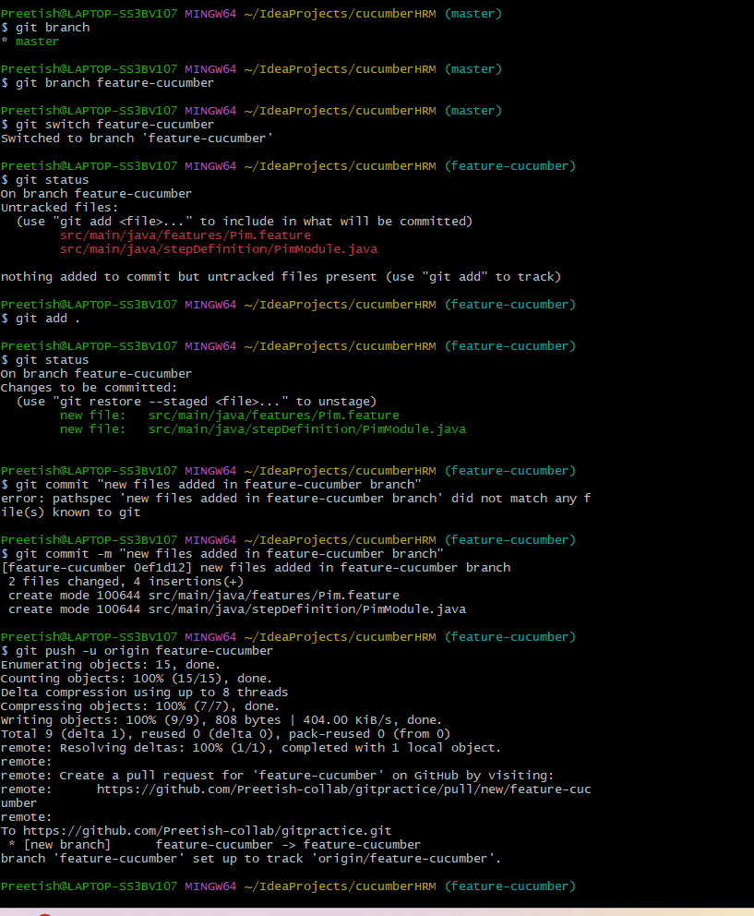
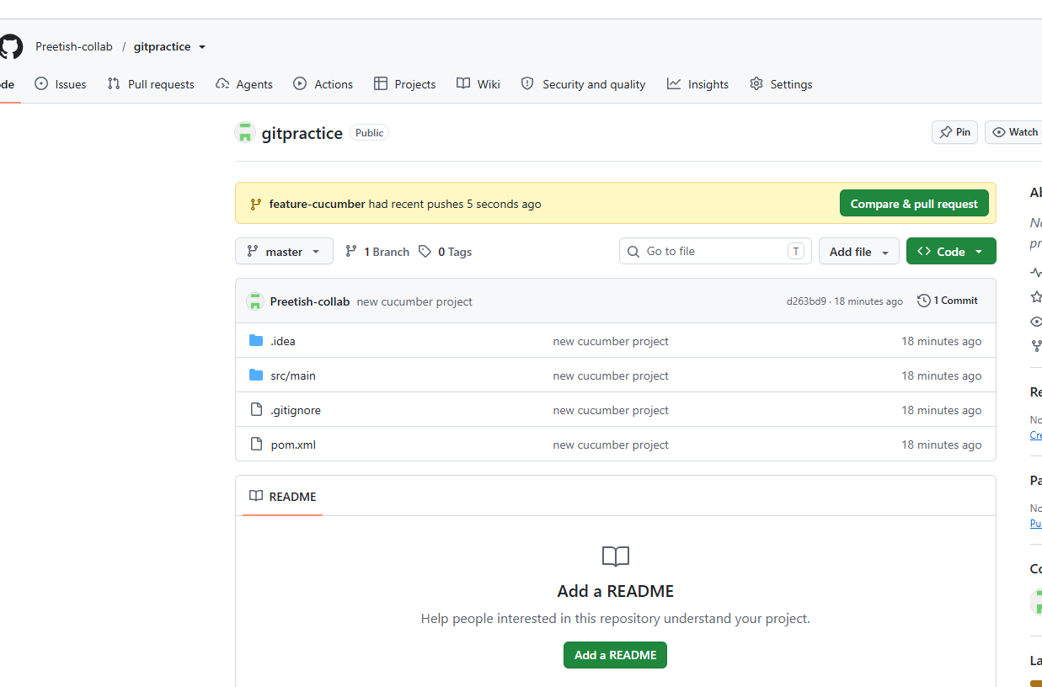
Now in feature-cucumber branch I have two new files pim.feature in feature folder and pimModule in stepDefinition folder . But its not present in my master branch , so to bring it into my master branch 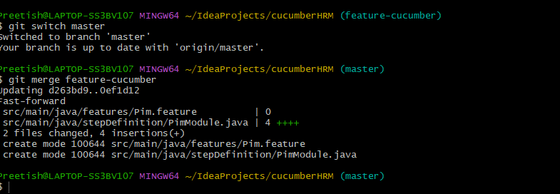
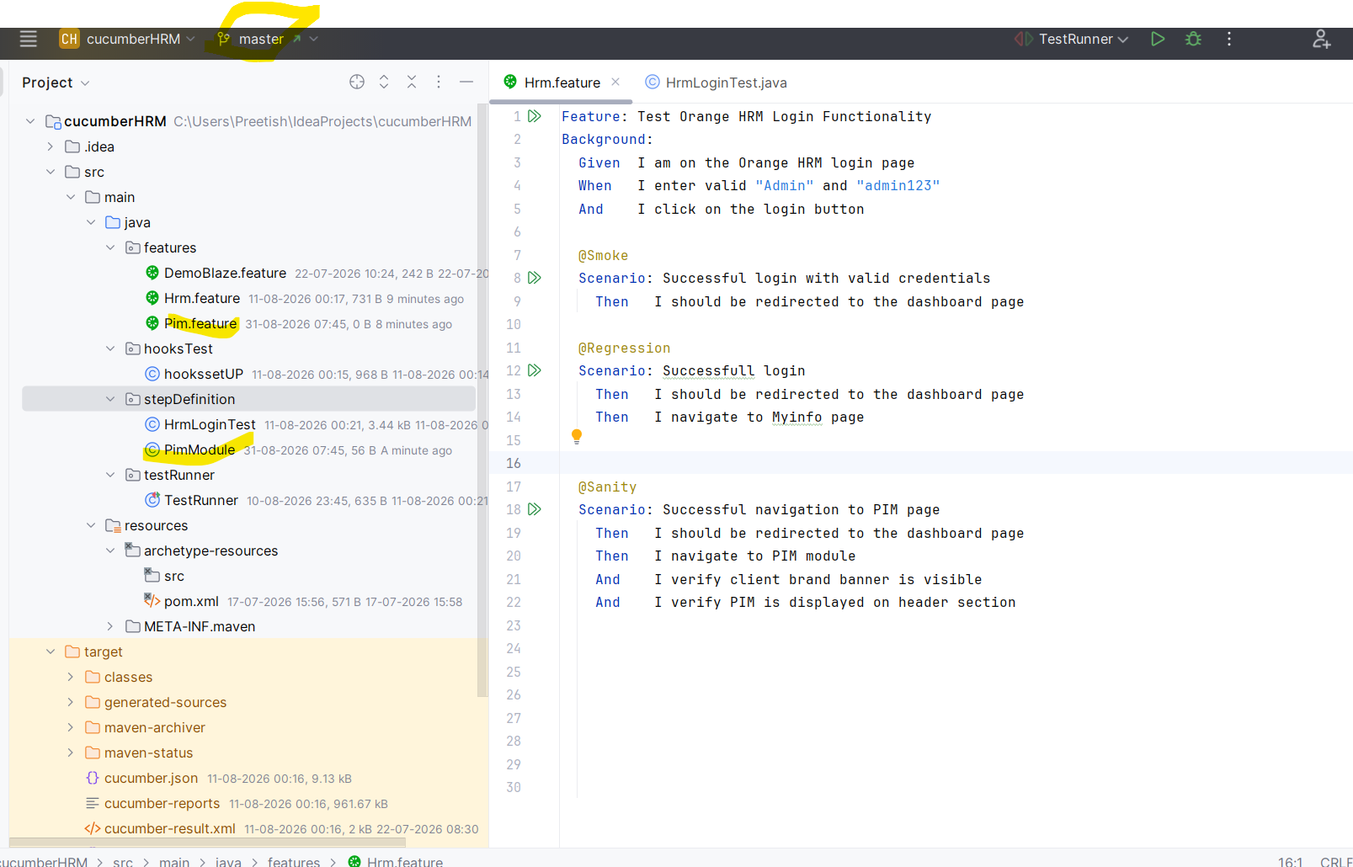
Now you can create PR(pull request) in git hub and compare your feature-cucumber branch with master and if all goods you can merge your feature-cucumber branch incoming changes to master
By merging (In real time there will be approver who will review your code before merging it to master or main branch)
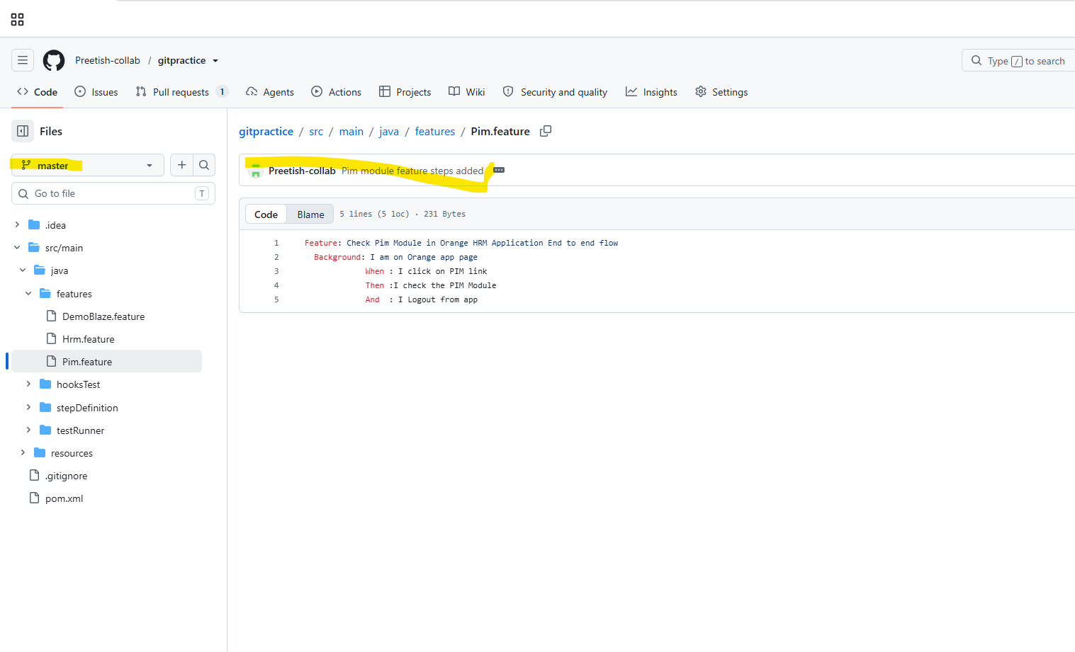
Now I have changes in pim.feature file from remote repository master branch but the changes are not present in my local machine
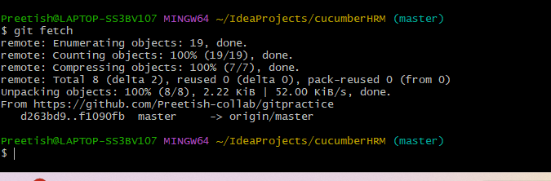
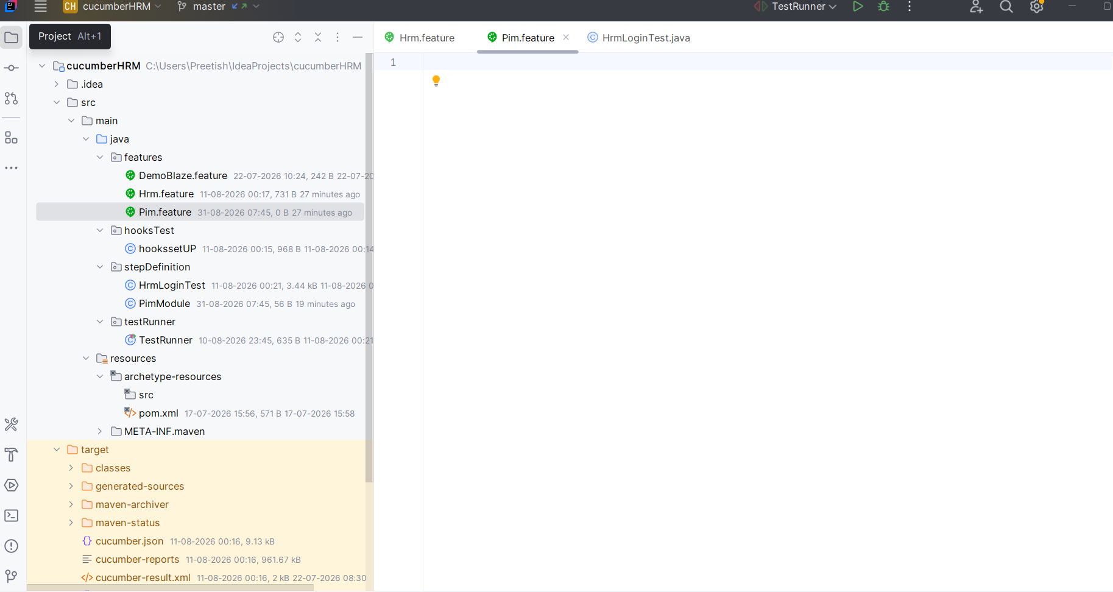
Remote Synchronization
- git remote — Connects your local repository to a remote server.
Bash
git remote add origin https://github.com/user/repository.git
- git fetch — Downloads changes and commits from the remote repository without merging them.
Bash
git fetch origin
- git pull — Fetches updates from the remote repository and immediately merges them into your active branch.
Bash
git pull origin master
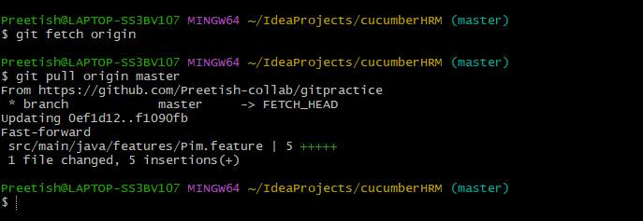
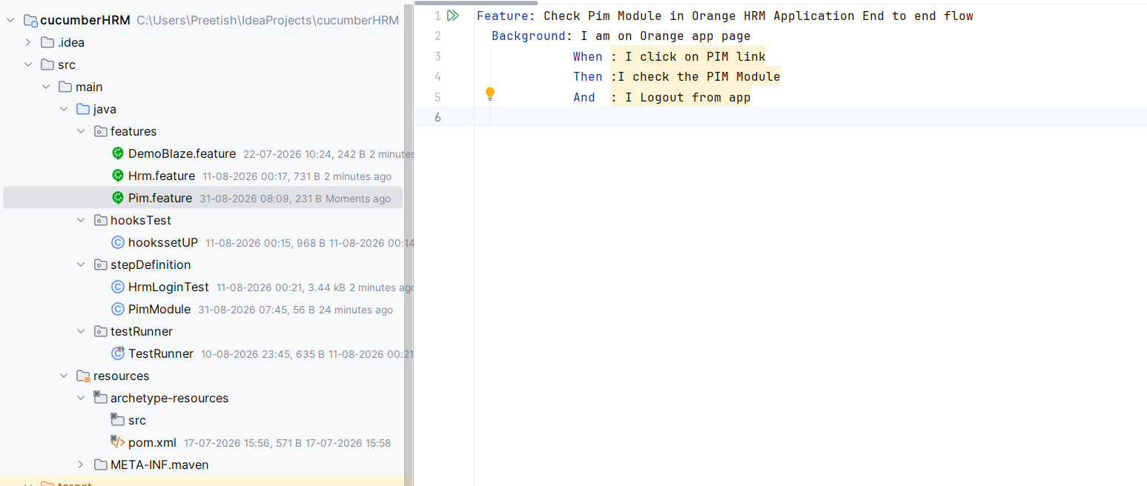
Note: Now we can see the changes in our local system coming from remote it
Undoing Changes & Stashing
- git stash — Temporarily shelves uncommitted modifications so you can work on something else.
Bash
git stash # Save uncommitted changes
git stash pop # Reapply the stashed changes
- git reset — Unstages files or reverts commits in local history.
Bash
git reset HEAD main.js # Unstage a specific file
- git revert <commit-hash> — Safely undoes a previous commit by creating a brand-new commit with the inverse changes.
git stash temporarily shelves changes you've made in your working directory without committing them, allowing you to switch branches or pull updates with a clean tree.
Core Commands
- Save changes: git stash or git stash push -m "my descriptive message" Temporarily removes modified and staged tracked files and saves them onto a stack.
- Include untracked files: git stash -u Stashes untracked files in addition to modified tracked files.
- Apply and remove (pop): git stash pop Applies the most recent stashed changes back to your working directory and removes them from the stash list.
- Apply without removing: git stash apply Applies the most recent stash to your working directory while keeping it saved in the stash list.
- List stashes: git stash list Shows all stashed sets of changes, ordered from newest (stash@{0}) to oldest.
- Pop a specific stash: git stash pop stash@{N} Reapplies and removes a specific stash index (e.g., git stash pop stash@{1}).
- Delete a stash: git stash drop stash@{N} or git stash clear (deletes all) Removes a specific stash entry or purges the entire stash list.
Common Workflow Example
- You are working on a feature, but need to jump to main to fix an urgent bug.
- Run git stash push -m "work in progress on feature X".
- Switch branches with git checkout main and do your work.
- Switch back with git checkout feature-branch.
- Run git stash pop to restore your working state and clear the stash stack.

Bash >> git revert a1b2c3d
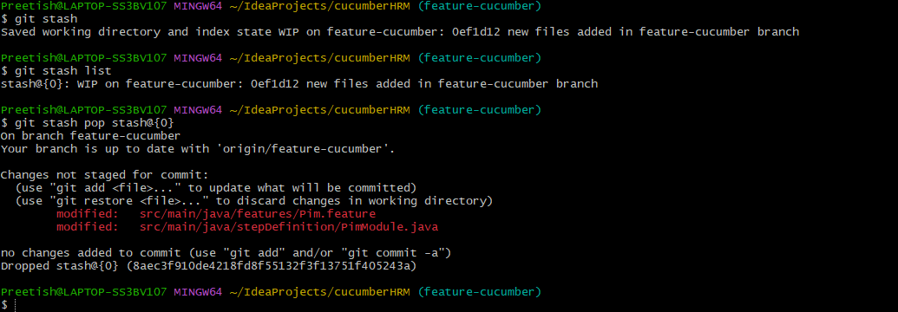
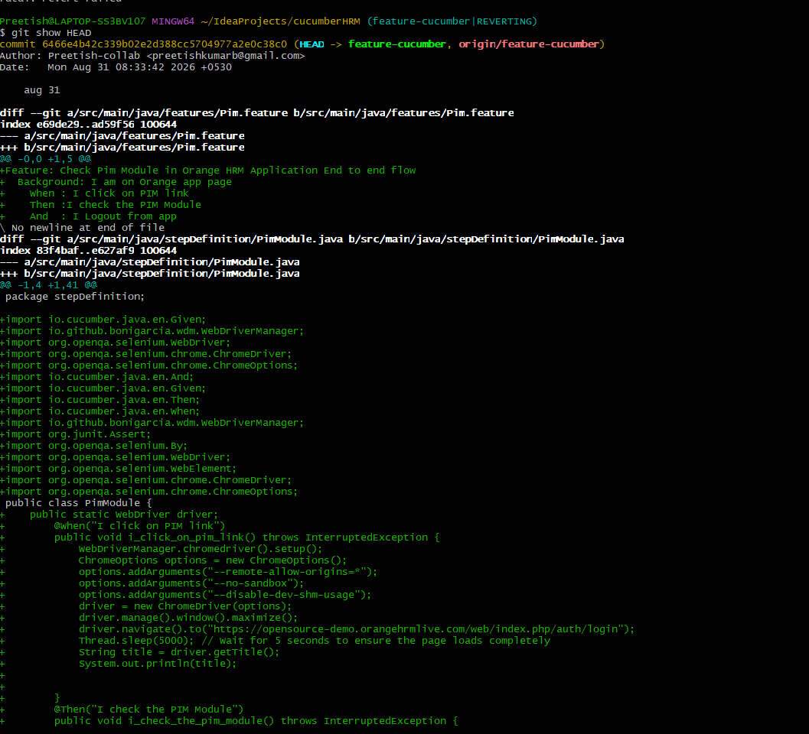

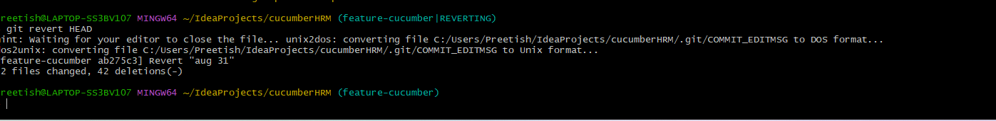
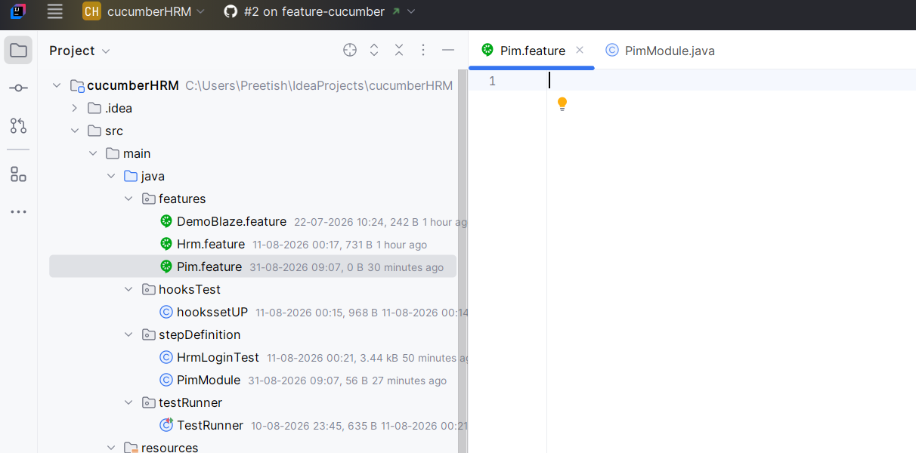
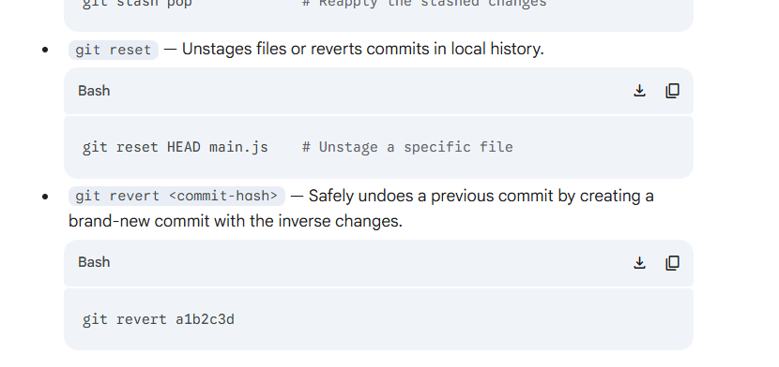
Deleting a branch
