**SELECT * FROM CUSTOMERS;**

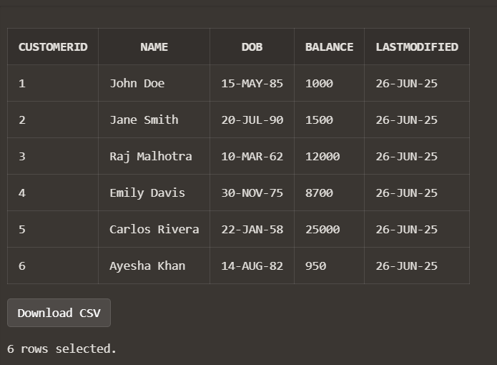

**SELECT * FROM LOANS;**

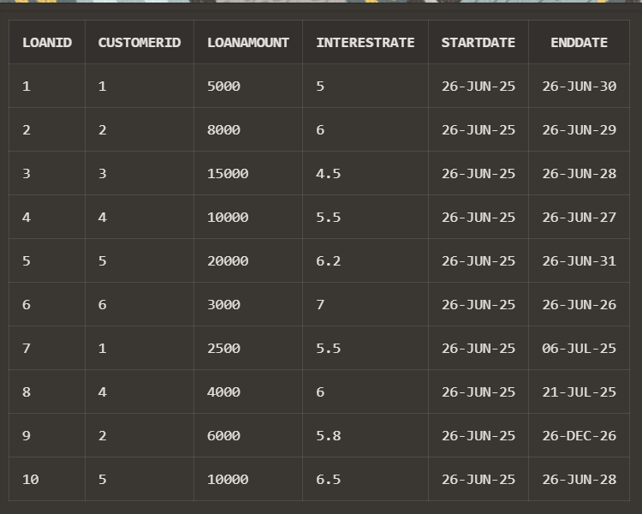

**Scenario 1:**

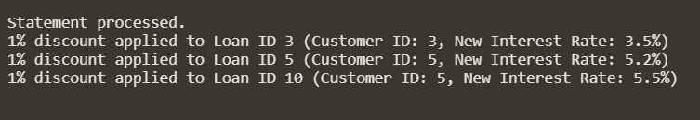

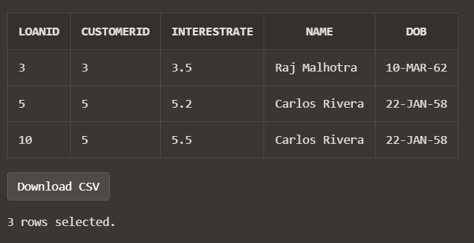

**Scenario 2:**

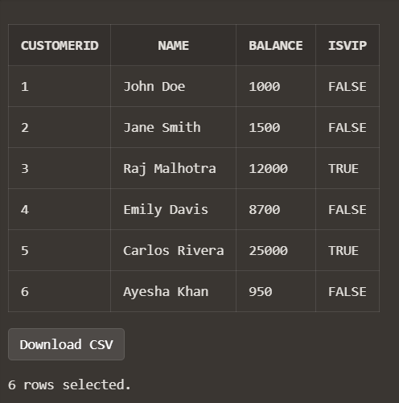

**Scenario 3:**

