Final Project: 610

-prekshah

-Preksha Kamleshkumar Shah

**Introduction**

P(Population): Adult population (≥ 18 years) residing in the United States, I/E(Intervention or Exposure): E-Cigarette Smokers, C(Comparison group): Non-Smokers, O(Outcome of interest): Risk of COPD are the PICO elements being focused on in this paper. Our PICO question is, Does e-cigarette smoking increase the risk of COPD in the Adult population residing in the United States, compared to that in non-smokers?

Vaping may exacerbate COPD. However, there isn't enough data to conclusively prove that e-cigarettes are to blame. E-cigarettes haven't been available that long, and COPD symptoms don't manifest until years later. "We did not detect any clear evidence of harm from nicotine EC, but the longest follow-up was two years, and the overall number of studies was small.” (Hartmann-Boyce et al. 2021)

Chronic lower respiratory disease, primarily COPD, was the fourth leading cause of death in the United States in 2018(Murphy et al., 2021). Almost 15.7 million Americans (6.4%) reported that they had been diagnosed with COPD(Wheaton et al., 2015). More than 50% of adults with low pulmonary function were unaware that they had COPD,(Mannino et al., 2000) so the actual number may be higher. One study of 10 healthy smokers using 1 brand of e-cigarette (Nobacco, 11 mg of nicotine, >60% propylene glycol) as desired for 5 minutes found no significant effect on conventional spirometry measures but did find a small but significant increase in dynamic airway resistance (18%) and a significant decrease in exhaled nitric oxide (16%)(Vardavas et al., 2012). Respiratory irritation and bronchial constriction from a propylene glycol aerosol raise concerns about harm to people with asthma and chronic obstructive pulmonary disease, but 1 small study reports no harm but rather benefit when users quit smoking or smoke fewer cigarettes per day(Bhatnagar et al., 2014).

Although there is evidence linking vaping with COPD, as we can see over here, no confirmatory research has found a conclusive link between the two. Given that this could become an epidemic that threatens public health, research in this area will flourish in the next years.

One of the triple aims of US healthcare is to improve the patient health, here the adult population (≥ 18 years) residing in the United States. This PICO statement is crucial since smoking is a major contributor to preventable deaths globally. Additionally, e-cigarette addiction is on the rise, which raises the possibility of a new public health problem. Positive advertising for e-cigarettes has been widely spread. They are thought of as a positive practice, as stated in some publications. Some believe that acceptance of e-cigarettes has the potential to reverse the social norm for prohibiting smoking in public places achieved over decades of advocacy work, others see these products as a way to denormalize smoking because they are a potential mechanism for quitting(Abrams, 2014). They have recently been promoted by doctors as a smoking cessation aid. Clinicians are advised to be aware that the use of e-cigarettes, especially among cigarette smokers, is growing rapidly. These devices are unregulated, of unknown safety, and of uncertain benefit in quitting smoking.(Harrell et al., 2014). The answer to this question could have a significant impact on public health programs and regulations aimed at reducing the prevalence of smoking. The broad perspective and overview of the possible negative impacts of this behavior are no longer with us. We may only be seeing the tip of the iceberg when it comes to the negative consequences and drawbacks of e-cigarettes. Preliminary research suggests that e-cigarettes may potentially contribute to a variety of respiratory conditions, including COPD, asthma, and others.

Second, we must concentrate on bringing healthcare costs for patients and public healthcare systems under control. The cost of treating issues brought on by smoking is very high. Research has shown that using vape or e-cigarettes either makes the addiction worse or has never been a successful method of quitting smoking. If so, the PICO statement warns of an imminent epidemic of vaping-related addiction difficulties and respiratory health problems. Once more, this will be extremely expensive for both the government and public health systems and the people. “This cohort study found that e-cigarette use was associated with an increased risk of developing respiratory disease independent of cigarette smoking. These findings add important evidence on the risk profile of novel tobacco products.” (Xie et al., 2020). The use of e-cigarettes and vaping will necessitate new awareness campaigns and protocol requirements, and patients who were prescribed e-cigarettes for addiction treatment but developed respiratory health issues may take healthcare systems to court.

The final aim is to improve the experience of care. The current healthcare approach among physicians regarding the same appears to have reached crossroads. “Overall, 37.9% have at some point recommended electronic cigarettes to their patients that smoke, with 11.5% reporting recommending them at least 25% of the time.” (Nickels et al. 2016). The triple objective framework takes the experience of care for COPD patients who use e-cigarettes into serious account. Patients with COPD require all-encompassing care that attends to their social, psychological, and physical requirements. In order to effectively manage COPD, patients, and healthcare professionals must work together. Healthcare professionals should inform patients about the advantages and disadvantages of using e-cigarettes and motivate them to give up smoking entirely in order to improve the patient experience of care. But in order to do so, we need to be well-informed ourselves, and hence we need more research and evidential support to guide the patients accordingly.

**Methods**

My data is downloaded from the CDC website for BRFSS, the link for which is available on [CDC - 2021 BRFSS Survey Data and Documentation](https://www.cdc.gov/brfss/annual_data/annual_2021.html). The BRFSS is a system of ongoing health-related telephone surveys created to gather information from the non-institutionalized adult population ( 18 years) living in the United States and participating areas. State health departments use the BRFSS data for a variety of purposes, such as identifying demographic variations in health-related behaviors, designing, implementing, and evaluating public health programs, addressing urgent and emergent health issues, putting forward legislation for health initiatives, and tracking advancement toward state health goals.

Over 400,000 adults in the US provided replies for the BRFSS dataset, giving researchers access to a sizable and varied sample for analysis. Since 1984, the BRFSS survey has been conducted yearly, allowing for the longitudinal investigation of health-related behaviors and conditions. The BRFSS survey uses self-reported data, which might be prone to recall bias or social desirability bias, resulting in the under or over-reporting of specific behaviors or situations. Other drawbacks include non-response bias, a lack of clinical data, and the design's inability to develop informal correlations between variables because it is a cross-sectional one.

Current e-cigarette use was the main exposure variable, with current use further classified as daily or occasional use. The main outcome was defined as reported ever having a diagnosis of chronic obstructive pulmonary disease. The exposure variable was further cleaned into categories of E-Cigarette smokers, E-Cigarette non-smokers and Unknown. For outcome variable, it was categorized into COPD +, COPD-, and Unknown values. The unknown, n/a values were later cleaned from the dataset.

My null hypothesis is There is no significant difference in the risk of COPD between e-cigarette smokers and non-smokers in the adult population residing in the United States. I expect to find the null hypothesis to be false, because there are various evidences showing that COPD and E-cigarette smoking are related as mention in the above section. Two potential confounders in the data set are sex and income. There are several reasons why COPD might affect women differently than men.[6](https://www.cdc.gov/copd/basics-about.html#ref6) Women tend to be diagnosed later than men, when the disease is more advanced and treatment is less effective. Women also seem to be more vulnerable to the effects of tobacco and other harmful substances. For example, tobacco smoke is the main cause of COPD in the United States, but women who smoke tend to get COPD at younger ages and with lower levels of smoking than men who smoke. There also appear to be differences in how women and men respond to different treatments. (Centers for Disease Control and Prevention, 2021).

**Results**

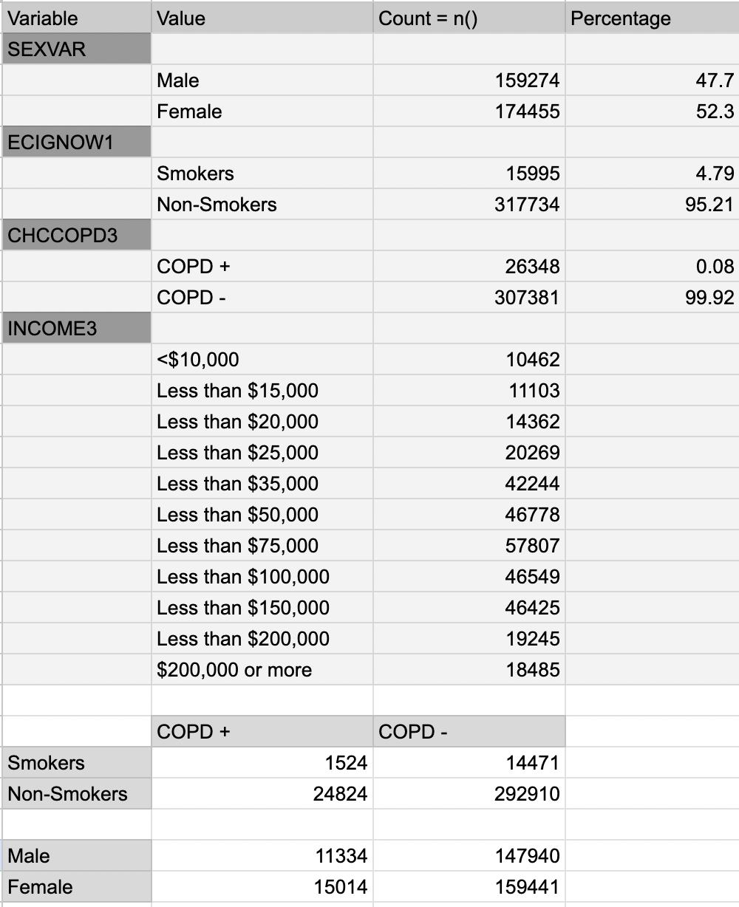

**Clinical Table 1**

In the study population (N =333,729 ), 15,995 respondents were current e-cigarette users and 317,734 were non-e-cigarette-users. Using R programming, we created a bar chart from categorical data and Unstratified Analysis. For a better understanding, see Figure 1a. The null hypothesis is False when the Chi-Square test is done since the p-value is less than 0.05 (Figure 1b). This indicates that smoking e-cigarettes and COPD are significantly related. In a stratified analysis including SEX as a confounder, it was clear that women who smoke electronic cigarettes have a higher prevalence of COPD.(In Figure 2.) Faceting according to socioeconomic status reveals that COPD and E-cigarette usage were more prevalent among lower-income households, but the gap in COPD prevalence between smokers and non-smokers decreased in richer households.(Figure 3).

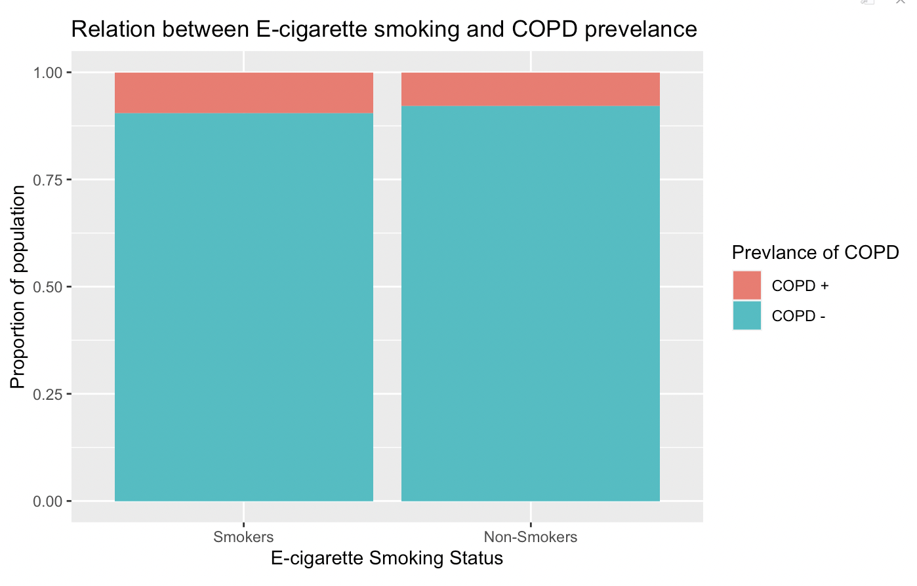

Figure 1a

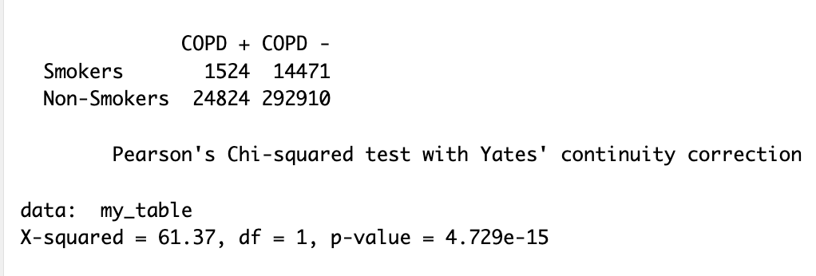

Figure 1b : Statistical Test

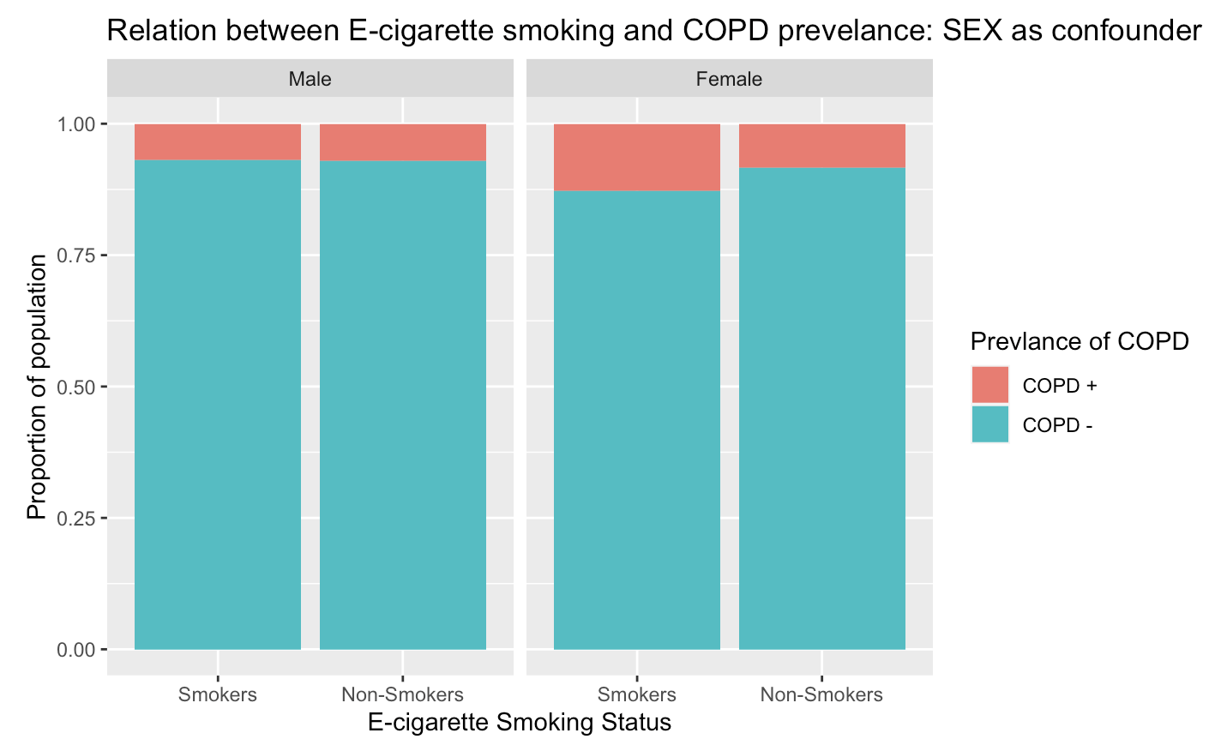

Figure 2 : Confounder 1

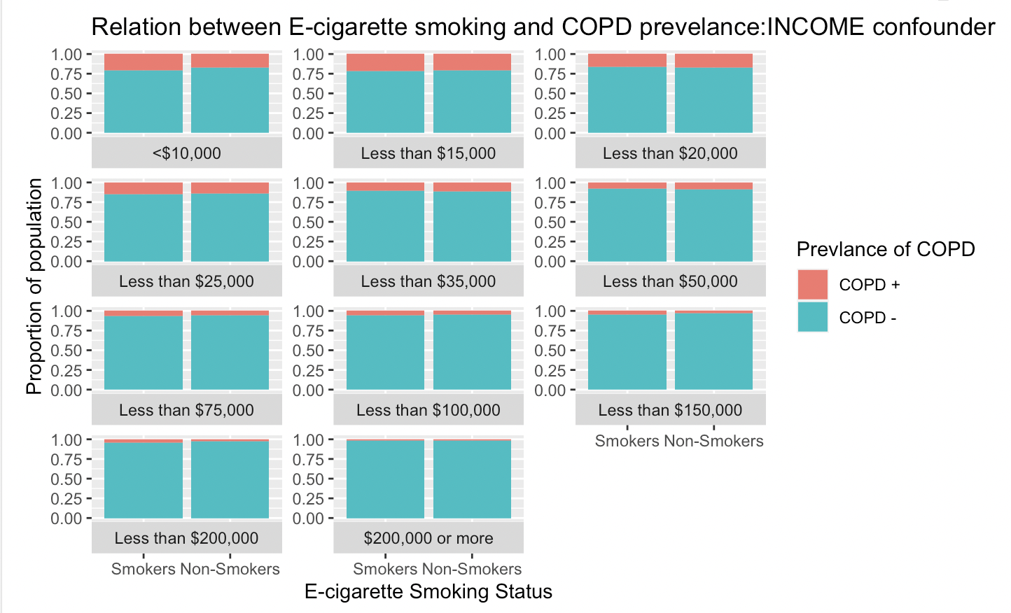

Figure 3: Confounder 2

**Discussion**

By studying the relationship between reported COPD and e-cigarette use in a sizable cohort that is representative of the adult population in the US, the study contributes to the body of literature. Studies that have indicated a deterioration in lung function with e-cigarette aerosol exposure and parallels in the biological response to traditional tobacco cigarette smoke corroborate this relationship. In humans, at least one study using the COPDGene and SPIROMICS cohorts found an association between e-cigarette use and the progression of COPD among subjects at risk or in whom the disease had already been established(Bowler et al., 2017). Because there is not enough information to support this study, the findings contribute to what is already known by providing evidence of a relationship between the exposure and outcome variable. Confounders expand the areas of study and trials based on certain cohorts that can be planned in order to advance this research. One of the weaknesses of my analysis is that I did not account for traditional smoking, which is a documented and established risk factor for COPD. It may affect the findings of this study, hence a more thorough investigation of a cohort of E-cigarette users who have never smoked traditionally is required. These findings have ramifications for everyone from legislators and FDA regulators who oversee the promotion of e-cigarettes to doctors and patients who personally observe this occurrence. This is crucial for developing awareness campaigns for young people, who are unaware of the issues brought on by e-cigarettes. Additionally, it instructs scientists and researchers to delve deeply into this aspect of healthcare issues. Thus the question serves public health, patient health, and US healthcare as a whole.

**Conclusions**

The results show that adults who smoke E-cigarettes are more likely to a risk of having COPD. There is a connection between the two even after controlling for confounding factors. Both women and those from lower socioeconomic strata experience worse consequences. To describe the nature of this connection and the long-term implications of e-cigarette use on the respiratory and systemic systems, more research is required.

**References:**

1. Murphy, S., Kochanek, K., Xu, J., & Arias, E. (2021). Mortality in the United States, 2020 key findings data from the national vital statistics system. https://www.cdc.gov/nchs/data/databriefs/db427.pdf
2. Wheaton, A. G., Cunningham, T. J., Ford, E. S., Croft, J. B., & Centers for Disease Control and Prevention (CDC). (2015). Employment and activity limitations among adults with the chronic obstructive pulmonary disease--United States, 2013. MMWR. Morbidity and Mortality Weekly Report, 64(11), 289–295. https://pubmed.ncbi.nlm.nih.gov/25811677/
3. Mannino, D. M., Gagnon, R. C., Petty, T. L., & Lydick, E. (2000). Obstructive Lung Disease and Low Lung Function in Adults in the United States. Archives of Internal Medicine, 160(11), 1683. <https://doi.org/10.1001/archinte.160.11.1683>
4. Vardavas, C. I., Anagnostopoulos, N., Kougias, M., Evangelopoulou, V., Connolly, G. N., & Behrakis, P. K. (2012). Short-term Pulmonary Effects of Using an Electronic Cigarette. Chest, 141(6), 1400–1406. https://doi.org/10.1378/chest.11-2443
5. Bhatnagar, A., Whitsel, L. P., Ribisl, K. M., Bullen, C., Chaloupka, F., Piano, M. R., Robertson, R. M., McAuley, T., Goff, D., & Benowitz, N. (2014). Electronic Cigarettes. Circulation, 130(16), 1418–1436. <https://doi.org/10.1161/cir.0000000000000107>
6. Abrams, D. B. (2014). Promise and Peril of e-Cigarettes. JAMA, 311(2), 135. <https://doi.org/10.1001/jama.2013.285347>
7. Harrell, P. T., Simmons, V. N., Correa, J. B., Padhya, T. A., & Brandon, T. H. (2014). Electronic Nicotine Delivery Systems (“E-cigarettes”). Otolaryngology–Head and Neck Surgery, 151(3), 381–393. <https://doi.org/10.1177/0194599814536847>
8. Xie, W., Kathuria, H., Galiatsatos, P., Blaha, M. J., Hamburg, N. M., Robertson, R. M., Bhatnagar, A., Benjamin, E. J., & Stokes, A. C. (2020). Association of Electronic Cigarette Use With Incident Respiratory Conditions Among US Adults From 2013 to 2018. JAMA Network Open, 3(11), e2020816. <https://doi.org/10.1001/jamanetworkopen.2020.20816>
9. Hartmann-Boyce, J., McRobbie, H., Lindson, N., Bullen, C., Begh, R., Theodoulou, A., Notley, C., Rigotti, N. A., Turner, T., Butler, A. R., Fanshawe, T. R., & Hajek, P. (2021). Electronic cigarettes for smoking cessation. Cochrane Database of Systematic Reviews. <https://doi.org/10.1002/14651858.cd010216.pub5>
10. Centers for Disease Control and Prevention. (2021). Basics about COPD. Centers for Disease Control and Prevention. <https://www.cdc.gov/copd/basics-about.html>
11. Bowler, R. P., Hansel, N. N., Jacobson, S., Graham Barr, R., Make, B. J., Han, M. K., O’Neal, W. K., Oelsner, E. C., Casaburi, R., Barjaktarevic, I., Cooper, C., Foreman, M., Wise, R. A., DeMeo, D. L., Silverman, E. K., Bailey, W., Harrington, K. F., Woodruff, P. G., & Drummond, M. B. (2017). Electronic Cigarette Use in US Adults at Risk for or with COPD: Analysis from Two Observational Cohorts. *Journal of General Internal Medicine*, *32*(12), 1315–1322. https://doi.org/10.1007/s11606-017-4150-7