**Final Project SI 564**

**Name: Preksha Shah**

**Uniqname: prekshah**

**______________________________________________________________________________**

From: Lawrence Summerset

To: DBA team

Hello DBA team!  I hope you are all doing well! We are planning on investing in a hospital setting and beginning our journey in the healthcare industry. But before that, we would like to analyze the place and the services they offer. We have a small sample database that they have provided, which will help us understand their current workflow and profitability.

I have some questions regarding the same and it would be great if you could answer them by the end of this week. Also, it seems that the person who built this database did not leave any documentation, so can you attach an ERD and document it as well?

**Demographics**

1. I would like to know the religious structure of the population we are dealing with. Can you give me the list of any 5 random religions?

**Profitability**

1. The profitability of a hospital depends on the kind of insurance they have in its Payer mix. I would like to see the proportion of deaths among each insurance type, to determine whether the hospital is biased in their treatment and care, considering Private insurance pays more compared to Medicare/Medicaid.
2. Can we determine the average length of stay for Elective and Emergency admissions? The more the length of stay, the more resources are getting used up.

**Public health:**

1. What are the 5 most common types of cancer in the White population in this dataset and can you count the number of diagnosed cases for each type of cancer?
2. What is the survival rate for newborns? This will help us understand whether we want to invest in their pediatric subsidiary or not.

**Hospital Outcomes:**

1. Is there a correlation between the length of admission and death during the hospital stay?
2. Is there a significance of marital status when a patient is diagnosed with breast cancer?

Thank you for your help on this matter. Also, can you asses what was the rationale behind them giving us this dataset and making these design choices?

Have a great week ahead.

Dr. Lawrence Summerset

Head of Research

---------------------------------------------------------------------------------------------------------------------

From: DBA team

To: Lawrence Summerset

This is a great opportunity for the company and a great space to work in. I would gladly answer the questions and provide the relevant statistics. I have attached an appendix at the bottom, with the required data tables, documentation, and design concepts.

The answers are as follows:

**Demographics**

1. I would like to know the religious structure of the population we are dealing with. Can you give me the list of any 5 random religions?

Query:

select distinct Religion_Name as "Religion"  
from Hospital_Admissions_Data  
join Religion R on Hospital_Admissions_Data.Religion_Type = R.Religion_Id order by *rand*() limit 5;

Output:

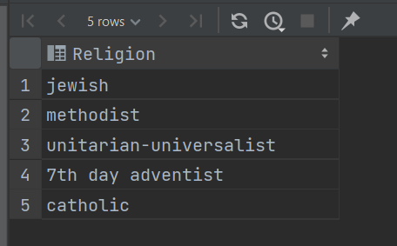

Answer:

These are random 5 religions in this dataset.

**Profitability**

1. The profitability of a hospital depends on the kind of insurance they have in its Payer mix. I would like to see the proportion of deaths among each insurance type, to determine whether the hospital is biased in their treatment and care, considering Private insurance pays more compared to Medicare/Medicaid.

Query:

select Insurance_Name, *round*(*count*(Outcome_Id)/*count*(Insurance_Type), 2) AS "Total Death Rate"  
from Hospital_Admissions_Data had  
join Insurance I on I.Insurance_Id = had.Insurance_Type  
left join (SELECT Outcome_Id from Outcome O where Outcome like "%Dead%") OT on OT.Outcome_Id = had.Outcome_Status  
group by Insurance_Name  
order by *count*(Outcome_Id)/*count*(Insurance_Type);

Output:

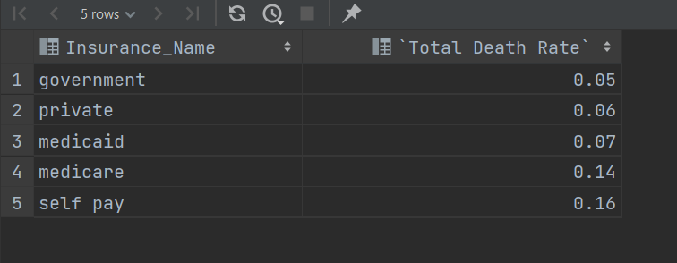

Answer:

There seems to be a bias in the treatment of those who pay via Medicare and Medicaid, compared to those who pay via Govt/private insurance. This is an area to look at because such a scenario can bring in legal issues and cause loss to us.

Also, to note, the reimbursement rate is more for Govt/private insurance compared to those of Medicare/Medicaid. As commercial/ private insurance payers pay more/ generate more revenue when compared to payments from Medicare/Medicaid (Lopez et al., 2020)

1. Can we determine the average length of stay for Elective and Emergency admissions?

Query:

select Admission_Cat, *avg*(Admission_Length_Days) as "Days Admitted"  
from Hospital_Admissions_Data  
join Admission_Category AC on AC.Admission_Cat_Id = Hospital_Admissions_Data.Admission_Type  
where Admission_Cat not like "%newborn%" and Admission_Cat not like "%urgent%"  
group by Admission_Cat;

Output:

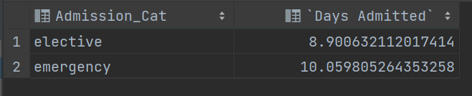

Answer:

As we can see, the emergency department has more average length of stay. The more the length of stay, the more resources are getting used up. Hence, we need to optimize emergency care and invest in resources for that department to avoid loss.

**Public health:**

1. What are the 5 most common types of cancer in the White population in this dataset and can you count the number of diagnosed cases for each type of cancer?

Query:

select Diagnosis as "Cancer Type", R.Race, *count*(Id) as "Number of Cases" from Hospital_Admissions_Data  
JOIN Race R on R.Race_Id = Hospital_Admissions_Data.Race  
where Diagnosis like "%cancer%" and R.Race like "%White%"  
group by Diagnosis, R.Race  
order by *count*(Id) desc  
limit 5;

Output:

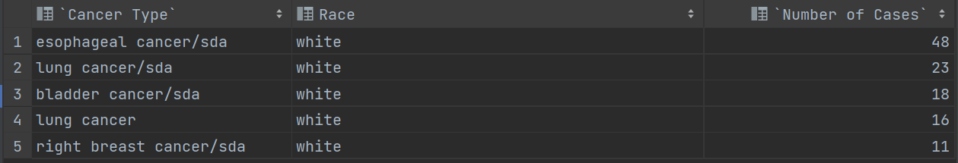

Answer:

Esophageal cancer, Lung cancer/sda, Bladder Cancer, Lung cancer, and breast cancer are among its top five. We can also recommend they streamline their diagnosis terminology to avoid misinformation.

1. What is the survival rate for newborns? This will help us understand whether we want to invest in their pediatric subsidiary or not.

Query:

select  
 *round*((select *count*(Id) from Hospital_Admissions_Data  
 join Admission_Category AC on Hospital_Admissions_Data.Admission_Type = AC.Admission_Cat_Id  
 join Outcome O on O.Outcome_Id = Hospital_Admissions_Data.Outcome_Status  
 where Admission_Cat = "newborn" and Outcome = "Alive")/*count*(Id)*100, 2) as "Survival Rate" FROM Hospital_Admissions_Data  
JOIN Admission_Category A on A.Admission_Cat_Id = Hospital_Admissions_Data.Admission_Type  
WHERE Admission_Cat = "newborn";

Output:



Answer:

The survival rate is 99.21 %. This is a great thing and shows that we should invest in their pediatric subsidiary.

**Hospital Outcomes:**

1. Is there a correlation between the length of admission and death during the hospital stay?

Query:

select *round*(*avg*(Admission_Length_Days), 2) as "Average stay", Outcome  
from Hospital_Admissions_Data  
join Outcome O on O.Outcome_Id = Hospital_Admissions_Data.Outcome_Status  
group by Outcome;

Output:

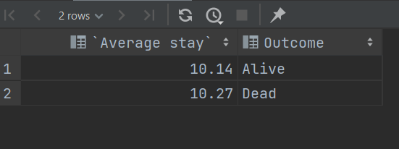

Answer:

There seems to be no correlation between the two. The average stay of patients is the same for either Outcome.

1. Is there a significance of marital status when a patient is diagnosed with breast cancer?

Query:

select Status_Of_Marriage, *count*(Status_Of_Marriage) as "Total Patients with Breast Cancer" from Hospital_Admissions_Data  
join Marital_Status MS on MS.Marital_Status_Id = Hospital_Admissions_Data.Marital_Status  
where Diagnosis like "%Breast%"  
group by Status_Of_Marriage  
order by *count*(Status_Of_Marriage) desc;

Output:

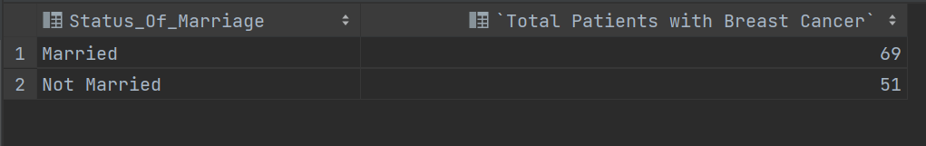

Answer:

Though there is not a drastic relation between Breast Cancer and marital status. This area should be explored further and can be used for research purposes.

Hope this helps and in case of any further questions do let me know. Keep me updated on whether we go through with this final project or not. I am excited about it.

Have a great weekend ahead.

Best,

Preksha Shah

DBA Team

-----------------------

Appendix:

ERD Diagram:

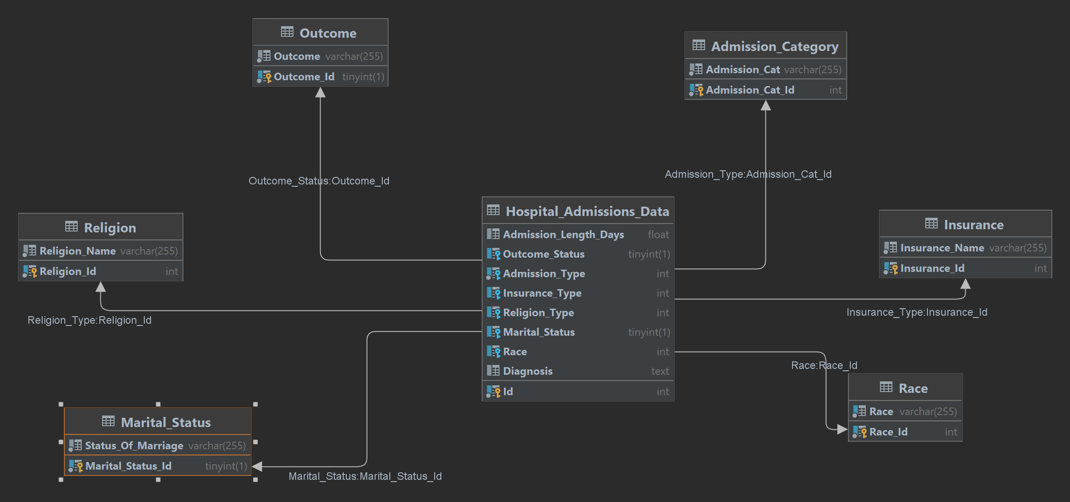

---------------------------------------------------------------------------------------------------------------------

**Documentation and Database design choices:**

The dataset was taken from one of my course work, where we come across Hospital Admissions Dataset. The raw data has 10 attributes, which are then lowered to 9 after cleaning the dataset. There are 58863 rows, each belonging to a unique patient id. There were various field types like categorical data, Boolean, integer, text, and varchar.

Source: <https://drive.google.com/file/d/10DQtxiyIkvFpRADHpH3M0iOb3bAz3Y1J/view?usp=share_link>

I cleaned the raw data after importing it into DataGrip.

For that:

1. Checked for any duplicate or repeated entries , or loss of information for the same id in the table made from raw data.

select ID, *COUNT*(1) from HospitalAdmissionsData_1 group by ID ORDER BY ID DESC ;

I de-identified that data from the raw data. This was done to ensure patient privacy as per HIPAA rules.

1. De-identified data

ALTER TABLE HospitalAdmissionsData  
DROP COLUMN Hospital_id;

1. Deleted unnecessary data

ALTER TABLE HospitalAdmissionsData  
DROP COLUMN EnglishLanguage_1;

1. Remove negative values from Admission_Length_Days

update Hospital_Admissions_Data h set Admission_Length_Days = NULL where Admission_Length_Days < 0;

**Data Normalization:**

To reduce repetition and redundancy, I created sub-tables from it as follows:

1. **Hospital_Admissions_Data**

Id: Autoincrement, int, PrimaryKey, not null

Admission_Length_Days: No. Of Days in Hospital, float

Outcome_Status: Outcome of Treatment (Boolean), 0 is alive, 1 is dead.

Admission_Type: Category ID under which admitted, int

Insurance_Type: Category ID for type of Health insurance, int

Religion_Type: Category ID of Religion, int

Marrital_Status: Status of marriage(Boolean), 0 is not married, 1 is married

Race: Category ID of Race, int

Dx: Diagnosis (text string)

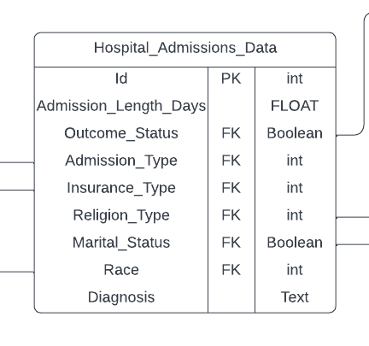

1. **Admission_Category**

Admission_Cat_Id : Category Id, int, autoincrement, not null, PrimaryKey

Admission_Cat : Category Name, varchar(255)

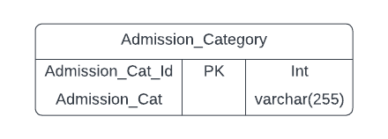

1. **Insurance**

Insurance_Id : Category Id, int, autoincrement, not null, PrimaryKey

Insurance_Name: Category Name, varchar(255)

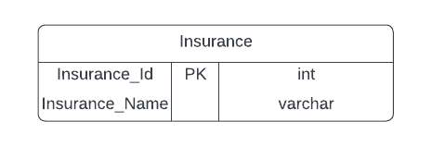

1. **Marital_Status**

Marital_Status_Id : Boolean, Tinyint, notnull, Primarykey

Status_Of_Marriage : Married/NotMarried, varchar(255)

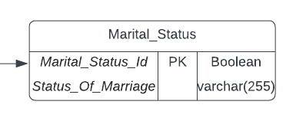

1. **Outcome**

Outcome_Id : Boolean, Tinyint, notnull, Primarykey

Outcome: Alive/Dead, varchar(255)

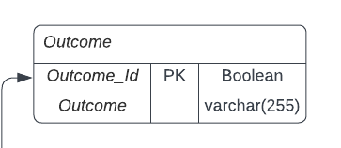

1. **Race**

Race_Id : Category Id, int, autoincrement, not null, PrimaryKey

Race: Category Name, varchar(255)

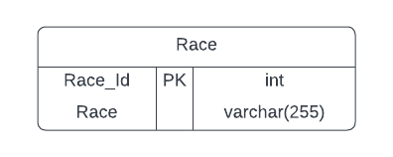

1. **Religion**

Religion_Id : Category Id, int, autoincrement, not null, PrimaryKey

Religion_Name: Category Name, varchar(255)

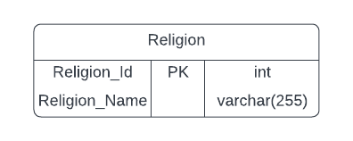

ERD Made manually:

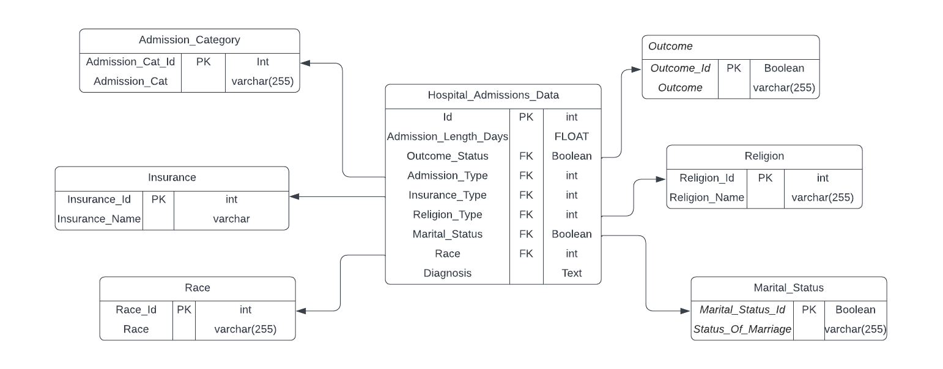

The above tables were made from the raw table data, and then main table was created using following queries:

update HospitalAdmissionsData h set Religion_Type = (select id from Religion_Type re where re.Religion = h.Religion_Type)

update Hospital_Admissions_Data h set Admission_Type = (select Id from Admission_Category ac where ac.Admission_Cat = h.Admission_Type)

update Hospital_Admissions_Data h set Insurance_Type = (select Insurance_Id from Insurance i where i.Insurance_Name = h.Insurance_Type)

update Hospital_Admissions_Data h set Race = (select Race_Id from Race r where r.Race = h.Race)

Further, I also made foreign keys and joined the tables accordingly.

I have attached three MySQL dump files, so that it covers all the changes I made in the dataset throughout the week at different intervals.

The most latest one is Done_Finally_With_Project

---------------------------------------------------------------------------------------------------------------------