**(XYZ BANK APPLICATION)**

**(JAVA FULL STACK)**

**Mid Term Project Report**

Submitted by

**(Preksha Mendiratta)**

**(159108095)**

Under the Supervision of

**(Mr. Tanmaya Acharya)**

(Senior Consultant - L&D, Capgemini, Bangalore)



(Department of Electronics & Communication Engineering)

MANIPAL UNIVERSITY JAIPUR  
JAIPUR-303007  
RAJASTHAN, INDIA

April/2019

**Project Details**

|  |  |  |  |  |
| --- | --- | --- | --- | --- |
| *Student Details* | | | | |
| **Student Name** | **Preksha Mendiratta** | | | |
| Register Number | 159108095 | Section / Roll No | Section B | |
| Email Address | [prekshamendiratta@gmail.com](mailto:prekshamendiratta@gmail.com) | Phone No (M) | 9149983375/7073863525 | |
|  | | | | |
| *Project Details* | | | | |
| **Project Title** | XYZ Banking Application | | | |
| Project Duration | 12 Weeks | Date of reporting | 16th January 2019 | |
|  |  | | | |
| *Organization Details* | | | | |
| Organization Name | Capgemini Pvt. Ltd. | | | |
| Full postal address with pin code | Capgemini Technology Services Plot No-1, IT Park, 115/32&35, Nanakramguda, Gachibowli, Hyderabad - 500032 | | | |
| Website add. | <https://www.capgemini.com> | | | |
|  |  | | | |
| *Supervisor Details* | | | | |
| **Supervisor Name** | **Mr Vikas Mohindra** | | | |
| Designation | Senior Consultant | | | |
| Email address | vikas.mohindra@capgemini.com | Phone No (M) | +91 9912121321 | |
|  |  | | | |
| Internal Guide Details | | | | |
| Faculty Name | **Mr Mohit Kumar Sharma** | | | |
| Full contact address with pin code | Manipal University Jaipur, Ajmer-jaipur Express Highway,Jaipur, Rjasathan,303007, Department of Electronics & Communication, 1A Block, Second Floor,Faculty Block 2 | | | |
| Email address | mohitkumar.sharma@jaipur.manipal.edu | Phone No | | +91-9116934935 |

This is to certify that the above project is being carried out under my supervision and guidance



Place: Hyderabad ___________________

Date: 1st April 2019 (Supervisor signature with Seal)

**1. Introduction**

Full stack development refers to the development of both front end and back end portions of an application. This web development process involves all three layer- Presentation layer (front end part that deals with the user interface), Business Logic Layer(back end part that deals with data validation) and the database Layer. It takes care of all the steps from the conception of an idea to the actual finished product.

A full stack developer has the functional knowledge and the ability to work on all aspects involved in building an application. He is proficient in

* Writing optimized front-end code in HTML, Java, JavaScript
* Creating and using APIs and writing backend code in Java
* Working with system infrastructure including hardware and OS
* Networking, Security
* Understanding, creating and querying databases
* Project management and Client coordination

Hence a full stack developer can develop strategies for every part of the web development process. He develops this deep knowledge of the systems through years of experience in working in this field. So a full stack developer is nothing less than a veteran who has high responsibilities. Such skills are difficult to gather and people who possess these skills are greatly in-demand in the industry.

*Here are some of the most common technologies that you will develop expertise in, under each segment.*

* Front end- HTML, HTML5, JavaScript, J Query, CSS3
* Backend- Ruby on Rails, Spring Framework
* Database- Oracle

*A full stack web developer* is someone who has both front end as well as backend knowledge. They are well versed with programming languages needed for client side development. They know how to write back end applications and APIs that power the website. They can work with databases, operating systems and they can also handle project management activities. Basically, they are comfortable working on all tiers of application development.

There are some essential technologies that you must learn in order to call yourself a full stack developer. You must have the knowledge of the following technologies in order to be a Full Stack Developer.

#### ***HTML, CSS, JavaScript, Bootstrap(Web Basics)-***

To begin your career in web development you must have the fundamental knowledge of HTML and CSS. They are the basic building blocks of web that enable you to add content and styles to your webpages. So start your journey of becoming a full stack developer by gaining a sound understanding of these front end concepts.

#### ***Backend programming languages (BDD, Testing)***–

After gaining a strong foothold in the front end arena next comes backend languages like Ruby, Python, PHP etc. which handle application logic, user authentication, and data operations.

#### ***Database& Web Storage (Oracle, JPA Hibernate)-***

In order to design and develop dynamic websites, one should surely know how database driven websites store and access data. Learn the benefits of relational database management system like SQL. Understand how to connect a backend language with a database. Gain knowledge about web storage so that you know how to store cookies, sessions and cached data in the browser.

#### HTTP and REST (Spring Framework)-

You must gain insights into HTTP- that is the protocol required to facilitate communication between the client and server. You must also know how REST is important to HTTP protocol and web applications. Knowledge of Chrome DevTools and SSL certificates would be advantageous.

#### ***Application Architecture (Layered Architecture)-***

Developing complex applications would require a deep knowledge of how the code should be structured, how the data needs to be structured in the database, how to separate files, where to perform computational tasks and where to host large media files. So a full stack web developer surely needs a deep knowledge of web application architecture.

**2. Motivation**

Our major objective was to create payment wallet application for XYZ bank using the following technologies:

1. JDBC implementation
2. Core Spring
3. JPA
4. Spring JPA Integration
5. Spring Data
6. Application as Restful web service
7. Spring Boot

The sole purpose of digitalization was, banks can provide enhanced customer services like, they will be able to park their money in the wallet, check the balance, deposit money, withdraw money, transfer funds and print all their transactions etc. The need of the hour is to be able to have round-the-clock access to the services offered by the bank with the help of the developed application.

* *Brief importance of the work in the present context*
* *Uniqueness of the methodology that will be adopted*
* *Significance of the possible end result*

**3. Literature Review**

A full-stack web developer is a technology expert who can work on both in the front end as well the back-end of any application. The person should be familiar with each layer of a 3-tier model. The 3-tier consists of

* The presentation layer ( Main front end portion which deals with the user interface)
* Business Logic Layer (back-end portion of any application which deals with data validation)
* Database Layer

A Full-Stack Developer doesn't necessarily master of all technologies. However, the professional is expected to work on the client as well as server sides and understand what is going on when developing an application. He or she should have a genuine interest in all software technologies.

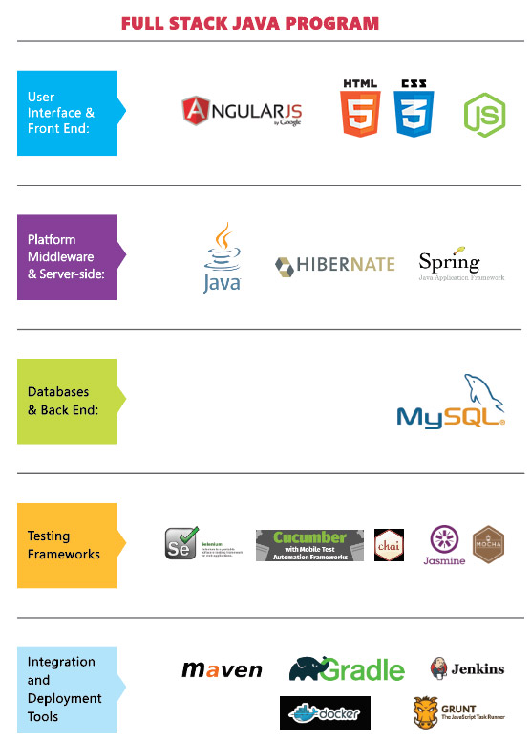

1) Front-end technology

Full stack developer should be master of essential front-end technologies like HTML5, CSS3, JavaScript. Knowledge of third-party libraries like jQuery, LESS, Angular and React Js is desirable

2) Development Languages

Full stack enginer should know atleast one server-side programming languages like Java, Python, Ruby, . Net etc.

3) Database

Knowledge of various DBMS technology is another important need of full stack developer. MySQL, MongoDB, Oracle, SQLServer are widely used for this purpose.

4) Basic design ability

In order to become a successful full stack developer, the knowledge of designing is also recommended. Moreover, the person should know the principle of basic prototype design and UI /UX design.

5) Server

Exposure to handling Apache or nginx servers is desirable. A good background in Linux helps tremendously in administering servers.

6) Version control system (VCS)

A version control system allows full stack developers to keep track of all the changes made in the codebase. The knowledge of Git helps full stack developers to understand how to get the latest code, update parts of the code, make changes in other developer's code without breaking things.

7) Working with API (REST & SOAP):

Knowledge of web services or API is also important for full stack developers. Knowledge of creations and consumption of REST and SOAP services is desirable.

As a full stack developer, you may be involved in following activities:

* Translate user requirements into the overall architecture and implementation of new systems
* Manage Project and coordinate with the Client
* Write backend code in Ruby, Python/ Java, PHP languages
* Writing optimized front end code HTML and JavaScript
* Understand, create and debug database related queries
* Create test code to validate the applicaition against client requirement.
* Monitor the performance of web applications & infrastructure
* Troubleshooting web application with a fast and accurate a resolution
* *Present state / recent developments in the work area*
* *Brief background theory*
* *Literature Survey*

**4. Objective of the work** *(not exceeding 100 words)*

* *Main work objective*
* *Secondary objective if any*

**5. Target Specifications** *(not exceeding 100 words)*

* *Importance of the end result*

**6. Functional partitioning of project** *(max 5 bullet points)*

* Segregation of project into various components.

**7. Methodology** *(detailed)*

* *Detailed methodology that will be adopted*
* *Assumptions made*
* *Circuit Layouts (one line / block diagrams) if any*
* *Component / equipment specifications*
* *Justification for component / design specifications*

**8. Tools required**

* Detailed specifications of the various components, measuring devices, software tool box, data sheet references etc

**9. Results Analysis** *(detailed)*

* *Results in graphical plots (with axes quantity & its units of measurement) or tabular form (with notation & its units of measurement)*
* *Significance of the results obtained and its analysis*
* *Any deviation from the expected results and its justification*
* *Justification for further progress / investigation if any*

**10. Conclusions**

* General conclusions from the results and its analysis

**11. Project Work Schedule**

## (a) Jan 2019: Status – Completed

The Core Java module was undertaken which covered topics like OOPS (Abstraction, Inheritance and polymorphism), collections, Multithreading. JUnit Testing, Layered Architecture. A project was implemented in JAVA Framework using collections. .

The task assigned to us was:-

Create a payment wallet application for XYZ bank. Customers will be able to park their money in the wallet. Application should allow customers to check the balance, deposit money etc. The (XYZ Bank Application had to include the following modules.

* Create account
* Show balance
* Deposit
* Withdraw
* Fund transfer
* Print Transactions

(b) Feb 2019: Status – Completed

The same project(XYZ Bank Application) was implemented using JDBC in JAVA Framework.

The JAVA framework

(c) Mar 2019: Status – In progress

The Spring module was undertaken which consisted of:

* Database and SQL
* HTML, CSS, Bootstrap and JavaScript
* JPA with Hibernate
* Servlet and JSP
* Spring MVC
* Spring Boot
* Spring Restful

The (XYZ Bank Application) will be implemented in the Spring MVC Framework using Spring JPA and web basics.

(d) Apr 2019: Status – Scheduled

A module on Behavior-driven development (BDD) will be undertaken.

Behaviour Driven Development, or BDD, is a process to build and test software that has emerged from Test Driven Development (TDD) practices. BDD will help software professionals to focus on; where to start when building software, what to test, how much to test, understanding the tests and what to build.

**Overall Project Status: On Schedule**

**12. Technical References**

*Journal / Conference Papers*

[1] Name 1 and Name 2, “Paper Title”, Full Journal Name, volume no, publication year, page numbers

[2] Name 1 and Name 2, “Paper Title”, Proceedings of the International / National Conference on ___, Institution, Country, Date, page numbers

*Reference / Hand Books*

[1] Name 1, “Book Title”, Publication Name, Edition, ISBN number

*Web*

[1] Topic 1, website name (do not include long URL’s)

**General Guidelines (Delete this page when making the report submission)**

* Report be limited to maximum 20 - 25 pages
* Paper Size: A4; Left = Right = Top = Bottom Margins = 0.7”;
* 1.15 line spacing; Times New Roman Font with Normal Style and paragraph justified
* Paragraph Heading: Times New Roman Font, Bold, Font Size 14; Paragraph Matter: Times New Roman Font, Normal, Font Size 12;
* Sub-paragraphs be appropriately numbered as in 1.1, 1.2, 1.3 etc; Sub-paragraph Heading: Times New Roman Font, Italics, Font Size 12; Sub-paragraph Matter: Times New Roman Font, Normal, Font Size 12;
* Include figures / sketches / circuit / images only if necessary
* Figure captions below Figure with continuous numbering
* Tables captions above Table with continuous numbering
* All references must be quoted in ascending order (follow IEEE format for referencing)
* Spiral binding only
* Bullet markings in Italics on page 3 are general guidelines indicating what subject matter must be discussed under respective headings
* Project students are advised to discuss with their supervisor & guide regarding the contents of the mid-term project report
* 1 hard copy with supervisor signature & seal to be speed posted / couriered to the coordinator; soft copy (without signature & seal) to be emailed to coordinator & internal (department) guide
* **Kindly take permission from supervisor / guide before including his / her email address and mobile number**
* This report will be considered for acceptance only if signed by the supervisor with seal
* Project students should submit the hard/soft copy of the synopsis report to department project coordinator