Azure-devops tool has been used for test case preparation.  
The link for the same is: <https://dev.azure.com/prekshakasliwal/CafeTownsend/_testPlans>  
  
Reason to use Azure Dev-Ops tool: It provides easy UI, helps executing the test cases on a click and also generates reports instantly. Even we can create bug on a click post failure of test cases.  
  
It might be possible you are not able to access this as I am using trial version of azure dev ops on my personal machine and does not allow me to keep test plan public. I am happy to give permissions to any id if required.

So, For skim purpose, I have detailed the test cases in excel as well which is as attached.  
  
  
  
In Azure dev-ops, following is done:  
Creating a test plan, then creation of respective test suite followed by creating test cases.

Note: I have not added all the test cases and have skipped basic validation cases like email validation, text field validation, date validation, long strings validation, special characters’ validations etc in test case sheet.

Attaching screenshots for your quick reference:  
  
1. Test Cases:  
  
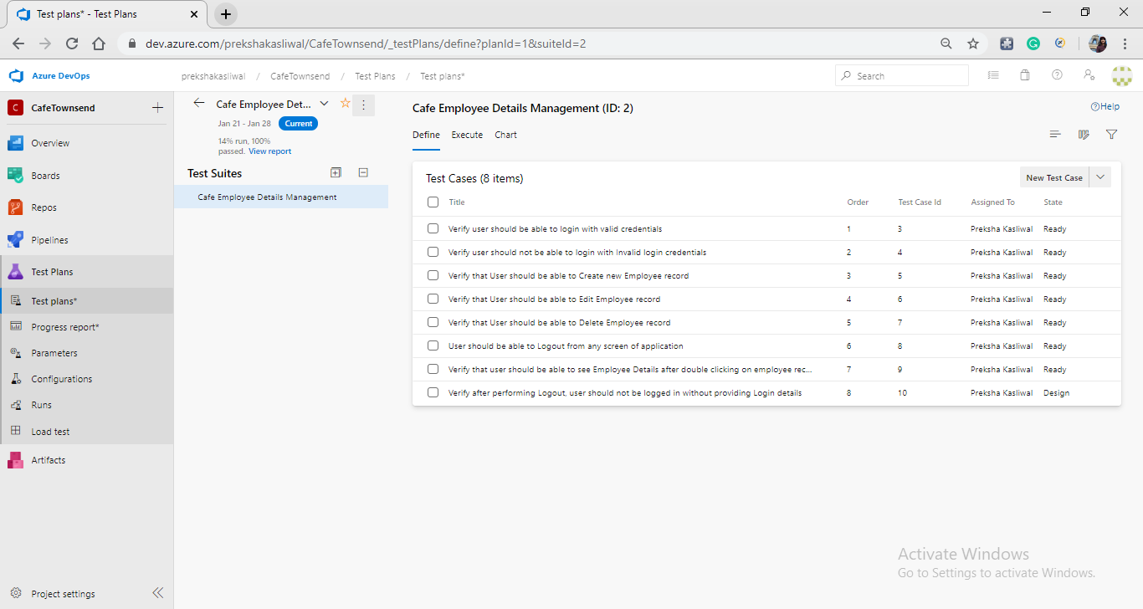

2. Running the test cases in Azure:  
  
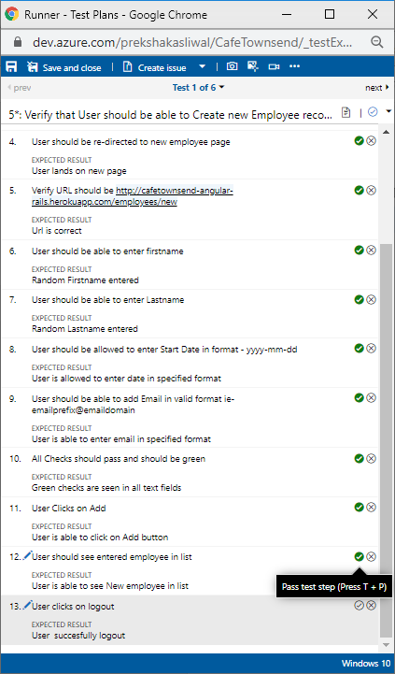  
  
3. Test Report:  
  
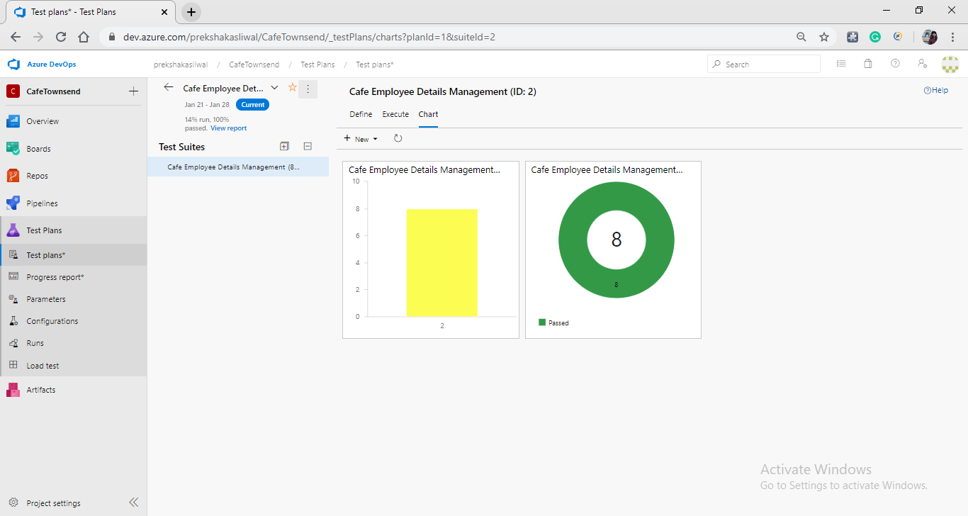

There is a different document which covers detailed explanation of automation script prepared using Selenium.  
  
Thanks,  
Preksha Kasliwal