Create local REPO

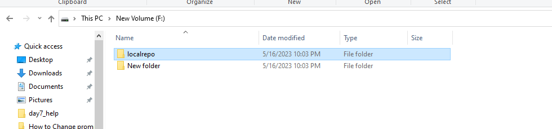

CLICK ON CREATE CMD

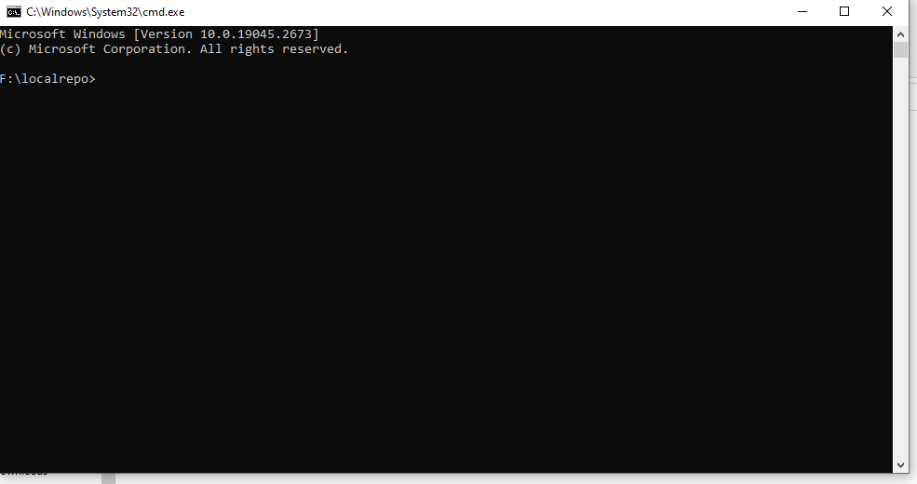

CREATE GIT HUB REPO

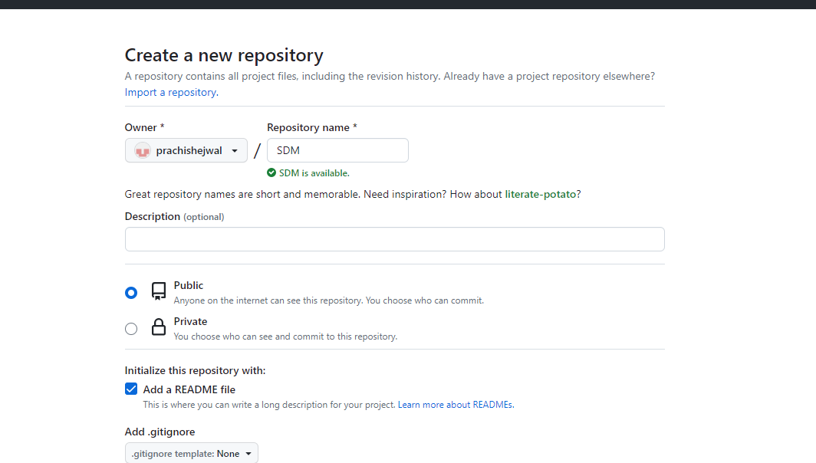

CREATE REPOSITORY ON GITHUB AND COPIES THE PATH

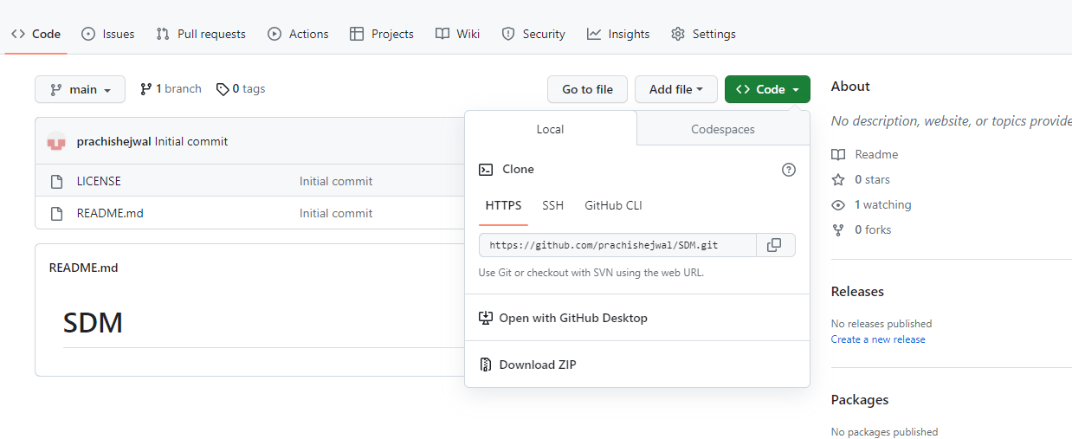

CLONE IT TO CMD

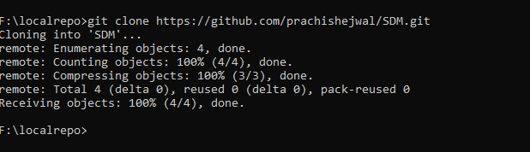

Add your git hub credential on cmd

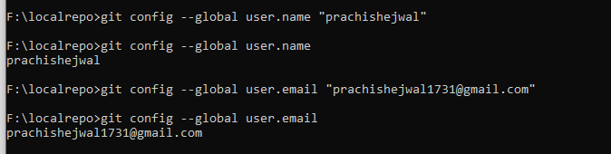

Go to created repo on github….cd SDM

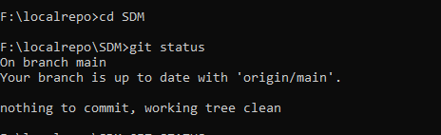

Copy all files which are going topush in folder and then push

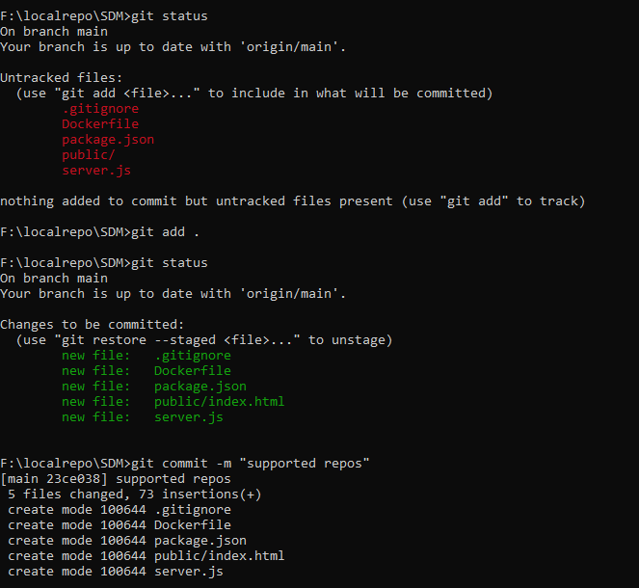

Then push all files on github

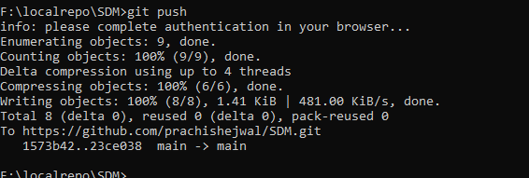

Create instance and add ip address on putty

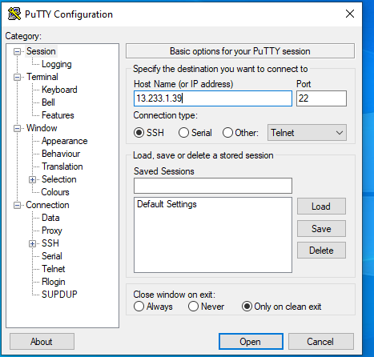

Add username for auto login

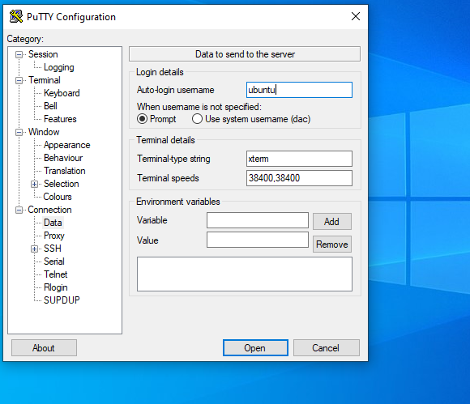

Add downloaded token path to putty

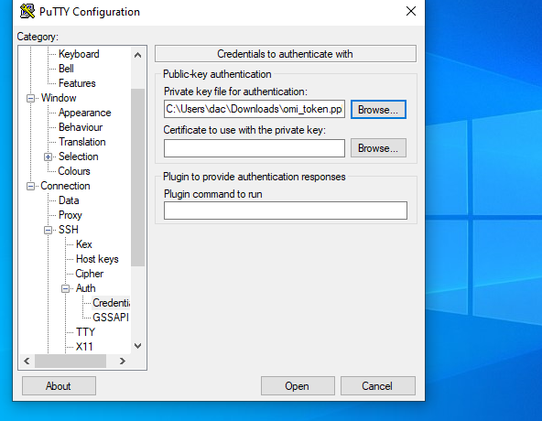

Add following commands on putty

sudo apt update

sudo apt install docker.io

sudo systemctl status docker

sudo docker images

git clone <https://github.com/prachishejwal/SDM.git>

cd SDM

sudo docker images

sudo docker build -t prachi .

sudo docker run -d -p 1456:7667 prachi