**Machine Learning (ICP # 2)**

**Name: Preksha Reddy**

**700#: 700759508**

[**https://colab.research.google.com/drive/1C_Zxk3Pju5KOMbm1-8ftJ7MnoI4WxgLe#scrollTo=r9aASm4qp8kU**](https://colab.research.google.com/drive/1C_Zxk3Pju5KOMbm1-8ftJ7MnoI4WxgLe%23scrollTo=r9aASm4qp8kU)

**Question 1:**

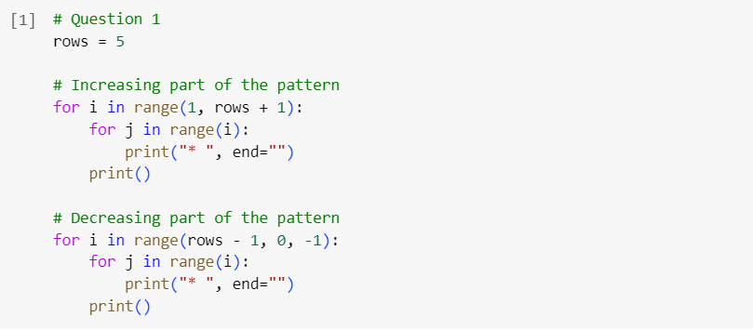

Output:

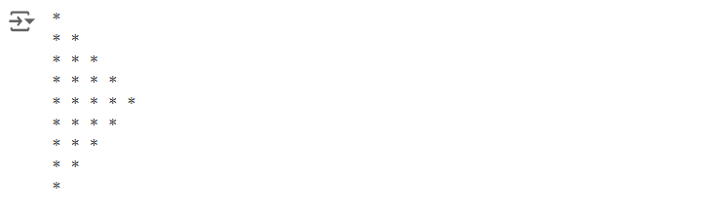

This code generates an asterisk (‘*’) pattern. It displays lines with increasing asterisk counts from 1 to 5 first, followed by lines with decreasing counts from 4 to 1. The asterisks and lines per line are controlled by the loops to create a symmetrical pattern.

**Question 2:**

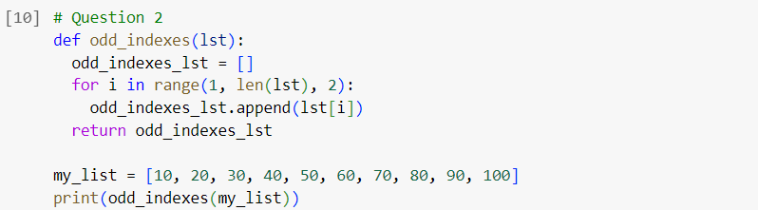

Output:



The function odd_indexes, defined in this code, accepts a list as input and outputs a new list that only has the members at odd index positions (1, 3, 5, etc.). The function is then tested with a list of numbers ranging from 10 to 100, and the outcome is printed.

**Question 3:**

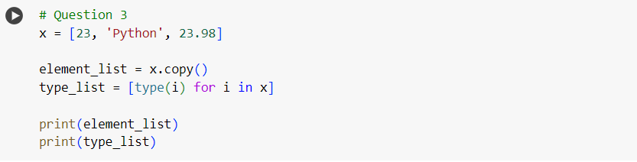

Output:



An integer, a text, and a float are the three different sorts of components that this code creates in a list called x. Then, it creates an element_list copy of x. It then generates a list called type_list containing the types of all the elements in x. Lastly, element_list and type_list are printed.

**Question 4:**

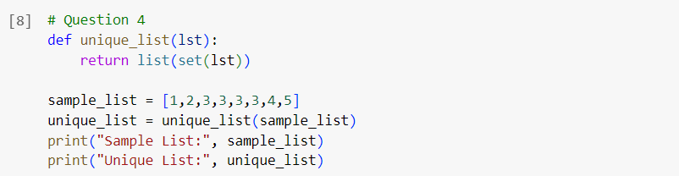

Output:



First converting a list to a set and then back to a list, the function unique_list in this code eliminates duplicates from a list. After that, it creates a new list with unique entries and tests this function using a sample list [1, 2, 3, 3, 3, 4, 5]. Lastly, it prints the unique list as well as the original.

Question 5:

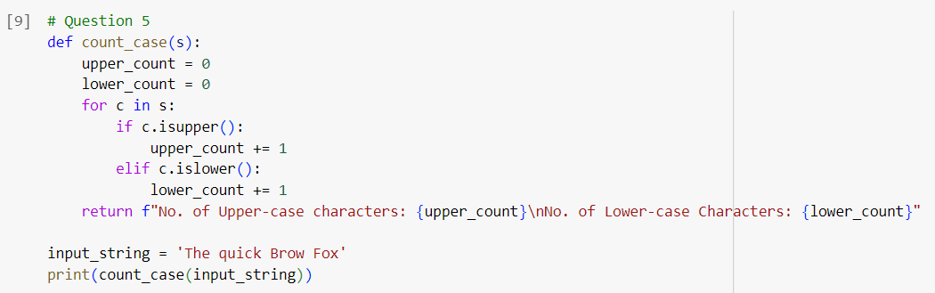

Output:



The function count_case, defined by this code, counts the number of capital and lowercase letters in a string. Two counters, upper_count and lower_count, are set to 0 at initialization. Then, iterating through each character in the string s, it increases the corresponding counter according to whether the character is lowercase or capital. Ultimately, a formatted string containing the counts is returned. The input string "The quick Brow Fox" is used to test the function, and the output is printed.