Argument Mining in Spanish Clinical Trials
A 27-Run Transformer Benchmark and Ensemble for Evidence Component Detection

GRACE @ IberLEF 2026 · Track 1 (Evidence Component Detection, Spanish) · Subtask 1 · Technical Report
Headline result
A single parallel sweep trained 9 transformer backbones × 3 seeds (27 runs) on Modal serverless GPU. The strongest single backbone, mDeBERTa-v3-base, reaches 0.705 ± 0.028 dev strict macro-F1. Averaging all 27 softmax distributions (the all-9 ensemble) raises this to 0.743 — a +3.9-point gain with no extra training and no selection bias — and produces a validated blind-test submission of 11,752 argumentative components across 2,474 abstracts.

1 Task and Dataset
Track 1 of GRACE asks systems to read a Spanish randomised-controlled-trial (RCT) abstract and label each argumentative segment as one of three component types — Premise (reported evidence and statistical results), Claim (interpretive statements), or MajorClaim (the abstract's overall conclusion) — while leaving non-argumentative text unlabelled. The official ranking metric is strict macro-F1, which requires predicted spans to match gold-standard character offsets exactly.
We frame the problem as sentence-level 4-class classification (None / Premise / Claim / MajorClaim). Sentences are segmented with spaCy (es_core_news_sm); each is classified in the context of its previous sentence. The corpus is small and severely imbalanced:
Split | Abstracts | Premise | Claim | MajorClaim
Train | 350 | 1,536 | 666 | 64
Dev | 50 | 218 | 99 | 9
Blind test | 2,474 | — | — | —

MajorClaim is only 2.8% of training components and just 9 spans in dev — the central difficulty of the task and the dominant source of variance in our results.
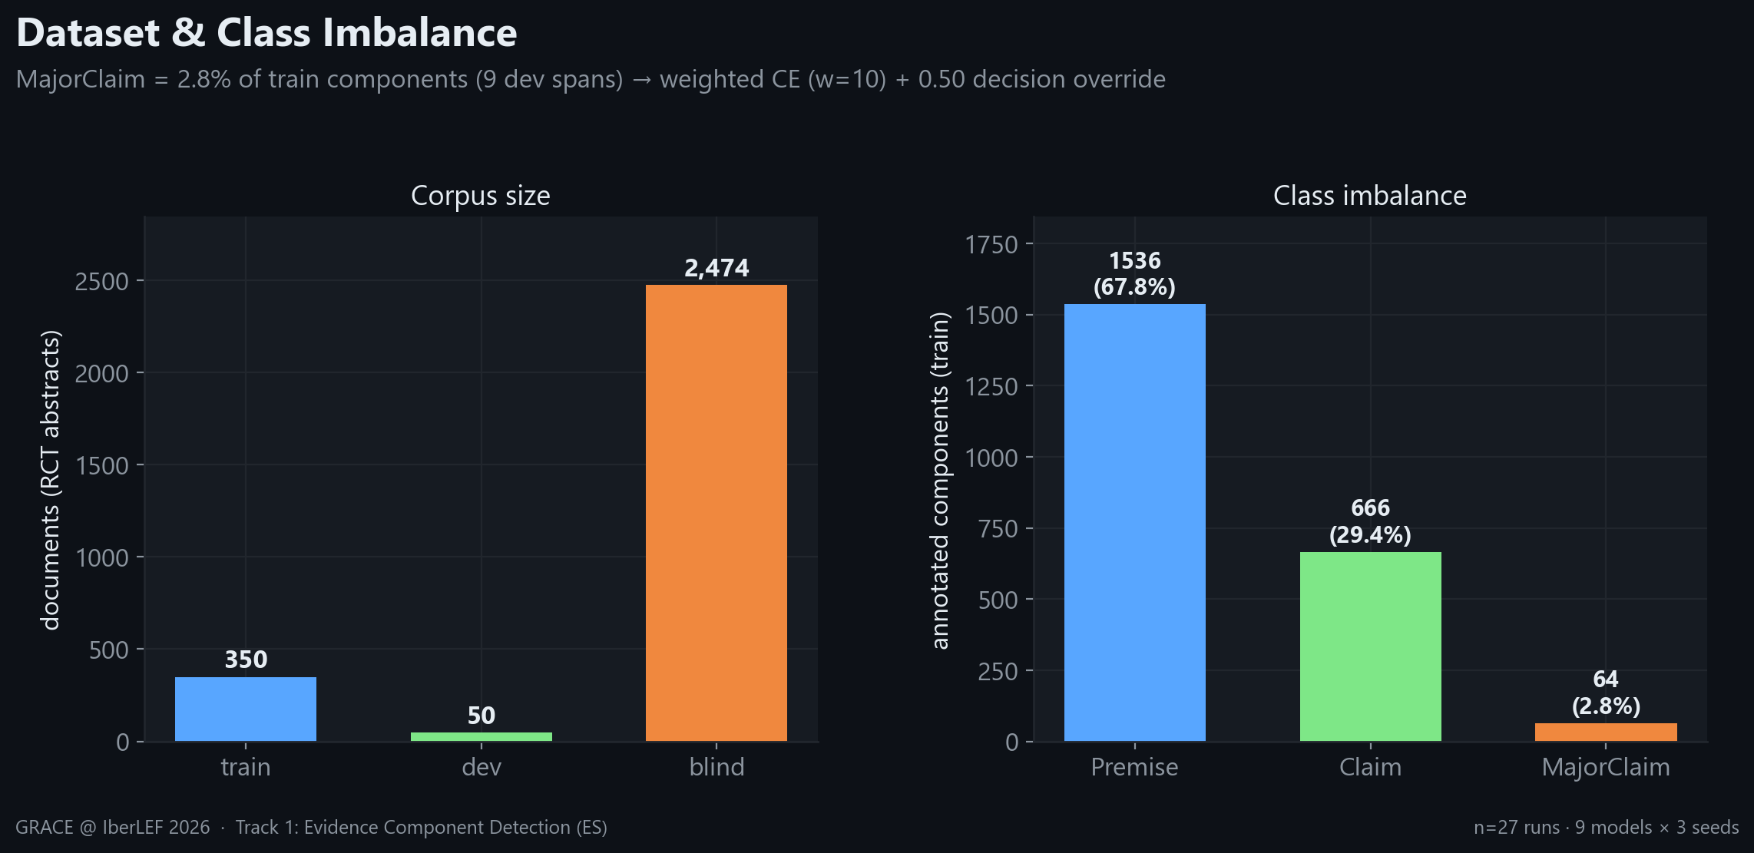
Figure 1. Corpus size (left) and training class distribution (right). MajorClaim's scarcity motivates a weighted loss and a low decision threshold.

2 Method
All nine backbones share an identical pipeline so the comparison reflects the model, not the recipe.

2.1 Input and training
- Representation: prev_sentence [SEP] sentence, max length 192 tokens, spaCy es_core_news_sm segmentation.
- Differential learning rate: body 1e-5, classifier head 1e-4 (AdamW, weight decay 0.05).
- Imbalance handling: weighted cross-entropy with MajorClaim weight 10, label smoothing 0.15, and a 0.50 probability override that promotes a segment to MajorClaim whenever its probability exceeds the threshold.
- Schedule: cosine with 100 warmup steps, batch size 16, up to 15 epochs, early-stopping patience 4.

2.2 Two-stage auto-runner
Each run executes two stages. Stage 1 trains on the training split and evaluates strict macro-F1 on dev after every epoch, keeping the best epoch (load-best-model-at-end); its dev logits are saved for ensemble construction. Stage 2 refits the model on train+dev for (best_epoch + 1) epochs and emits logits for the blind test. This cleanly separates held-out model selection from the final full-data fit used for submission.
Training ran on Modal serverless GPU (NVIDIA A10G, Ampere) using bf16 mixed precision, with the full 9×3 grid dispatched in parallel from a single launch.

3 Experimental Setup
Nine Spanish and multilingual encoders — spanning general, biomedical, and clinical pretraining — were each trained with three seeds (42, 100, 2026), giving 27 runs. All 27 converged.
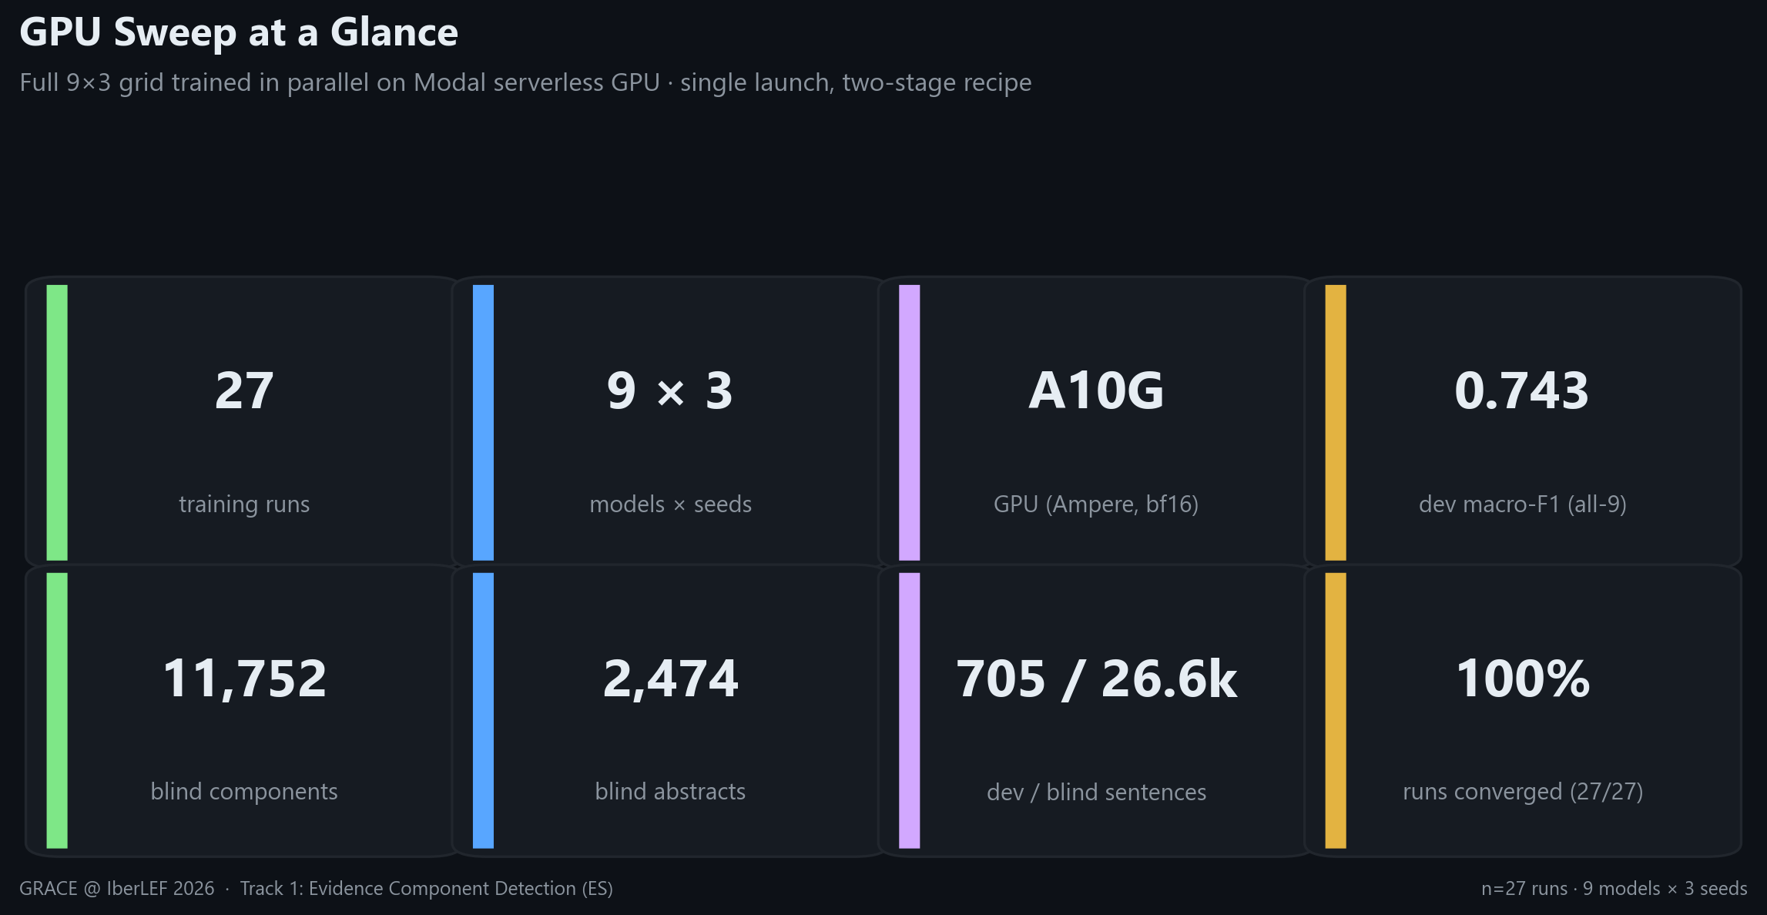
Figure 2. The sweep at a glance: a single parallel Modal launch produced every model, seed, dev score, and blind prediction reported here.

4 Results
We report mean ± standard deviation over the three seeds. Reporting distributions rather than a single best seed is essential on a dataset this small.
Model | Macro-F1 (mean ± std) | Premise | Claim | MajorClaim
mDeBERTa-v3-base | 0.705 ± 0.028 | 0.888 | 0.800 | 0.426
bsc-bio-ehr-es | 0.702 ± 0.008 | 0.895 | 0.804 | 0.408
MrBERT-es | 0.696 ± 0.021 | 0.884 | 0.799 | 0.405
RigoBERTa-Clinical | 0.692 ± 0.026 | 0.883 | 0.772 | 0.421
MrBERT-biomed | 0.691 ± 0.030 | 0.898 | 0.824 | 0.353
roberta-clinical-es | 0.685 ± 0.016 | 0.890 | 0.809 | 0.356
XLM-RoBERTa-large | 0.677 ± 0.021 | 0.886 | 0.777 | 0.367
BETO | 0.675 ± 0.007 | 0.899 | 0.773 | 0.351
BETO-Galén | 0.568 ± 0.007 | 0.821 | 0.645 | 0.237

Table 1. Per-model dev strict macro-F1 (mean ± std over 3 seeds) and per-class F1. mDeBERTa-v3-base leads; per-class columns are seed means.
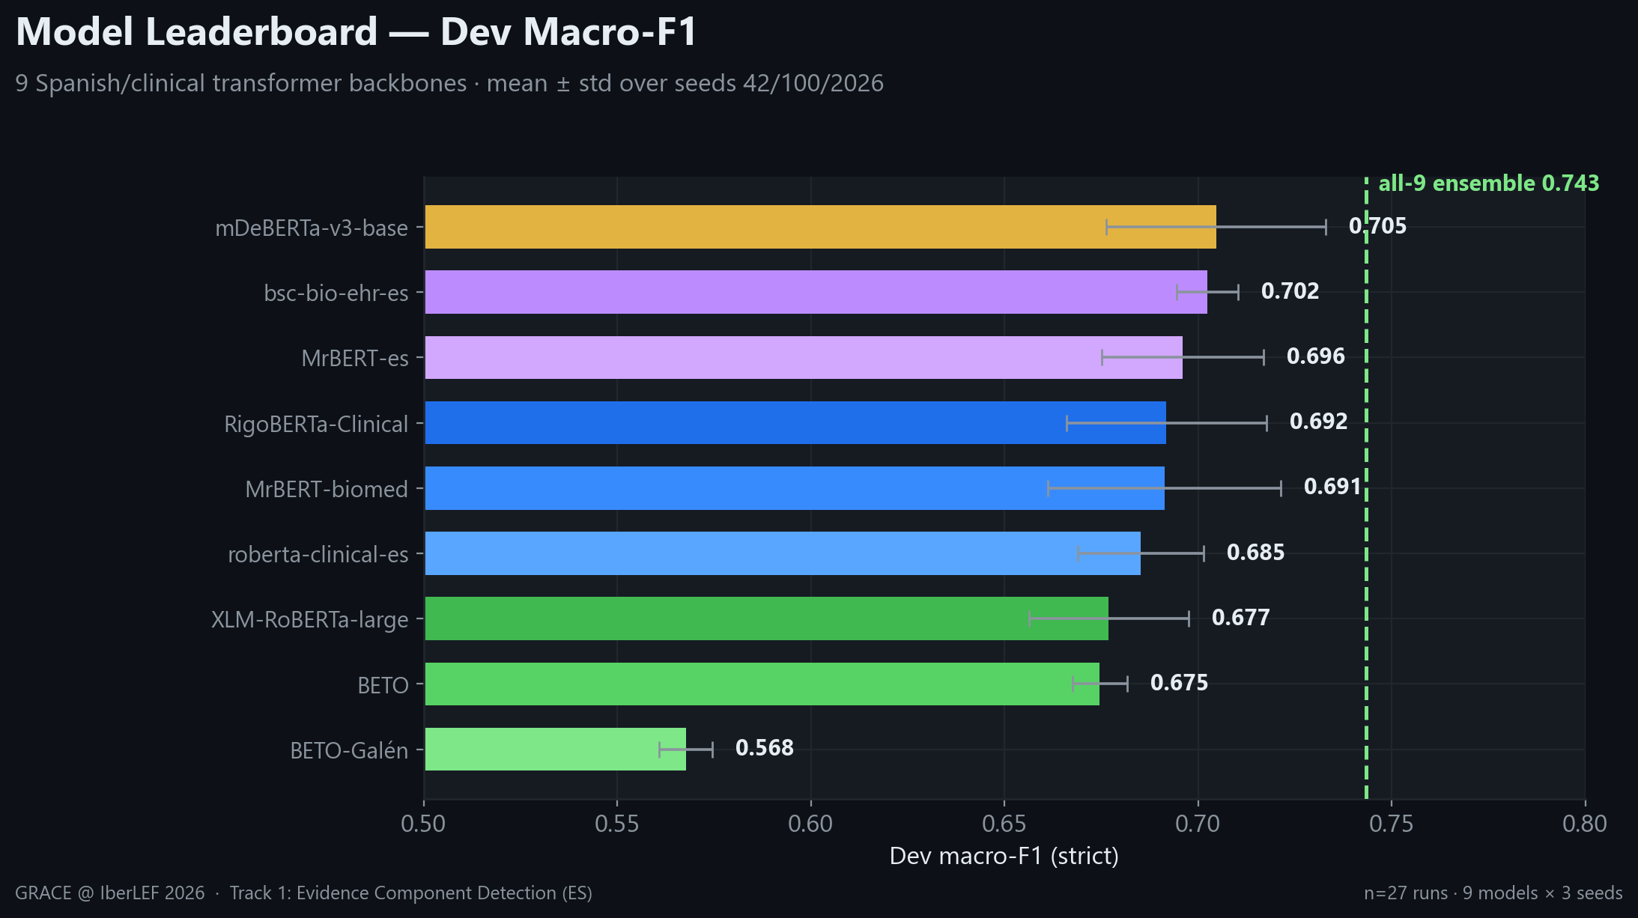
Figure 3. Model leaderboard. The dashed line marks the all-9 ensemble (0.743), which clears every single model.
Two patterns stand out. First, clinical/biomedical pretraining helps but does not dominate: the general multilingual mDeBERTa-v3 edges out the domain-specific Spanish clinical encoders. Second, the per-class view (Figure 4) shows a consistent ceiling — every backbone scores 0.82–0.90 on Premise yet only 0.24–0.43 on MajorClaim, confirming the bottleneck is data scarcity rather than any single architecture.
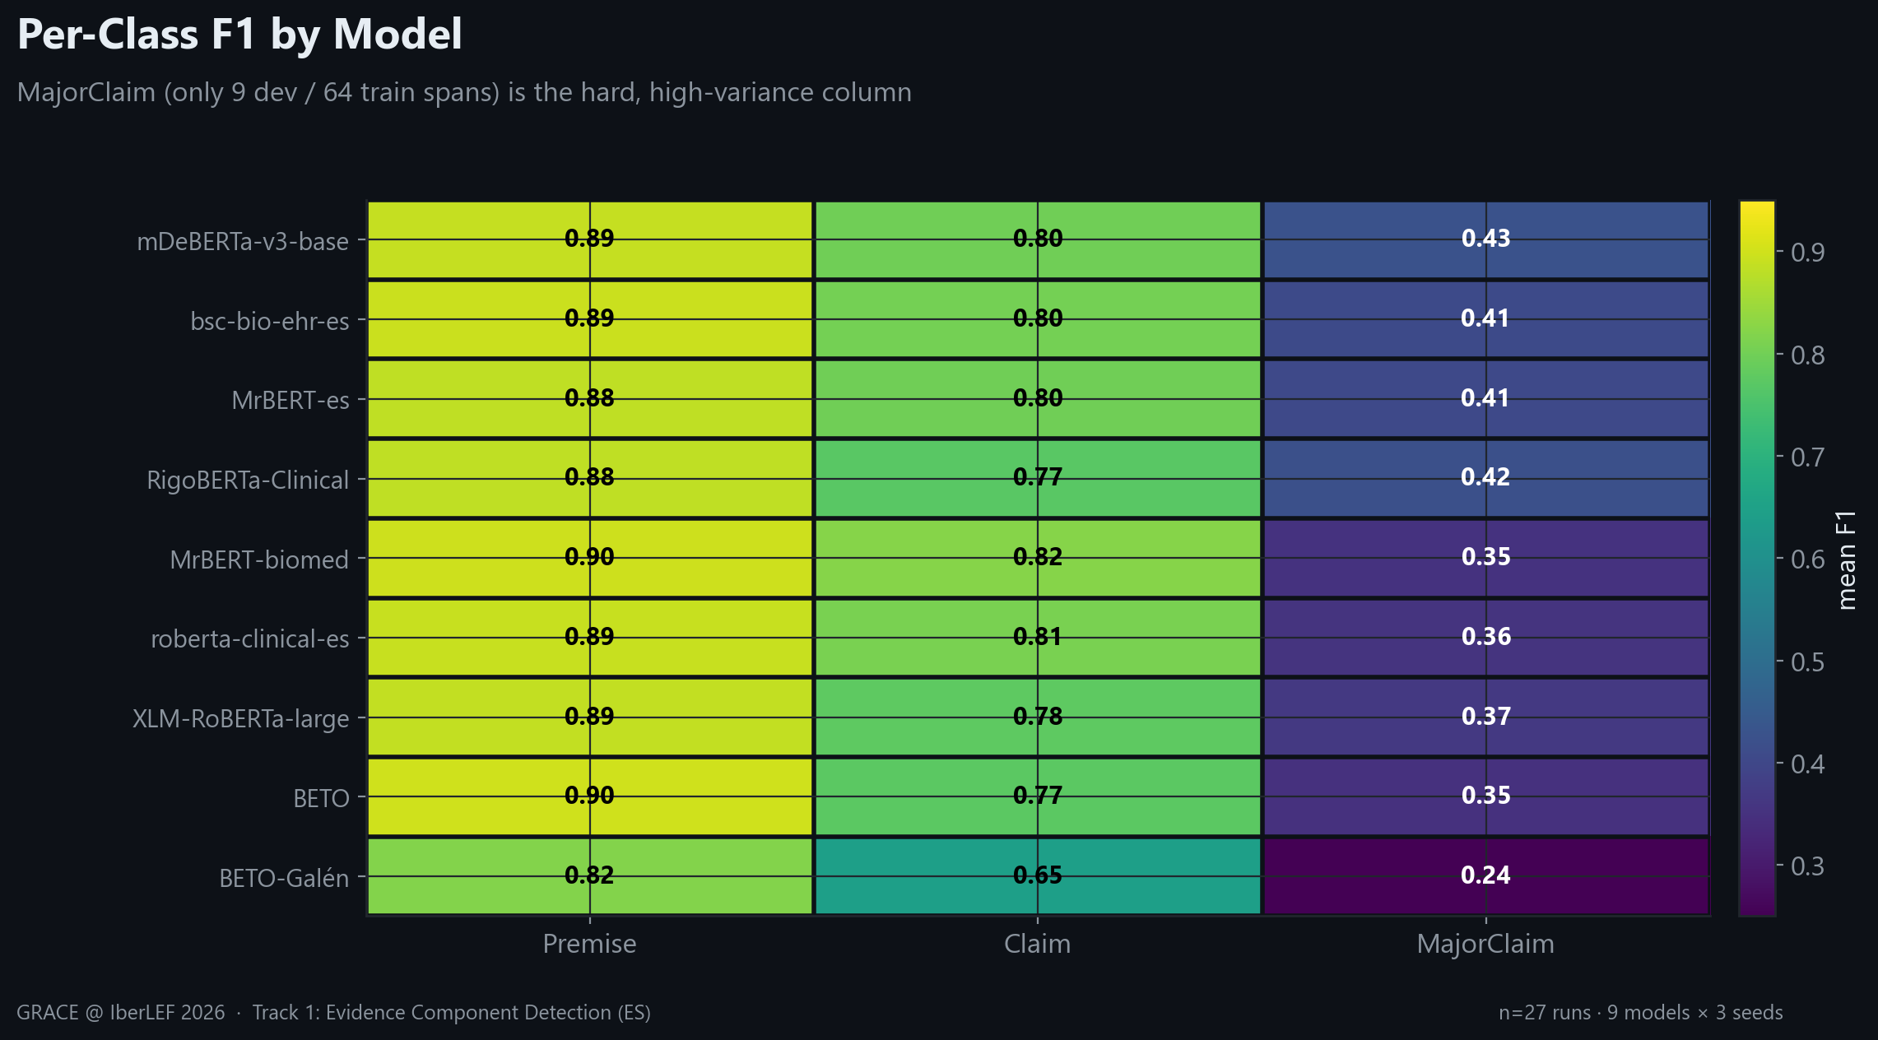
Figure 4. Per-class F1 by model. The cold MajorClaim column is universal.
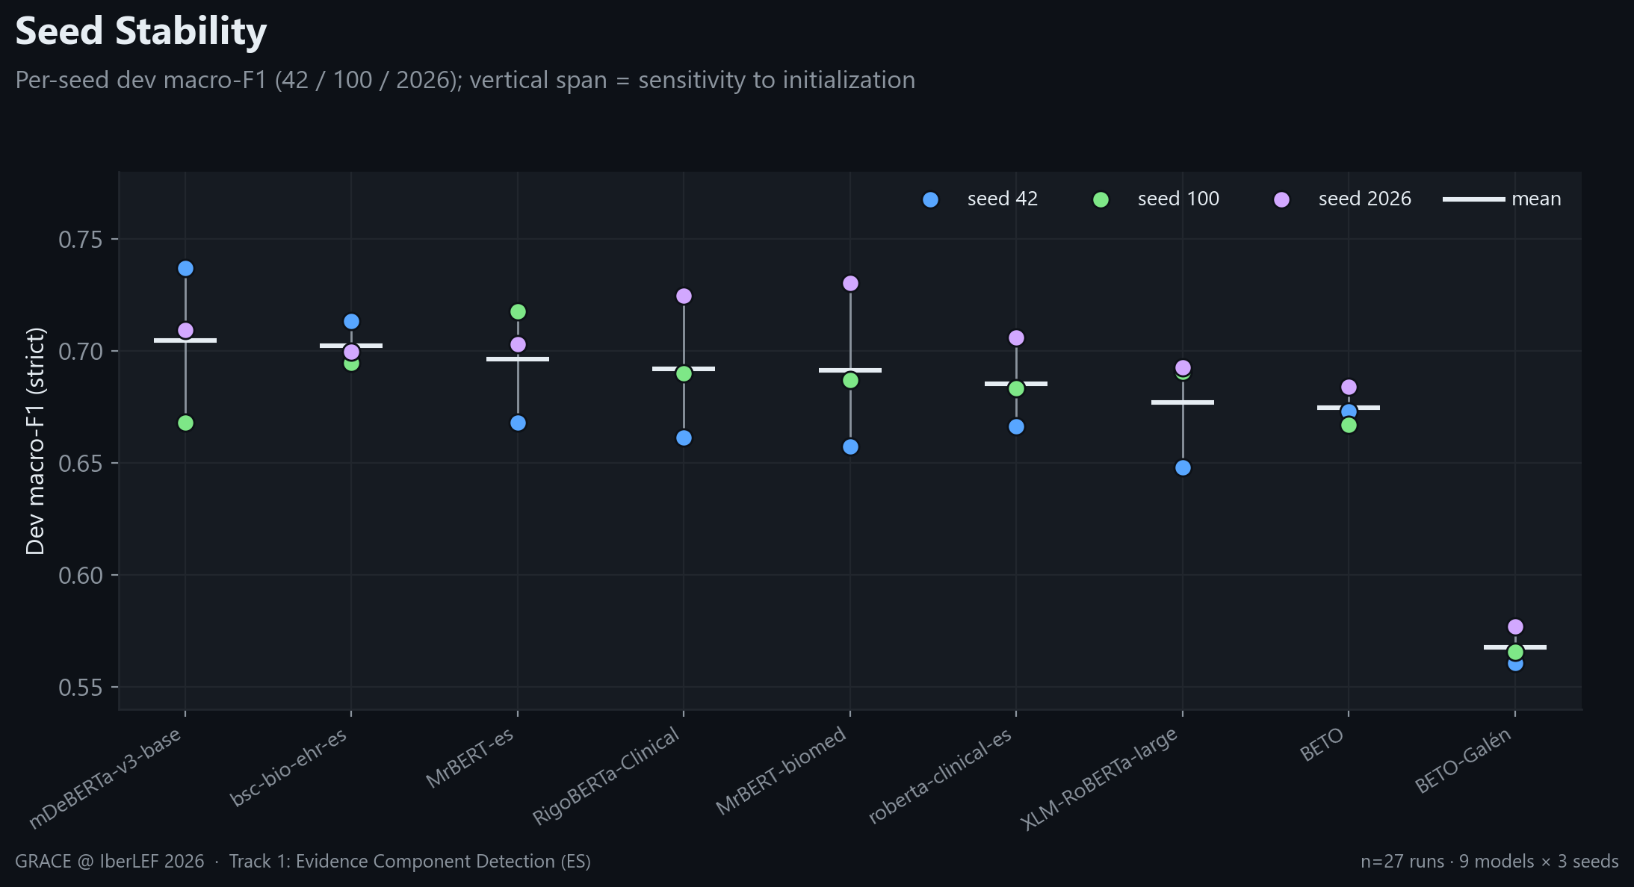
Figure 5. Seed stability. Per-seed spread reaches ~0.07 macro-F1, so single-seed rankings are unreliable.
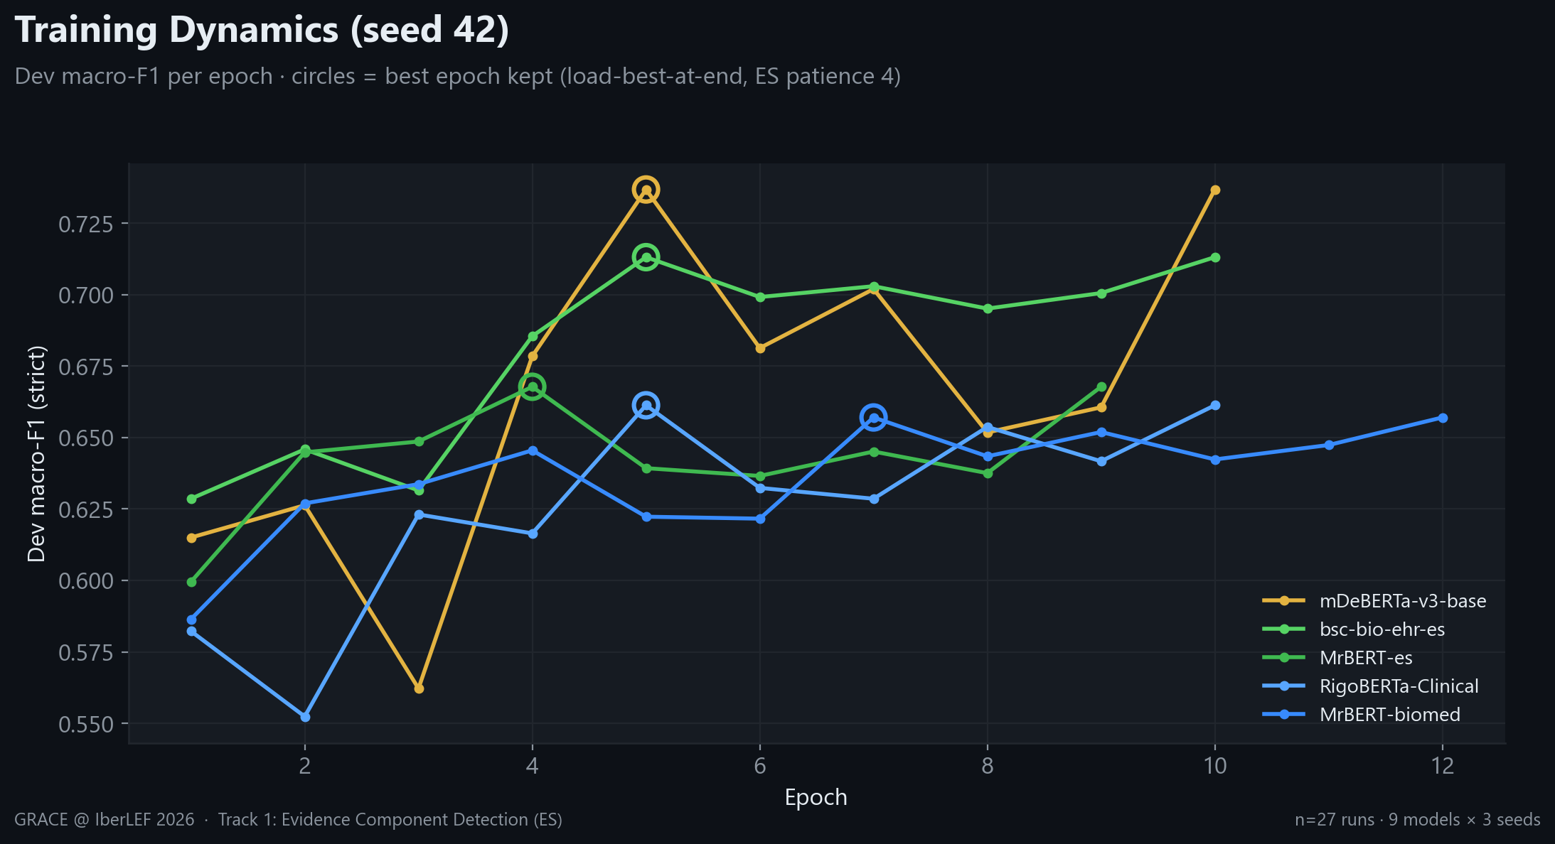
Figure 6. Dev macro-F1 per epoch (seed 42) for the five strongest backbones, which peak within 4–7 epochs; the best epoch is retained (early stopping, patience 4).

5 Ensemble
We average softmax distributions across runs (mean over the three seeds per model, then over models) and decode with the same 0.50 MajorClaim override. We evaluate three candidates with the official scorer:
- All-9 (zero-peek): the bias-free choice using every run — dev strict macro-F1 = 0.7434.
- Top-3 (dev-selected): the three highest-mean backbones — 0.7416.
- Greedy: forward selection on dev — 0.7426 (dev-optimistic upper bound).
Crucially, the all-9 ensemble (0.7434) is not only the best — it also beats the dev-selected top-3 (0.7416). Because the #3 and #4 backbones differ by less than the seed noise, selecting members on dev adds bias without adding accuracy. We therefore submit all-9: the choice that peeks at nothing is also the strongest.
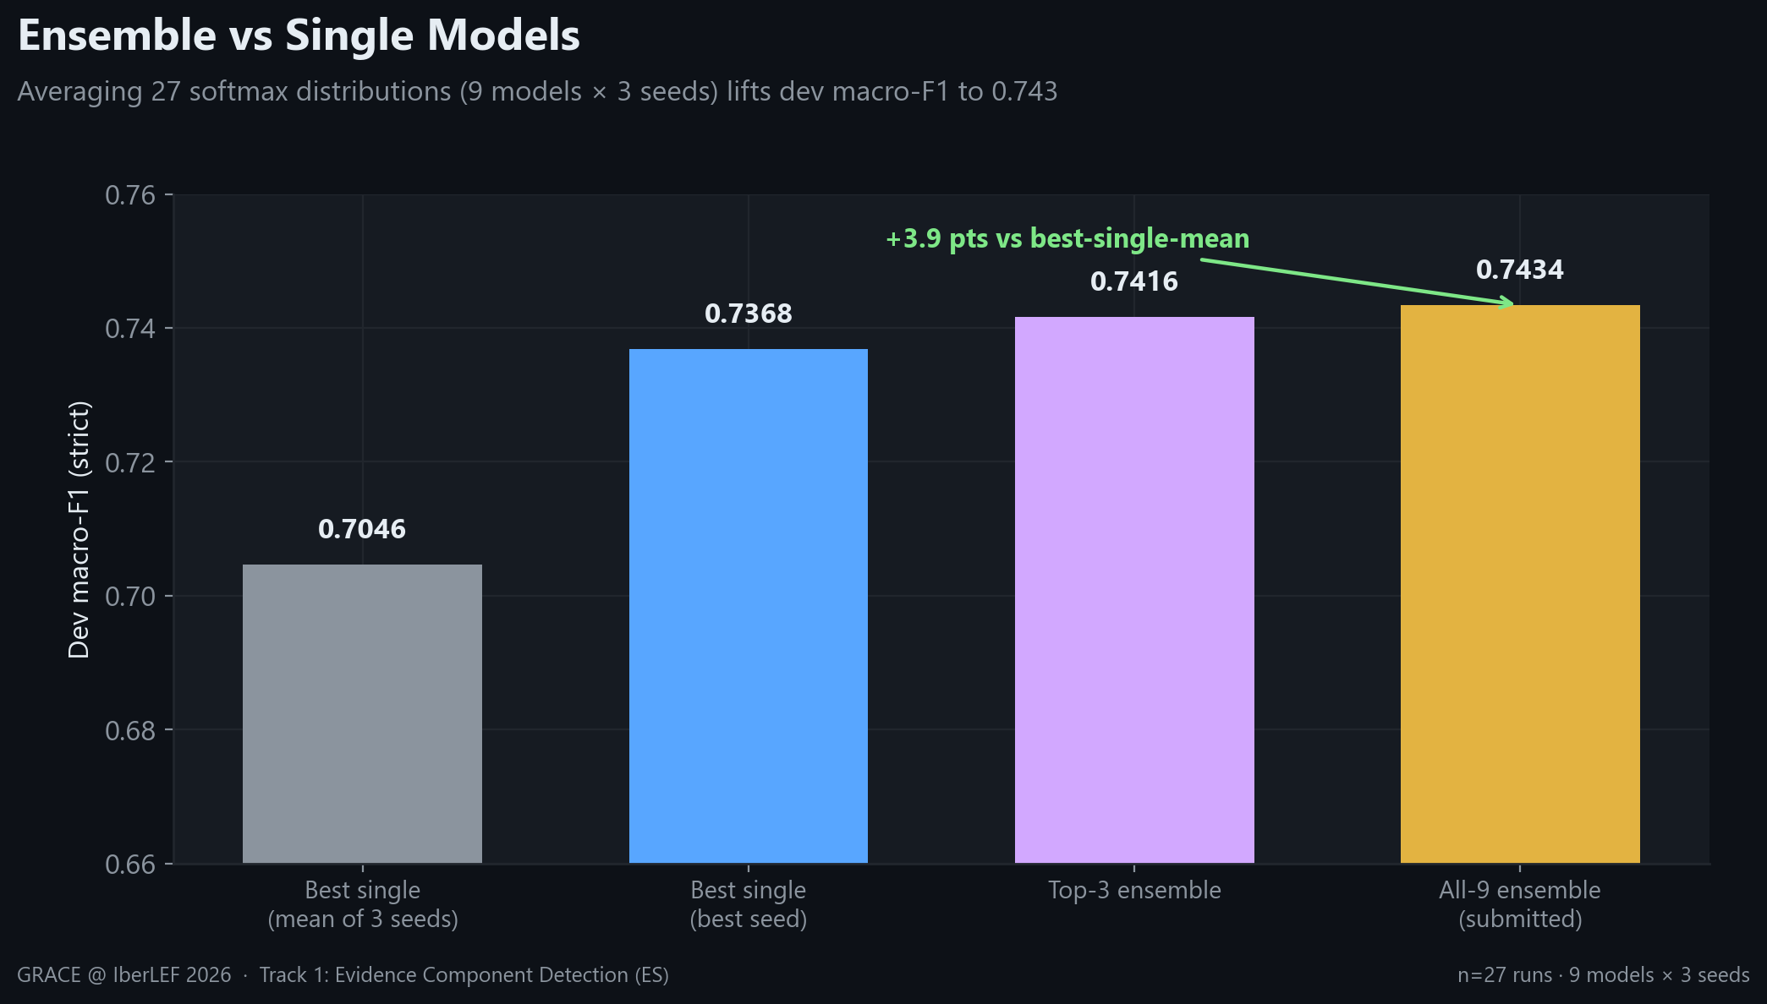
Figure 7. Ensemble vs single models. Averaging 27 distributions adds +3.9 points over the best single model's mean, with no extra training.

6 Blind-Test Submission
Applying the all-9 ensemble to the 2,474 blind abstracts (26,640 segmented sentences) yields 11,752 predicted argumentative components: 7,872 Premise, 3,717 Claim, and 163 MajorClaim. Every predicted span was offset-validated (raw_text[start:end] exactly equals the predicted text — 0 mismatches after trimming spaCy's trailing whitespace). For the two majority classes the predicted split closely matches the training prior (Premise 67.0% vs 67.8%, Claim 31.6% vs 29.4%); MajorClaim is predicted even more conservatively (1.4% vs 2.8%), consistent with its known difficulty — a useful sanity check that the ensemble did not collapse to a single class.
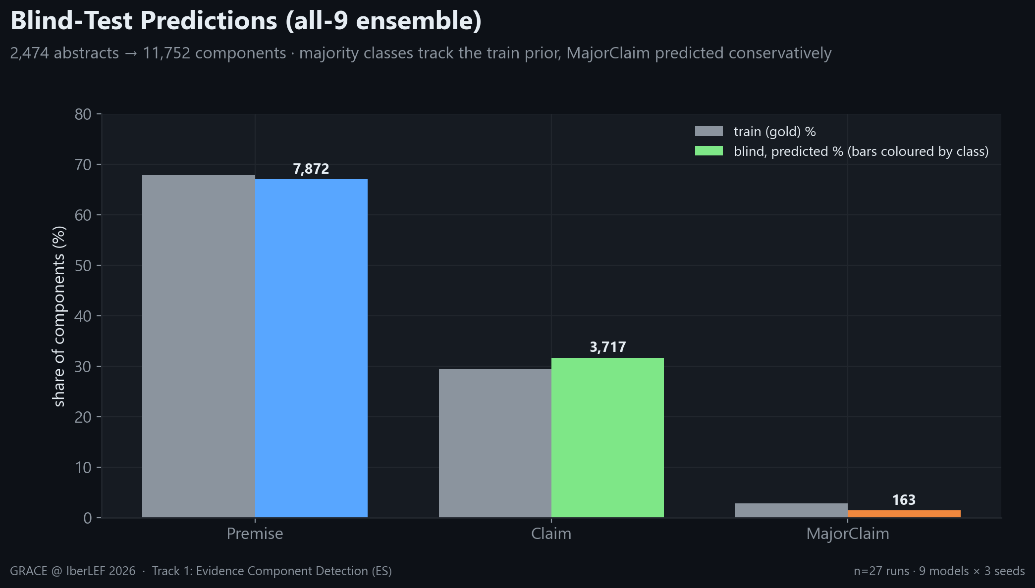
Figure 8. Blind-test predicted class distribution vs the training prior.

7 Engineering Notes and Lessons
- Precision unlocks the best model. mDeBERTa-v3-base diverged to NaN gradients under fp32 and scored 0.0. Switching to bf16 on Ampere hardware stabilised training and turned it into the top single model. The right numerical precision mattered more than the choice of architecture.
- Ensembling is the honest win. Averaging 27 distributions is the cheapest reliable gain available — +3.9 points over the best single model with zero additional training — and, chosen as all-9, it carries no model-selection bias.
- Seeds matter. Identical results across seeds are the exception, not the rule: spread reaches ~0.07 macro-F1 on 350 training documents. Mean ± std over multiple seeds is the defensible way to compare models here.
- Reproducibility caveat. Per-platform numbers differ (the same model trained on a different cloud produced different dev scores), so all comparisons in this report come from one consistent Modal sweep. We report mean ± std, never a cherry-picked seed or platform.

8 Conclusion and Next Steps
A disciplined 27-run benchmark plus a bias-free ensemble reaches 0.743 dev strict macro-F1 on GRACE Track 1 and delivers a clean blind-test submission. The remaining headroom is concentrated in MajorClaim, a data-scarcity problem rather than a modelling one.
Priorities going forward: (1) clause-level segmentation to recover sub-sentence spans the strict metric penalises; (2) MajorClaim-targeted augmentation or contrastive objectives to lift the weakest class; and (3) Track-2 relation detection built on top of these components.

Appendix A Full Per-Run Results (27 runs)
Model | Seed | Best epoch | Macro-F1 | Premise | Claim / MajorClaim
mDeBERTa-v3-base | 42 | 5 | 0.7368 | 0.887 | 0.824 / 0.500
mDeBERTa-v3-base | 100 | 7 | 0.6679 | 0.887 | 0.783 / 0.333
mDeBERTa-v3-base | 2026 | 4 | 0.7091 | 0.891 | 0.792 / 0.444
bsc-bio-ehr-es | 42 | 5 | 0.7131 | 0.891 | 0.803 / 0.444
bsc-bio-ehr-es | 100 | 6 | 0.6944 | 0.892 | 0.810 / 0.381
bsc-bio-ehr-es | 2026 | 9 | 0.6996 | 0.901 | 0.798 / 0.400
MrBERT-es | 42 | 4 | 0.6678 | 0.885 | 0.802 / 0.316
MrBERT-es | 100 | 5 | 0.7176 | 0.867 | 0.786 / 0.500
MrBERT-es | 2026 | 8 | 0.7028 | 0.899 | 0.810 / 0.400
RigoBERTa-Clinical | 42 | 5 | 0.6613 | 0.885 | 0.766 / 0.333
RigoBERTa-Clinical | 100 | 6 | 0.6899 | 0.874 | 0.767 / 0.429
RigoBERTa-Clinical | 2026 | 5 | 0.7244 | 0.891 | 0.782 / 0.500
MrBERT-biomed | 42 | 7 | 0.6570 | 0.902 | 0.820 / 0.250
MrBERT-biomed | 100 | 6 | 0.6867 | 0.890 | 0.806 / 0.364
MrBERT-biomed | 2026 | 4 | 0.7302 | 0.901 | 0.845 / 0.444
roberta-clinical-es | 42 | 4 | 0.6662 | 0.898 | 0.798 / 0.303
roberta-clinical-es | 100 | 5 | 0.6832 | 0.887 | 0.814 / 0.348
roberta-clinical-es | 2026 | 4 | 0.7060 | 0.886 | 0.816 / 0.417
XLM-RoBERTa-large | 42 | 5 | 0.6479 | 0.883 | 0.794 / 0.267
XLM-RoBERTa-large | 100 | 11 | 0.6906 | 0.892 | 0.779 / 0.400
XLM-RoBERTa-large | 2026 | 8 | 0.6924 | 0.884 | 0.759 / 0.435
BETO | 42 | 9 | 0.6728 | 0.891 | 0.775 / 0.353
BETO | 100 | 4 | 0.6670 | 0.902 | 0.784 / 0.316
BETO | 2026 | 4 | 0.6840 | 0.905 | 0.762 / 0.385
BETO-Galén | 42 | 12 | 0.5606 | 0.810 | 0.649 / 0.222
BETO-Galén | 100 | 9 | 0.5655 | 0.829 | 0.645 / 0.222
BETO-Galén | 2026 | 11 | 0.5770 | 0.824 | 0.641 / 0.267

Appendix B Reproducibility
All artifacts derive from two Modal apps in FINAL/ and one consolidation step:
- modal_sweep.py: trains the 9×3 grid (two-stage recipe) and writes per-run logits + metrics to a Modal volume.
- modal_ensemble.py: loads the 27 logit sets, reproduces a known single-model dev F1 as an alignment gate, builds the all-9 / top-3 / greedy ensembles, scores them with the official program, and writes the blind submission.
- report/: collect_data.py → make_figures.py → build_docx.py / build_pptx.py regenerate this report from the saved results.
Key settings: max_len 192, body LR 1e-05, head LR 0.0001, weighted CE (MajorClaim w=10), cosine + 100 warmup steps, label smoothing 0.15, batch 16, ≤15 epochs, ES patience 4, MajorClaim override 0.5. GPU: NVIDIA A10G (Ampere, 24 GB).

