Volunteering, Internship & Fellowship Opportunities
for Students in India — Data Analysis Report
Analysis of a 20-opportunity dataset compiled July 2026

Executive Summary
A dataset of 20 verified volunteering, internship, and fellowship opportunities for Indian students was compiled and analyzed across four dimensions: opportunity type, engagement mode, compensation structure, and application timeline. The analysis shows the landscape is dominated by low-barrier, unpaid, rolling-admission volunteering (40% of entries), while paid, structured fellowships remain a smaller but higher-value tier (25%) reserved mostly for graduates. Three-quarters of all opportunities are open to current students without requiring a completed degree, and 80% accept applications on a rolling or ongoing basis rather than a fixed annual deadline — meaning timing is rarely the binding constraint for students; eligibility and mode of engagement are.

1. Methodology
Twenty organizations were identified through targeted research (government portals, NGO databases, and fellowship listings, current as of July 2026). Each entry was coded across five variables — opportunity type, eligibility level, engagement mode, compensation structure, and deadline structure — to allow quantitative comparison rather than a simple directory listing. Percentages below are of the full n=20 dataset.

2. Dataset Composition
Table 1 breaks the 20 opportunities into five mutually exclusive categories.
Category | Count | % of 20 | Example
Volunteering (unpaid) | 8 | 40% | NSS, Bhumi, Youth for Seva, eVidyaloka
Fellowship (paid, structured) | 5 | 25% | SBI Youth for India, Gandhi Fellowship, YIF
Volunteering & Internship (mixed) | 4 | 20% | CRY, Smile Foundation, HelpAge India
Volunteer-matching platform | 2 | 10% | iVolunteer, GiveIndia
Paid government internship | 1 | 5% | PM Internship Scheme
Table 1. Opportunity type breakdown (n=20)
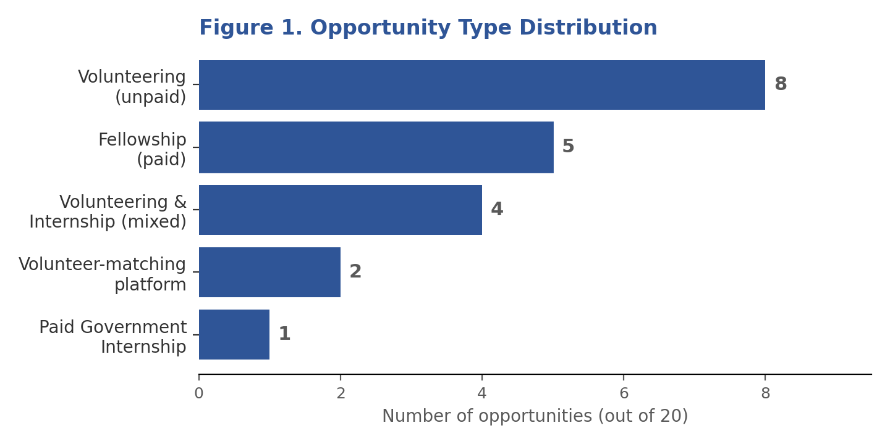
Figure 1 — Unpaid volunteering is the largest single category, but fellowship + paid-internship + mixed types together make up 50% of the dataset.

3. Engagement Mode Analysis
Opportunities were classified by where the work happens: on-ground/residential, hybrid (mix of remote and in-person), or fully remote.
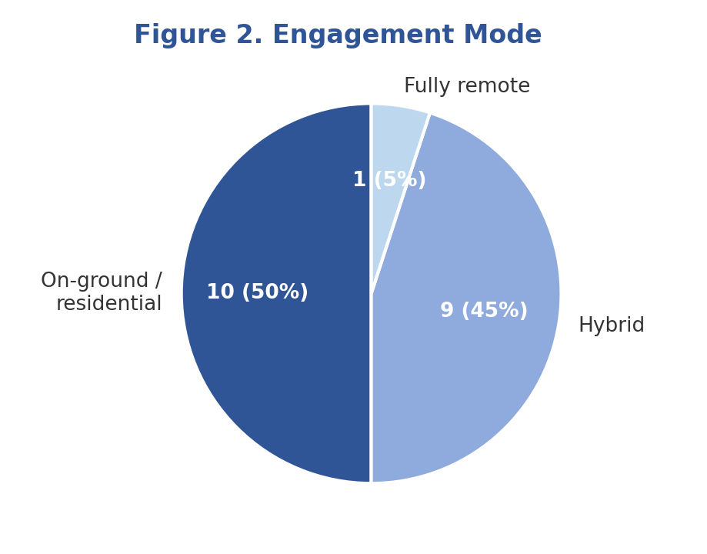
Figure 2 — Half of all opportunities (9/20) now offer hybrid engagement, showing NGOs have moved past the pandemic-era all-remote or all-in-person binary. Only 1 opportunity (eVidyaloka) is fully remote, so location remains a real constraint for most listings.

4. Compensation Structure
Only 6 of 20 opportunities (30%) offer a monetary stipend or financial aid; the remaining 14 (70%) are certificate/experience-based with no direct payment.
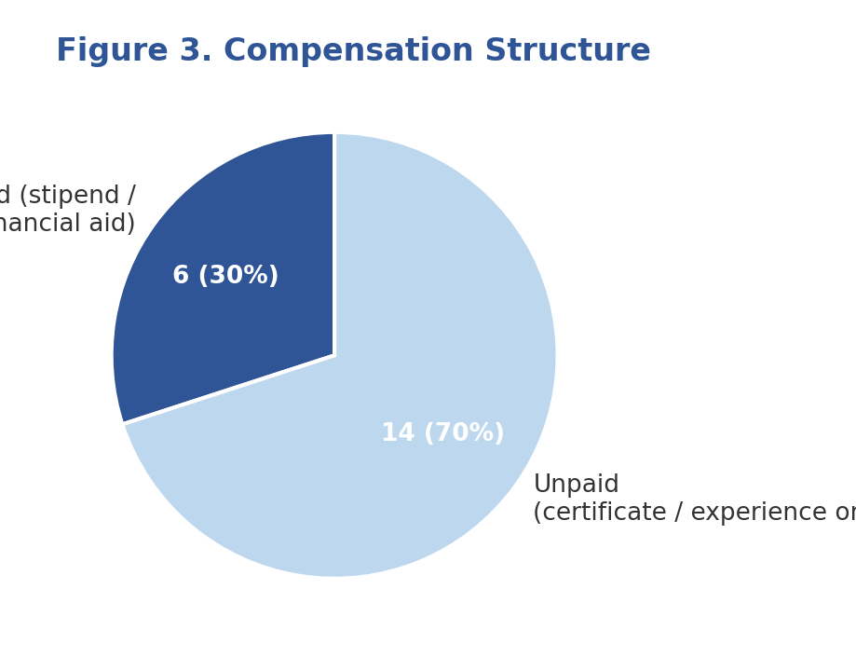
Figure 3 — Paid opportunities cluster almost entirely in the Fellowship category, suggesting students seeking income (not just experience) have a narrower, more competitive set of options.

5. Deadline Structure & Eligibility Level
Deadlines and eligibility were cross-tabulated to see how much of the dataset is actually time-gated versus open year-round, and how much requires a completed degree.
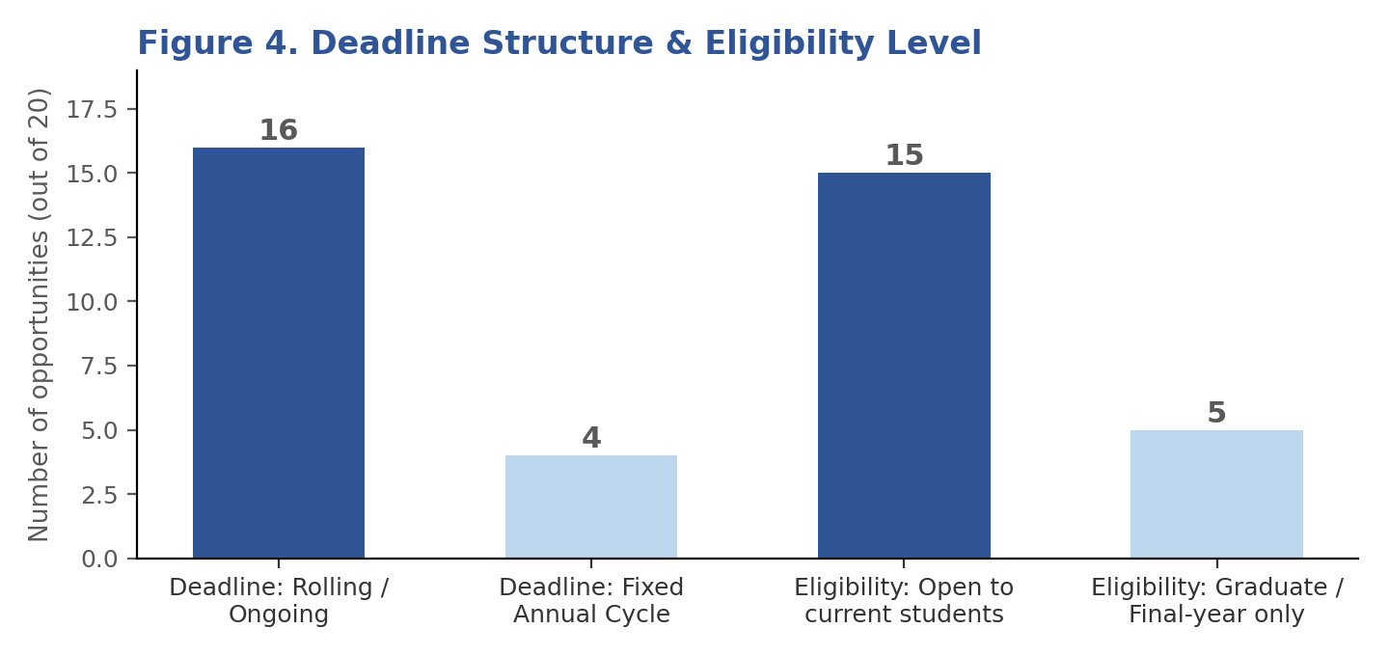
Figure 4 — 80% of opportunities accept rolling applications (mostly volunteering roles), while the 20% with fixed annual deadlines are concentrated in the higher-value fellowships (Gandhi Fellowship, YIF, AIF Clinton, Nehru Fellowship) — these are the ones students most need to calendar in advance.

6. Key Insights
- Entry barrier is low overall: 75% of opportunities (15/20) are open to current students, so lack of a degree is rarely a blocker — the real filter is age, location, and time commitment.
- Paid opportunities are concentrated and competitive: nearly all 6 paid options are multi-month fellowships with structured selection (essays, interviews), unlike the low-friction sign-up process for unpaid volunteering.
- Deadlines matter for a minority, but a critical minority: the 4 fixed-deadline programs are also the 4 highest-value paid fellowships — missing these costs a student a full year's wait, unlike rolling volunteering roles.
- Hybrid is now the norm, not remote: students outside metro cities have more real options than pure-remote listings suggest, since 9 of 20 opportunities explicitly support hybrid participation.
- Government-run channels (NSS, NYKS, PM Internship) account for 3 of 20 entries but reach by far the largest number of total participants (NSS alone: 8.2 crore+ students historically), indicating scale and selectivity are inversely related in this dataset.

7. Recommendations by Student Profile

Class 11-12 / early undergraduate students
Start with NSS/NYKS or an unpaid NGO role (Bhumi, Youth for Seva, Unessa) — no degree required, rolling deadlines, and low commitment thresholds make these accessible entry points to build a track record.

Final-year undergraduates seeking paid, resume-building experience
Target the PM Internship Scheme now (rolling, open to final-year students) and calendar the Gandhi Fellowship (~March) and Young India Fellowship (priority deadline December) applications a full year ahead, since these are the fixed-cycle, higher-value programs.

Recent graduates seeking a structured leadership fellowship
SBI Youth for India, AIF Clinton Fellowship, and Nehru Fellowship offer stipends plus mentorship; apply to more than one given the competitive, deadline-bound selection process.

8. Full Dataset (Coded)
# | Organization | Category | Eligibility Level | Mode | Paid? | Deadline Type
1 | NSS | Volunteering | Open (Class 11+) | On-ground | No | Rolling
2 | NYKS | Volunteering | Open (age 15-29) | On-ground | No | Rolling
3 | SBI Youth for India Fellowship | Fellowship | Graduate | On-ground | Yes | Rolling (stage-1)
4 | Gandhi Fellowship | Fellowship | Graduate | On-ground | Yes | Fixed (~Mar 31)
5 | Young India Fellowship | Fellowship | Graduate | On-campus | Yes (aid) | Fixed (Jan 19)
6 | PM Internship Scheme | Paid Internship | Open (18-25) | On-site | Yes | Rolling
7 | Teach For India | Volunteering & Internship | Open / Graduate (Fellowship) | Hybrid | Mixed | Rolling
8 | Bhumi | Volunteering | Open | On-ground | No | Rolling
9 | Youth for Seva | Volunteering | Open (age 16+) | Hybrid | No | Rolling
10 | Unessa Foundation | Volunteering | Open | Hybrid | No | Rolling
11 | eVidyaloka | Volunteering | Open | Remote | No | Rolling
12 | iVolunteer | Platform | Open | Hybrid | No | Rolling
13 | GiveIndia | Platform | Open | Hybrid | No | Rolling
14 | Robin Hood Army | Volunteering | Open | On-ground | No | Rolling
15 | Make A Difference | Volunteering | Open | Hybrid | No | Rolling
16 | CRY | Volunteering & Internship | Open | Hybrid | Mixed | Rolling
17 | Smile Foundation | Volunteering & Internship | Open (16+) | Hybrid | Mixed | Rolling
18 | AIF Clinton Fellowship | Fellowship | Graduate | On-ground | Yes | Fixed (Jan-Feb)
19 | HelpAge India | Volunteering & Internship | Open | Hybrid | Mixed | Rolling
20 | Nehru Fellowship | Fellowship | Graduate | On-ground | Yes | Fixed (varies)

Notes
Coding reflects the primary/most common pathway for each organization (e.g., Teach For India's short-term volunteering is rolling even though its 2-year Fellowship has an annual cycle). Verify current deadlines and stipend amounts on each organization's official site before applying, as these change yearly.

