**PSG COLLEGE OF TECHNOLOGY, COIMBATORE -4**

**DEPARTMENT OF APPLIED MATHEMATICS AND COMPUTATIONAL SCIENCES**

**II year M.Sc. –Software Systems - Fourth Semester**

**Completion Time: 20/12/2023**

1. Write HTML code to develop a web page having the background in red and title as “My First Page”.
2. Print the numbers 1 - 10, each number being a different color.
3. Create a HTML document giving details of your name, age, telephone, address & enrollment no. aligned in proper order?
4. Write a HTML code to print your name with different heading style.
5. Print a paragraph that is a description of a book, include the title of the book as well as its author. Names and titles should be underlined, adjectives should be italicized and bolded.
6. Print a paragraph with 4 - 5 sentences. Each sentence should be in a different font.
7. Design a page having background color, given text color red and use all the attributes of font tag.
8. Print the squares of the numbers 1 - 20. Each number should be on a separate line, next to it the number 2 superscripted, an equal sign and the result. (Example: 102 = 100)
9. Prints 10 names with a line break between each name. The list should be alphabetized, and to do this place a subscripted number next to each name based on where it will go in the alphabetized list. (Example: Alan1). Print first, the unalphabetized list with a subscript number next to each name, then the alphabetized list. Both lists should have an <h1> level heading.
10. Print two paragraphs that are both indented using the &nbsp; command.
11. Print two lists with any information you want. One list should be an ordered list, the other list should be an unordered list.
12. Create a HTML document containing three ordered lists: ice cream, soft serve and frozen yogurt. Each ordered list should contain a nested, unordered list of your favorite flavors. Provide a minimum of three flavors in each unordered list.
13. Prints an h1 level heading followed by a horizontal line whose width is 100%. Below the horizontal line print a paragraph relating to the text in the heading.
14. Print some preformatted text of your choosing. (hint: use the <pre> tag)
15. Print a long quote and a short quote. Cite the author of each quote.
16. Print some deleted and inserted text of your choosing.
17. Print a definition list with 5 items.
18. Print two addresses in the same format used on the front of envelopes (senders address in top left corner, receivers address in the center).
19. Print ten acronyms and abbreviations of your choosing, each separated by two lines. Specify the data that the abbreviations and acronyms represent.
20. Write a HTML code to create a web page of blue color and display links in red color.
21. Create some links to various search engines (google, yahoo, altavista, lycos, etc).
22. Create links to five different pages on five different websites that should all open in a new window.
23. Create a page with a link at the top of it that when clicked will jump all the way to the bottom of the page. At the bottom of the page there should be a link to jump back to the top of the page.
24. Design a web page to display five different images. Skip two lines between each image. Each image should have a title. Also, display each image that has a border of size 2, a width of 200, and a height of 200.
25. Design a web page with two images, when the first image clicked will link to a search engine of your choice (should be opened in a new window) and when the second image clicked will link to itself and will display the image in the browser by itself.
26. Create HTML documents to obtain the following designs on your web browser screen using appropriate HTML elements

**Heading Centering**

**Heading Level #1**

**Heading Level #2**

**Heading Level #3**

**Heading Level #4**

**Heading Level #5**

**Heading Level #6**

1. **TEXT Modification elements**

**High Flying**

I gazed down into valleys,  
At the snowcaps white as cream,  
Then soared above the puffy clouds—  
Too bad it was a dream!

**High Flying**

I gazed down into valleys,  
At the snowcaps white as cream,  
Then soared above the puffy clouds—  
Too bad it was a dream!

**High Flying**

I gazed down into valleys,  
At the snowcaps white as cream,  
Then soared above the puffy clouds—  
Too bad it was a dream!

1. **Text Formatting tags**

**India Flag**

The **National flag** of India has three equal *horizontal bands* - the top panel is India saffron (Kesari), the bottom panel is India green and white middle band bearing at its centre the design of Ashoka Chakra in navy blue colour with 24 equally spaced spokes. ~~It was adopted~~ by the Constituent Assembly on 22nd July 1947, when it became the official flag of the Dominion of India. The flag was subsequently retained as that of the Republic of India. The flag is based on the Swaraj flag, a flag of the Indian National Congress designed by PingaliVenkayya.

1. **Nested Lists**

As listed in the *Jackson Heights Journal*, Jackson Heights Middle School ranked **5th** in the city-wide achievement test given last week:

1. Oakfield Middle School
   1. Tod Hastings
      1. Math (#3)
      2. History (#2)
      3. Science (#2)
   2. Bonita Chavez
      1. Math (#1)
      2. History (#4)
      3. Science (#3)
2. Parkview Mid-High
   1. Jacque Russell
      1. Math (#2)
      2. History (#5)
      3. Science (#4)
   2. Dwayne Clancy
      1. Math (#4)
      2. History (#7)

III.Create Definition lists

HTML

Hypertext Markup Language

TP

Transfer Protocol

FTP

File Transfer Protocol

HTTP

Hypertext Transfer Protocol

URL

Uniform Resource Locator (= web address)

WWW

World Wide Web

1. Textformatting elements and lists

### f5-26

1. **Practice Preformatted text tag**

< PRE >

int x = 5; // global variable

int main() {

       int y = 10; // local variable

return 0;

}

< /PRE >

1. **Image tag**

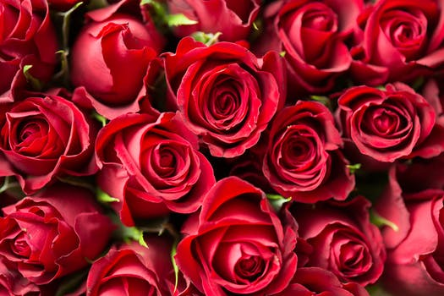

**Rose Flower** is a perennial plant the genus rosa, within the family roses. Roses are a popular crop for both domestic and commercial cut flowers. Generally they are harvested and cut when in bud, and held in refrigerated conditions until ready for display at their point of sale. In temperate climates, cut roses are often grown in greenhouses, and in warmer countries they may also be grown under cover in order to ensure that the **flowers** are not damaged by ~~weather~~ and that pests and disease control can be carried out effectively. There are many model project is on production of roses for use as cut flowers, which have an important place in preparation of bouquets, floral arrangements, worship, social occasions and presentation of gifts

33. Image and text

The red chilipepperchilipepperis a popular food product in New Mexico.  What creates the heat in this pepper is the chemical *capsaicin* (C18H27NO3).  When eaten, natural endorphins in the body are released which not only reduce the pain from the heat but create a feeling of general well-being.

1. **Image and align text**

**India Flag**

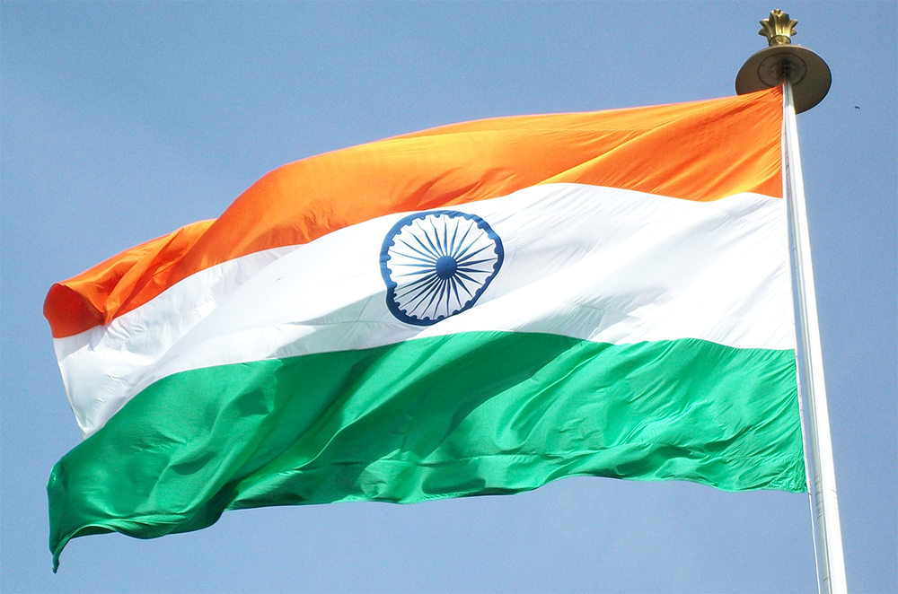

The National flag of India hasthreeequal horizontal bands - the top panel is India saffron (Kesari), the bottom panel is India green and white middle band bearing at its centre the design of Ashoka Chakra in navy blue colour with 24 equally spaced spokes. It was adopted by the Constituent Assembly on 22nd July 1947, when it became the official flag of the Dominion of India. The flag was subsequently retained as that of the Republic of India. The flag is based on the Swaraj flag, a flag of the Indian National Congress designed by PingaliVenkayya.

1. **Image Alignment**

**Left**

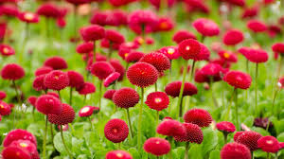

**Center**



**Right**

