📊 HISTOGRAM - Explanation
What is a Histogram?
A histogram is a graphical representation that shows the frequency distribution of numerical data. It divides the data into intervals (called "bins") and displays how many data points fall into each interval using bars.
What We Used to Create It:
- Library: matplotlib.pyplot
- Function: plt.hist()
- Key Parameters:
  - bins=20 - Divides data into 20 intervals
  - color - Bar colors (skyblue, lightcoral, etc.)
  - edgecolor='black' - Border around bars
  - alpha=0.7 - Transparency level
What It Does with Your Aadhar Dataset:
6 Histograms Created:
- Age 0-5 Histogram: Shows how enrollment counts for children aged 0-5 are distributed. For example, it tells you how many districts have 10-20 enrollments, 20-30 enrollments, etc.
- Age 5-17 Histogram: Displays the distribution pattern for school-age enrollments. Shows this group has higher enrollment values (mean: 49.12).
- Age 18+ Histogram: Shows adult enrollment distribution, which has lower values (mean: 21.82).
- Total Enrollment Histogram: Combines all age groups to show overall enrollment patterns (mean: 95.88).
- Overlapping Histogram: Compares all three age groups simultaneously to see which group dominates.
- Cumulative Histogram: Shows how enrollments accumulate, helping understand percentiles and overall trends.
Key Insights from Histograms:
- Right-skewed distribution: Most districts have lower enrollments, few have very high
- Mean vs Median: Red line (mean: 95.88) is higher than green line (median: 83), confirming the skew
- Age 5-17 dominates: This age group has the highest enrollment numbers
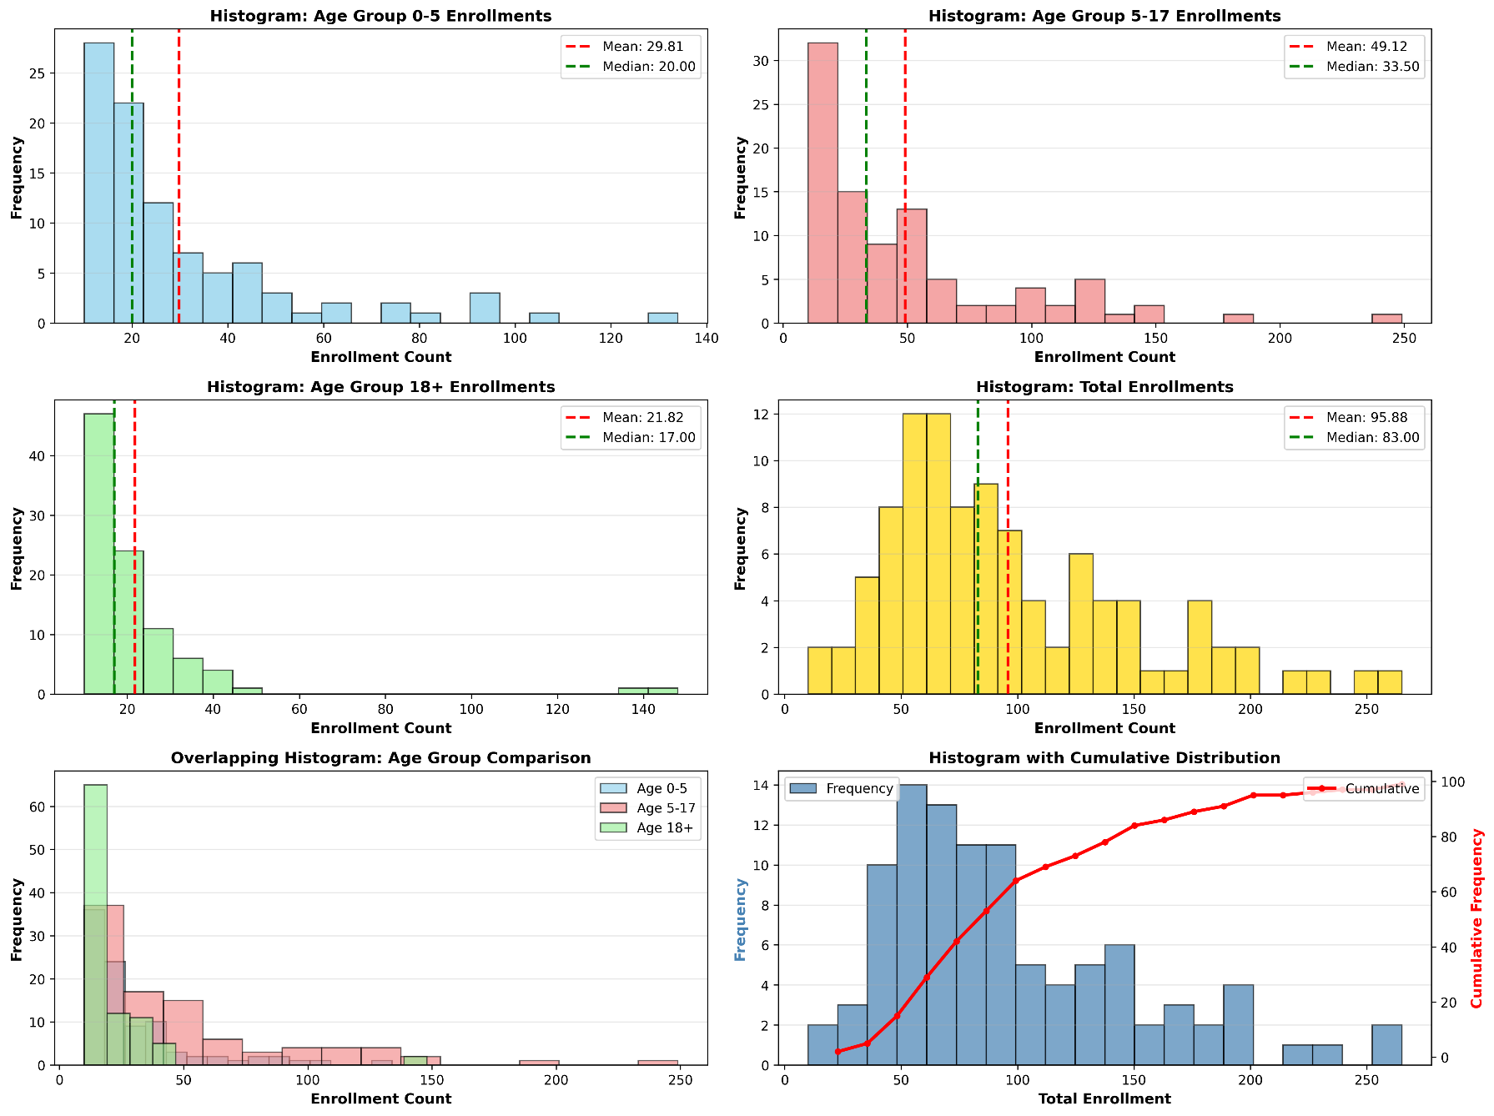
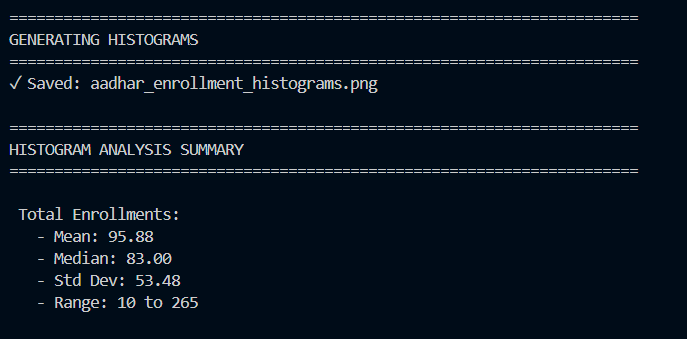
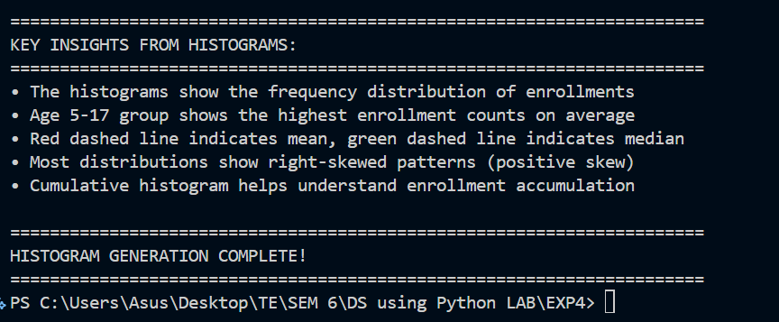

🔥 CORRELATION HEATMAP - Explanation
What is a Heatmap?
A heatmap is a data visualization technique that uses colors to represent values in a matrix. In a correlation heatmap, it shows the strength and direction of relationships between different numerical variables.
What We Used to Create It:
- Library: seaborn (built on matplotlib)
- Function: sns.heatmap()
- Key Parameters:
  - annot=True - Shows correlation values on cells
  - fmt='.3f' - Formats numbers to 3 decimal places
  - cmap='coolwarm' - Color scheme (blue=negative, white=neutral, red=positive)
  - center=0 - Centers the color scale at zero
  - square=True - Makes cells square-shaped
  - linewidths=1 - Adds gridlines between cells
What It Does with Your Aadhar Dataset:
Correlation Matrix Analyzed:
The heatmap calculates Pearson correlation coefficients between:
- pincode
- age_0_5
- age_5_17
- age_18_greater
- Total_Enrollment
How to Read It:
Color Coding:
- 🔴 Red cells: Strong positive correlation (+0.5 to +1.0)
  - Both variables increase together
- ⚪ White cells: Weak/no correlation (around 0)
  - Variables are independent
- 🔵 Blue cells: Negative correlation (-1.0 to -0.5)
  - One variable increases as the other decreases
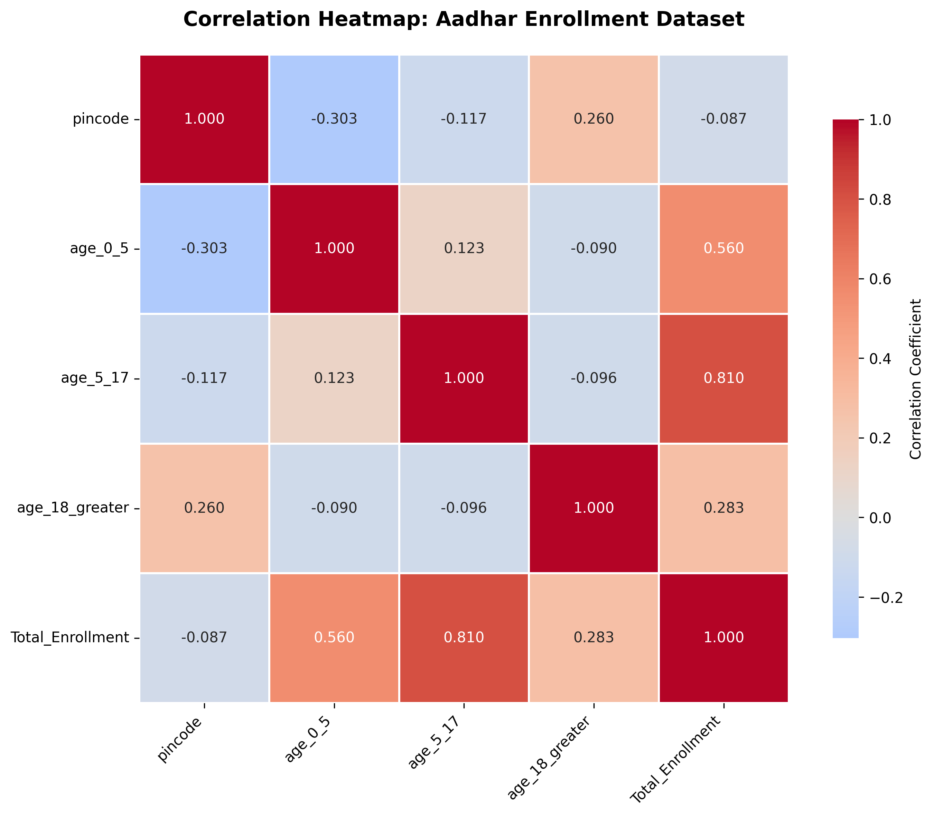
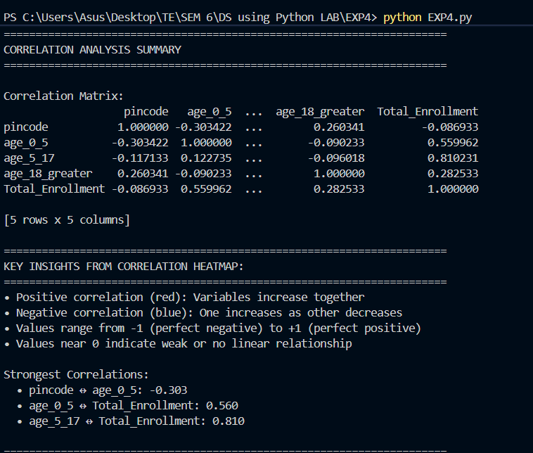

Key Findings from Your Dataset:
- age_5_17 ↔ Total_Enrollment = 0.810 (Strong Red)
  - The 5-17 age group has the strongest influence on total enrollments
  - When 5-17 enrollments are high, total enrollments are high
- age_0_5 ↔ Total_Enrollment = 0.560 (Moderate Red)
  - 0-5 age group also contributes significantly to total
- pincode ↔ age_0_5 = -0.303 (Light Blue)
  - Weak negative correlation
  - Higher pincode numbers tend to have slightly lower 0-5 enrollments
- age_0_5 ↔ age_18_greater = -0.090 (Almost White)
  - No significant relationship between these two age groups
Practical Use:
The heatmap helps you understand:
- Which age groups drive total enrollment numbers
- Whether certain age groups are related or independent
- Geographic patterns (pincode relationships)
- Which variables to focus on for predictions or policy decisions

📊 What We're Doing in Scatter Plots - Detailed Explanation
What is a Scatter Plot?
A scatter plot is a graph that uses dots/points to represent the relationship between two numerical variables. Each point represents one observation (in our case, one district's enrollment record).
🎯 Purpose in Your Aadhar Dataset Analysis:
We're creating 6 different scatter plots to analyze relationships between enrollment variables:

1️⃣ Scatter Plot: Age 0-5 vs Age 5-17
What it does:
Plots child enrollments (0-5) on X-axis vs school-age enrollments (5-17) on Y-axis
Each point = one district's data
Trend line (red dashed) shows the overall relationship direction
What we learn:
Do districts with high child enrollments also have high school-age enrollments?
The correlation is 0.123 (weak positive) - these groups are somewhat independent

2️⃣ Scatter Plot: Age 0-5 vs Age 18+
What it does:
Compares child enrollments against adult enrollments
Helps see if child and adult enrollment patterns are related
What we learn:
Correlation: -0.090 (very weak negative)
Districts with many child enrollments don't necessarily have many adult enrollments
These age groups enroll independently

3️⃣ Scatter Plot: Age 5-17 vs Age 18+
What it does:
Shows relationship between school-age and adult enrollments
Identifies if these groups follow similar patterns
What we learn:
Correlation: -0.096 (weak negative)
No strong relationship between these two groups

4️⃣ Multi-Colored Scatter Plot: Age Groups vs Total Enrollment
What it does:
3 overlapping scatter plots in different colors:
🔵 Blue (Age 0-5) vs Total
🔴 Red (Age 5-17) vs Total
🟢 Green (Age 18+) vs Total
Shows which age group has the strongest relationship with total enrollment
What we learn:
Age 5-17 (red) shows strongest correlation (0.810) - it drives total enrollments
Age 0-5 shows moderate impact (0.560)
Age 18+ shows weak impact (0.283)

5️⃣ Color Gradient Scatter Plot: Age 5-17 vs Total (Color: Age 0-5)
What it does:
X-axis: Age 5-17 enrollments
Y-axis: Total enrollments
Color intensity: Represents Age 0-5 values (purple = low, yellow = high)
Shows 3 variables in one plot!
What we learn:
Visualizes how all three age groups interact
Darker colors (higher Age 0-5) at certain total enrollment levels
Helps identify multi-dimensional patterns

6️⃣ Scatter Plot: Pincode vs Total Enrollment
What it does:
Tests if geographic location (pincode number) affects enrollment
Higher pincodes might represent different regions
What we learn:
Correlation: -0.087 (very weak)
Geography (as represented by pincode) doesn't significantly predict enrollment levels
Enrollment patterns are independent of pincode values

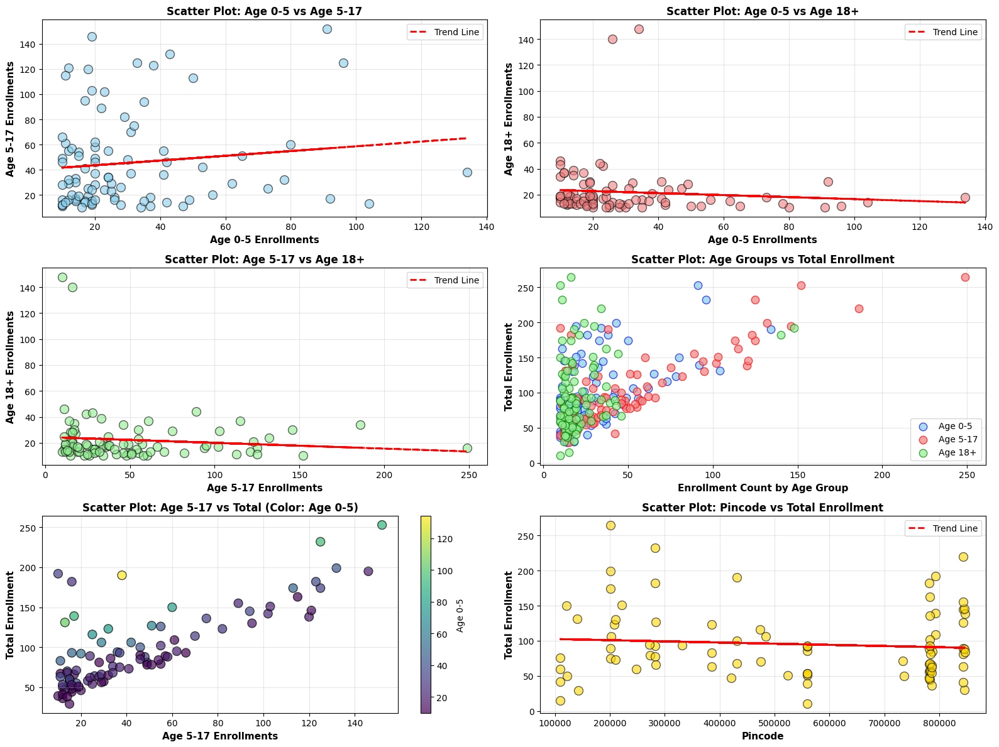
🔍 Key Techniques Used:
1. plt.scatter()
ax.scatter(df['age_0_5'], df['age_5_17'], alpha=0.6, c='skyblue', s=100)
- alpha=0.6: Transparency (see overlapping points)
- c='skyblue': Color of points
- edgecolors='black': Black borders around points
- s=100: Size of points

2. Trend Lines with np.polyfit()
valid_data = df.dropna(subset=['age_0_5', 'age_5_17'])
z = np.polyfit(valid_data['age_0_5'], valid_data['age_5_17'], 1)
p = np.poly1d(z)
ax.plot(valid_data['age_0_5'], p(valid_data['age_0_5']), "r--")
- Removes missing data to avoid length mismatch errors
- Calculates best-fit line (linear regression)
- Red dashed line shows overall relationship directio

3. Color Mapping with cmap='viridis'
scatter = ax.scatter(x, y, c=df['age_0_5'], cmap='viridis')
plt.colorbar(scatter, ax=ax, label='Age 0-5')
- Maps numerical values to colors
- Creates a color scale legend

💡 Why Scatter Plots Matter:
- Visual Correlation Check: Confirms what correlation coefficients tell us numerically
- Outlier Detection: Identifies unusual districts (points far from trend line)
- Pattern Recognition: Reveals linear, non-linear, or no relationship
- Prediction Insights: Trend line helps predict one variable from another
- Multi-variable Analysis: Color gradients show 3+ dimensions

