Experiment - 02

**Write a sci lab code for the following problems: **
1.Plotting of a Scalar Field f (x, y) = x^2y.
Code:- clc
clear
clf
function z=scalarfield(x, y)
z=(x.^2).*y
endfunction
x=linspace(-10,10,100)
y=linspace(-10,10,100)
[X,Y]=meshgrid(x,y)
z=scalarfield(X, Y)
surf(x, y, z)
xtitle('Scalar field', 'X-Axis', 'Y-Axis')
Colorbar
Output:-

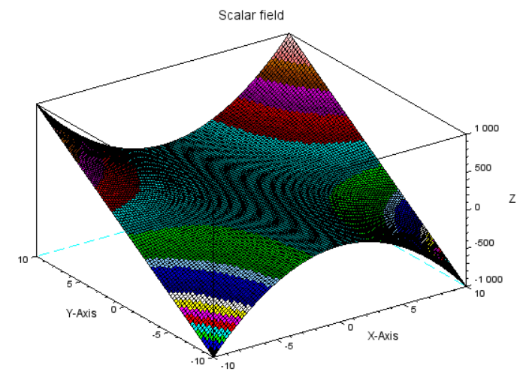
2. Plotting of a Scalar Field f(x, y) = xe^-(x^2+y^2).
Code:- clc
clear
clf
function z=scalarfield(x, y)
z=x.*exp(-x.^2-y.^2)
endfunction
x=linspace(6,-6100)
y=linspace(6,6,100)
[X,Y]=meshgrid(x,y)
z=scalarfield(X, Y)
surf(x, y, z)
xtitle('Scalar field', 'X-Axis', 'Y-Axis')
colorbar
Output:-

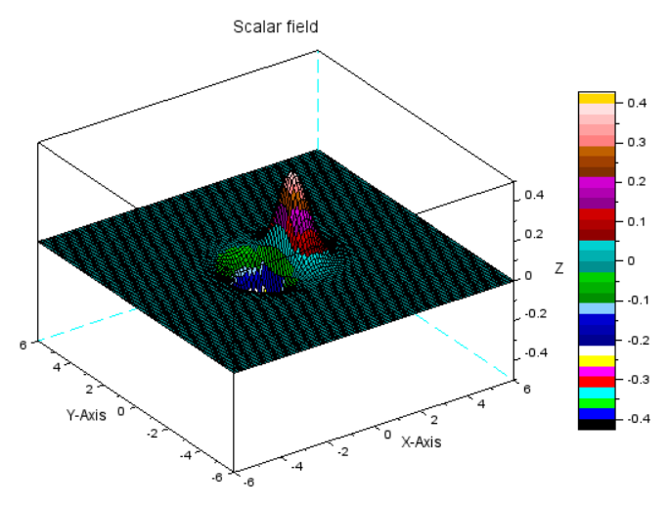
3. Plotting of a Vector Field f( x, y) = (x, y)
Code:- clc
clear
clf
function [Zx, Zy]=vfield(x, y)
Zx=x
Zy=y
endfunction
x=-4:.1:4
y=-4:.1:4
[X,Y]=ndgrid(x,y)
[Zx,Zy]=vfield(X,Y)
champ(x,y,Zx,Zy,0.2,rect=[-2,-2,2,2])
gce().colored="on"
xtitle('Vector field f(x,y)=(x,y)','X-Axis','Y-Axis');
colorbar
Output:-

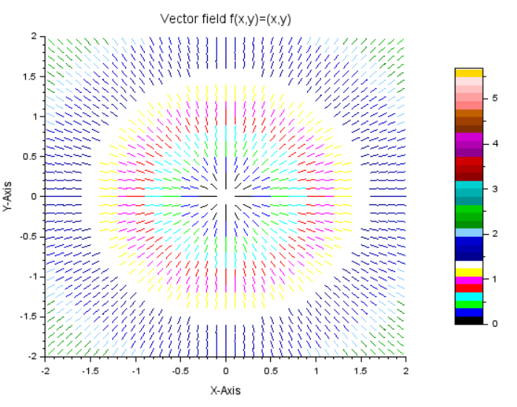

4. Plotting of a Vector Field f( x, y) = (-y, x)
Code:- clc
clear
clf
function [Zx, Zy]=vfield(x, y)
Zx=-y
Zy=x
endfunction
x=-4:.1:4
y=-4:.1:4
[X,Y]=ndgrid(x,y)
[Zx,Zy]=vfield(X,Y)
champ(x,y,Zx,Zy,0.2,rect=[-2,-2,2,2])
gce().colored="on"
xtitle('Vector field f(x,y)=(-y,x)','X-Axis','Y-Axis')
colorbar
Output:-

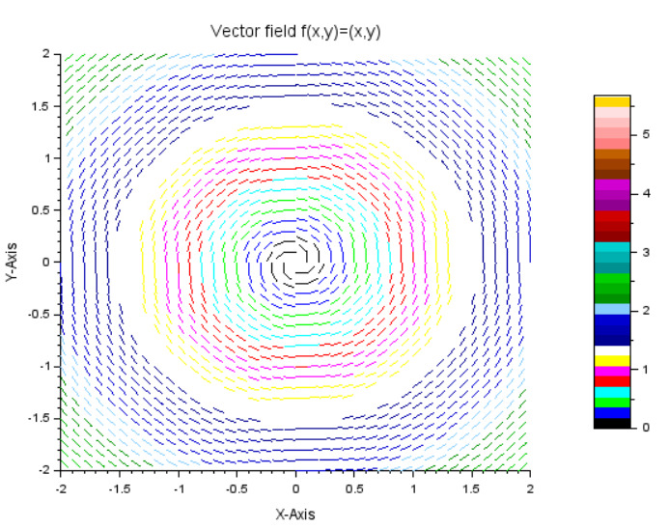
5. Plotting of a Vector Field f( x, y) = (sin y, cos x).
Code:- clc
clear
clf
function [Zx, Zy]=vfield(x, y)
Zx=sin (y)
Zy=cos (x)
endfunction
x=linspace(-1,1,100)*2*%pi
y=linspace(-1,1,100)*2*%pi
[X,Y]=ndgrid(x,y)
[Zx,Zy]=vfield(X,Y)
champ(x,y,Zx,Zy,0.5,rect=[-3,-2,3,2])
gce().colored="on"
xtitle('Vector field f(x,y)=(sin y, cos x)','X-Axis','Y-Axis')
colorbar
Output:-

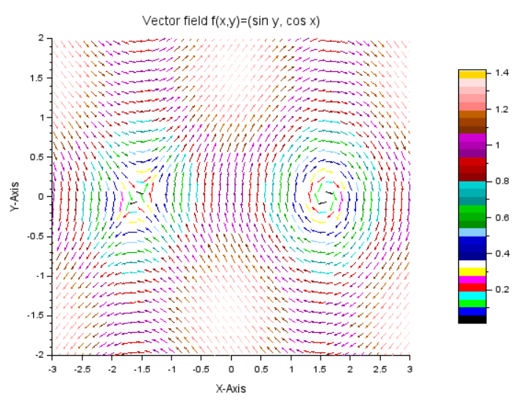
6. The gradient of a scalar Field f( x, y) = x^2*y.
Code:-
clc
clear
clf
function [z, DZx, DZy]=scalarfield(x, y)
z=x.^2.*y
DZx=2*x.*y
DZy=x.^2
endfunction
x=linspace(-5,5,100)
y=linspace(-5,5,100)
[X,Y]=meshgrid(x,y)
[z,DZx,DZy]=scalarfield(X,Y)
surf(x,y,z)
xtitle('scalar field f(x,y)=x^2y','X-Axis','Y-Axis')
scf
champ(x,y,DZx,DZy,0.5,rect=[-3,-3,3,3])
gce().colored="on"
xtitle('Gradient of scalar field f(x,y)=x^2y','X-Axis','Y-Axis');
colorbar
Output:-
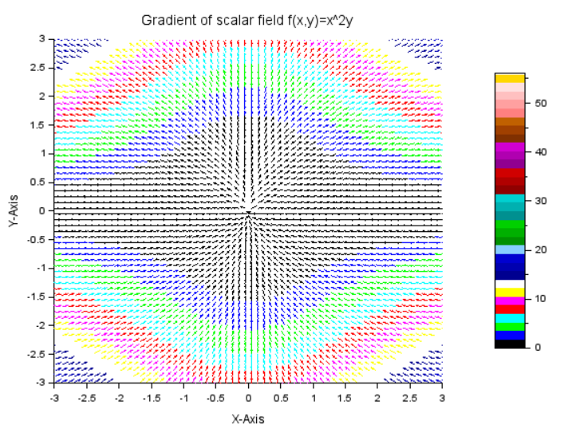
7. The gradient of a Scalar Field f(x, y) = xe^-(x^2+y^2).
Code:-
clc
clear
clf
function [z, DZx, DZy]=scalarfield(x, y)
z=x.*exp(-x.^2-y^2)
DZx=exp(-x.^2-y.^2)-2*x.^2.*exp(-x.^2-y.^2)
DZy=-2*x.*y.*exp(-x.^2-y.^2)
endfunction
x=linspace(-4,4,100)
y=linspace(-4,4,100)
[X,Y]=meshgrid(x,y)
[z,DZx,DZy]=scalarfield(X,Y)
surf(x,y,z)
xtitle('scalar field ','X-Axis','Y-Axis')
colorbar
scf
champ(x,y,DZx,DZy,0.3,rect=[-2,-2,2,2])
gce().colored="on"
xtitle('Gradient of scalar field f(x,y)=x^2y','X-Axis','Y-Axis')
colorbar
Output:-
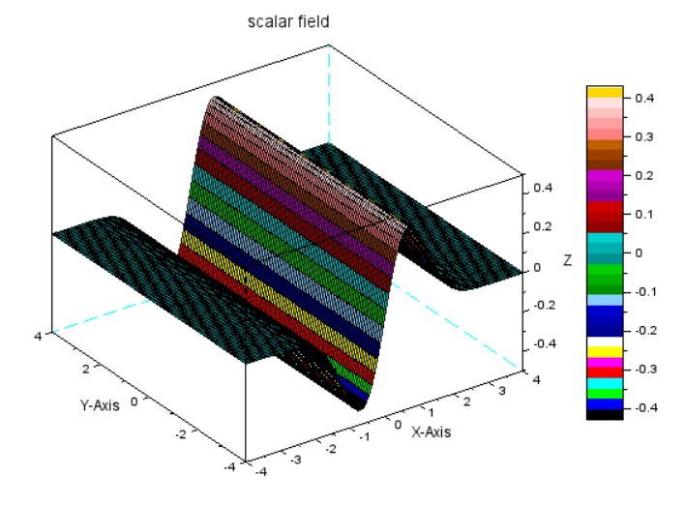
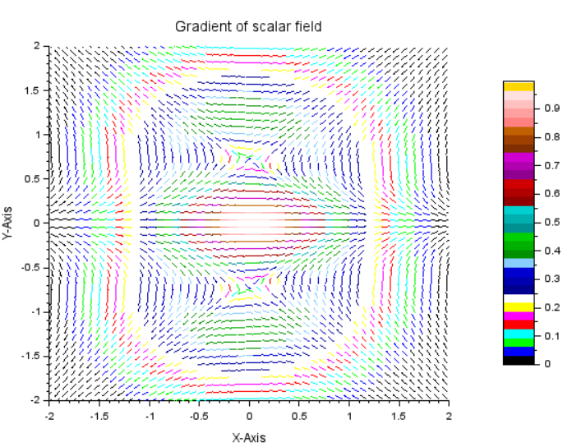
8.Divergence of a Vector Field f( x, y) = (-y, x)
Code:-
clc
clear
clf
function [Zx, Zy, Div]=vfield(x, y)
Zx=-y
Zy=x
Div=0*x
endfunction
x=-4:.1:4
y=-4:.1:4
[X,Y]=meshgrid(x,y)
[Zx,Zy,Div]=vfield(X,Y)
surf(x,y,Div)
xtitle('Divergence of Vector field f(x,y)=(y,x)','X-Axis','Y-axis')
colorbar
scf
champ(x,y,Zx,Zy,0.2,rect=[-2,-2,2,2])
gce().colored="on"
xtitle('Vector field f(x,y)=(-y,x)','X-Axis','Y-Axis')
colorbar
Output:-
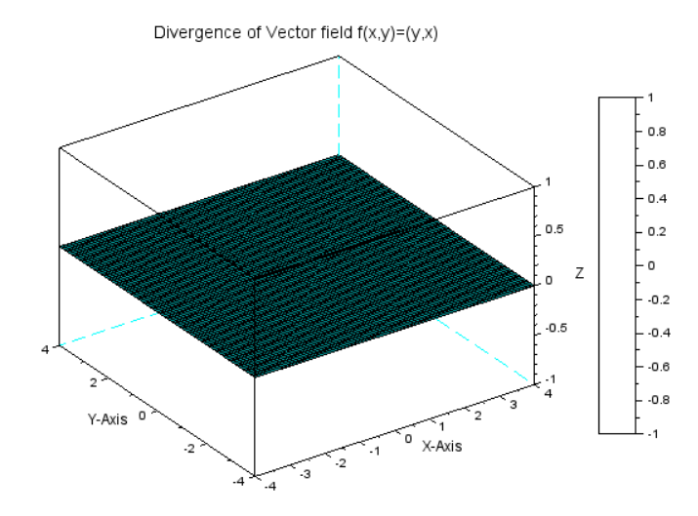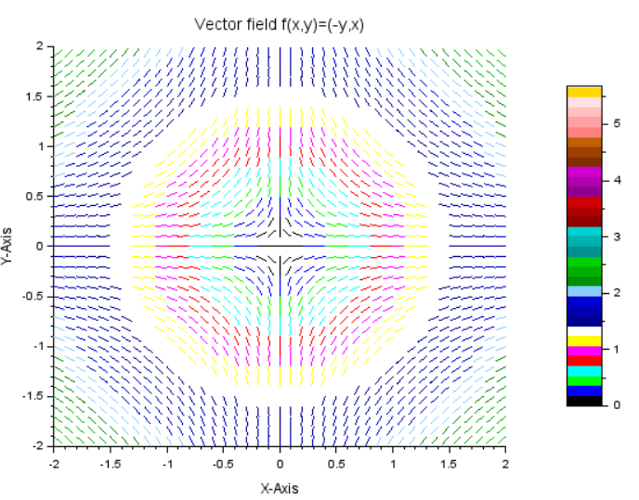

9. Divergence of a Vector Field f( x, y) = (sin y, cos x).
Code:- :-
clc
clear
clf
function [Zx, Zy, Div]=vfield(x, y)
Zx=sin(x)
Zy=cos(y)
Div=cos(x)-sin(y)
endfunction
x=-1:1:50*%pi
y=-1:1:50*%pi
[X,Y]=ndgrid(x,y)
[Zx,Zy,Div]=vfield(X,Y)
surf(x,y,Div)
xtitle('Divergence of Vector field','X-Axis','Y-axis')
colorbar
scf
champ(x,y,Zx,Zy,0.2,rect=[-3,-%pi,2.5,%pi])
gce().colored="on"
xtitle('Vector field','X-Axis','Y-Axis')
colorbar

Experiment - 03
**Write a sci lab code for the following problems: **
Write a script file to determine the Linear independence (LI) of vectors and plot these vectors in their respective space.
1.(i) (0,1), (1,0)
Code:-
clc
clear
clf
a=[0,1]
b=[1,0]
A=[a;b]
n=input("Enter the numbers of vectors:")
r=rank(A)
if r==n then
disp("Linear Independent.")
else
disp("Linear dependent.")
end
plot2d([0,0],[0,0],[0,0])
xarrows([0,0],[0,1],4,5)
xarrows([0,1],[0,0],2,3)
xtitle( 'Multiple 2D arrows', 'X axis', 'Y axis')

Output:- Enter the numbers of vectors:2
"Linear Independent."
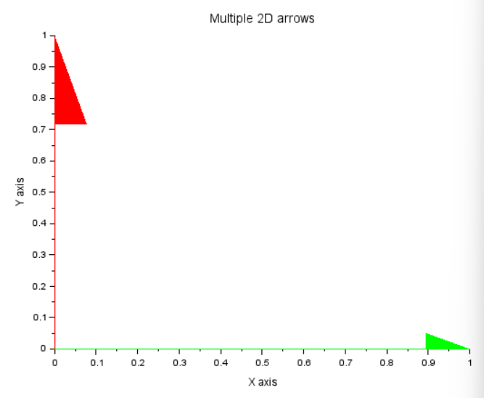
(ii) (2,4), (1,2)
Code:-
clc
clear
clf
a=[2,4]
b=[1,2]
A=[a;b]
n=input("Enter the numbers of vectors:")
r=rank(A)
if r==n then
disp("Linear Independent.")
else
disp("Linear dependent.")
end
plot2d([0,0],[0,0],[0,0])
xarrows([0,2],[0,4],4,5)
xarrows([0,1],[0,2],2,3)
xtitle( 'Multiple 2D arrows', 'X axis', 'Y axis')

Output:- Enter the numbers of vectors:2
"Linear dependent."
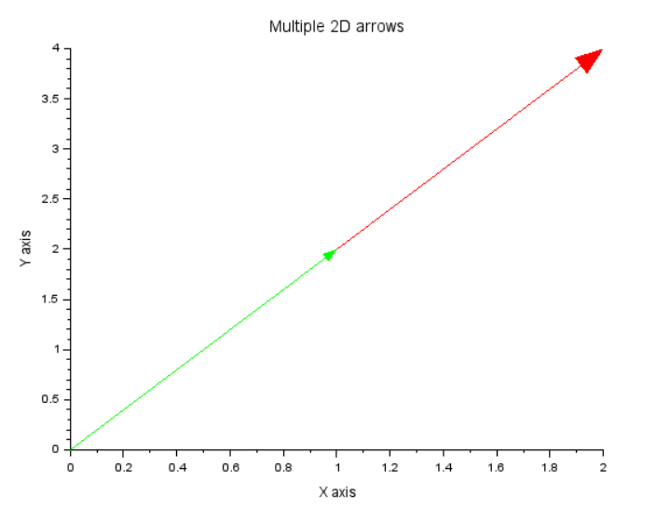
(iii) (1,1), (1,3), (2,4)
Code:-
clc
clear
clf
a=[1,1]
b=[1,3]
c=[2,4]
A=[a;b;c]
n=input("Enter the numbers of vectors:")
r=rank(A)
if r==n then
disp("Linear Independent.")
else
disp("Linear dependent.")
end
plot2d([0,0],[0,0],[0,0])
xarrows([0,1],[0,1],4,5)
xarrows([0,1],[0,3],2,3)
xarrows([0,2],[0,4],2,3)
xtitle( 'Multiple 2D arrows', 'X axis', 'Y axis')
Output:- Enter the numbers of vectors:2
"Linear dependent."
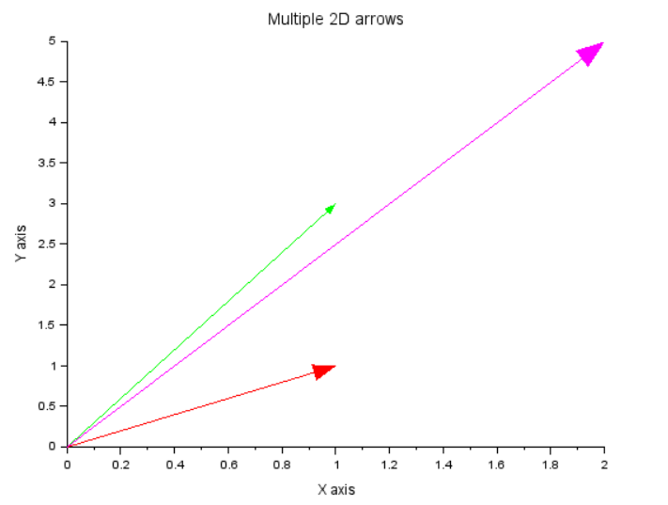
(iv) (1,2,3), (1,2,4)
Code:-
clc
clear
clf
a=[1,2,3]
b=[1,2,4]
A=[a;b]
n=input("Enter the numbers of vectors:")
r=rank(A)
if r==n then
disp("Linear Independent.")
else
disp("Linear dependent.")
end
plot3d([0,0],[0,0],[0,0],[0,0])
xarrows([0,1],[0,2],[0,3],4,5)
xarrows([0,1],[0,2],[0,4],,2,3)
xtitle( 'Multiple 3D arrows', 'X axis', 'Y axis')
Output:- Enter the numbers of vectors:2
"Linear Independent."

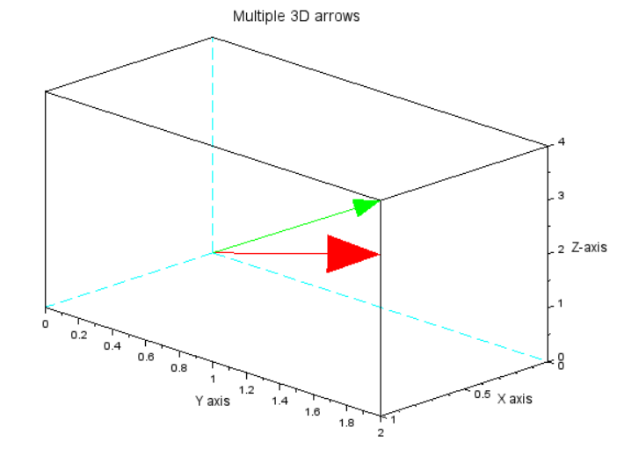
(v) (1,1,0), (1,0,1), (0,1,1)
Code:-
clc
clear
clf
a=[1,1,0]
b=[1,0,1]
c=[0,1,1]
A=[a;b;c]
n=input("Enter the numbers of vectors:")
r=rank(A)
if r==n then
disp("Linear Independent.")
else
disp("Linear dependent.")
end
plot3d([0,0],[0,0],[0,0],[0,0])
xarrows([0,1],[0,1],[0,0],4,5)
xarrows([0,1],[0,0],[0,1],,2,3)
xarrows([0,0],[0,1],[0,1],,2,3)
xtitle( 'Multiple 3D arrows', 'X axis', 'Y axis')
Output:- Enter the numbers of vectors:3
"Linear Independent."
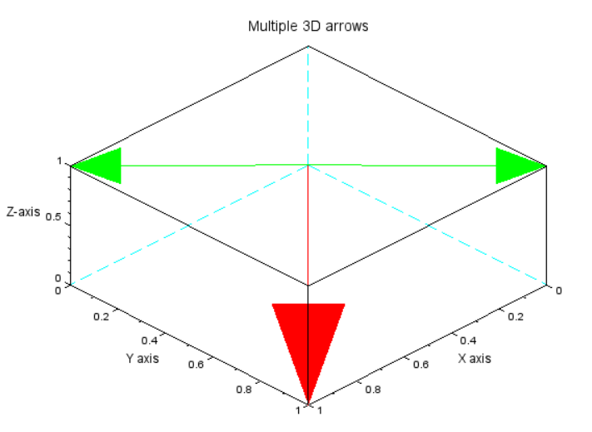
(vi) (2,2,1), (1,-1,1), (1,0,1)
Code:-
clc
clear
clf
a=[2,2,1]
b=[1,-1,1]
c=[1,0,1]
A=[a;b;c]
n=input("Enter the numbers of vectors:")
r=rank(A)
if r==n then
disp("Linear Independent.")
else
disp("Linear dependent.")
end
plot3d([0,0],[0,0],[0,0],[0,0])
xarrows([0,2],[0,2],[0,1],4,5)
xarrows([0,1],[0,-1],[0,1],,2,3)
xarrows([0,1],[0,0],[0,1],,2,3)
xtitle( 'Multiple 3D arrows', 'X axis', 'Y axis')
Output:- Enter the numbers of vectors:3
"Linear Independent."
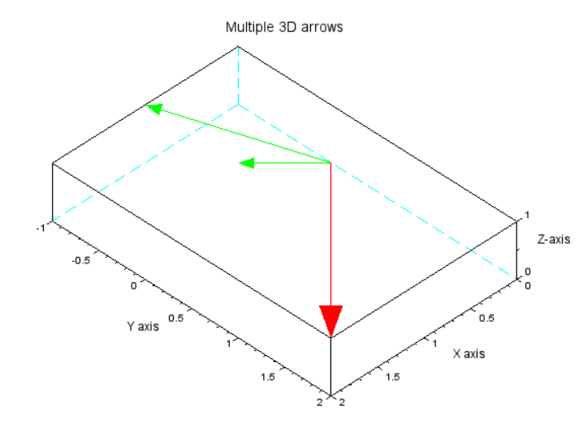
(vii)(1,2,3,1), (2,1,-1,1), (4,5,5,3), (5,4,1,3)
Code:-
clc
clear
clf
a=[1.2,3,1]
b=[2,1,-1,1]
c=[4,5,5,3]
d=[5,4,1,3]
A=[a;b;c;d]
n=input("Enter the numbers of vectors:")
r=rank(A)
if r==n then
disp("Linear Independent.")
else
disp("Linear dependent.")
end
Output:- Enter the numbers of vectors:4
"Linear dependent."

(viii) (1,2,3), (1,2,4), (0, 0, 0)
Code:- clc
clear
clf
a=[1.2,3]
b=[1,2,4]
c=[0,0,0]
A=[a;b;c]
n=input("Enter the numbers of vectors:")
r=rank(A)
if r==n then
disp("Linear Independent.")
else
disp("Linear dependent.")
end
plot3d([0,0],[0,0],[0,0],[0,0])
xarrows([0,1],[0,2],[0,3],4,5)
xarrows([0,1],[0,2],[0,4],,2,3)
xarrows([0,0],[0,0],[0,0],,2,3)
xtitle( 'Multiple 3D arrows', 'X axis', 'Y axis')
Output:- Enter the numbers of vectors:3
"Linear dependent."
