Inheritance Concept
The inheritance is a very useful and powerful concept of object-oriented programming. In java, using the inheritance concept, we can use the existing features of one class in another class. The inheritance provides a greate advantage called code re-usability. With the help of code re-usability, the commonly used code in an application need not be written again and again.

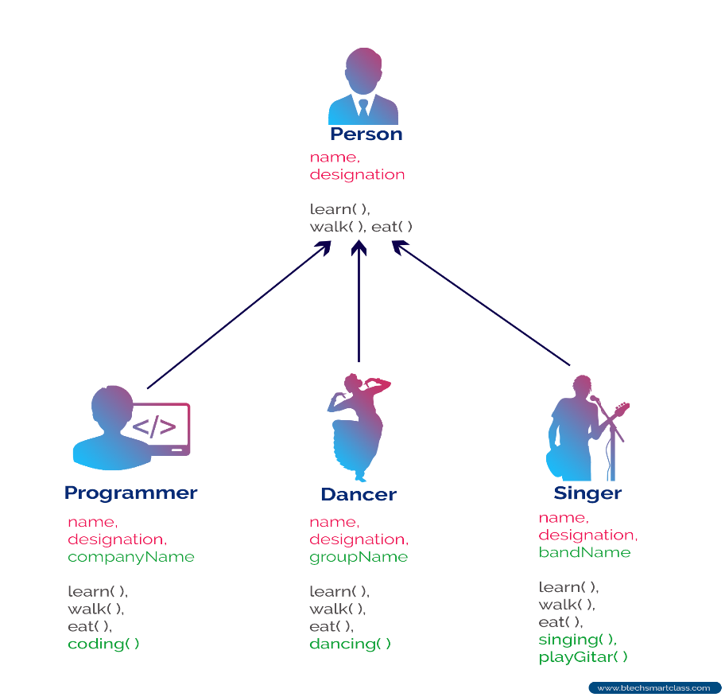

The inheritance can be defined as follows.
The inheritance is the process of acquiring the properties of one class to another class.

Inheritance Basics
In inheritance, we use the terms like parent class, child class, base class, derived class, superclass, and subclass.
The Parent class is the class which provides features to another class. The parent class is also known as Base class or Superclass.
The Child class is the class which receives features from another class. The child class is also known as the Derived Class or Subclass.
In the inheritance, the child class acquires the features from its parent class. But the parent class never acquires the features from its child class.
There are five types of inheritances, and they are as follows.
- Simple Inheritance (or) Single Inheritance
- Multiple Inheritance
- Multi-Level Inheritance
- Hierarchical Inheritance
- Hybrid Inheritance
The following picture illustrates how various inheritances are implemented.

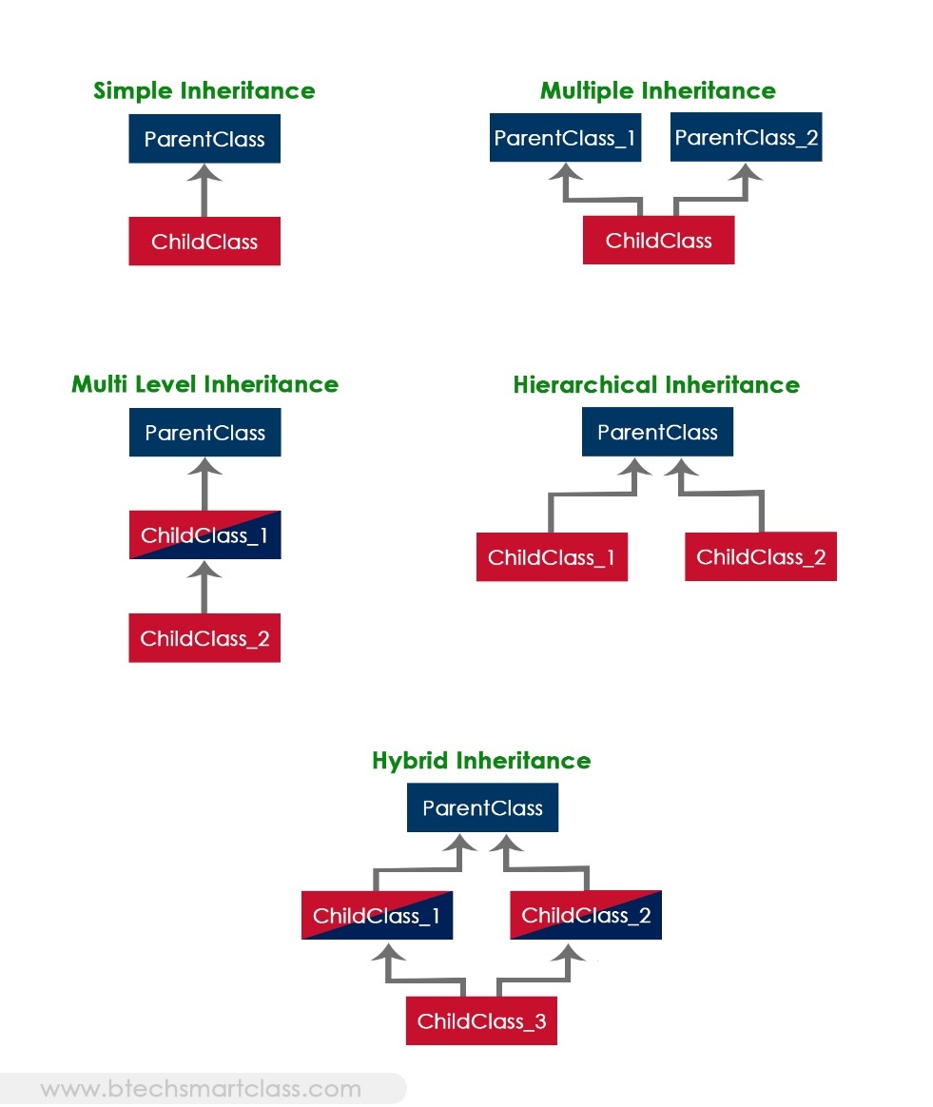

The java programming language does not support multiple inheritance type. However, it provides an alternate with the concept of interfaces.

Creating Child Class in java
In java, we use the keyword extends to create a child class. The following syntax used to create a child class in java.
Syntax
class <ChildClassName> extends <ParentClassName>{
...
//Implementation of child class
...
}

In a java programming language, a class extends only one class. Extending multiple classes is not allowed in java.
Let's look at individual inheritance types and how they get implemented in java with an example.

Single Inheritance in java
In this type of inheritance, one child class derives from one parent class. Look at the following example code.
Example
class ParentClass{
int a;
void setData(int a) {
this.a = a;
}
}
class ChildClass extends ParentClass{
void showData() {
System.out.println("Value of a is " + a);
}
}
public class SingleInheritance {

public static void main(String[] args) {
ChildClass obj = new ChildClass();
obj.setData(100);
obj.showData();
}
}

Multi-level Inheritance in java
In this type of inheritance, the child class derives from a class which already derived from another class. Look at the following example java code.
Example
class ParentClass{
int a;
void setData(int a) {
this.a = a;
}
}
class ChildClass extends ParentClass{
void showData() {
System.out.println("Value of a is " + a);
}
}
class ChildChildClass extends ChildClass{
void display() {
System.out.println("Inside ChildChildClass!");
}
}
public class MultipleInheritance {

public static void main(String[] args) {

ChildChildClass obj = new ChildChildClass();
obj.setData(100);
obj.showData();
obj.display();

}
}

Hierarchical Inheritance in java
In this type of inheritance, two or more child classes derive from one parent class. Look at the following example java code.
Example
class ParentClass{
int a;
void setData(int a) {
this.a = a;
}
}
class ChildClass extends ParentClass{
void showData() {
System.out.println("Inside ChildClass!");
System.out.println("Value of a is " + a);
}
}
class ChildClassToo extends ParentClass{
void display() {
System.out.println("Inside ChildClassToo!");
System.out.println("Value of a is " + a);
}
}
public class HierarchicalInheritance {

public static void main(String[] args) {

ChildClass child_obj = new ChildClass();
child_obj.setData(100);
child_obj.showData();

ChildClassToo childToo_obj = new ChildClassToo();
childToo_obj.setData(200);
childToo_obj.display();
}
}

Hybrid Inheritance in java
The hybrid inheritance is the combination of more than one type of inheritance. We may use any combination as a single with multiple inheritances, multi-level with multiple inheritances, etc.,

Java Constructors in Inheritance
It is very important to understand how the constructors get executed in the inheritance concept. In the inheritance, the constructors never get inherited to any child class.
In java, the default constructor of a parent class called automatically by the constructor of its child class. That means when we create an object of the child class, the parent class constructor executed, followed by the child class constructor executed.
Let's look at the following example java code.
Example
class ParentClass{
int a;
ParentClass(){
System.out.println("Inside ParentClass constructor!");
}
}
class ChildClass extends ParentClass{
ChildClass(){
System.out.println("Inside ChildClass constructor!!");
}
}
class ChildChildClass extends ChildClass{
ChildChildClass(){
System.out.println("Inside ChildChildClass constructor!!");
}
}
public class ConstructorInInheritance {
public static void main(String[] args) {
ChildChildClass obj = new ChildChildClass();
}
}
However, if the parent class contains both default and parameterized constructor, then only the default constructor called automatically by the child class constructor.
Let's look at the following example java code.
Example
class ParentClass{
int a;
ParentClass(int a){
System.out.println("Inside ParentClass parameterized constructor!");
this.a = a;
}
ParentClass(){
System.out.println("Inside ParentClass default constructor!");
}
}
class ChildClass extends ParentClass{
ChildClass(){
System.out.println("Inside ChildClass constructor!!");
}
}
public class ConstructorInInheritance {
public static void main(String[] args) {
ChildClass obj = new ChildClass();
}
}
The parameterized constructor of parent class must be called explicitly using the super keyword.

Java super keyword
In java, super is a keyword used to refers to the parent class object. The super keyword came into existence to solve the naming conflicts in the inheritance. When both parent class and child class have members with the same name, then the super keyword is used to refer to the parent class version.
In java, the super keyword is used for the following purposes.
- To refer parent class data members
- To refer parent class methods
- To call parent class constructor
🔔 The super keyword is used inside the child class only.

super to refer parent class data members
When both parent class and child class have data members with the same name, then the super keyword is used to refer to the parent class data member from child class.
Let's look at the following example java code.
Example
class ParentClass{
int num = 10;
}
class ChildClass extends ParentClass{
int num = 20;

void showData() {
System.out.println("Inside the ChildClass");
System.out.println("ChildClass num = " + num);
System.out.println("ParentClass num = " + super.num);
}
}
public class SuperKeywordExample {
public static void main(String[] args) {
ChildClass obj = new ChildClass();

obj.showData();

System.out.println("\nInside the non-child class");
System.out.println("ChildClass num = " + obj.num);
//System.out.println("ParentClass num = " + super.num); //super can't be used here
}
}

super to refer parent class method
When both parent class and child class have method with the same name, then the super keyword is used to refer to the parent class method from child class.
Let's look at the following example java code.
Example
class ParentClass{
int num1 = 10;
void showData() {
System.out.println("\nInside the ParentClass showData method");
System.out.println("ChildClass num = " + num1);
}
}
class ChildClass extends ParentClass{
int num2 = 20;

void showData() {
System.out.println("\nInside the ChildClass showData method");
System.out.println("ChildClass num = " + num2);

super.showData();
}
}
public class SuperKeywordExample {
public static void main(String[] args) {
ChildClass obj = new ChildClass();
obj.showData();
//super.showData(); // super can't be used here
}
}

super to call parent class constructor
When an object of child class is created, it automatically calls the parent class default-constructor before it's own. But, the parameterized constructor of parent class must be called explicitly using the super keyword inside the child class constructor.
Let's look at the following example java code.
Example
class ParentClass{

int num1;

ParentClass(){
System.out.println("\nInside the ParentClass default constructor");
num1 = 10;
}

ParentClass(int value){
System.out.println("\nInside the ParentClass parameterized constructor");
num1 = value;
}
}

class ChildClass extends ParentClass{
int num2;
ChildClass(){
super(100);
System.out.println("\nInside the ChildClass constructor");
num2 = 200;
}
}
public class SuperKeywordExample {
public static void main(String[] args) {
ChildClass obj = new ChildClass();
}
}
To call the parameterized constructor of the parent class, the super keyword must be the first statement inside the child class constructor, and we must pass the parameter values.

Java final keyword
In java, the final is a keyword and it is used with the following things.
- With variable (to create constant)
- With method (to avoid method overriding)
- With class (to avoid inheritance)
Let's look at each of the above.

final with variables
When a variable defined with the final keyword, it becomes a constant, and it does not allow us to modify the value. The variable defined with the final keyword allows only a one-time assignment, once a value assigned to it, never allows us to change it again.
Let's look at the following example java code.
Example
public class FinalVariableExample {
public static void main(String[] args) {

final int a = 10;

System.out.println("a = " + a);

a = 100; // Can't be modified
}
}

final with methods
When a method defined with the final keyword, it does not allow it to override. The final method extends to the child class, but the child class can not override or re-define it. It must be used as it has implemented in the parent class.
Let's look at the following example java code.
Example
class ParentClass{

int num = 10;

final void showData() {
System.out.println("Inside ParentClass showData() method");
System.out.println("num = " + num);
}
}

class ChildClass extends ParentClass{
void showData() {
System.out.println("Inside ChildClass showData() method");
System.out.println("num = " + num);
}
}
public class FinalKeywordExample {
public static void main(String[] args) {
ChildClass obj = new ChildClass();
obj.showData();
}
}
final with class
When a class defined with final keyword, it can not be extended by any other class.
Let's look at the following example java code.
Example
final class ParentClass{

int num = 10;

void showData() {
System.out.println("Inside ParentClass showData() method");
System.out.println("num = " + num);
}
}
class ChildClass extends ParentClass{

}
public class FinalKeywordExample {
public static void main(String[] args) {
ChildClass obj = new ChildClass();
}
}

Java Polymorphism
The polymorphism is the process of defining same method with different implementation. That means creating multiple methods with different behaviors.
In java, polymorphism implemented using method overloading and method overriding.

Ad hoc polymorphism
The ad hoc polymorphism is a technique used to define the same method with different implementations and different arguments. In a java programming language, ad hoc polymorphism carried out with a method overloading concept.
In ad hoc polymorphism the method binding happens at the time of compilation. Ad hoc polymorphism is also known as compile-time polymorphism. Every function call binded with the respective overloaded method based on the arguments.
The ad hoc polymorphism implemented within the class only.
Let's look at the following example java code.
Example
import java.util.Arrays;

public class AdHocPolymorphismExample {

void sorting(int[] list) {
Arrays.parallelSort(list);
System.out.println("Integers after sort: " + Arrays.toString(list) );
}
void sorting(String[] names) {
Arrays.parallelSort(names);
System.out.println("Names after sort: " + Arrays.toString(names) );
}

public static void main(String[] args) {
AdHocPolymorphismExample obj = new AdHocPolymorphismExample();
int list[] = {2, 3, 1, 5, 4};
obj.sorting(list); // Calling with integer array

String[] names = {"rama", "raja", "shyam", "seeta"};
obj.sorting(names); // Calling with String array
}
}

Pure polymorphism
The pure polymorphism is a technique used to define the same method with the same arguments but different implementations. In a java programming language, pure polymorphism carried out with a method overriding concept.
In pure polymorphism, the method binding happens at run time. Pure polymorphism is also known as run-time polymorphism. Every function call binding with the respective overridden method based on the object reference.
When a child class has a definition for a member function of the parent class, the parent class function is said to be overridden.
The pure polymorphism implemented in the inheritance concept only.
Let's look at the following example java code.
Example
class ParentClass{

int num = 10;

void showData() {
System.out.println("Inside ParentClass showData() method");
System.out.println("num = " + num);
}

}

class ChildClass extends ParentClass{

void showData() {
System.out.println("Inside ChildClass showData() method");
System.out.println("num = " + num);
}
}

public class PurePolymorphism {
public static void main(String[] args) {
ParentClass obj = new ParentClass();
obj.showData();

obj = new ChildClass();
obj.showData();
}
}

Java Method Overriding
The method overriding is the process of re-defining a method in a child class that is already defined in the parent class. When both parent and child classes have the same method, then that method is said to be the overriding method.
The method overriding enables the child class to change the implementation of the method which aquired from parent class according to its requirement.
In the case of the method overriding, the method binding happens at run time. The method binding which happens at run time is known as late binding. So, the method overriding follows late binding.
The method overriding is also known as dynamic method dispatch or run time polymorphism or pure polymorphism.
Let's look at the following example java code.
Example
class ParentClass{
int num = 10;
void showData() {
System.out.println("Inside ParentClass showData() method");
System.out.println("num = " + num);
}
}
class ChildClass extends ParentClass{
void showData() {
System.out.println("Inside ChildClass showData() method");
System.out.println("num = " + num);
}
}
public class PurePolymorphism {
public static void main(String[] args) {
ParentClass obj = new ParentClass();
obj.showData();
obj = new ChildClass();
obj.showData();
}
}
10 Rules for method overriding
While overriding a method, we must follow the below list of rules.
- Static methods can not be overridden.
- Final methods can not be overridden.
- Private methods can not be overridden.
- Constructor can not be overridden.
- An abstract method must be overridden.
- Use super keyword to invoke overridden method from child class.
- The return type of the overriding method must be same as the parent has it.
- The access specifier of the overriding method can be changed, but the visibility must increase but not decrease. For example, a protected method in the parent class can be made public, but not private, in the child class.
- If the overridden method does not throw an exception in the parent class, then the child class overriding method can only throw the unchecked exception, throwing a checked exception is not allowed.
- If the parent class overridden method does throw an exception, then the child class overriding method can only throw the same, or subclass exception, or it may not throw any exception.

Java Abstract Class
An abstract class is a class that created using abstract keyword. In other words, a class prefixed with abstract keyword is known as an abstract class.
In java, an abstract class may contain abstract methods (methods without implementation) and also non-abstract methods (methods with implementation).
We use the following syntax to create an abstract class.
Syntax
abstract class <ClassName>{
...
}
Let's look at the following example java code.
Example
import java.util.*;

abstract class Shape {
int length, breadth, radius;
Scanner input = new Scanner(System.in);
abstract void printArea();

}
class Rectangle extends Shape {
void printArea() {
System.out.println("*** Finding the Area of Rectangle ***");
System.out.print("Enter length and breadth: ");
length = input.nextInt();
breadth = input.nextInt();
System.out.println("The area of Rectangle is: " + length * breadth);
}
}
class Triangle extends Shape {
void printArea() {
System.out.println("\n*** Finding the Area of Triangle ***");
System.out.print("Enter Base And Height: ");
length = input.nextInt();
breadth = input.nextInt();
System.out.println("The area of Triangle is: " + (length * breadth) / 2);
}
}
class Cricle extends Shape {
void printArea() {
System.out.println("\n*** Finding the Area of Cricle ***");
System.out.print("Enter Radius: ");
radius = input.nextInt();
System.out.println("The area of Cricle is: " + 3.14f * radius * radius);
}
}
public class AbstractClassExample {
public static void main(String[] args) {
Rectangle rec = new Rectangle();
rec.printArea();

Triangle tri = new Triangle();
tri.printArea();

Cricle cri = new Cricle();
cri.printArea();
}
}
🔔 An abstract class can not be instantiated but can be referenced. That means we can not create an object of an abstract class, but base reference can be created.
In the above example program, the child class objects are created to invoke the overridden abstract method. But we may also create base class reference and assign it with child class instance to invoke the same. The main method of the above program can be written as follows that produce the same output.
Example
public static void main(String[] args) {
Shape obj = new Rectangle(); //Base class reference to Child class instance
obj.printArea();

obj = new Triangle();
obj.printArea();

obj = new Cricle();
obj.printArea();
}

8 Rules for method overriding
An abstract class must follow the below list of rules.
- An abstract class must be created with abstract keyword.
- An abstract class can be created without any abstract method.
- An abstract class may contain abstract methods and non-abstract methods.
- An abstract class may contain final methods that can not be overridden.
- An abstract class may contain static methods, but the abstract method can not be static.
- An abstract class may have a constructor that gets executed when the child class object created.
- An abstract method must be overridden by the child class, otherwise, it must be defined as an abstract class.
- An abstract class can not be instantiated but can be referenced.

Java Forms of Inheritance
The inheritance concept used for the number of purposes in the java programming language. One of the main purposes is substitutability. The substitutability means that when a child class acquires properties from its parent class, the object of the parent class may be substituted with the child class object. For example, if B is a child class of A, anywhere we expect an instance of A we can use an instance of B.
The substitutability can achieve using inheritance, whether using extends or implements keywords.
The following are the different forms of inheritance in java.
- Specialization
- Specification
- Construction
- Extension
- Limitation
- Combination

Specialization
It is the most ideal form of inheritance. The subclass is a special case of the parent class. It holds the principle of substitutability.

Specification
This is another commonly used form of inheritance. In this form of inheritance, the parent class just specifies which methods should be available to the child class but doesn't implement them. The java provides concepts like abstract and interfaces to support this form of inheritance. It holds the principle of substitutability.

Construction
This is another form of inheritance where the child class may change the behavior defined by the parent class (overriding). It does not hold the principle of substitutability.

Extension
This is another form of inheritance where the child class may add its new properties. It holds the principle of substitutability.

Limitation
This is another form of inheritance where the subclass restricts the inherited behavior. It does not hold the principle of substitutability.

Combination
This is another form of inheritance where the subclass inherits properties from multiple parent classes. Java does not support multiple inheritance type.

Benefits and Costs of Inheritance in java
The inheritance is the core and more usful concept Object Oriented Programming. It proWith inheritance, we will be able to override the methods of the base class so that the meaningful implementation of the base class method can be designed in the derived class. An inheritance leads to less development and maintenance costs.vides lot of benefits and few of them are listed below.

Benefits of Inheritance
- Inheritance helps in code reuse. The child class may use the code defined in the parent class without re-writing it.
- Inheritance can save time and effort as the main code need not be written again.
- Inheritance provides a clear model structure which is easy to understand.
- An inheritance leads to less development and maintenance costs.
- With inheritance, we will be able to override the methods of the base class so that the meaningful implementation of the base class method can be designed in the derived class. An inheritance leads to less development and maintenance costs.
- In inheritance base class can decide to keep some data private so that it cannot be altered by the derived class.

Costs of Inheritance
- Inheritance decreases the execution speed due to the increased time and effort it takes, the program to jump through all the levels of overloaded classes.
- Inheritance makes the two classes (base and inherited class) get tightly coupled. This means one cannot be used independently of each other.
- The changes made in the parent class will affect the behavior of child class too.
- The overuse of inheritance makes the program more complex.

Defining Packages in java
In java, a package is a container of classes, interfaces, and sub-packages. We may think of it as a folder in a file directory.
We use the packages to avoid naming conflicts and to organize project-related classes, interfaces, and sub-packages into a bundle.
In java, the packages have divided into two types.
- Built-in Packages
- User-defined Packages

Built-in Packages
The built-in packages are the packages from java API. The Java API is a library of pre-defined classes, interfaces, and sub-packages. The built-in packages were included in the JDK.
There are many built-in packages in java, few of them are as java, lang, io, util, awt, javax, swing, net, sql, etc.
We need to import the built-in packages to use them in our program. To import a package, we use the import statement.

User-defined Packages
The user-defined packages are the packages created by the user. User is free to create their own packages.

Definig a Package in java
We use the package keyword to create or define a package in java programming language.
Syntax
package packageName;

🔔 The package statement must be the first statement in the program.
🔔 The package name must be a single word.
🔔 The package name must use Camel case notation.
Let's consider the following code to create a user-defined package myPackage.
Example
package myPackage;

public class DefiningPackage {

public static void main(String[] args) {
System.out.println("This class belongs to myPackage.");
}
}
Now, save the above code in a file DefiningPackage.java, and compile it using the following command.
javac -d . DefiningPackage.java

The above command creates a directory with the package name myPackage, and the DefiningPackage.class is saved into it.
Run the program use the following command.
java myPackage.DefiningPackage

🔔 When we use IDE like Eclipse, Netbeans, etc. the package structure is created automatically.

Defining an interface in java
In java, an interface is similar to a class, but it contains abstract methods and static final variables only. The interface in Java is another mechanism to achieve abstraction.
We may think of an interface as a completely abstract class. None of the methods in the interface has an implementation, and all the variables in the interface are constants.
All the methods of an interface, implemented by the class that implements it.
The interface in java enables java to support multiple-inheritance. An interface may extend only one interface, but a class may implement any number of interfaces.
🔔 An interface is a container of abstract methods and static final variables.
🔔 An interface, implemented by a class. (class implements interface).
🔔 An interface may extend another interface. (Interface extends Interface).
🔔 An interface never implements another interface, or class.
🔔 A class may implement any number of interfaces.
🔔 We can not instantiate an interface.
🔔 Specifying the keyword abstract for interface methods is optional, it automatically added.
🔔 All the members of an interface are public by default.
Defining an interface in java
Defining an interface is similar to that of a class. We use the keyword interface to define an interface. All the members of an interface are public by default. The following is the syntax for defining an interface.
Syntax
interface InterfaceName{
...
members declaration;
...
}
Let's look at an example code to define an interface.
Example
interface HumanInterfaceExample {

void learn(String str);
void work();

int duration = 10;

}
In the above code defines an interface HumanInterfaceExample that contains two abstract methods learn(), work() and one constant duration.
Every interface in Java is auto-completed by the compiler. For example, in the above example code, no member is defined as public, but all are public automatically.
The above code automatically converted as follows.
Converted code
interface HumanInterfaceExample {
public abstract void learn(String str);
public abstract void work();

public static final int duration = 10;
}

Implementing an Interface in java
In java, an interface is implemented by a class. The class that implements an interface must provide code for all the methods defined in the interface, otherwise, it must be defined as an abstract class.
The class uses a keyword implements to implement an interface. A class can implement any number of interfaces. When a class wants to implement more than one interface, we use the implements keyword is followed by a comma-separated list of the interfaces implemented by the class.
The following is the syntax for defineing a class that implements an interface.
Syntax
class className implements InterfaceName{
...
boby-of-the-class
...
}
Let's look at an example code to define a class that implements an interface.
Example
interface Human {
void learn(String str);
void work();

int duration = 10;
}
class Programmer implements Human{
public void learn(String str) {
System.out.println("Learn using " + str);
}
public void work() {
System.out.println("Develop applications");
}
}

public class HumanTest {

public static void main(String[] args) {
Programmer trainee = new Programmer();
trainee.learn("coding");
trainee.work();
}
}
In the above code defines an interface Human that contains two abstract methods learn(), work() and one constant duration. The class Programmer implements the interface. As it implementing the Human interface it must provide the body of all the methods those defined in the Human interface.

Implementing multiple Interfaces
When a class wants to implement more than one interface, we use the implements keyword is followed by a comma-separated list of the interfaces implemented by the class.
The following is the syntax for defineing a class that implements multiple interfaces.
Syntax
class className implements InterfaceName1, InterfaceName2, ...{
...
boby-of-the-class
...
}

Let's look at an example code to define a class that implements multiple interfaces.
Example
interface Human {
void learn(String str);
void work();
}
interface Recruitment {
boolean screening(int score);
boolean interview(boolean selected);
}
class Programmer implements Human, Recruitment {
public void learn(String str) {
System.out.println("Learn using " + str);
}
public boolean screening(int score) {
System.out.println("Attend screening test");
int thresold = 20;
if(score > thresold)
return true;
return false;
}
public boolean interview(boolean selected) {
System.out.println("Attend interview");
if(selected)
return true;
return false;
}
public void work() {
System.out.println("Develop applications");
}
}
public class HumanTest {
public static void main(String[] args) {
Programmer trainee = new Programmer();
trainee.learn("Coding");
trainee.screening(30);
trainee.interview(true);
trainee.work();
}
}
In the above code defines two interfaces Human and Recruitment, and a class Programmer implements both the interfaces.

Nested Interfaces in java
In java, an interface may be defined inside another interface, and also inside a class. The interface that defined inside another interface or a class is konwn as nested interface. The nested interface is also refered as inner interface.
🔔 The nested interface declared within an interface is public by default.
🔔 The nested interface declared within a class can be with any access modifier.
🔔 Every nested interface is static by default.
The nested interface cannot be accessed directly. We can only access the nested interface by using outer interface or outer class name followed by dot( . ), followed by the nested interface name.

Nested interface inside another interface
The nested interface that defined inside another interface must be accessed as OuterInterface.InnerInterface.
Let's look at an example code to illustrate nested interfaces inside another interface.
Example
interface OuterInterface{
void outerMethod();

interface InnerInterface{
void innerMethod();
}
}
class OnlyOuter implements OuterInterface{
public void outerMethod() {
System.out.println("This is OuterInterface method");
}
}
class OnlyInner implements OuterInterface.InnerInterface{
public void innerMethod() {
System.out.println("This is InnerInterface method");
}
}
public class NestedInterfaceExample {
public static void main(String[] args) {
OnlyOuter obj_1 = new OnlyOuter();
OnlyInner obj_2 = new OnlyInner();
obj_1.outerMethod();
obj_2.innerMethod();
}
}

Nested interface inside a class
The nested interface that defined inside a class must be accessed as ClassName.InnerInterface.
Let's look at an example code to illustrate nested interfaces inside a class.
Example
class OuterClass{

interface InnerInterface{
void innerMethod();
}
}

class ImplementingClass implements OuterClass.InnerInterface{
public void innerMethod() {
System.out.println("This is InnerInterface method");
}
}
public class NestedInterfaceExample {
public static void main(String[] args) {
ImplementingClass obj = new ImplementingClass();

obj.innerMethod();
}
}

Variables in Java Interfaces
In java, an interface is a completely abstract class. An interface is a container of abstract methods and static final variables. The interface contains the static final variables. The variables defined in an interface can not be modified by the class that implements the interface, but it may use as it defined in the interface.
🔔 The variable in an interface is public, static, and final by default.
🔔 If any variable in an interface is defined without public, static, and final keywords then, the compiler automatically adds the same.
🔔 No access modifier is allowed except the public for interface variables.
🔔 Every variable of an interface must be initialized in the interface itself.
🔔 The class that implements an interface can not modify the interface variable, but it may use as it defined in the interface.
Let's look at an example code to illustrate variables in an interface.
Example
interface SampleInterface{

int UPPER_LIMIT = 100;

//int LOWER_LIMIT; // Error - must be initialised

}
public class InterfaceVariablesExample implements SampleInterface{
public static void main(String[] args) {

System.out.println("UPPER LIMIT = " + UPPER_LIMIT);

// UPPER_LIMIT = 150; // Can not be modified
}
}

