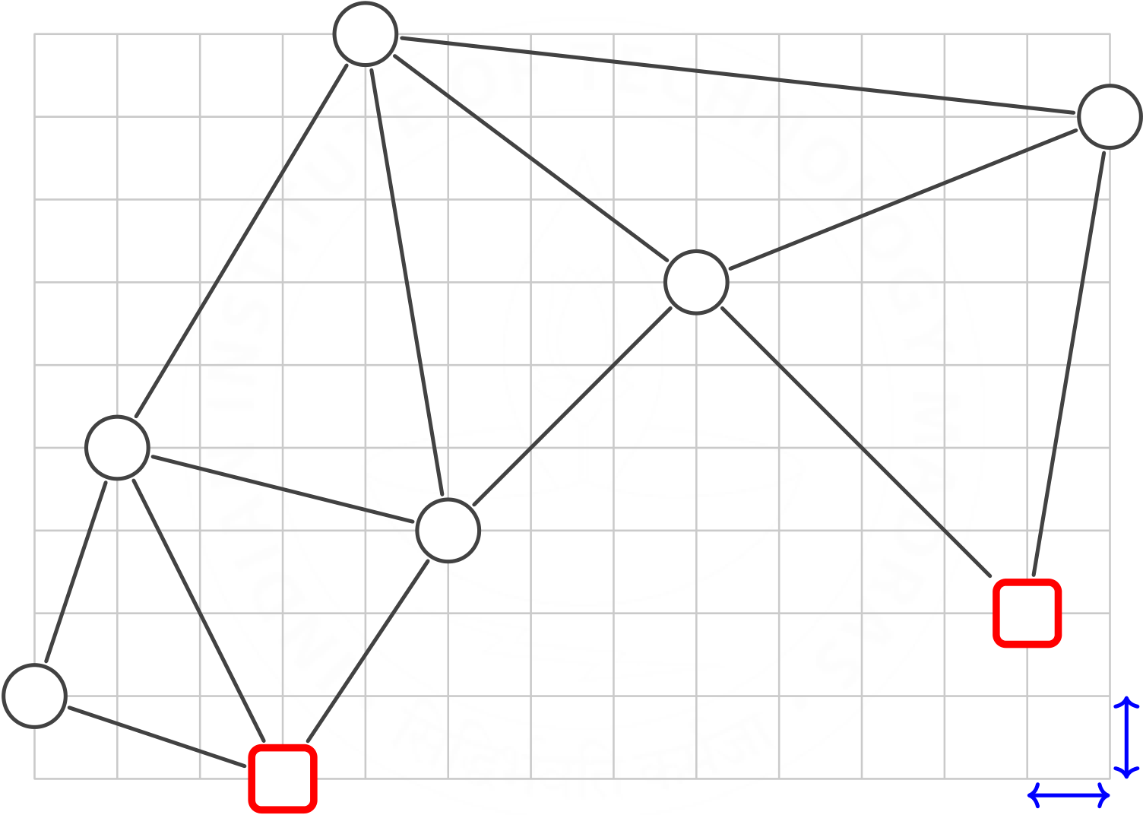

**Practice Assignment: City Map Example 2 wA* (w=3) Search**

Prepared by S. Baskaran

**State Space**

MoveGen returns nodes in ALPHABETICAL ORDER.

|  |  |  |  |  |  |  |
| --- | --- | --- | --- | --- | --- | --- |
| 10 | **F** | 8 | **D** | 12 | 8 | **E** |
| 14 |

8

|  |  |  |  |  |  |  |  |  |  |  |
| --- | --- | --- | --- | --- | --- | --- | --- | --- | --- | --- |
| 6 | **C** | 14 | 6 | 10 | **B** | 20 | 20 | **S** | **1** | **1** |
| **A** | 6 | **G** |

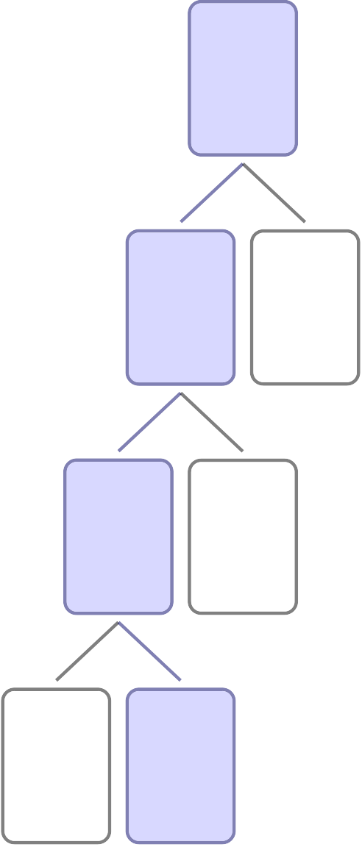

**Search Tree**

**S:1**   
**33**   
**(1)**

**D:2**  **E**   
**53**  **62**   
**(2)**  **(3)**

**B:3**  **F**   
**55**  **58**   
**(4)**  **(5)**

**C**  **G:4**   
**64**  **50**   
**(6)**  **(7)**

**Solution**

f = g + w *∗*h, where w = 3.

OPEN and CLOSED carry tuples: (NODE,PARENT,f,g,h)

OPEN (S,null,33,0,11):[]

CLOSED []

1.

NODE S

close (S,null,33,0,11)

moveGen D:E:[]

new-open (D,S,53,20,11)

new-open (E,S,62,8,18)

OPEN (D,S,53,20,11):(E,S,62,8,18):[]

CLOSED (S,null,33,0,11):[]

2.

NODE D

close (D,S,53,20,11)

moveGen B:E:F:S:[]

new-open (B,D,55,40,5)

new-open (F,D,58,28,10)

OPEN (B,D,55,40,5):(F,D,58,28,10):

(E,S,62,8,18):[]

CLOSED (D,S,53,20,11):(S,null,33,0,11):[]

3.

NODE B

close (B,D,55,40,5)

moveGen C:D:F:G:[]

new-open (C,B,64,46,6)

new-open (G,B,50,50,0)

OPEN (G,B,50,50,0):(F,D,58,28,10):

(E,S,62,8,18):(C,B,64,46,6):[]

CLOSED (B,D,55,40,5):(D,S,53,20,11):

(S,null,33,0,11):[]

4.

NODE G

close (G,B,50,50,0)

GOAL G

OPEN (F,D,58,28,10):(E,S,62,8,18):

(C,B,64,46,6):[]

CLOSED (G,B,50,50,0):(B,D,55,40,5):

(D,S,53,20,11):(S,null,33,0,11):[]

PATH S:D:B:G:[]

PATH COST 50