**From ChatGPT 3.5 (free) with the prompt:** Write a description of an application that helps me to create a Web application wherein users can post their favorite posts or specific readings from the novels or biographies, along-with tags referencing the books and more info on the same. Users additionally can follow back the app handler for more book recommendations or thought of the day quotes. It will also have the feature of saving the desired post categorically based on the genres of the book or paragraph posted in their account.

Nouns:

Verbs:

**Title: Musing: A Literary Sharing Platform**

Description:

Musing is a dynamic web application designed for bibliophiles and literary enthusiasts to share their favorite excerpts, thoughts, and recommendations from novels, biographies, and other literary works. With its user-friendly interface and robust features, Musing allows users to engage with each other, discover new reads, and organize their literary preferences efficiently.

Key Features:

1. Post Sharing: Users can easily share their favorite passages, quotes, or thoughts from books they love. They can write a brief commentary or reflection alongside the post to provide context or insight.

2. Tagging System: Musing employs a tagging system to categorize posts based on relevant themes, genres, or books. Users can add tags to their posts, making it easier for others to discover content related to their interests.

3. Follow System: Users have the option to follow other members of the Musing community, including the app handler. By following the app handler, users can receive regular book recommendations, thought of the day quotes, or updates on new features and events.

4. Save Feature: Musing enables users to save posts that resonate with them for future reference. They can organize saved posts into categories based on genres, allowing for easy navigation and retrieval.

5. Search Functionality: The application offers a powerful search feature that allows users to find specific posts, authors, or books quickly. Users can filter search results by tags, genres, or other criteria to discover content tailored to their preferences.

6. Community Engagement: Musing fosters a vibrant and interactive community where users can like, comment on, and share posts. The platform encourages discussions, recommendations, and connections among fellow book lovers.

Conclusion:

Musing is more than just a platform for sharing literary snippets; it's a thriving community where users can connect, explore, and celebrate their love for books. Whether you're seeking inspiration, recommendations, or simply want to share your passion for literature, Musing provides the perfect space to indulge in the world of words. Join the Musing community today and embark on a journey of literary discovery and connection.

**Nouns:**

* Musing
* Users
* Actions
* Engagement
* Handler

**Verbs:**

* Share
* Engage
* Organize
* Write
* Categorize
* Add
* Follow
* Save
* Search
* Filter
* Like
* Comment
* Share

**Target Audience:**

1. Bibliophiles: Individuals who have a deep passion for books, reading, and literature.
2. Literary Enthusiasts: People who enjoy engaging with literary works, discussing themes, analyzing texts, and sharing insights. People seeking book recommendations, thought-provoking quotes, and insightful discussions to enhance their reading experience.
3. Writers and Authors: Individuals who write or create content related to literature and seek a platform to share their work or engage with readers.
4. Students and Educators: Those studying literature or teaching literature-related subjects who are interested in sharing and discussing literary content.
5. Readers Looking for Recommendations: People seeking book recommendations, thought-provoking quotes, and insightful discussions to enhance their reading experience.
6. Online Community Participants: Individuals who enjoy being part of online communities, engaging in discussions, and connecting with like-minded individuals with similar interests.
7. Tech-Savvy Users: Individuals comfortable with using web applications and technology to access and interact with literary content.
8. Social Media Users: Those who are active on social media platforms and enjoy sharing content, engaging with others, and participating in online communities focused on literature and reading.

**Rules:**

* Users can post their favorite posts or specific readings from novels or biographies, along with tags referencing the books and more info on the same.
* Users can follow back the app handler for more book recommendations or thought of the day quotes.
* Users can have the feature of saving the desired post categorically based on the genres of the book or paragraph posted in their account.

**Challenge Questions:**

* How do you enhance content discovery on the platform to help users find relevant posts, authors, and discussions?
* How do you facilitate connections between users with similar literary interests and preferences?
* How do you ensure that the platform is user-friendly and intuitive, catering to users with varying levels of technological proficiency?
* How can you ensure consistent user engagement on the platform beyond initial sign-up?

**Summary of Classes, Attributes and Associations (from nouns and verbs):**

* Musing: Represents the overall web application platform designed for sharing literary content.

Attributes: None

Associations: Users, Actions, Handler

* Users: Represents individuals who use the Musing platform to engage with literary content, share their thoughts, and interact with others.

Attributes: None

Associations: Musing, Actions

* Actions: Represents the various actions that users can perform on the platform, such as sharing posts, engaging in discussions, liking, commenting, and sharing content.

Attributes: Share, Engage, Organize, Write, Categorize, Add, Follow, Save, Search, Filter, Like, Comment, Share

Associations: Musing, Users

* Engagement: Represents the level of interaction and involvement of users with the platform and with each other, fostering a vibrant community of literary enthusiasts.

Attributes: None

Associations: Actions

* Handler: Represents the entity responsible for managing and overseeing certain aspects of the Musing platform, such as providing recommendations, managing community engagement, and facilitating discussions.

Attributes: None

Associations: Musing

**User stories:**

1. User Story: Book Enthusiast Sharing Excerpts

User: Riya, a passionate book enthusiast

Action: Riya wants to share captivating excerpts from the latest novels she's read to inspire others to pick up the book. She logs onto the Musing platform, selects her favorite passage from the novel she just finished, writes a brief commentary highlighting its significance, and shares it with the Musing community. She adds relevant tags to categorize the post by genre and themes, making it easier for other users to discover and engage with her content.

1. User Story: Writer Showcasing Original Work

User: Dev, an aspiring writer

Action: Dev wants to showcase his writing skills by sharing an original short story he's been working on. He accesses the Musing platform, uploads his story, and provides a brief introduction to set the context for readers. He encourages feedback and constructive criticism from the Musing community to help him refine his writing craft. Dev also explores other writers' posts, leaving thoughtful comments and engaging in discussions to learn from their techniques and experiences.

1. User Story: Literary Influencer Sharing Reviews

User: Jessica, a literary influencer and book reviewer

Action: Jessica wants to share her latest book reviews and recommendations with her followers on the Musing platform. She logs in and creates a curated list of recommended reads for the month, highlighting her top picks and reasons why readers should check them out. Jessica collaborates with authors and publishers to host virtual book tours and author interviews, providing exclusive content and behind-the-scenes insights for her audience. She engages sessions with her followers by responding to comments, hosting Q&A sessions, and sharing sneak peeks of upcoming releases.

1. User Story: Casual Reader Exploring Inspirational Quotes

User: Alex, a casual reader looking for inspiration

Action: Alex wants to explore inspirational quotes and excerpts from popular novels and biographies on the Musing platform. He browses through curated collections of quotes, saving the ones that resonate with him for future reference. Alex engages with other users by liking, commenting on, and sharing posts that he finds inspiring or thought-provoking. He connects with like-minded individuals who share his love for literature, exchanging book recommendations, reading suggestions, and favorite quotes with them.

**UML Class Diagram:**

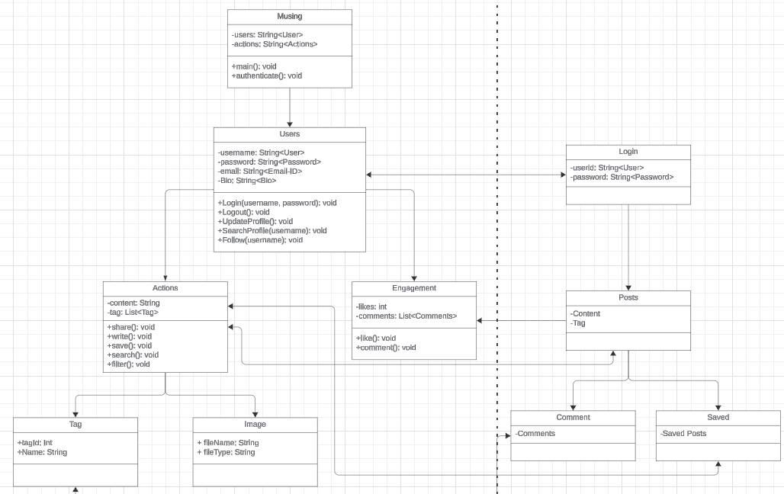

**Figma Mockups:**

