**Standard Deviation and Normal Distribution**

1. The length of bolts made in factory Z is normally distributed, with a mean length of 0.1630 meters and a standard deviation of 0.0084 meters. The probability that a randomly selected bolt is between 0.1546 meters and 0.1756 meters long is between

(A) 54% and 61%

(B) 61% and 68%

(C) 68% and 75%

(D) 75% and 82%

(E) 82% and 89%

1. Which of the following sets of data applies to this graph?

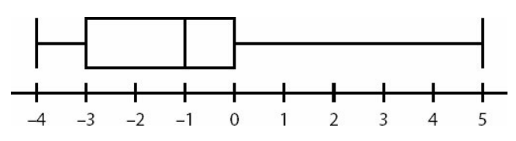

(A) -4, -4, -2, 0, 0, 5

(B) -4, 1, 1, 3, 4, 4

(C) -4, -4, -3, 1, 5

(D) -5, 3, 4, 5

(E) -4, -4, -2, -2, 0, 0, 0, 5

1. In a class with 20 students, a test was administered, scored only in whole numbers from 0 to 10. At least one student got every possible score, and the average was 7.

**Quantity A Quantity B**

4 The lowest score that two students could have received

1. A test is scored out of 100 and the scores are divided into five quintile groups. Students are not told their scores, but only their quintile group.

**Quantity A Quantity B**

The scores of two students in the bottom quintile The score of a student in the top quintile group, group, chosen at random chosen at random

and added together

1. A data set contains at least two different integers.

**Quantity A Quantity B**

The range of the data set The interquartile range of the data set

1. On a particular test whose scores are distributed normally, the 2nd percentile is 1720, while the 84th percentile is 1990. What score, rounded to the nearest 10, most closely corresponds to the 16th percentile?

(A) 1,750

(B) 1,770

(C) 1,790

(D) 1,810

(E) 1,830

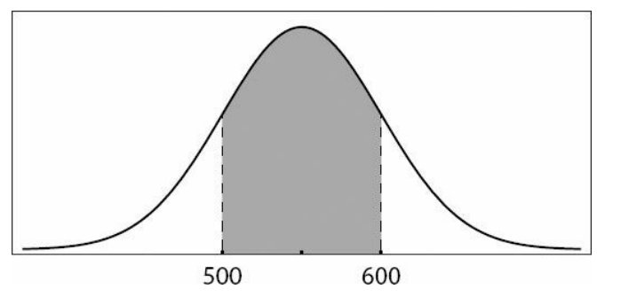

1. The graph represents the normally distributed scores on a test. The shaded area represents approximately 68% of the scores.

**Quantity A Quantity B**

The mean 550

1. A and B are graphical representations of normally distributed random variables X and Y, respectively, with relative positions, shapes, and sizes as shown. Which of the following must be true? Indicate all such statements.

* Y has a larger standard deviation than X.
* The probability that Y falls within 2 standard deviations of its mean is larger than the probability that X falls within 2 standard deviations of its mean.
* Y has a larger mean than X.

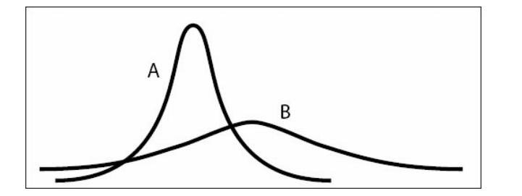

**Answer:**

**1**. D **2.** E **3.** B  **4.** D  **5**. D **6.** D **7.** D **8.** I and III

**Polygons and Rectangular Solids**

1. **Quantity A Quantity B**

x y

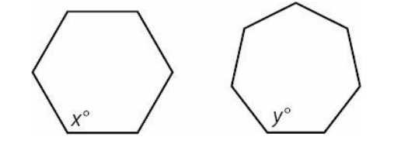

Answer: D ( Since not given regular)

1. A 2 foot by 2 foot by 2 foot solid cube is cut into 2 inch by 2 inch by 4 inch rectangular solids. What is the ratio of the total surface area of all the resulting smaller rectangular solids to the surface area of the original cube? (1foot = 12 inches)

(A) 2 : 1

(B) 4 : 1

(C) 5 : 1

(D) 8 : 1

(E) 10 : 1 (Answer: E)

1. A 1 meter by 1 meter by 1 meter sheet of paper is to be cut into 4 centimeter by 5 centimeter rectangles. How many such rectangles can be cut from the sheet of paper? (1 meter = 100 centimeters) (Answer: 500)
2. What is the area of a regular hexagon with side length 2?

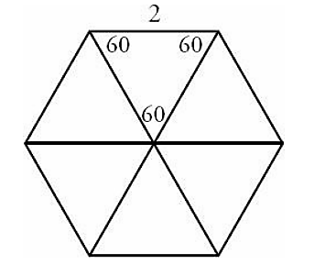Answer: 6 sqroot(3)

**Circles and Cylinders, Triangles**

1. If a solid right circular cylinder with height 9 and radius 2 is cut as shown into three new cylinders, each of equal and uniform height, how much new surface area is created?

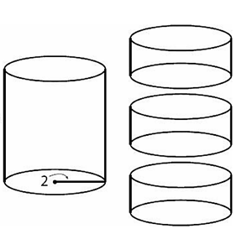

(A) 4π (B) 12π (C) 16π (D) 24π (E) 36π (**Answer:** C)

1. **Quantity A Quantity B**

The area of WYX The area of ZYW

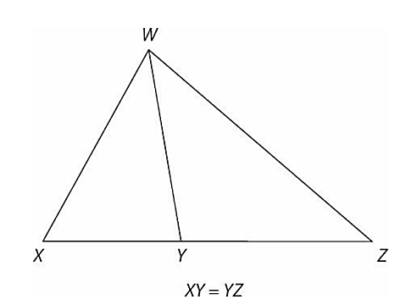

(**Answer:** C)

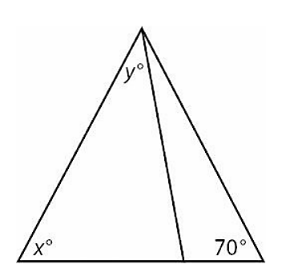

Note: Figure NOT drawn to scale

1. **Quantity A Quantity B**

x + y 110

**(Answer:** B) (x + y) + 70 < 180

x + y < 110

**Coordinate Geometry**

1. Which of the following is most likely to be the equation of line l?

(A) y = 4x + 4 (B) y = 4x – 4 (C) y = x – 6 (D) y = x + 1/2 (E) y = -x - 3

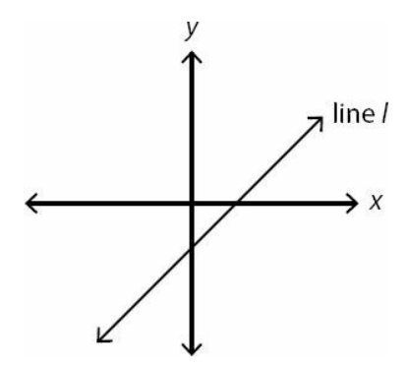 (**Answer:** C)

2. Lines l1 and l2 are parallel and have slopes that sum to less than 1.

**Quantity A Quantity B**

The slope of a line -(1/2)  
perpendicular to lines l1 and l2

(**Answer:** D)

**Probability**

1. A history exam features 5 questions. 3 of the questions are multiple-choice with four options each. The other two questions are true or false. If Caroline selects one answer for every question, how many different ways can she answer the exam?

(**Answer:** 4*4*4*2*2= 256)

1. Quantity A Quantity B

The number of 4-digit positive integers where 625

all 4 digits are less than 5

**(Answer:** 4*5*5*5)

1. BurgerTown offers many options for customizing a burger. There are 3 types of meats and 7 condiments: lettuce, tomatoes, pickles, onions, ketchup, mustard, and special sauce. A burger must include meat, but may include as many or as few condiments as the customer wants. How many different burgers are possible?

**Answer:** This problem tests the fundamental counting principle, which states that the total number of choices is equal to the product of the independent choices. The key to this problem is realizing how many choices there are for each option. For the meat, there are obviously 3 choices. For each of the condiments there are exactly 2 choices: yes or no.

The only real choice regarding each condiment is whether to include it at all. As there are 7 condiments, the total number of choices is (3)(2)(2)(2)(2)(2)(2)(2) = (3)(27).

1. A small nation issues license plates that consist of just one number (selected from the digits 0 through 9, inclusive) and four letters, selected from a 20-letter alphabet. Repeats are permitted. However, there is one four-letter combination that is not allowed to appear on license plates. How many allowable license plate combinations exist?

**Answer**: Multiply to get 1,600,000= 10*20*20*20*20

Now, consider all the license plates that contain the forbidden word. Say, for example, that the forbidden word is GURG. That means that the plates 0GURG, 1GURG, 2GURG, 3GURG, etc. are forbidden, for a total of 10 forbidden plates. You can also express this mathematically as:

10*1*1*1*1

Multiply to get 10 forbidden plates.

Subtract: 1,600,000 - 10 = 1,599,990.

1. A bag contains 6 black chips numbered 1–6 respectively and 6 white chips numbered 1–6 respectively. If Pavel reaches into the bag of 12 chips and removes 2 chips, one after the other, without replacing them, what is the probability that he will pick black chip #3 and then white chip #3?

**Answer:** 1/(12*11)

1. Tarik has a pile of 6 green chips numbered 1–6 respectively and another pile of 6 blue chips numbered 1–6 respectively. Tarik will randomly pick 1 chip from the green pile and 1 chip from the blue pile.

**Quantity A** **Quantity B**

The probability that both chips

selected by Tarik will display 1/2

a number less than 4

**Answer:** B

A=3/6 * 3/6 = 1/4

1. A bag contains 6 red chips numbered 1–6 respectively and 6 blue chips numbered 1–6 respectively. If 2 chips are to be picked sequentially from the bag of 12 chips, without replacement, what is the probability of picking a red chip and then a blue chip with the same number?

**Answer:** ANY of the 6 red chips is acceptable for the first pick. However, on the second pick, only the blue chip with the same number as the red one that was just picked is acceptable (you need whatever chip is the “match” for the first one picked). Thus 6/12 * 1/11 = 1/22

1. Jan and 5 other children are in a classroom. The principal of the school walks in and chooses two children at random. What is the probability that Jan is chosen?

(A) 4/5 (B) 1/3 (C) 2/5 (D) 7/15 (E)1/2

**Answer:** (1*5)/(6C2)

1. A student council is to be chosen from a class of 12 students consisting of a president, a vice president, and 3 committee members. How many such councils are possible?

**Answer:** (12C1* 11C1 * 10C3 )

1. A certain city has a 1/3 chance of rain occurring on any given day. In any given 3-day period, what is the probability that the city experiences rain?

**Answer:** 19/27

The probability of no rain on any given day is 1 - 1/3 = 2/3. Therefore, the probability of no rain on three consecutive days is (2/3)(2/3)(2/3) = 8/27. Finally, subtract from 1 to find the probability that it rains on one or more days: P(1 or more days) = 1 - P(no rain) = 1 - 8/27 = 19/27.

**Averages, Weighted Averages, Median, and Mode**

1. In Clarice’s class, each test weights her overall grade average three times as much as each quiz does. If Clarice scored 88 and 94 on two quizzes, respectively, and she scored 90 on the only test, what is her current overall grade average?

**Answer:** To account for the fact that tests weight the grade three times as much as quizzes, include each test score as if it were three identical quizzes. So, 2 quizzes and 1 test = 2 + 3 = 5 quizzes.

Average = (88 + 94 + 90 + 90 + 90)/5

Average = 452/5 = 90.4

1. Every week, Renee is paid 40 dollars per hour for the first 40 hours she works, and 80 dollars per hour for each hour she works after the first 40 hours. How many hours would Renee have to work in one week to earn an average of 60 dollars per hour that week?

**Answer:** [(40*40) +((x-40)*80)]/40 = 60

= 80

1. The average age of the buildings on a certain city block is greater than 40 years old. If four of the buildings were built two years ago and none of the buildings are more than 80 years old, which of the following could be the number of buildings on the block?

Indicate all such numbers.

* 4
* 6
* 8
* 11
* 40 Answer: 8, 11, 40

1. Set S consists of the first 500 positive, even multiples of 7.

**Quantity A Quantity B**

The average of the set The median of the set

Answer: C (Arithmetic Sequence)

**Inequalities and Absolute Values**

1. |x| + |y| > |x + z|

**Quantity A Quantity B**

Y z Answer: D

1. x and y are integers such that |x|(y) + 9 < 0 and |y|≤ 1.

**Quantity A Quantity B**

x -9 Answer: D

1. |*x*|*y* > *x*|*y*|

**Quantity A Quantity B**

(*x* + *y*)2 (*x* - *y*)2 Answer: B

1. The reciprocal of *x*’s non-integer decimal part equals *x* + 1, and *x >* 0.

**Quantity A Quantity B**

*x Sqroot(2) Answer: C*

1. Ramon wants to cut a rectangular board into identical square pieces. If the board is 18 inches by 30 inches, what is the least number of square pieces he can cut without wasting any of the board?

(A) 4 (B) 6 (C) 9 (D) 12 (E) 15

Answer: E