TASK -1 : PROTOTPYE OF DESIGN OF WEBSITE IN FIGMA.

SLIDE -1: This slide of figma contain welcome page with the symbol and branding of Flipkart. Here, I have attached a screenshoot below. 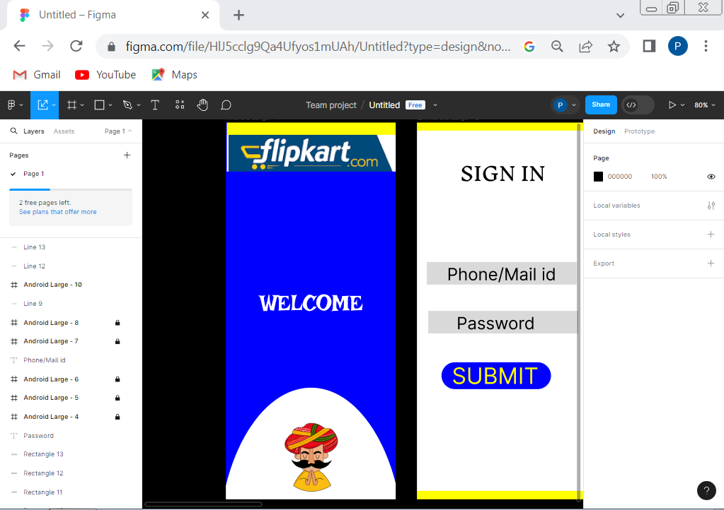

SLIDE-2 : This slide of figma contain some necessary inputs like SIGN IN with email and phone login with Password and atlast Submit Button.Here below I have attached the screenshot.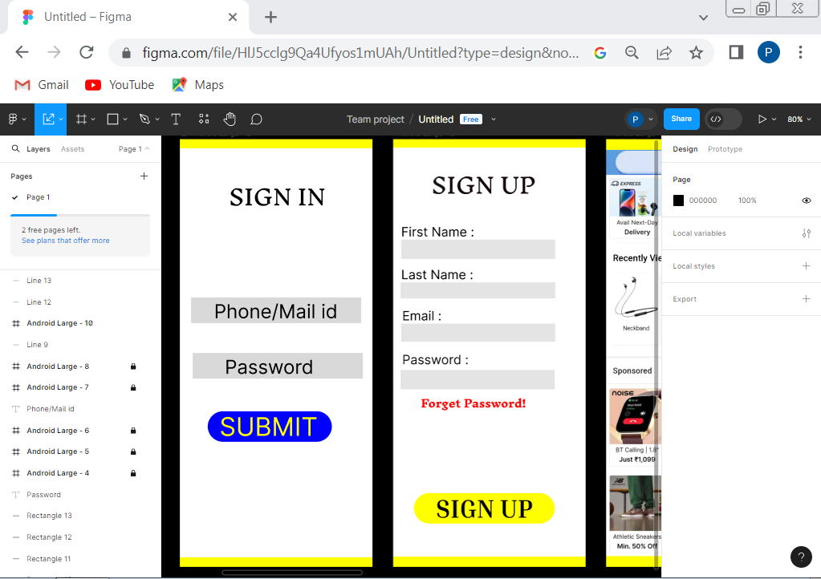

* SLIDE 3 : In this slide 3 SIGN UP Form is attached with the submit button in which we can register new customers using Mobile number and Email id in which they can use their mail password or one time password.

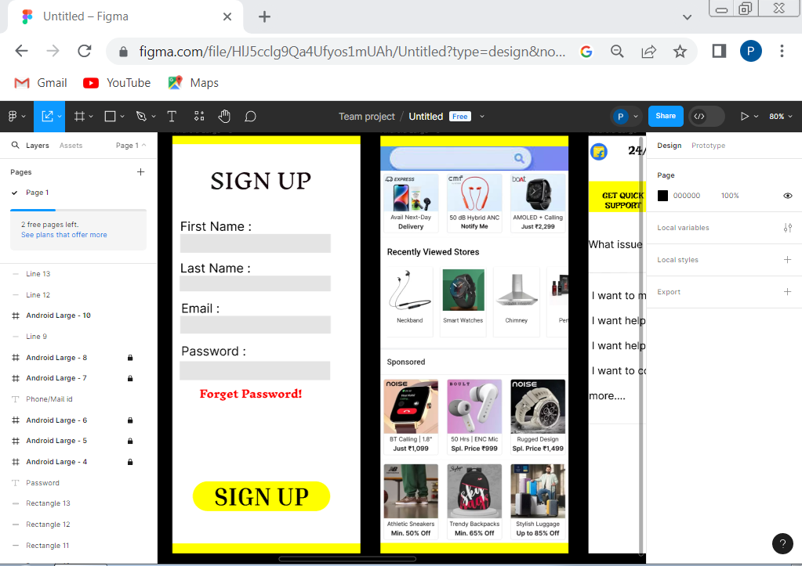

SLIDE-4: In this slide contain HOME PAGE in which upper side the search bar is their and also it contains some art. It also contain items and product with their description with price and ratings.

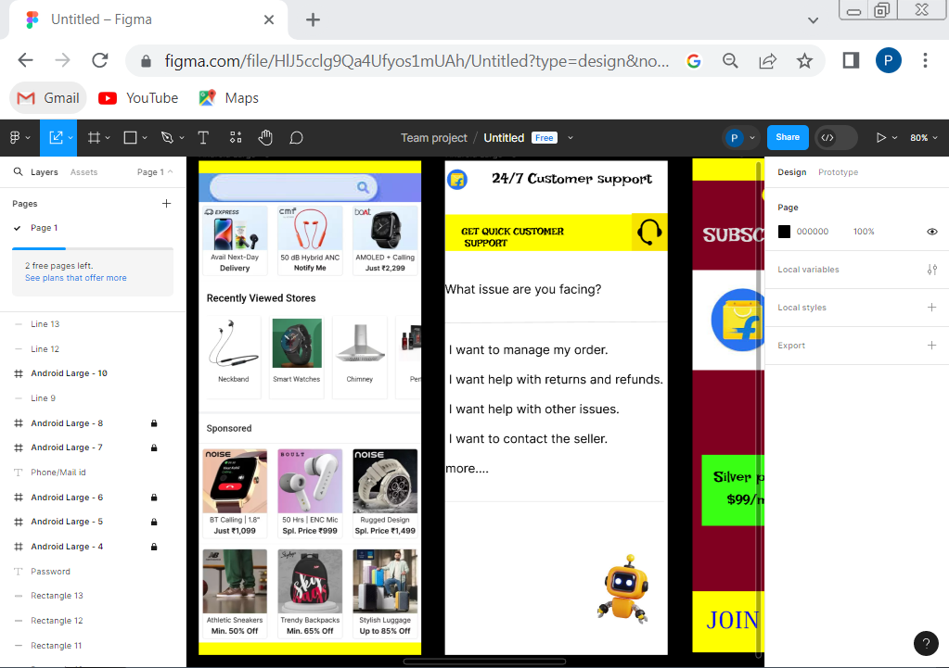

SLIDE-5: In this slide contain 24\*7 Customer support which deals with the problems faced by the customers during their shopping and their payment and tracking problems .

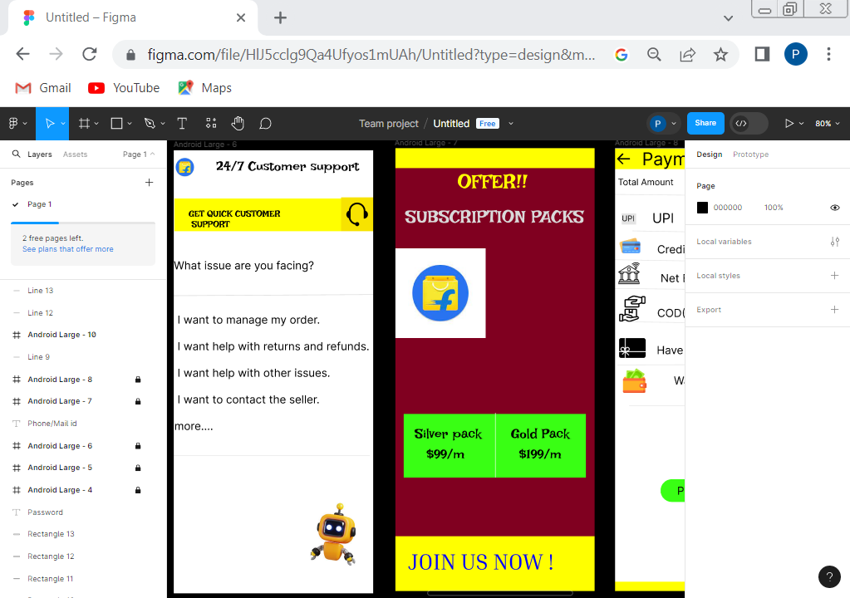

SLIDE-6: This slide contain the subscription page ion which customer got offer for their monthly subscription based on their packs.

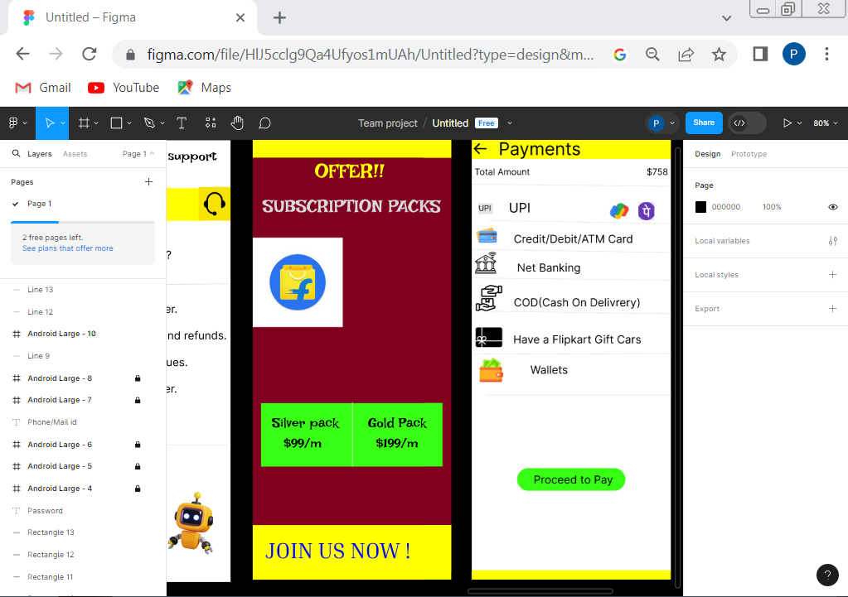

SLIDE-7: This slide contains Payment page in which customer will get many modes of payment either it is using UPI, COD(Cash on Delivery), Etc. and also it contain option of add Vouchers.

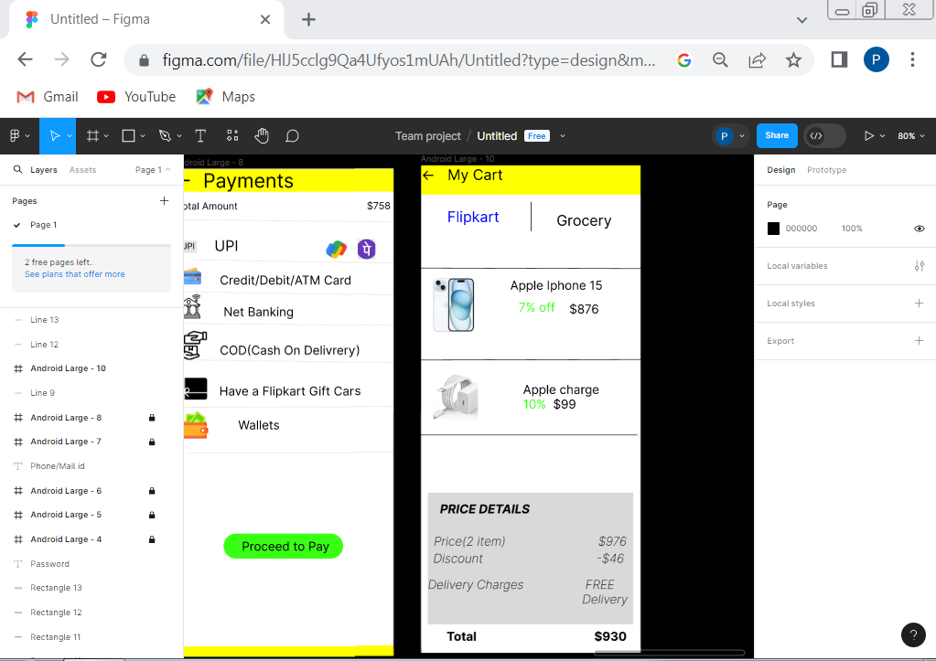

SLIDE-8: In this slide is option of add cart page in which it contain items follow with the price and Discount over it.

